Name : Zeinab Dast Mozd
ID :2323135
Date 25/3/2024

EEG-Based Binary-Class Workload Identification
Using Feature Fusion and Selection

ABSTRACT
EEG (Electroencephalography) workload classification is a field within neuroscience and computational biology focused on analysing brain activity patterns to infer cognitive workload levels. It utilizes EEG technology to measure electrical activity in the brain, particularly focusing on frequency bands such as alpha, beta, theta, and gamma waves. The background of EEG workload classification involves understanding the relationship between cognitive workload levels and EEG patterns, typically through machine learning algorithms. Researchers aim to develop models that can accurately classify workload levels based on EEG signals, which has applications in various fields such as human-computer interaction, healthcare, and aviation. EEG workload classification research often involves experimental paradigms where participants perform tasks of varying cognitive demands while their brain activity is recorded. By analysing EEG data from these experiments and applying machine learning techniques, researchers seek to create reliable models for real-time workload assessment, which can enhance performance, safety, and well-being in diverse human-cantered activities.
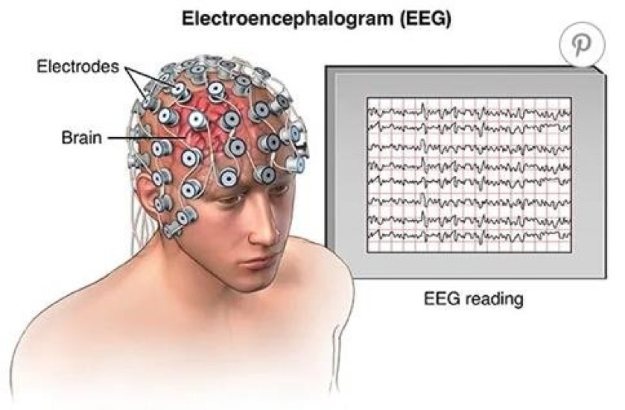

In this report, I worked on classify binary classes of workload based on EEG. I utilized two models The first one is, logistic model, which I made from scratch. The second method is by using CNN model which is stands for Convolutional Neural Network. It's a type of artificial neural network that is primarily used for analysing visual imagery. CNNs are powerful models for image recognition, classification, segmentation, and other tasks in computer vision. It performs well with huge data that is why I chose to work with it. After using these two models, I evaluated using the five-Fold Cross-Validation, which is made from scratch as well. And I compared the accuracy that I got as well as the result and I will give my own opinion on the result that I obtained.
First, I briefly demonstrate some facts about the EEG data that I have in this assignment.
1-there are Two Classes: Low Workload and Medium Workload.
2- the Number of Samples is 180 for each class so overall we have 360 samples
3-Sampling Rate is 256Hz for each sample
4 - Number of Channels are 62 and Number of Data Points are 512.

Backgrounds

INTRODUCTION

These days a lot of changes happened to people live which led to mental workload is elevated. The previous study has demonstrated a significant correlation between mental overload and errors during decision-making [1]. Mental overload stands out as one of the primary causes of mistakes and accidents. Therefore, it is extremely important to give proper attention to mental workload. In a way that maintaining an appropriate workload level that ensures high efficiency without overloading is essential. Accurate identification of workload levels is a prerequisite for achieving this. In general, the workload can be assessed using subjective or objective manners [2]. Subjective methods rely on self-reporting or human judgment to evaluate workload. This approach typically involves asking individuals to rate their perceived level of workload, stress, or mental effort using questionnaires provide how individual feel while performing tasks. Example of subjective methods is assessment questionnaires [3].
Objective methods, on the other hand, involve the direct measurement of workload using physiological or behavioural. These are often collected using sensors, instruments, or computational algorithms. Objective assessments provide quantifiable data such as accuracy.
Therefore, EEG is one of the best methods for assessing workload level as it directly reflects brain activity [4].
EEG signals are divided into different frequency bands, each associated with specific brain activities. Here's a brief explanation of the five bands in a study these all were used [5]
- Delta (δ) Waves: Delta waves are the slowest brainwaves, typically ranging from 0.5 to 4 Hz. They are associated with deep sleep, unconsciousness, and certain cognitive processes such as memory consolidation.
- Theta (θ) Waves: Theta waves have a frequency range of 4 to 8 Hz and are often observed during states of drowsiness, relaxation, and meditation. They are also associated with memory formation and creative thinking.
- Alpha (α) Waves: Alpha waves have a frequency range of 8 to 12 Hz and are prominent during wakeful relaxation with eyes closed. They are considered an indicator of the brain's idling state and are associated with reduced cognitive workload.
- Beta (β) Waves: Beta waves have a frequency range of 12 to 30 Hz and are observed during active wakefulness, concentration, and cognitive engagement. Higher beta frequencies may indicate increased mental activity and arousal.
- Gamma (γ) Waves: Gamma waves have the highest frequency range, typically above 30 Hz. They are associated with cognitive processes such as attention, memory encoding, and information processing.

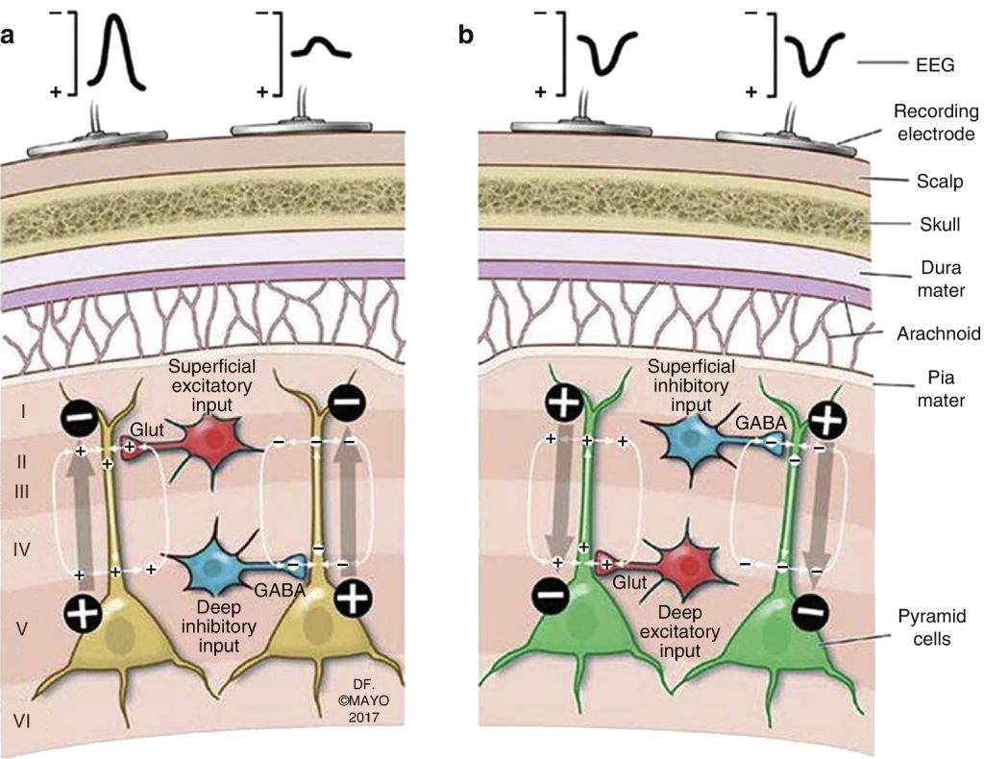

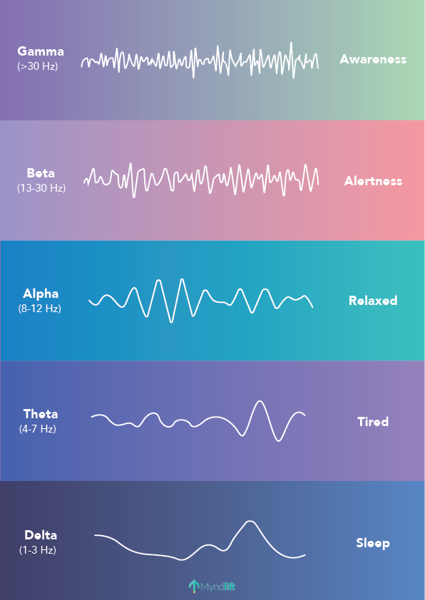

There are studies indicated that utilizing band powers could achieve high accuracy in classifying mental workload. All standard frequency bands were employed in the previous studies and in these two studies [6] and [7].
To clarify more and explain, mental workload classification, this means that by analysing the power levels in different frequency bands of brain signals, researchers can effectively distinguish between various levels of mental workload experienced by drivers. For instance, certain frequency bands might indicate a stress state, while others might signify a more relaxed or focused state.

relevant works
"Brain-Computer Interfaces: Principles and Practice" by Jonathan Wolpaw and Elizabeth Winter Wolpaw: This book explores the emerging field of brain-computer interfaces (BCIs), which utilize EEG signals to establish direct communication between the brain and external devices. It covers the theoretical foundations, technological advancements, and practical applications of BCIs in healthcare, assistive technology, and gaming.
"Dynamic Brain Imaging: Multi-Modal Methods and In Vivo Applications" edited by Fahmeed Hyder and Spencer Smith: This edited volume explores the integration of EEG with other neuroimaging modalities, such as functional MRI (fMRI), magnetoencephalography (MEG), and transcranial magnetic stimulation (TMS). It discusses the synergistic benefits of combining EEG with other imaging techniques for studying brain function and connectivity.

Relevant method
Feature Extraction:
- Time-domain Features: Statistical measures such as mean amplitude, peak amplitude, and variance are computed from EEG signal epochs.
- Frequency-domain Features: EEG signals are transformed into the frequency domain using techniques such as Fourier transform, or wavelet transform. Features such as power spectral density, band power, and spectral entropy are extracted.
- Spatial Features: Spatial patterns of EEG activity are analysed using techniques such as scalp topography or source localization to extract features related to brain regions or networks.
EEG Signal Preprocessing:
- Filtering: EEG signals are filtered to remove noise and artifacts. Common filters include high-pass filters (to remove baseline drift), low-pass filters (to remove high-frequency noise), and notch filters (to remove powerline interference).
- Artifact Rejection: Artifacts such as eye blinks, muscle activity, and environmental noise are identified and removed using automated algorithms or manual inspection.
- Segmentation: EEG data are divided into epochs or segments corresponding to specific experimental events or tasks for further analysis.
Interpretation and Visualization:
- Statistical Analysis: Statistical tests, such as t-tests, ANOVA, or non-parametric tests, are used to assess the significance of differences in EEG measures between conditions or groups.
- Visualization: EEG data are often visualized using scalp topography plots, time-frequency spectrograms, ERP waveforms, or connectivity matrices to explore patterns of brain activity and connectivity.

Methods
I used two methods on the data the I got. the first method was a logistic model which I previously made in the labs. the second is deep learning model CNN. And I will explain more.
First, I download the data and make it acceptable by the model that I made, logistic model. As it is known that logistic model takes matrix x and y ground truth. So, if we have picture, we must convert in the way that is acceptable by the model. So here I change the data and reshape it . After downloading the data, I extract the data and the label, and I put the data in data only and the label in the variable label. Then I convert the label to a matrix of 2 rows and 360 samples and the data to a matrix of 31744 rows and 360 sample. After this must done steps, I got my data and label. Then I rewrote all the previous function which they are
- Gradient weight: which is used to calculate the weight.
- Gradient bias: which is used to calculate the bias.
- Forward propagation: here I calculate the loss and this function return the prediction which is represented by y hat and the loss.
- Model function: here I update the weight and the bias to get the minimum loss and enhance my model performance.
- Calculate accuracy function: here I calculate the accuracy for each element as it is known that the accuracy is how far y hat from y so we have 2 cases when y hat > 0.5 then accuracy is y hat. When y hat < 0.5 the accuracy is 1-yhat.

After using the previous labs and making the accuracy function. I used cross validation function and its steps of shuffling the data and splitting it into train and test sets. We use 5 folds, every fold was 72 so 288 was for training and 72 for testing and then I evaluated the logistic model, and I got low accuracy then I used CNN and got high accuracy compared with logistic model. After that I applied feature selection Fourier transformation and obtain the accuracy for each model logistic and CNN.

Results

I got these results after several changing. To enhance loss function I can either increase the number of iteration or I can change the learning rate at first, I used learning rate = 0.0000001 so and got loss = 1.36

Learning rate | 0.000000001 | 0.0000001 | 0.00001 | 0.00001
loss | 1.38 | 1.36 | 1.26 | 0.805

So, from the result I think the optimal learning rate is 0.00001 because the loss is low. And I will not get nan values for loss function which I think it is happening because gradient vanishing in deep learning models, particularly during backpropagation, gradients can vanish that is mean becoming very small this can lead to numerical instability and nan values in the loss function.

In this table I will demonstrate the result I obtained from logistic model

Learning rate | 0.000000001 | 0.0000001 | 0.00001
Accuracy 1 | 0.49952085190561085 | 0.4892104829265624 | 0.503998338676891
Accuracy 2 | 0.5002855005419989 | 0.47498287337068845 | 0.5125771881987284
Accuracy 3 | 0.5001894482057759 | 0.4862726352774121 | 0.489228625090961
Accuracy 4 | 0.4982674201128585 | 0.4965254578651 | 0.4818980234112321
Accuracy 5 | 0.49566722692424137 | 0.47914225006392464 | 0.467443709951076
Approximate Mean accuracy | 0.492 | 0.478 | 0.48

First from my result I will choose to do my model with learning rate = 0.0000001 because I got higher accuracy and I also tried to decrease the learning rate and I notice that the more I decrease it the higher accuracy I get. and as it is know when the learning rate is large the model will fit the training date and perfume bad on unseen data. after observing these results, I can say that overall, I have low accuracy, in other words my model classify like it is doing that randomly because accuracy is less than 0.5. And what does that mean? low accuracy typically means that the model is not performing well in making correct predictions on the test data. There could be several reasons however I think that this low accuracy is because I need more complex model as well as reducing the data size, because my data is huge, by using a lot of method s like feature selection. In the other classification studied other than workload identification, feature fusion and feature selection gave an effective role in the improvement of classification performance. In the method proposed by Chen et al. [8].

In this table I will illustrate the result that I obtained from using a more complex model which is CNN

Accuracy1 | 0.8888888955116272
Accuracy 2 | 0.8888888955116272
Accuracy3 | 0.8888888955116272
Accuracy4 | 0.6944444179534912
Accuracy5 | 0.9444444179534912
Approximate average accuracy | 0.8611111044883728

First why I chose CNN? I chose it because CNN can efficiently handle large datasets with high dimensionality and many observations which suits my eeg data. It is computationally efficient and can parallelize the training process, making it suitable for big data applications.so I have huge number of rows and relatively a small number of samples.

From this result I can see that the performance is higher compared to logistic model and in my opinion that is because the complexity of the model which contain several layers. After that I will applied feature Fourier transformation selection and I got this result

Logistic model- AVERAGE ACCURACY | 0.725
CNN model- AVERAGE ACCURACY | 0.8055555582046509

The result shows that I got better accuracy in terms of logistic model after applying feature selection from 0.492 to 0.725 . In contrast, I got lower accuracy in terms of CNN model after applying feature selection.

Conclusion
in conclusion, my study was about observing the accuracy when applying logistic model which is made from scratch and CNN model on EEG data before and after feature selection. The highest performance was noticed at CNN model without feature selection and the lowest was noticed at logistic model without Fourier transformation.

Reflection
From the result I got it seems that when I apply feature selection I got higher result and that is shown by the result. Because EEG data often has a high-dimensional feature space, with each channel representing a different electrode location. Feature selection techniques can reduce the dimensionality of the data by selecting a subset of relevant features, which can mitigate the curse of dimensionality and improve the model's ability to generalize to new samples.
I will submit another code with the name of ‘with tanh’ in order to overcome the problem of nan value I replaced sigmoid function with tanh function, but I get approximately the same result and I have the same opinion that I give before, and I will display the result
 | Before feature selection | After feature selection
Logistic model | Approx. 0.49 | 0.7111111111111111
CNN | 0.7388888955116272 | 0.7777777791023255

Notice : I replace the sigmoid function with the tanh function in order to remove the nan value that I encounter and I had problem with shuffling the data that’s why I got inaccurate result in sogmoid file but after tanh function and correct the shuffling I got the accurate result . the result is in ‘tahn2’.
Thanks.
So the correct accuracy before feature selection is
Logistic model- AVERAGE ACCURACY | 4943443187774026
CNN model- AVERAGE ACCURACY | 0.7388888955116272

References

[1] T. Kakizaki, "Relationship between EEG amplitude and subjective rating of task strain during performance of a calculating task," European Journal of Applied Physiology, vol. 53, no. 3, pp. 206-212, 1984.

[2] Y. Yeh and C. D. Wickens, "Dissociation of Performance and Subjective Measures of Workload," Human Factors, vol. 30, no. 1, pp. 111-120, 1988.

[3] G. B. Reid and T. E. Nygren, "The Subjective Workload Assessment Technique: A Scaling Procedure for Measuring Mental Workload," Advances in psychology, vol. 52, pp. 185-218, 1988.

[4] M. A. Hogervorst, A. Brouwer, and J. B. F. Van Erp, "Combining and comparing EEG, peripheral physiology and eye-related measures for the assessment of mental workload," Frontiers in Neuroscience, vol. 8, pp. 322-322, 2014.

[5] S. G. Lei, W. Sebastian, and R. Matthias, "Representation of driver’s mental workload in EEG data," Human Factors security and safety, pp. 285-294, 2009.

[6] Z. Wang, R. M. Hope, Z. Wang, Q. Ji, and W. D. Gray, "Cross-subject workload classification with a hierarchical Bayes model," NeuroImage, vol. 59, no. 1, pp. 64-69, 2012.

[7] S. Chandra, K. L. Verma,
G. Sharma, A. P. Mittal, and D. Jha, "EEG BASED COGNITIVE WORKLOAD CLASSIFICATION DURING NASA MATB-II MULTITASKING," International Journal of Cognitive Research in Science, Engineering and Education, vol. 3, no. 1, pp. 35-41, 2015.

[8] J. Chen, B. Hu, L. Xu, P. Moore, and Y. Su, "Feature-level fusion of multimodal physiological signals for emotion recognition," in IEEE International Conference on Bioinformatics and Biomedicine, pp. 395- 399, 2015.

