Spec-Driven Development with AI Coding Tools: Key Resources & Example
Spec-Driven Development (SDD) with AI coding assistants (like GitHub Copilot and others) is a disciplined approach where you write a clear specification first (in Markdown) and then let the AI generate code guided by that spec. Instead of the “vibe coding” approach (typing ad-hoc prompts and letting the AI guess the details, which can lead to inconsistent or lost context), SDD uses well-structured Markdown files (e.g. spec.md, design.md, tasks.md, rules.md) as persistent, version-controlled guides for the AI. This yields more predictable, maintainable code, with far fewer re-writes or context resets required. [buildercog.com], [github.blog] [buildercog.com], [buildercog.com]
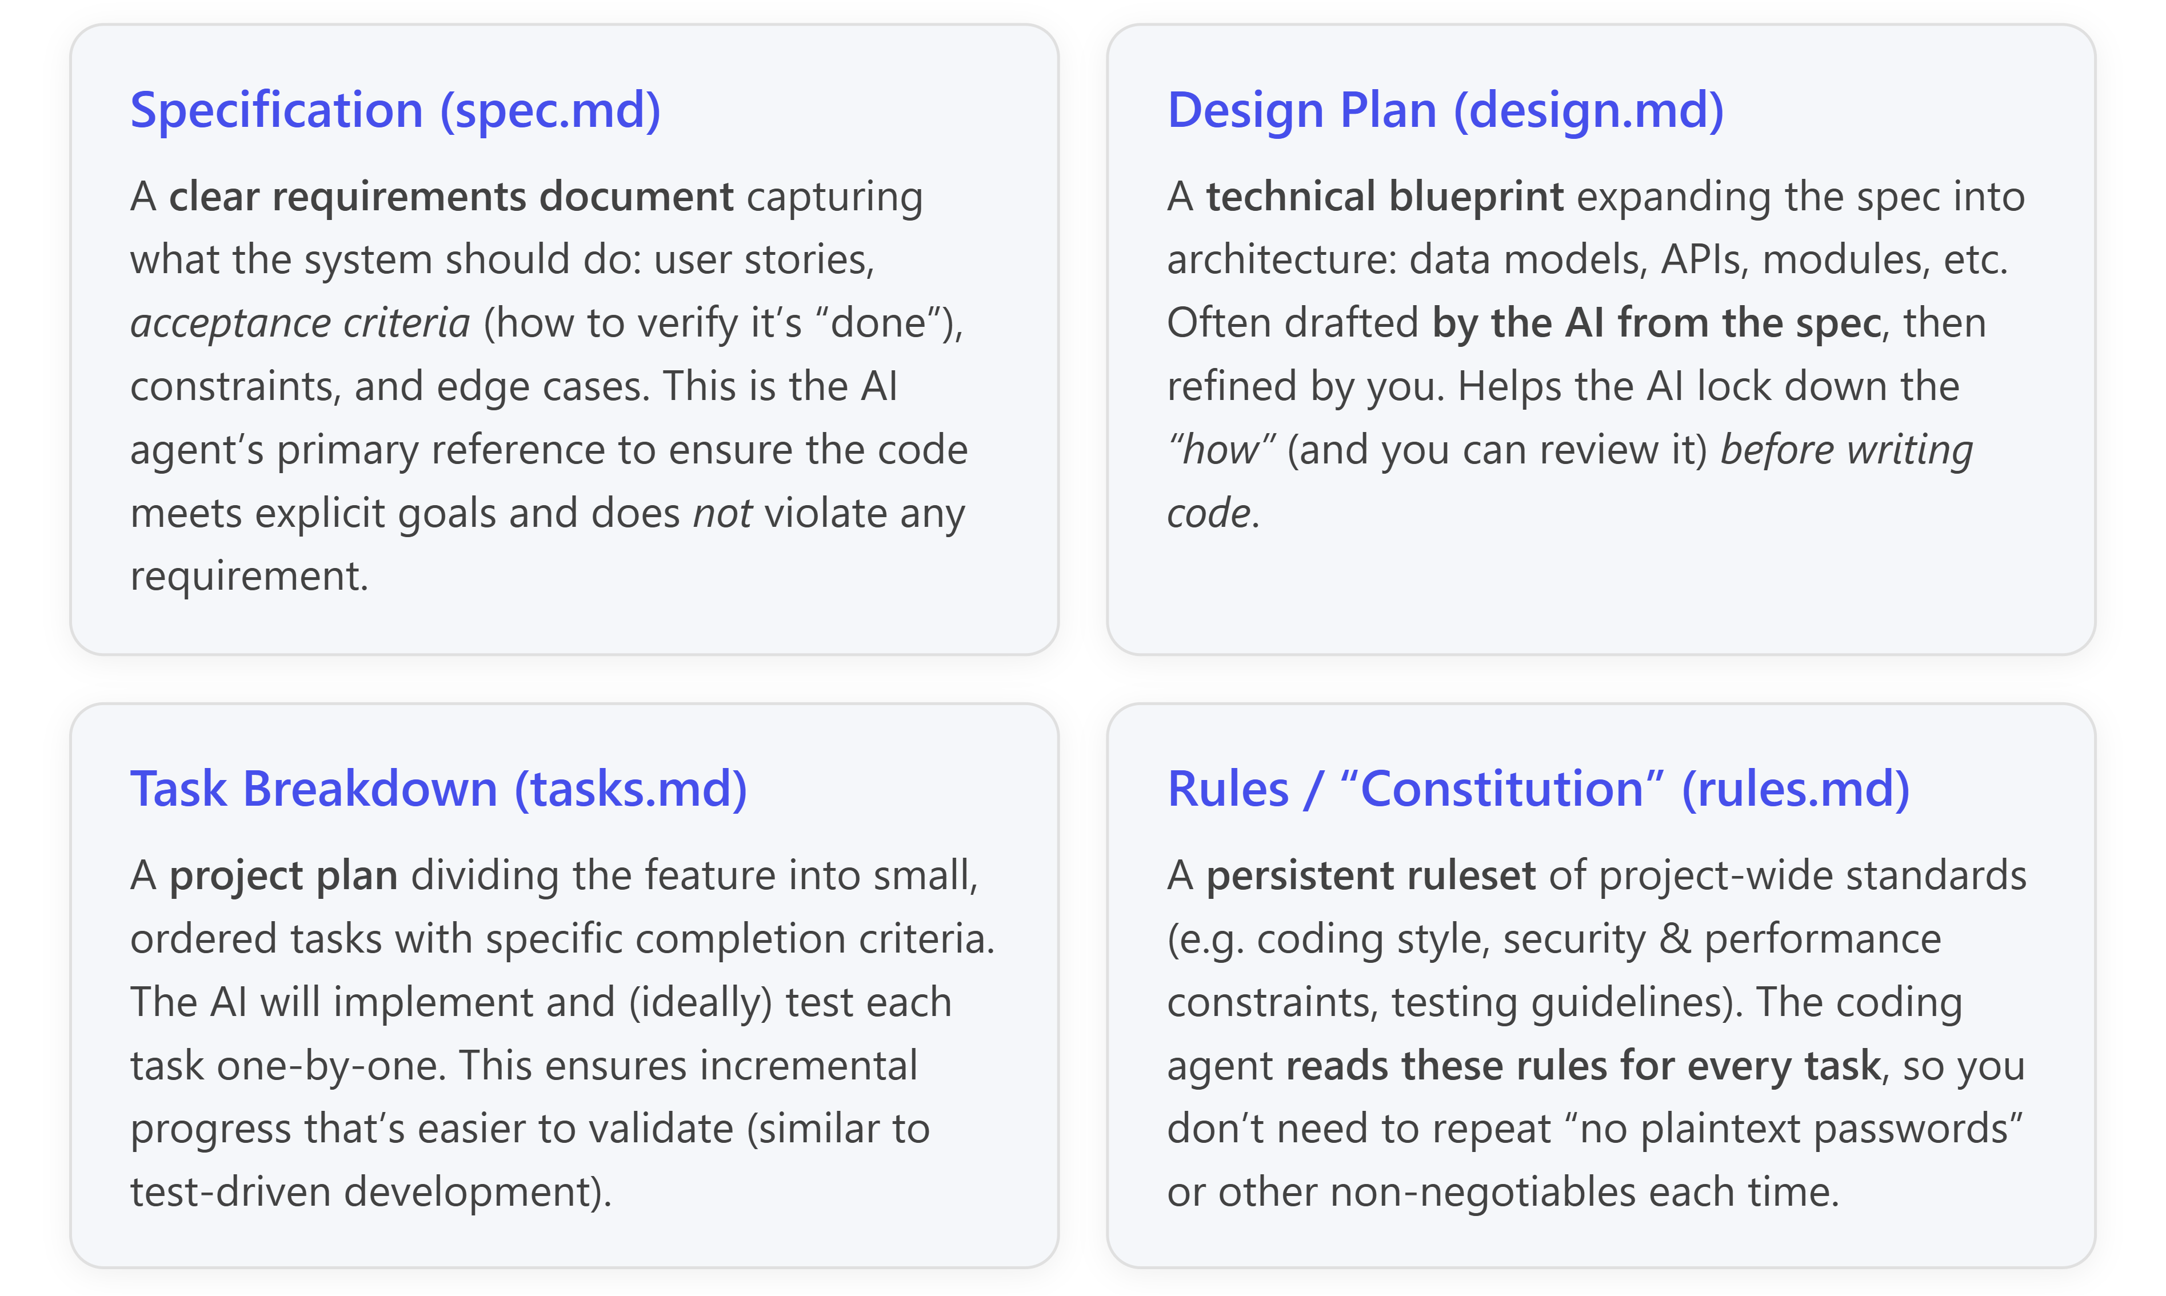
[buildercog.com]
With these Markdown specs and plans in place, you can incorporate them into GitHub Copilot’s workflow so the AI always has context when generating code. For instance, Copilot supports a copilot-instructions.md file where you can put your project’s purpose and design decisions, and it will read that file on each suggestion. GitHub’s open-source Spec Kit (2025–2026) formalizes this multi-file approach: it includes a CLI called “Specify” to automatically scaffold a project with spec-driven prompts (for each phase) and template Markdown files (spec, plan, tasks, etc.) for whichever AI agent you use (Copilot is fully supported). Spec Kit uses simple commands (like /specify, /plan, and /tasks) in VS Code or Copilot’s interface to feed the agent each artifact in turn and drive the spec → design → tasks → implement loop. This ensures the AI always works from a complete spec and design, rather than a one-off prompt, and makes the development loop more deterministic and easier to replicate. [github.blog] [github.blog], [buildercog.com] [github.blog], [github.blog]
Key resources for learning spec-driven development (SDD) and replicating it in Python projects:
- Official GitHub Guides and Toolkit: The GitHub Blog post “Spec-driven development: Using Markdown as a programming language when building with AI” by Tomas Vesely (Sept 2025) provides a detailed real-world example of writing an entire app in Markdown and letting Copilot compile it to code. The open-source GitHub Spec Kit (v0.8+ as of 2026) – announced by GitHub in 2025 – is a comprehensive toolkit that automates SDD workflows with Copilot and others. Spec Kit’s [documentation and repository] helps you quickly set up a project with spec.md, design.md, tasks.md, and a constitution.md for rules, plus prompt files to orchestrate Copilot. (Spec Kit’s specify init command will create the needed structure for you, including integration with Copilot’s new CLI and custom instructions.) [github.blog], [github.blog] [github.blog], [github.blog] [buildercog.com], [buildercog.com]
- Authoritative Courses & Articles: The DeepLearning.AI / JetBrains short course “Spec-Driven Development with Coding Agents” (2026) teaches SDD principles and step-by-step workflows in a hands-on format. It demonstrates writing project constitutions, feature specs, and iterating through plan-implement-verify loops with AI assistance (with Python examples). This course is taught by a JetBrains developer advocate and covers how to adapt SDD to both new and existing codebases. Additional reading: “From 'Vibe-Coding' to Spec-Driven Development” (2025) by Hamman Samuel and “From Vibe Coding to Spec-Driven Development” (2025–2026) articles and case studies (e.g. by Mariya Mansurova and by Abhimanyu Grover) which illustrate SDD in practice, comparing it to vibe coding and highlighting best practices like using explicit acceptance criteria, maintaining context via Markdown docs, and validating each step. [learn.deep...earning.ai], [learn.deep...earning.ai] [towardsdat...cience.com], [towardsdat...cience.com] [testcollab.com], [testcollab.com]
- Practical Example (Python): For a concrete example, the SDD approach can be applied to a Python project such as building a small web service or library. For instance, you would begin by writing Spec.md with the feature’s requirements, e.g. user stories and acceptance criteria for each function or API endpoint in your Python application (e.g. “When the user provides invalid input, the system shall return a clear error message with HTTP 400”). Next, you or the agent create Design.md with a plan: outlining key modules, classes, data models (like which Python libraries or frameworks to use) and any patterns (say, designing a REST API with FastAPI if you specify that tech). Then, you have a Tasks.md file enumerating the development steps in sequence (e.g. “1. Implement data model class with fields X, Y… [task criteria]; 2. Implement API route with validations… [criteria]”). Finally, you prepare a Rules.md (project guidelines) specifying things like coding style (PEP8 compliance, docstrings required), security constraints (e.g. “never embed secrets in code”), performance guidelines, etc., which the agent must always consider. These documents feed into your AI assistant’s context either through Copilot’s custom instructions file or by using Spec Kit’s prompts that automatically incorporate them. [buildercog.com] [github.blog] [github.blog], [github.blog]
Once set up, you iterate through the SDD workflow: let the agent produce or refine the design from your spec, break it into tasks, and then generate code task-by-task while you review and test each piece before moving on. The AI’s reasoning effectively mirrors your structured approach: it reads the spec to understand “what” to build, uses that to propose a design (“how”), decomposes the work into tasks, then implements each task in Python code while adhering to the spec’s acceptance tests and constant rules. By combining Copilot (or another coding agent) with these Markdown specs, you maintain a single source of truth for the project’s requirements and design, ensuring the AI’s output stays aligned with your intent through each development stage. [buildercog.com], [buildercog.com] [github.blog], [github.blog]

In summary: Adopting a spec-driven, Markdown-first workflow can make AI-assisted Python development more reliable and reproducible. By leveraging the resources above – especially GitHub’s Spec Kit and community guides – you can practice writing Specification documents and guiding Copilot (or similar tools) through a structured Plan → Task → Implement process that closely mirrors how experienced engineers plan and build software. Such an approach will help you replicate the logic seen in the conference slide: focusing on “Specification, Design, Planning, Implement” steps with clear Markdown artifacts, so the AI becomes a capable pair-programmer that writes consistent Python code according to your specs, not just by vibe. [buildercog.com], [github.blog] [github.blog], [buildercog.com]

