Laboratory work 8
We continue to work with the database from the previous laboratory works.
Take a full-page screenshot that covers the code and results of each task.

VIEW.

- Create a view to show details of all flights that are departing on a specific date. 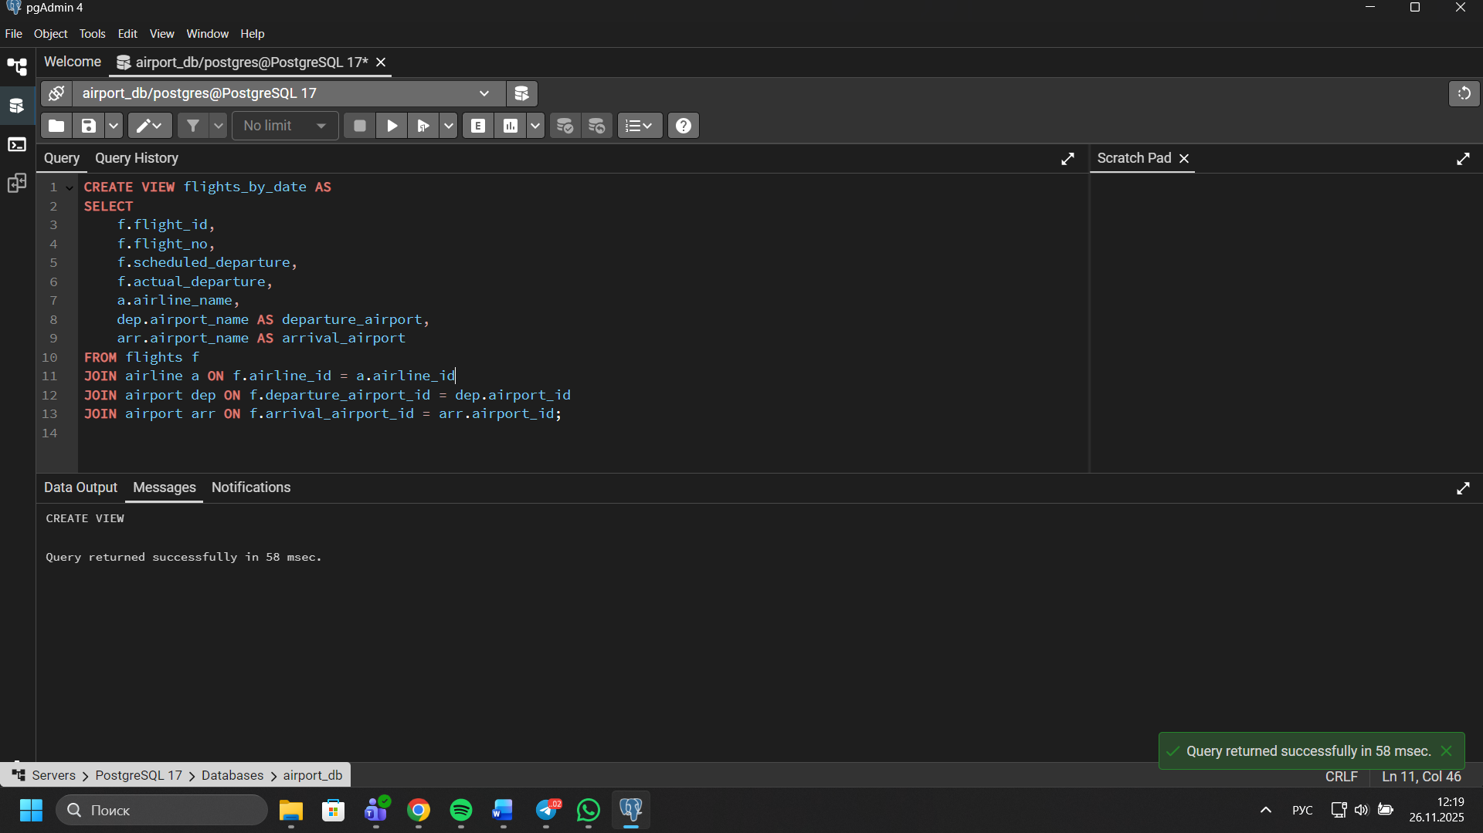
- Create a view that shows bookings for flights scheduled to depart within the next week. 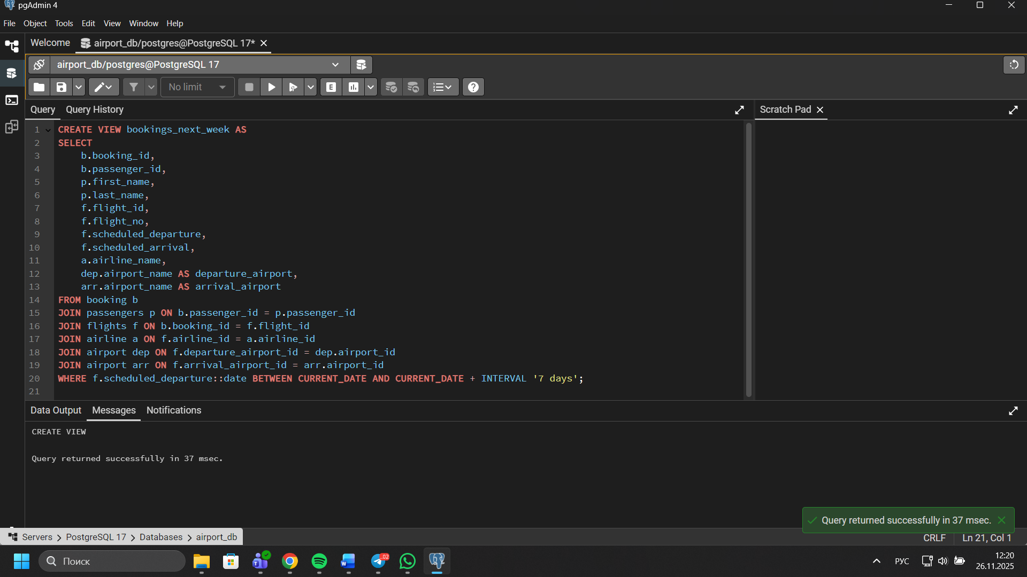
- Create a view to show the top 5 most popular flight routes based on the number of bookings. 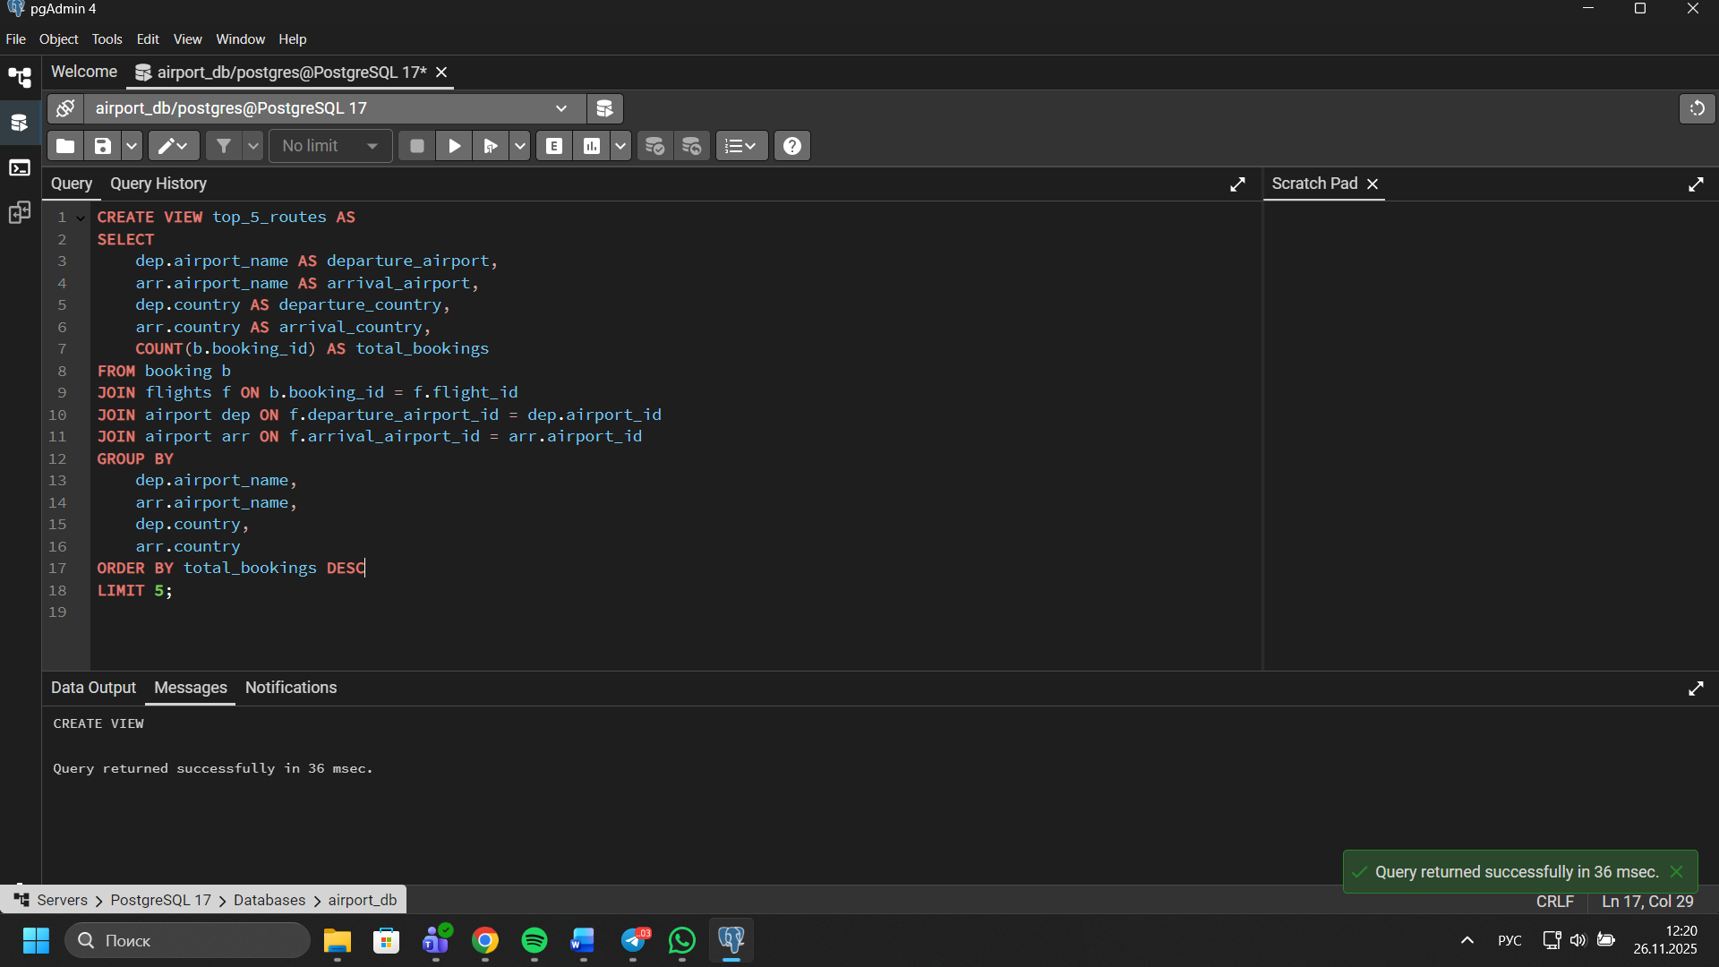
- Create a view that lists all flights for a specific airline. 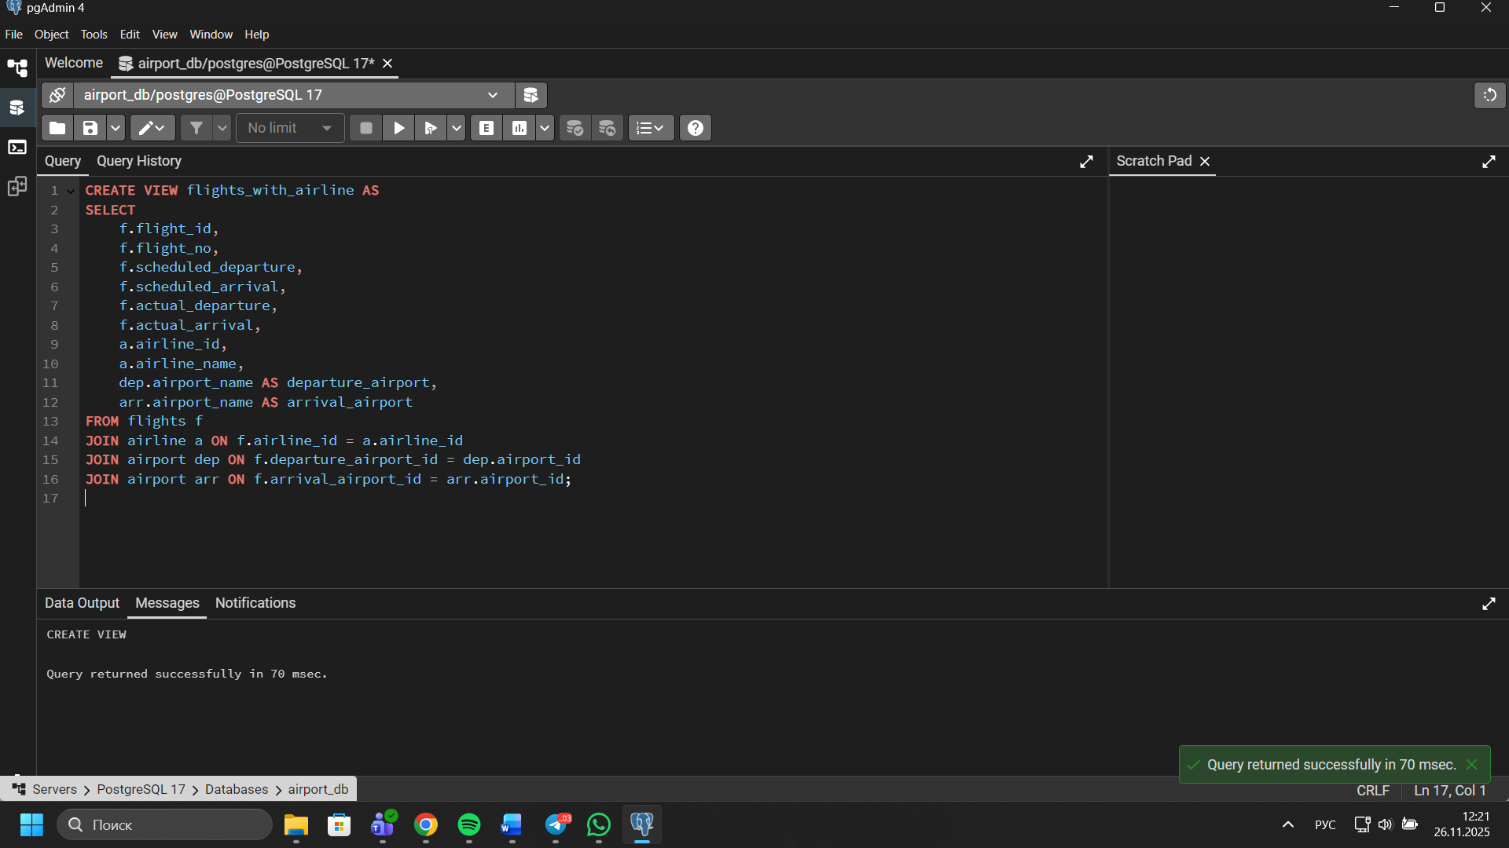
- Modify the view created in task 4 to show only flights departing within the next 7 days for a specific airline. 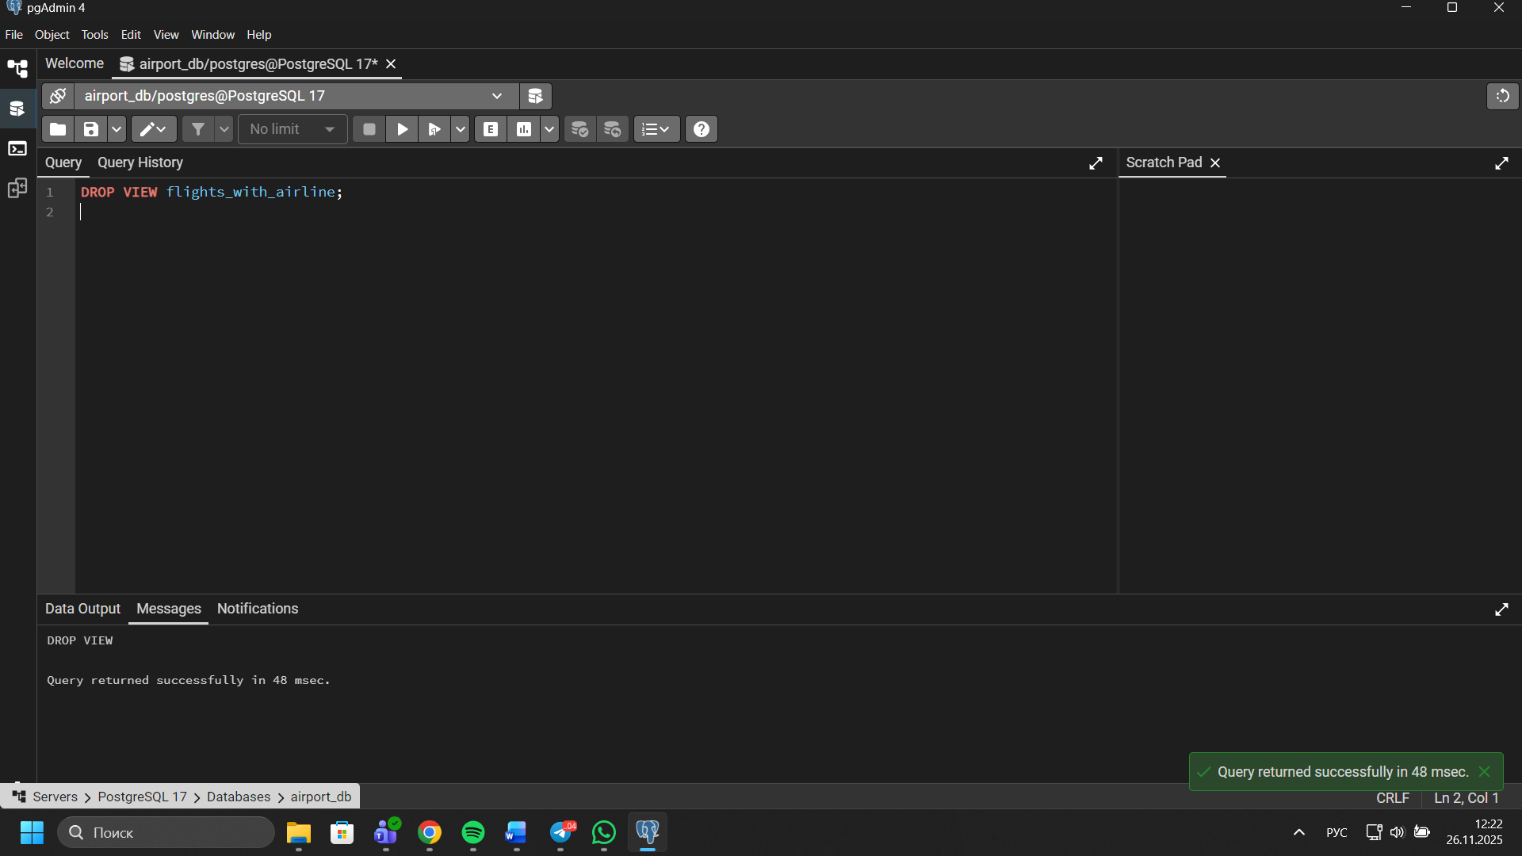 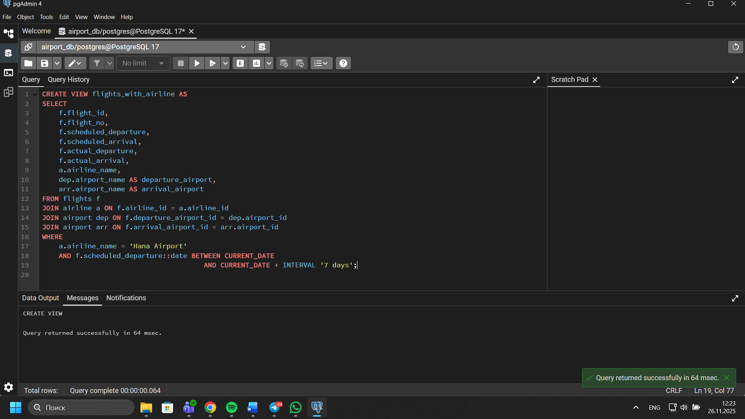
- Create a view to show flights that are delayed by more than 24 hours. 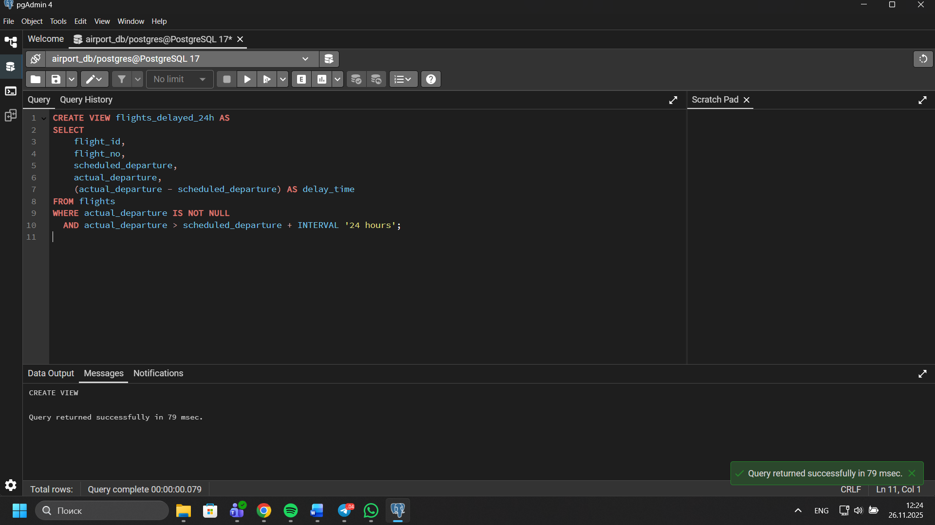
- Create a view in which you can display the full name and country of origin of passengers who made bookings on Leffler-Thompson platform. Then show the list of that passengers. 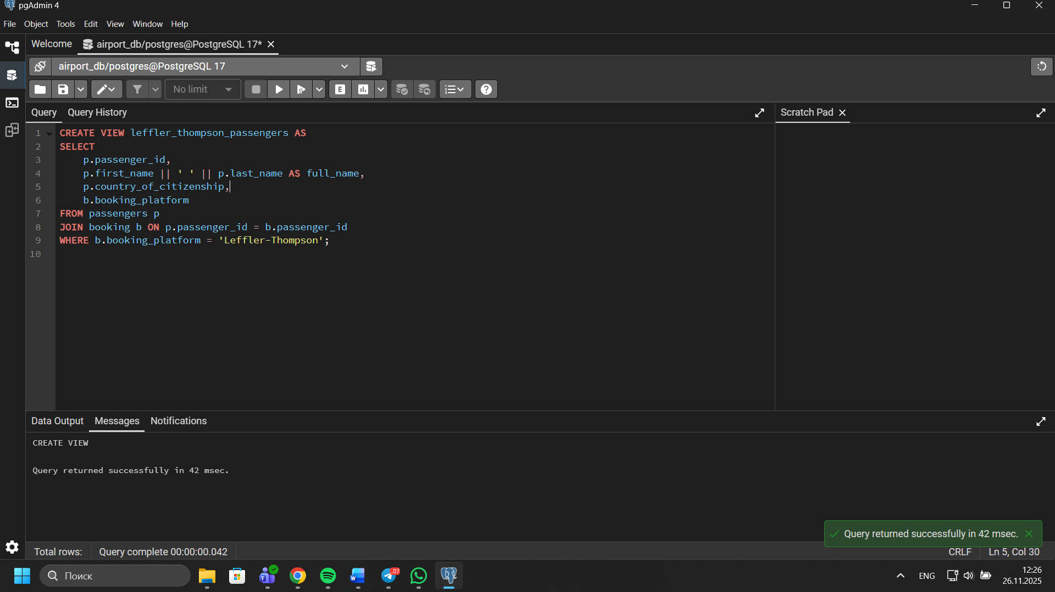
- Create a view that shows top 10 most visited countries. 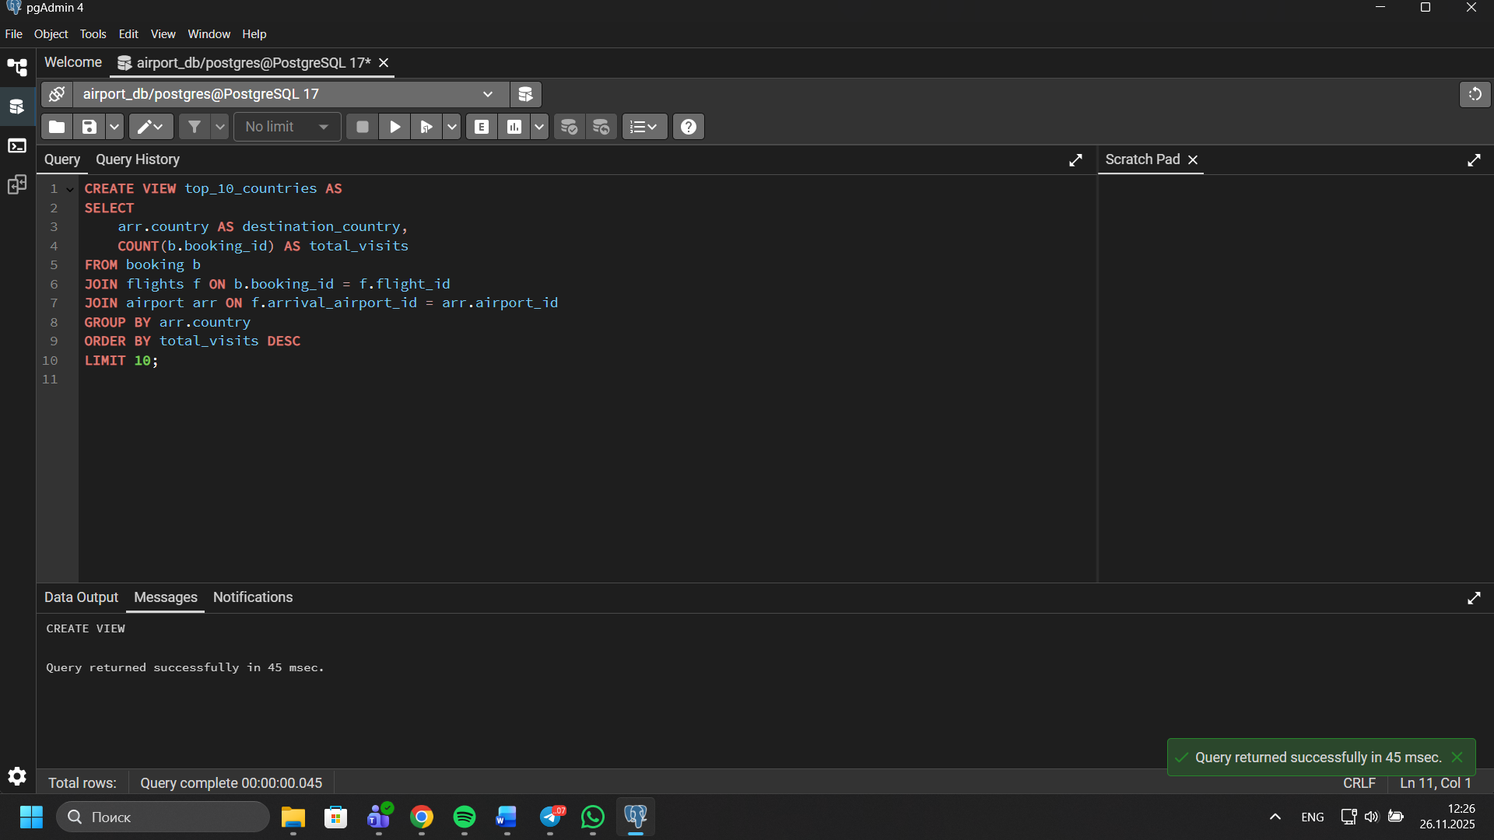
- Update any of the created views by adding new information in the view table. Show results. 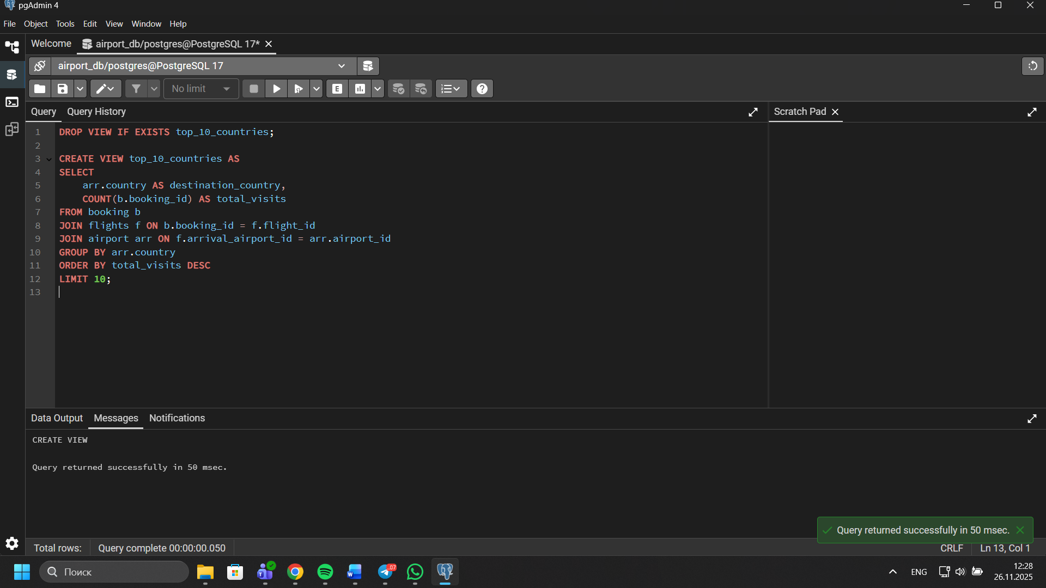
- Drop all existing views. 