Create tables with attributes

Define primary keys

Define all attributes not null constraint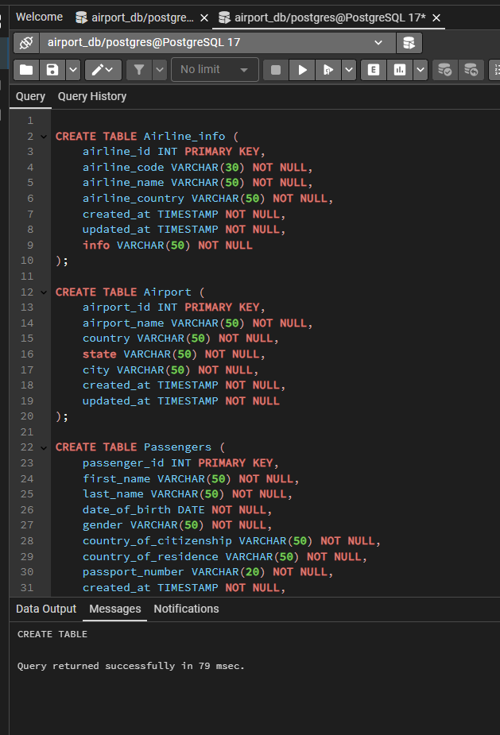

5. Rename airline_info table to airline;

6. Rename column price to ticket_price in booking table;

7. Change data type of departing_gate from varchar(50) to text;

8. Drop the column info(varchar(50)) from the airline table.

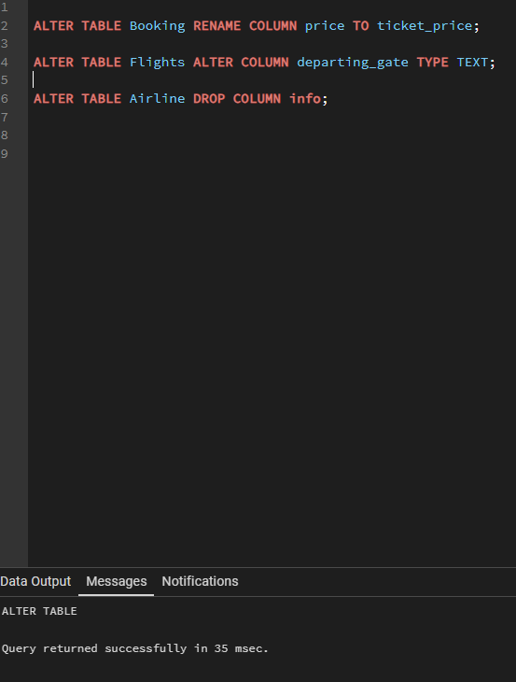

9. Make a relationship between following tables:

· Passengers with Secuitiry_check, Booking, Baggage_check by passenger_id;

· Booking with Baggage_check, Baggage, Boarding_pass, Booking_flight by booking_id;

· Flights with Booking_flight by flight_id;

· Airport with Flights by departing_airport_id;

· Airport with Flights by arriving_airport_id;

· Airline with Flights by airline_id;

Изображение выглядит как текст, снимок экрана, программное обеспечение, Шрифт

Содержимое, созданное искусственным интеллектом, может быть неверным.

2. Add a new airline named "KazAir" based in "Kazakhstan" to the airline table.

3. Update the airline country "KazAir" to "Turkey".

4. Add three airlines at once: "AirEasy" in "France", "FlyHigh" in "Brazil" and "FlyFly" in "Poland".

5. Delete all flights whose arrival in 2024 year.

6. Increase the price of all tickets in booking table for flights by 15%.

7. Delete all tickets where price is less than 10000.

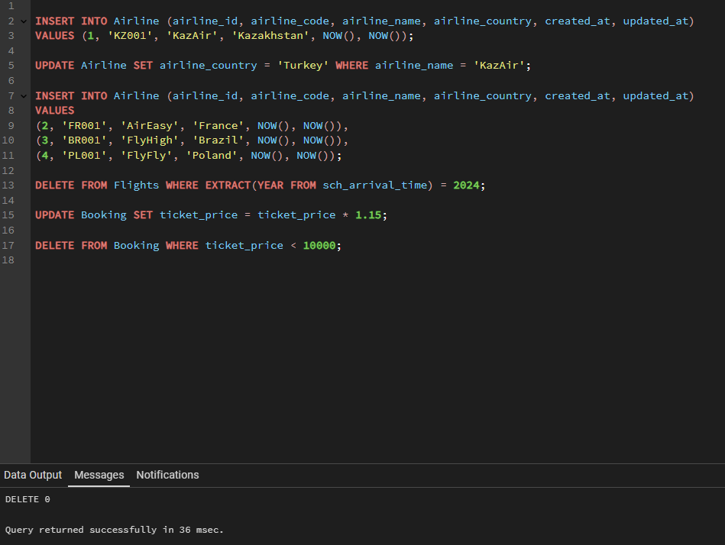

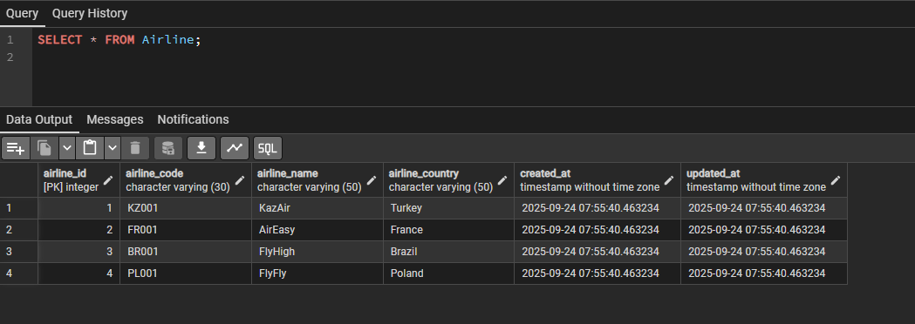

1. Generate and insert 200 random rows in your airport database.