**SCRUM**

During the development of the system an agile framework has been used which is SCRUM.

|  |  |  |
| --- | --- | --- |
| **Sprint ID** | **User Story** | **Priority** |
| 8 | As a Guest I want to be able to book a ticket for a certain movie, so that I can reserve a place for that movie. | High |
| 9 | As a guest I want to be able to book a ticket for a certain movie, so that I can reserve a place for that movie. | High |
| 10 | As an Admin I want to be able to add movie to the system, so that the Customer can see it | High |
| 11 | As an Admin I want to be able to add movie to the system, so that the Customer can see it. | High |
| 12 | As an Admin I want to be able to add movie to the system, so that the Customer can see it. | High |
| 13 | As an Admin I want to be able to remove movie from the system, so that I can delete movie. | High |
| 14 | As a guest I want to be able to select a movie, so that I can check all the details about it | High |
| 15 | As a Customer I want to be able to stream movie, so that I can watch movie at home. | High |
| 16 | As a guest I want to be able to pay using electronic payment method for my reservation or streaming, so that I can have a receipt | Low |

# Sprint backlog:

First two sprints:

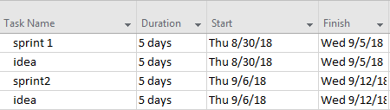

We spent the first two sprints on generating ideas for the project.

Third sprint:

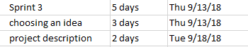

We decided after deep researching on what idea we will implement, and we also worked on the project description.

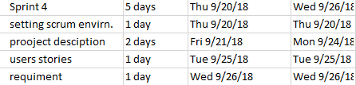

In the fourth sprint work has been put on setting scrum environment, project description, Analyzing the problem we have by setting up the reequipment and wrote some user stories

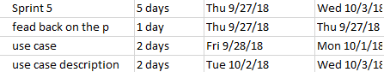

We got the feedback for project from our supervisor on the fifth sprint and we started out to design our project.

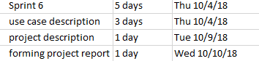

We continued designing, it took long time to design the use case and writing the description for it

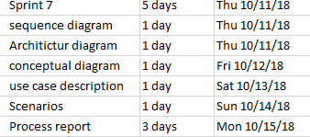

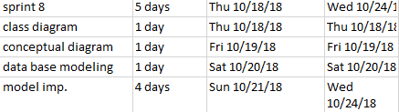

On sprint 8 we started implementation with the model in java.

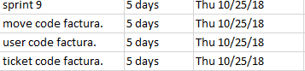

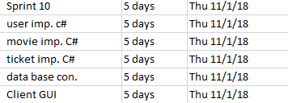

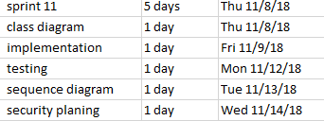

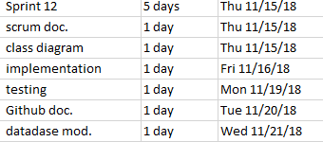

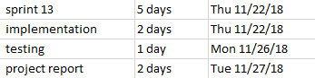

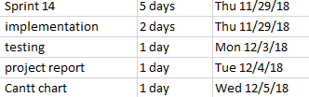

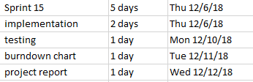

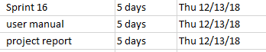

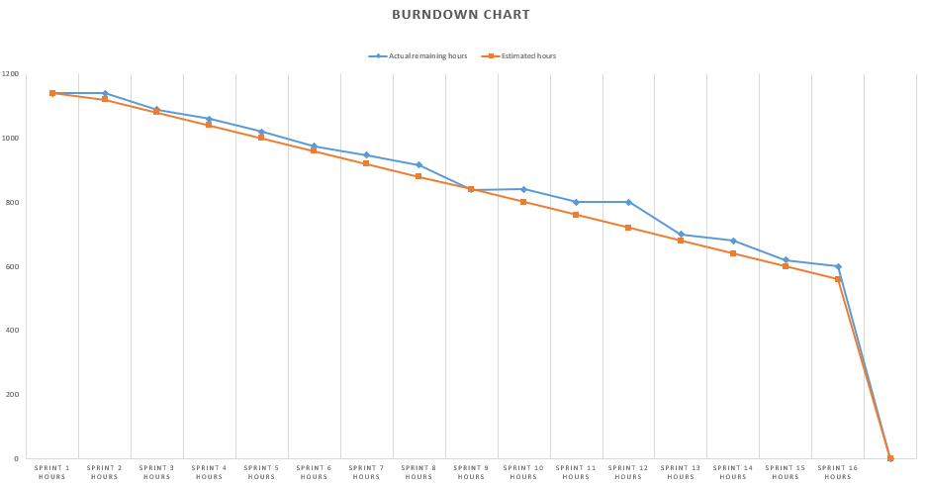

Orange line represents the estimated hours.

Blue line represents the Actual remining hours.

From the diagram above we can obviously see that our sprints were not equaled in hours but due to the project plan we were given we had to work 8 hours per week during the first three months, and at the lasts sprints we worked 56 hours, this clarifies the irregular drop for the tasks. The diagram also shows we were late at some point but in the end, we managed to do all the work we planned to without any delimitations.

**Cantt char:**

