2. measurement of frequency and duty cycle of the periodic signal.
Timing the diagram of signal is generated by signal function.
The system allows you to create and run KEIL for the parallel execution of the application program and simulate the external equipment.
External programs simulate signal.inc (name and extension are selected) will be launched for execution in the order queue that is generated Simulator in "real time". To allow time for implementation of signal functions in a cycle of periodic
signal operators apply delay twatch (100)-delay in Fo/12 cycles.
The function SIGNAL (time) are developed in C-like language, are interpreted. In language accessible to all external MCU ports that can be labeled virtual names (see. Keil/Help).
time-the name of the temporary parameter used in the functions to perform signalling functions:
1. go into download mode (Debug);
2. Select the virtual and real ports visually Analyzer commands La P2, La Port3, 3. In the COMMAND window, execute the downloaded file to the
>include fnt.inc (file fnt.inc must be in the same directory with the object).
4. Run the application
example of file func.inc. Functions of rectangular periodic input signal at the input P 3.2-INT0)
SIGNAL void Signa (unsigned int Time)
{twatch (Time); //delay Time the ISS frequency f0 = 12mGc
while (1)
{PORT3 = 0x3f; twatch (Time); PORT3 = 0; twatch (2*Time); }}
Signa (1000)//start function
La PORT3//output signal Analyzer

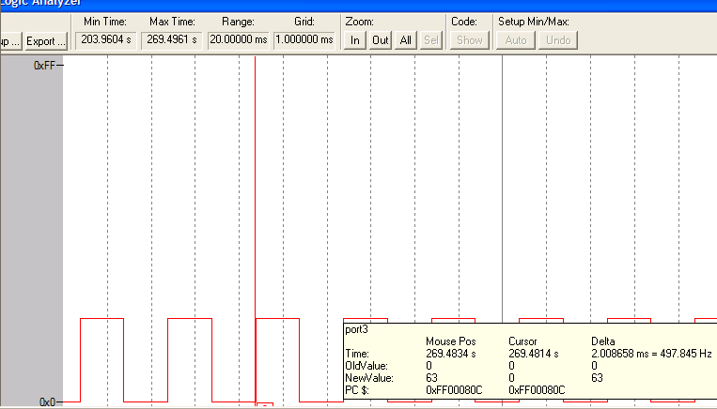

Task 2. Create a temporary diagram input INT0 external signals to the signal function. The C51 and A51 in Gate mode measured positive, in Capture mode interval measure the period. Assess environmental measurement accuracy time parameters and phase shift

