C-Bus System
The C-Bus System can be used to control lighting and other electrical systems and products automatically or via remote control and can also be interfaced to a home security system, AV products or other electrical items. The C-Bus system is available in a wired version and a wireless version, with a gateway available to allow messages to be sent between wired and wireless networks.
The wired C-Bus system uses a standard category 5 UTP (Unshielded Twisted Pair) cable as its network communications cable. Clipsal manufactures a specific category 5 cable for use within electrical distribution panels. This cable has a pink outer sheath which is rated to ensure adequate electrical isolation between the mains voltages found in distribution panels and the extra low voltage C-Bus. Outside of distribution panels standard category 5 UTP cable can be used.
The category 5 C-Bus network wiring uses a free topology architecture. The maximum length of cable used on a C-Bus network is 1000 metres; however this is easily extended using C-Bus Network Bridges. Up to 100 units can be installed on a C-Bus network and this can also be extended using Network Bridges.
The maximum number of C-Bus networks in one installation is 255 (note that this limitation does not apply if a C-Bus Ethernet Interface is utilised, the system size is then limited to IP Addressing only). The maximum number of networks connected in series to the local network via Network Bridges is seven (i.e. using six network bridges).
Each standard C-Bus unit requires 18mA @ 15-36Vdc to operate, however some C-Bus units require up to 40mA.
More than one C-Bus power supply can be connected to a C-Bus network to provide sufficient power to the C-Bus units, the C-Bus power supplies will share the load evenly.
Each C-Bus network requires a network burden if there are insufficient C-Bus units on the network. This network burden can be enabled on C-Bus output units through software or a hardware burden can be connected to the network.
Each C-Bus network requires at least one system clock generating unit for data synchronisation.
The isolation between the mains supply circuitry and the 36V DC C-Bus circuitry is greater than 3.5kV. This is achieved using double wound transformers and opto isolators. This means the C-Bus wiring, connections and circuitry can be considered Extra Low Voltage.

[edit] Wiring Design of C-Bus Systems
With conventional wiring, the mains power (120V/220V/240V) is wired from the Distribution Board (DB) to the load (for example, a ceiling light) via a wall switch.
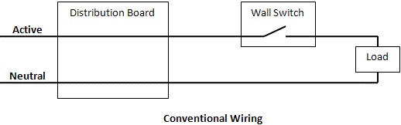
In C-Bus systems, the connections between the DB and (for example) the ceiling lights, and between the DB and the junction box (wall switch) are completely separate. In addition, there are no connections between the Junction Box and the respective ceiling lights.
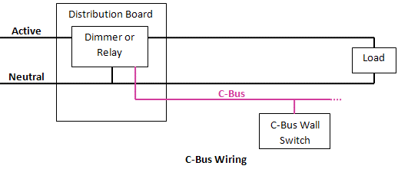
The power control in a C-Bus system lies in a “Dimmer” or “Relay” which is installed in the DB and replaces the traditional switch used in conventional wiring. This Dimmer (or Relay) has a 120/220V Line interconnection directly to the ceiling light and a neutral connection back from the ceiling light to the Dimmer. The Dimmer will control the light directly and will receive its commands from another device on the C-Bus network (for example, a wall mounted light switch/keypad). This wall mounted light switch would not be connected to any load whatsoever; it would be directly connected with the Dimmer by means of a control/signaling cable. The Dimmers normally come as 4-, 8- or 12-channel DIN-rail mounted devices.

[edit] C-Bus Interoperability
As of 9 December 2008 Clipsal opened its C-Bus protocols to anyone who wants to interact with it programatically.^{[1]}
Using one of Clipsal's C-Bus interface modules (PCI for RS232 or USB and CNI for Ethernet TCP/IP), you can interact with other home automation systems, or with applications on devices like Android, iPad or iPhone. All you do is plug a network cable from your Home WiFi router to the Clipsal C-Bus Ethernet module, and then any Android or iPad can control your home automation system. You can also use this same method to integrate C-Bus with HomeSeer using MCSxAP. And in theory you can also do this to integrate C-Bus via a X10 module for the PC.
If you are a .Net/Java/c++ software developer, you can find the C-Bus protocol information here to interact from your PC: http://www2.clipsal.com/cis/technical/downloads
The C-Bus protocol was developed using the ISO 7 layer reference model. C-Bus supports a number of interfaces such as RS232 and TCP/IP and makes these protocols available to third party companies. Clipsal has also developed a server application called C-Gate, to facilitate software integration. The C-Bus interface specifications are available at no-cost through the C-Bus Enabled Program, however it is necessary to agree to a license agreement. It is also possible to become a C-Bus enabled partner; This requires payment but provides a greater level of support for product development and certification.

[edit] The future of C-Bus
C-Bus as a home automation and building lighting control system is used primarily in Australia (Sydney Opera House etc.). C-Bus is currently available in Asia, the United Kingdom (installed in Number 10 Downing Street, Wembley Stadium and Manchester City Football Club), Russia, USA (named SquareD), Canada (from Sound Developments Ltd. [1]) and a number of other countries are now using this system. One major obstacle to widespread use of wired C-Bus is that it will not work with a standard mains wire installation, a completely new wiring system must be installed for a wired C-Bus system which means that it is normally only used for new builds. The C-Bus wireless (RF) system can however be retrofitted using the existing mains wiring.
C-Bus is compatible with OPC, DALI, DSI, BACnet, TCP/IP, Crestron, AMX, RTI, LonWorks, ModBus, Charmed Quark Controller, the Comfort Intelligent Home System and some other protocols through interfaces

