1. Uncertainty is the situation when we cannot entirely know and cannot control the distribution and state of the economic in the future, such as income and loss. In general, production, price, cost, income, expenditure, and other parameters are random variables; they might be different from the prediction, which leads to the uncertainty. Firstly, there are always some errors in statistical data, which cannot be avoided. Secondly, Inflation is a very common phenomenon in our life, which will never be predicted exactly. Thirdly, the supply and demand will always change in the structure of market.

2. We use the adj-closed prices to get the daily return. Then we use the excel to plot the series.

3.

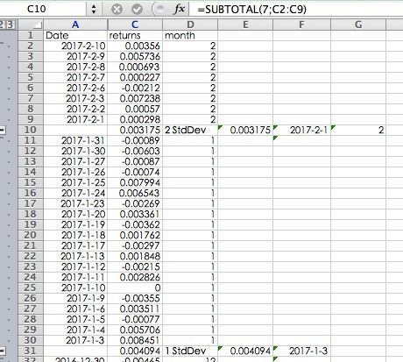

In this problem, we also use the excel to calculate the monthly standard deviation. Then we get the time series of the stock market returns.

4. VIX index is a leading measure of market expectations of near-term volatility conveyed by S&P500 index (SPX) option prices.

5. The indices of policy-related economic uncertainty are built based on newspaper coverage frequency. The uncertainty is captured about what will make economic policy decisions, what economic policy actions will be undertaken and when, and the economic effects of policy actions (or inaction) – including uncertainties related to the economic ramifications of “non-economic” policy matters, e.g., military actions. The measures capture both near-term concerns (e.g., when will the Fed adjust its policy rate) and longer-term concerns (e.g., how to fund entitlement programs), as reflected in newspaper articles.

6. The plot is shown as below:

We use the data analysis to get the cross correlation. The cross correlation is shown below:

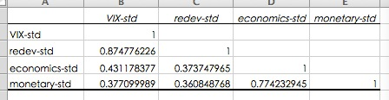

7. We use the fomula to calculate the growth rate as below:

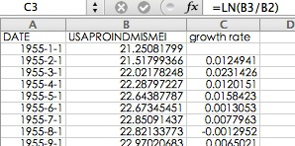

8. Before doing the regression, we multiple the growth rate by 100. In this question, we use a linear regression model where the four uncertainty measures--economics-std, monetary-std, redev-std, VIX-std--separately explain output growth. Then we get the results as blow:

|  |  |  |  |  |
| --- | --- | --- | --- | --- |
|  | intercept | coefficient | p-value | Adjusted-R^2 |
| Economics-std | -0.17646 | 0.15102 | <2.488e-5 | 0.05448 |
| Monetary-std | -0.17217 | 0.15672 | <3.233e-5 | 0.0529 |
| Redev-std | -0.2222 | 0.18748 | <4.896e-9 | 0.105 |
| VIX-std | -0.18456 | 0.14020 | <2.03e-7 | 0.08316 |

From the outcomes, we can find that the output growth is most sensitive to Redev-std and then Monetary-std. From the P-value, under the confidence of 5%, we can reject all the null hypothesis and all the uncertainty rate is statistically significant. For each uncertainty series, the P-value of all the four variables all approach 0. So, the significance does not depend on the uncertainty series used.

9. Using the growth rate data from period 1 to period 243, we can forecast the period 244 to period 302. Using the variables VIX-std, Redev-std, Economics-std, and Monetary-std, we can get the following forecast1, forecast2, forecast3, and forecast4.

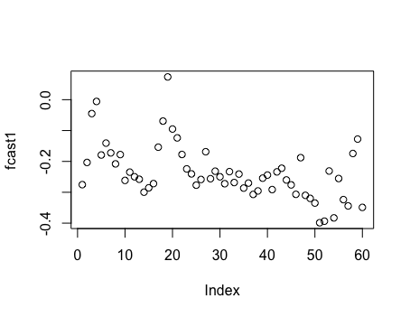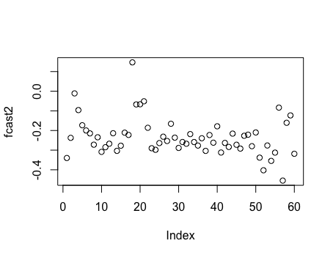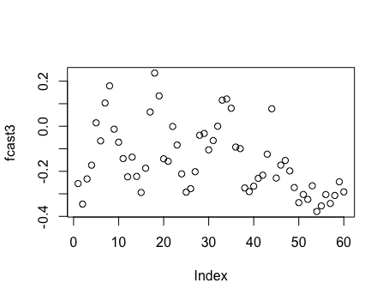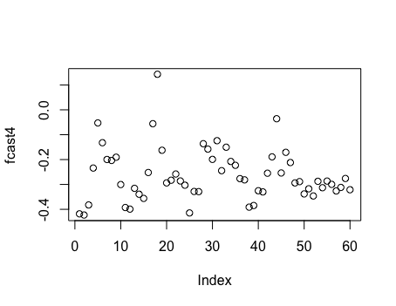

Then we calculate the MSFE separately.

|  |  |  |  |  |
| --- | --- | --- | --- | --- |
|  | VIX-std | Redev-std | Economics-std | Monetary-std |
| MSFE | 0.21094 | 0.21793 | 0.23259 | 0.20279 |

10. Using yt-1, we can forecast yt and get the benchmark. We calculate the MSFE for the benchmark for this model and get 0.46605. Then we compare the four models’ forecast with the benchmark using t-test. Then we get the P-value of each test.

|  |  |  |  |  |
| --- | --- | --- | --- | --- |
|  | VIX-std | Redev-std | Economics-std | Monetary-std |
| P-value | 0.0001451 | 0.0001806 | 0.0007718 | 0.0001312 |

Under the confidence level of 1%, we get reject all the null hypothesis, and we can find that all the four models’ forecast is significantly different from the benchmark. Comparing the MSFE of the four models and the benchmark model, we can get that using the variable-monetary-std, we can get the most precise forecast than the others.

The code for number 8 and 10:

data<-read.csv("/Users/apple/Desktop/ts1.csv")

data

str(data)

outcome=ts(data[,2],start=c(1990,1),frequency=12)

outcome

vix=ts(data[,3],start=c(1990,1),frequency=12)

red=ts(data[,4],start=c(1990,1),frequency=12)

econ=ts(data[,5],start=c(1990,1),frequency=12)

mon=ts(data[,6],start=c(1990,1),frequency=12)

red

econ

mon

Model1=lm(outcome~vix)

summary(Model1)

str(Model1)

a1=Model1$coefficients[1]

b1=Model1$coefficients[2]

a1

b1

Model2=lm(outcome~red)

summary(Model2)

str(Model2)

a2=Model2$coefficients[1]

b2=Model2$coefficients[2]

a2

b2

Model3=lm(outcome~econ)

summary(Model3)

str(Model3)

a3=Model3$coefficients[1]

b3=Model3$coefficients[2]

a3

b3

Model4=lm(outcome~mon)

summary(Model4)

str(Model4)

a4=Model4$coefficients[1]

b4=Model4$coefficients[2]

a4

b4

length(outcome)

length(vix)

past=length(vix)-60

past

T=60

T

fcast1=matrix(NA,nrow=T,ncol=1)

for (i in 1:T)

{

model11=lm(outcome[1:(past-61+i)]~vix[1:(past-61+i)])

fcast1[i]=model11$coefficients[1]+model11$coefficients[2]*vix[(past+i)]

}

fcast1

fcast2=matrix(NA,nrow=T,ncol=1)

for (i in 1:T)

{

model12=lm(outcome[1:(past-61+i)]~red[1:(past-61+i)])

fcast2[i]=model12$coefficients[1]+model12$coefficients[2]*red[(past+i)]

}

fcast2

fcast3=matrix(NA,nrow=T,ncol=1)

for (i in 1:T)

{

model13=lm(outcome[1:(past-61+i)]~econ[1:(past-61+i)])

fcast3[i]=model13$coefficients[1]+model13$coefficients[2]*econ[(past+i)]

}

fcast3

fcast4=matrix(NA,nrow=T,ncol=1)

for (i in 1:T)

{

model14=lm(outcome[1:(past-61+i)]~mon[1:(past-61+i)])

fcast4[i]=model14$coefficients[1]+model14$coefficients[2]*mon[(past+i)]

}

fcast4

actural=outcome[243:302]

length(actural)

actural

plot(fcast1)

plot(fcast2)

plot(fcast3)

plot(fcast4)

msfe1=mean((fcast1-actural)^2)

msfe1

msfe2=mean((fcast2-actural)^2)

msfe2

msfe3=mean((fcast3-actural)^2)

msfe3

msfe4=mean((fcast4-actural)^2)

msfe4

benchmark=matrix(NA,nrow=T,ncol=1)

for (i in 1:T)

{benchmark[i]=outcome[241+i]}

benchmark

msfe5=mean((benchmark-actural)^2)

msfe5

t1=(fcast1-actural)^2-(benchmark-actural)^2

t2=(fcast2-actural)^2-(benchmark-actural)^2

t3=(fcast3-actural)^2-(benchmark-actural)^2

t4=(fcast4-actural)^2-(benchmark-actural)^2

t.test(t1,conf.level = 0.99)

t.test(t2)

t.test(t3)

t.test(t4)