**ANKARA UNIVERSITY**

**COM102B**

**2015-16 Spring**

**Programming Assignment #3**

**Due Date: 27/04/2016, 23:55**

**Task:** Implementation of a Simple Calculator

**Details:**

Given the following expression grammar below, design and implement a comman line calculator that obeys the rules of this grammar. (Please refer to the Chapter 6 and 7 of the reference book – Programming by Bjarne Stroustroup - for detailed discussion)

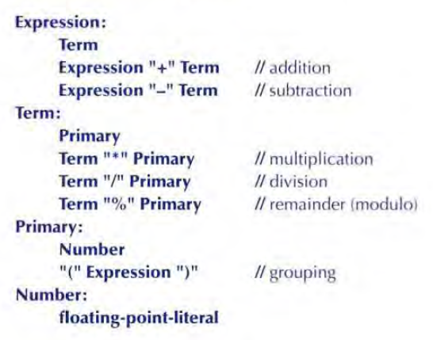

Note that,

1. The remainder operator will work only if the operands are integers.
2. Calculator will operate on positive numbers
3. Generate exceptions with proper error messages for invalid arguments/inputs

Possible input/output pairs and error handling details are discussed in detail in the book. Your task is to prepare

* All the necessary class files (headers and cpp files)
* A **makefile** which compiles your calculator source codes (make research on this topic from the internet). Your executable MUST be named as StudentNumber.
* A **ReadMe** file which explains the contents of the implementation files

Please submit the specified files using Moodle system. You can prepare and share the possible input/output files with your friends through Moodle Haber Forum. Please use the Haber Forum to discuss the relevant questions. **Do not use** personal email accounts of mine or our assistants to ask questions related with PAs.

Good luck ☺