**Zeke Zhou**

**Public Profile**

* 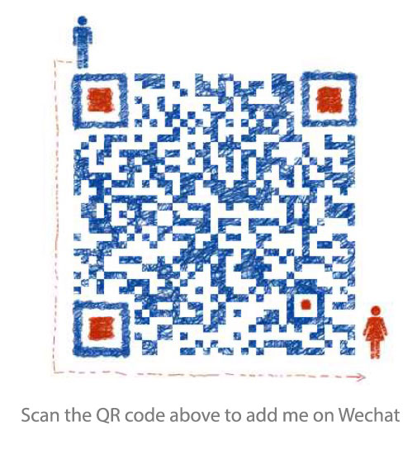**Gender:** Male
* **Education Background:** Bachelor of Software Engineering from Chongqing University of Posts and Telecommunications
* **Work Experiences:** Agile full stack web developer for two years and six months
* **Working Conditions:** Serving
* **Email:** [finalair29@gmail.com](mailto:finalair29@gmail.com)
* **Cellphone:** +86-18616132839
* **Tech Blog:** [http://track.zekeair.xyz](http://track.zekeair.xyz/)
* **Github Page:** <https://github.com/zekeair>
* **Looking Jobs:** Senior Full Stack Engineer, Java Programmer or PM(Product Manager/ Project Manager)

**Work Experiences**

* **I am working for Shanghai MoYing Information Technology Co., Ltd. as a full stack web developer from July, 2013 and a number of projects involved me are as follow**

**CRM System**

A Client Relationship System has based on Java Spring MVC framework. System data has stored in MySQL and abided by Hibernate specification. Bootstrap, jQuery have been used as web front-end techniques. My role in this project is a designer and a developer. I am in charge of demand analysis to whole system, designing prototype architecture, prototype interfaces and flow chart, database table design of roles and permissions, developing data sharing strategies.

**Questionnaire System for Shanghai International Studies University Affiliated Bilingual School**

[Access URL](http://www.smemobiletech.com/survey/paper/1). A questionnaire system to survey studying situation for students of Shanghai International Studies University Affiliated Bilingual School. This project has based on Java Spring MVC framework. System data has stored in MySQL and abided by Hibernate specification. FrozonUI, Zepto have been used as web front-end techniques. In addition to designing fron-end page, developing database tables and docking data analysis system, I was the project manager in this project and in charge of working arrangement for other developers.

**Mobile Education System for Fudan University School of Management**

[Access URL](http://m.fdsm.fudan.edu.cn/wx/). A system to address teaching affairs on smart mobile equipments has based on Java Spring MVC framework. System data has stored in MySQL and abided by Hibernate specification. FrozonUI, Zepto have been used as web front-end techniques. I had two different roles in the project. one was the project manger who needed to communicate with staff of the university and to track project progress. The other was a developer who was responsible for system architecture building, database table developing and docking unified authentication user center system.

**Marketing System for Shanghai New Oriental Schools’ VIP Class**

[Access URL](http://jw.sh.xdf.cn/xdfhd). A Marketing System has based on Java Spring MVC framework. System data has stored in MySQL and abided by Hibernate specification. Front-end is a IOS app with a hybrid framework. I was responsible for databse tabel design, management page layout and develop, data index building and HTML page templates design as a developer in this project.

Moreover, there are some other programs:

* + [**A System for Corporate Training working in Shanghai New Oriental School to serve its enterprise clients**](http://qp.sh.xdf.cn/xdfct/)
  + [**Micro Site of Fudan University School of Management MBA Program**](http://events.fdsm.fudan.edu.cn/microsite/mba/pages/home.html)
  + **Offical Android app for Fudan University School of Management**
* **I was a intern of Shanghai Ogilvy & Mather Advertising Co., Ltd. Beijing Branch from Aug, 2011 to Sep, 2011**

It was a good chance to understand the process of advertising from technique insight. I have learned how to use Flash ActionScript3.0 program language to estabish a advertising mini site and communicate with Xbox kinect via the apis so that I could try some awesome somatosensory interaction programs

* **It was a intern job for Jing Jie (Beijing) Network Technology Co., Ltd. from Jul, 2011 to Aug, 2011**

My job was to establish page navigators and Flash animations while I was involving the ActionScript3.0 code repository building.

**My Tech List**

* **Programming Language:** Java | Javascript
* **Development Framework:** Spring MVC
* **Front-end:** jQuery | Zepto | Bootstrap | HTML5 | CSS Animation
* **Pretreatment Tools:** Bower | Less | Stylus
* **Database:** MySQL | Hibernate | Redis | MangoDB
* **VCS, Tasks Runner, and Automated Deployment Tools:** Git | Maven | Grunt | Gulp
* **System Tools:** Vim | Shell

**Acknowledgements**

Thank you for reading my resume. It is my honor to receive job offers from your company. Have a nice day.