18/11/2025

ANKARA UNIVERSITY
FACULTY OF ENGINEERING DEPARTMENT OF COMPUTER ENGINEERING 2025-2026 FALL SEMESTER
COM2043 PROGRAMMING LANGUAGE CONCEPTS PROJECT-1

Student Name: Zekeriya Burak Küçüksabancı
Student ID:23290993
Department: Computer Engineering

The goal of this file is that if ubuntu file(rapor.docx) crash ,this file(rapor(windows).docx)can work at windows

1. Description of the Designed Rules
In this project, a new programming language named MPL (My Programming Language) has been designed. The language follows a structured syntax similar to C but incorporates specific keywords for block delimiters and logical operators to enhance readability. The key rules of MPL are as follows:
- Program Structure: Every program must start with the begin keyword and terminate with the end keyword.
- Variable Declarations: Variables are declared using the var keyword. The language supports initialization with types (e.g., var x = int;) or values (e.g., var y = 10;).
- Control Flow Blocks:
  - Conditional Statements: The if statements are terminated with the specific keyword ifend. An optional else block is supported.
  - Loop Structures: Both while and for loops are terminated with the keyword loopend. This distinguishes loop termination from the main program termination.
- Operators:
  - Logical: Instead of symbols like && or ||, verbal operators and, or, and not are used.
  - Arithmetic & Comparison: Standard operators (+, -, *, /, <, >, ==, etc.) are supported with standard precedence rules.
- Statement Termination: All executable statements must end with a semicolon (;).

2. Grammar in BNF Notation:

<program> ::= "begin" <statement_list> "end"

<statement_list> ::= <empty> | <statement_list> <statement>

<statement> ::= <declaration> ";"
| <assignment> ";"
| <if_statement>
| <while_statement>
| <for_statement>

<declaration> ::= "var" ID "=" <expression>
| "var" ID "=" <type>

<assignment> ::= ID "=" <expression>

<if_statement> ::= "if" "(" <expression> ")" <statement_list> "ifend"
| "if" "(" <expression> ")" <statement_list> "else" <statement_list> "ifend"

<while_statement> ::= "while" "(" <expression> ")" <statement_list> "loopend"

<for_statement> ::= "for" "(" <for_init> ";" <expression> ";" <assignment_no_semi> ")" <statement_list> "loopend"
<expression> ::= <expression> "+" <expression>
| <expression> "and" <expression>
| <expression> ">" <expression>
| "(" <expression> ")"
| ID | INT_VAL | FLOAT_VAL

3. Code Descriptions
The implementation consists of two main components: the lexical analyzer and the syntax analyzer.
- Lexical Analyzer (mpl.l): This file uses Lex to scan the input source code. It uses regular expressions to identify tokens.
  - Keywords: Tokens are defined for begin, end, if, ifend, loopend, etc.
  - Identifiers: Defined by the regex [a-zA-Z][a-zA-Z0-9]* to ensure variables start with a letter.
  - Operators: Verbal logical operators (and, or, not) are mapped to tokens here.
  - The %option noyywrap directive is used to handle end-of-file processing without external library dependencies.
- Syntax Analyzer (mpl.y): This file uses Yacc to parse the stream of tokens generated by Lex.
  - Token Declaration: All tokens identified in the Lex file are declared here.
  - Precedence Rules: Operator precedence is defined to match the C language (e.g., multiplication * has higher precedence than addition +).
  - Grammar Rules: The structure of the language (Program -> Statements -> Expressions) is defined here.
  - Integration: The lexical analyzer source (lex.yy.c) is included directly into this file to simplify the compilation process into a single executable.
  - Error Handling: A yyerror function is implemented to print "syntax error" if the input violates the rules. If the parsing completes successfully, "OK" is printed.

4. Implementation and Testing
The project is implemented and tested using the following steps in a Linux environment:
- Lex Compilation: The command lex mpl.l is used to generate lex.yy.c.
- Yacc Compilation: The command yacc mpl.y is used to generate the parser code y.tab.c.
- C Compilation: The command gcc -o mpl y.tab.c compiles the generated C code into an executable named mpl.
- Execution: The analyzer is tested with an input file using ./mpl < myprog.mpl.
The parser correctly validates the syntax of the input file and outputs "OK" for valid MPL programs as required by the project specifications.

- File Contents:
- The content of mpl.l as follows: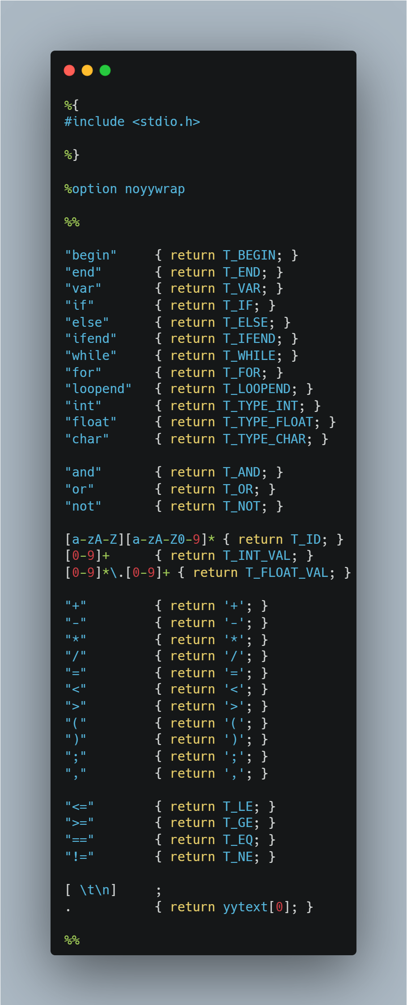

The content of mpl.y as follows:
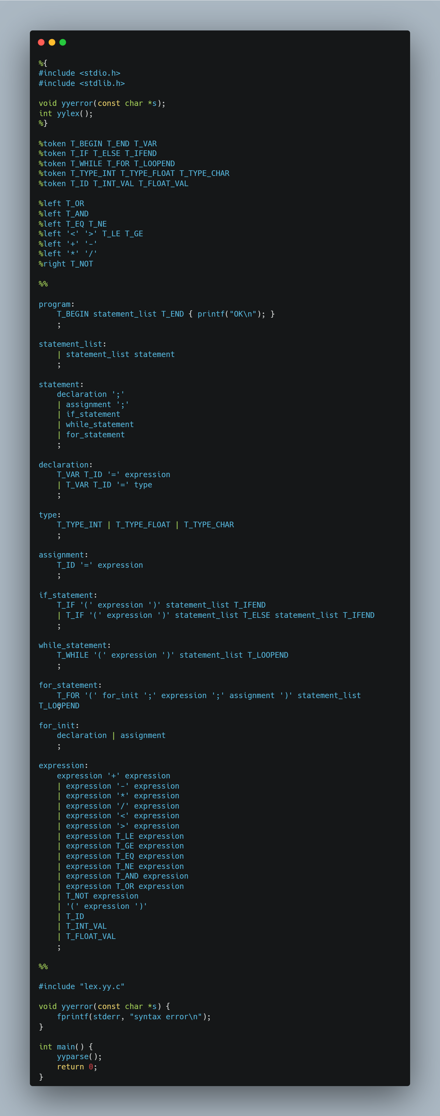

The content of the myprog.mpl as follows:

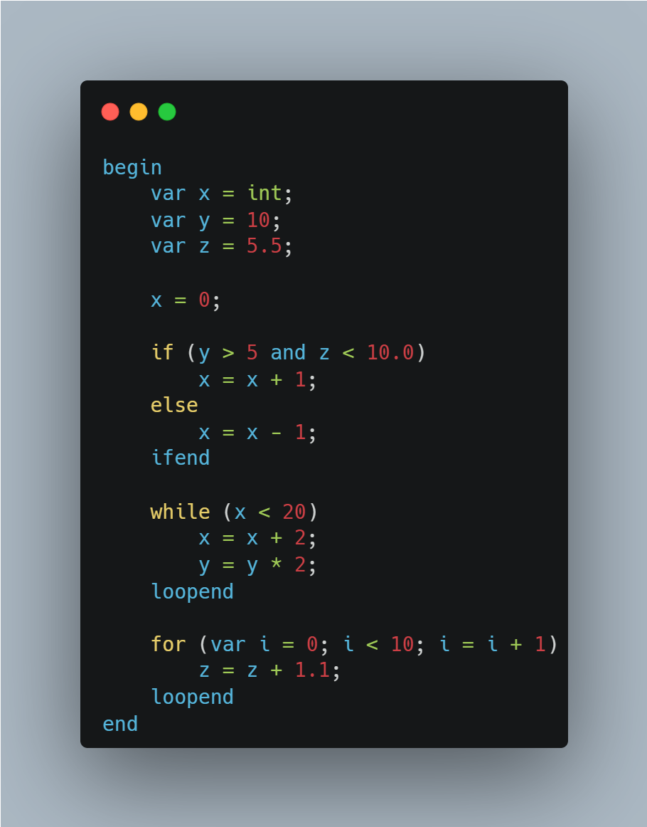

5. Explanations:
To be honest, the fact that this project is based on C was a significant advantage for me, as I really love the C syntax. However, in order to be original, I made some specific modifications. For instance, I simplified the variable declaration section; I designed it so that the var keyword is used to define both the data type and the value of the variable. I also chose to use verbal logical operators (like and, or) to make the code easier to understand and read. Additionally, I decided to terminate conditional and loop blocks with explicit keywords like ifend and loopend. Aside from these changes, I adopted other fundamental features from C, as I find them to be very practical.

I prepared after pages of this file in case Windows or Linux encounters a compatibility issue and the code isn't visible.
İf the code image is not visible
File Name: mpl.l
%{
#include <stdio.h>
%}

%option noyywrap

%%

"begin" { return T_BEGIN; }
"end" { return T_END; }
"var" { return T_VAR; }
"if" { return T_IF; }
"else" { return T_ELSE; }
"ifend" { return T_IFEND; }
"while" { return T_WHILE; }
"for" { return T_FOR; }
"loopend" { return T_LOOPEND; }
"int" { return T_TYPE_INT; }
"float" { return T_TYPE_FLOAT; }
"char" { return T_TYPE_CHAR; }

"and" { return T_AND; }
"or" { return T_OR; }
"not" { return T_NOT; }

[a-zA-Z][a-zA-Z0-9]* { return T_ID; }
[0-9]+ { return T_INT_VAL; }
[0-9]*\.[0-9]+ { return T_FLOAT_VAL; }

"+" { return '+'; }
"-" { return '-'; }
"*" { return '*'; }
"/" { return '/'; }
"=" { return '='; }
"<" { return '<'; }
">" { return '>'; }
"(" { return '('; }
")" { return ')'; }
";" { return ';'; }
"," { return ','; }

"<=" { return T_LE; }
">=" { return T_GE; }
"==" { return T_EQ; }
"!=" { return T_NE; }

[ \t\n] ;
. { return yytext[0]; }

%%

File Name: mpl.y
%{
#include <stdio.h>
#include <stdlib.h>

void yyerror(const char *s);
int yylex();
%}

%token T_BEGIN T_END T_VAR
%token T_IF T_ELSE T_IFEND
%token T_WHILE T_FOR T_LOOPEND
%token T_TYPE_INT T_TYPE_FLOAT T_TYPE_CHAR
%token T_ID T_INT_VAL T_FLOAT_VAL

%left T_OR
%left T_AND
%left T_EQ T_NE
%left '<' '>' T_LE T_GE
%left '+' '-'
%left '*' '/'
%right T_NOT

%%

program:
T_BEGIN statement_list T_END { printf("OK\n"); }
;

statement_list:
| statement_list statement
;

statement:
declaration ';'
| assignment ';'
| if_statement
| while_statement
| for_statement
;

declaration:
T_VAR T_ID '=' expression
| T_VAR T_ID '=' type
;

type:
T_TYPE_INT | T_TYPE_FLOAT | T_TYPE_CHAR
;

assignment:
T_ID '=' expression
;

if_statement:
T_IF '(' expression ')' statement_list T_IFEND
| T_IF '(' expression ')' statement_list T_ELSE statement_list T_IFEND
;

while_statement:
T_WHILE '(' expression ')' statement_list T_LOOPEND
;

for_statement:
T_FOR '(' for_init ';' expression ';' assignment ')' statement_list T_LOOPEND
;

for_init:
declaration | assignment
;

expression:
expression '+' expression
| expression '-' expression
| expression '*' expression
| expression '/' expression
| expression '<' expression
| expression '>' expression
| expression T_LE expression
| expression T_GE expression
| expression T_EQ expression
| expression T_NE expression
| expression T_AND expression
| expression T_OR expression
| T_NOT expression
| '(' expression ')'
| T_ID
| T_INT_VAL
| T_FLOAT_VAL
;

%%

#include "lex.yy.c"

void yyerror(const char *s) {
fprintf(stderr, "syntax error\n");
}

int main() {
yyparse();
return 0;
}

File Name: myprog.mpl
begin
var x = int;
var y = 10;
var z = 5.5;

x = 0;

if (y > 5 and z < 10.0)
x = x + 1;
else
x = x - 1;
ifend

while (x < 20)
x = x + 2;
y = y * 2;
loopend

for (var i = 0; i < 10; i = i + 1)
z = z + 1.1;
loopend
end

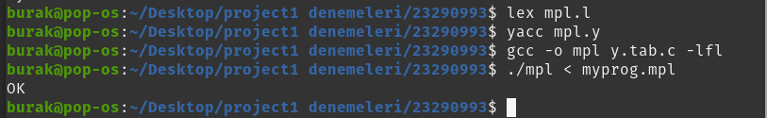
File Name: error.mpl

begin
var a = 10;
var b = 20;

/* ERROR 1: Missing semicolon */
a = a + 5

if (a > 10)
b = b + 1;
else
b = b - 1;

/* ERROR 2: Wrong closing keyword. Used '}' instead of 'ifend' */
}

while (a < 50)
a = a + 1;
loopend
end
