Q1)

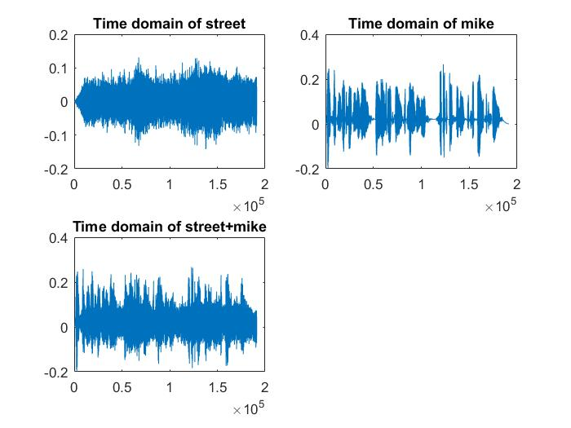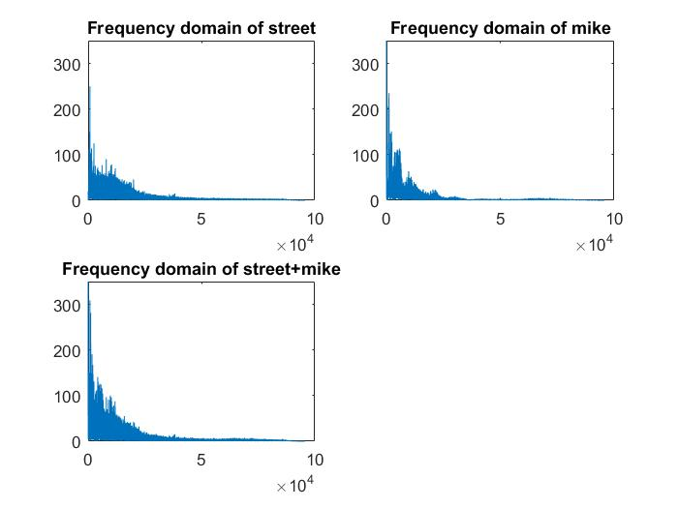

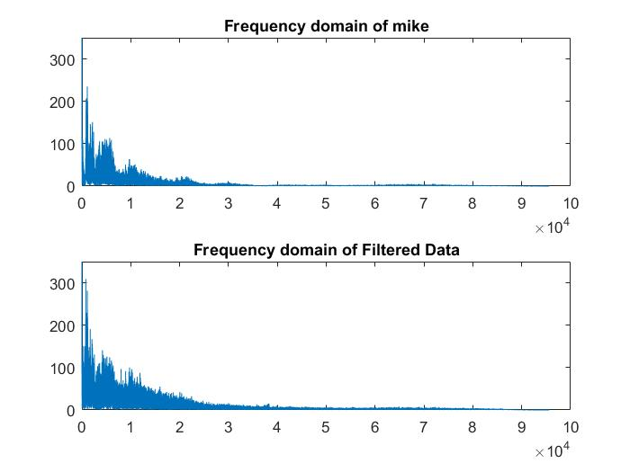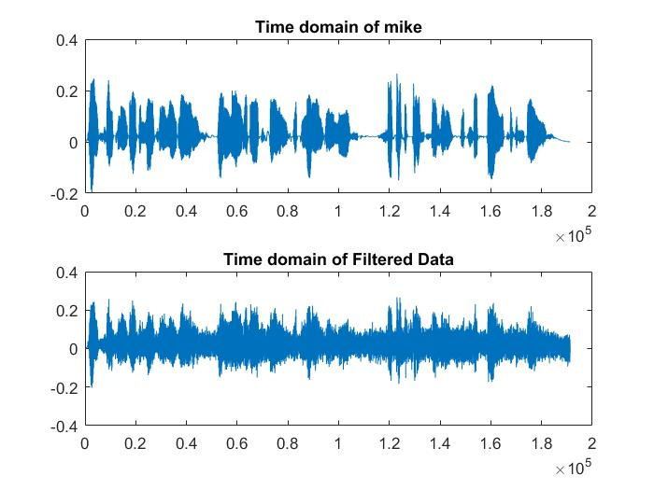

In this question , we filter the data then plot it both frequency domain and time domain. When we look at the filtered data graphs, we can see that the data is changed little bit , grapics is flattened, in the frequency domain data more flattens and difference is decreased in other worlds,standard

deviation is decreased.In the time domain, we see that gaps between the data fills with some data in the figure 4.

Q3)we see that changing K does not affect the SNR value.However, two parameter,a and N affect the SNR. In this question we test the parameters whether the parameters change the sound with echo or not. The result is that if SNR is negative value it means recovered sound with more echos .Echo has

inverse relation value of SNR.

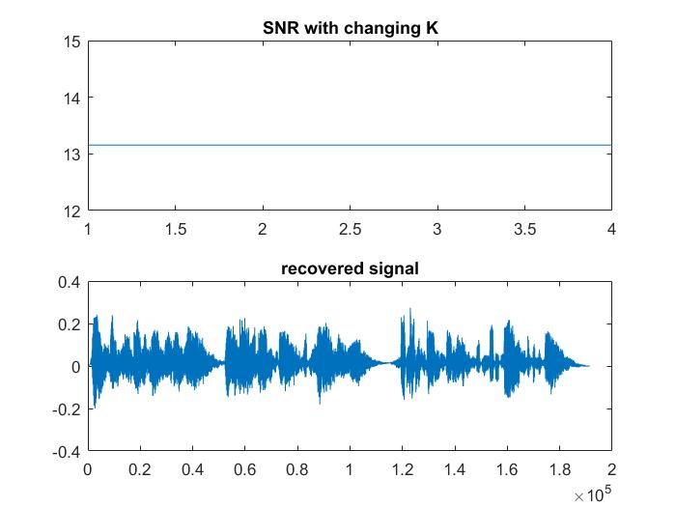

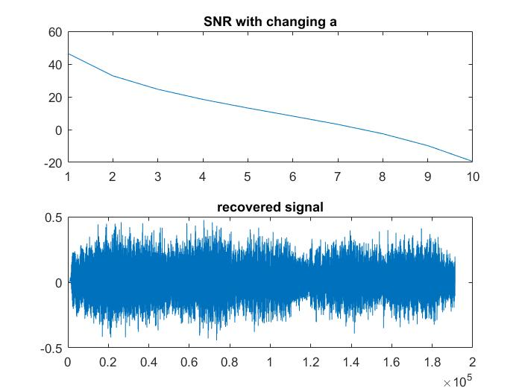

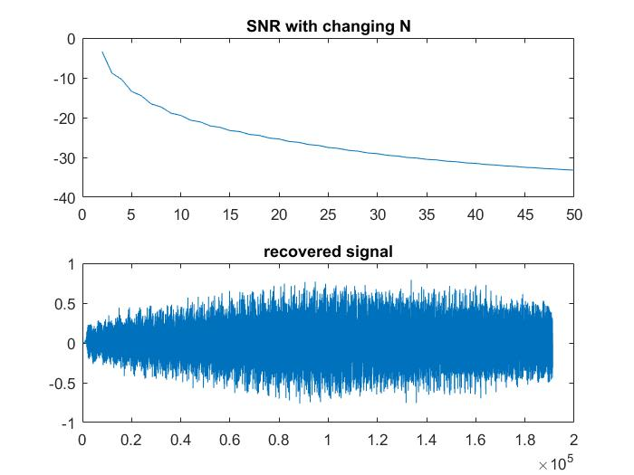

Q2) In this question , we detect the sound whether this is clap or slap. I solve the problem in this way.

Firstly, we convert data to frequency domain, when we analyze the data by plotting, we see that the clap sound is lower frequency than the snap sound. We have to find maximum of clap data closer to zero.It means that max of clap is in the 0-750 hz. On the other hand, max of snap should be in the 750-end Hz. We examine the check which is mentioned above.Then we detect the data.