CMPE 321
PROJECT # 3

PROJECT MANAGEMENT SYSTEM

Name: Zeki
Surname: TEL
ID: 2013400015
Lecturer: Taflan Gündem

1)Introduction :

This management system has 2 main user pages, one of them is admin page and the other is manager page, an admin have some abilities, such as:
- Creating a new project and a new manager with username and password
- Listing existing manager with their full name,username and password
- Deleting a project,manager and employee.
- Editing managers,projects and employees.

A manager has some abilities, such as:
- Creating a task , Editing on a task
- List existing tasks for their projects which is assigned by admin(or triggered) on it.
- Remove a task

2) Structure :

This program was implemented in Php. So there are 16 php files in this project apart from a style.css file.

2.1 ) Index.php
This script is for home page.We face firstly when we start the program.This page needs a username and password. According to our account type, we wiil be redirected adminpage or manager page.

2.2 ) Adminpage.php

Adminpage have 7 main function for an admin, main functions of this page :

  - Creating project, manager, employee
  - Deleting project, manager, employee
  - Editing project, manager, employee
  - Listing projects, managers, employees
  - Assignning a project to a manager
  - When the admin delete a employee, There is a trigger on the database, and it deletes all task on the employee
  - When we add a new project

2.3 ) Manager.php

Students can make their operations in this page, the functionalities of this script are :
  - Adding tasks for project
  - Editing on task,Delete a task
  - Assigning a task to an employee
If employee has a task on that date, you can only assign the task on the employee after the task has finished.
  - Listing the projects that the manager is assigned on it by admin.

2.4 ) Logout.php

This script clean all session variables. And directed user to index.php page.

2.5 ) Other functional php pages

They are useful to implement database queries and these pages includes these kinds of operations add,edit,remove etc.

3 ) Interface :

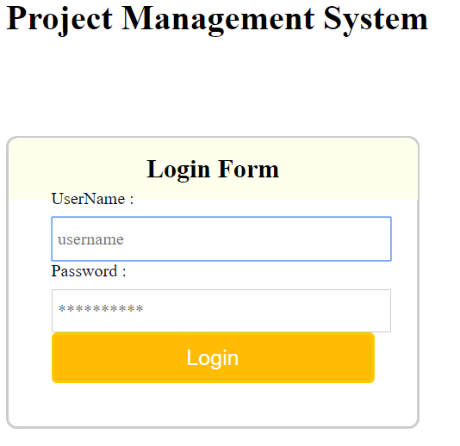
Firstly, we need to login with our username and password. If the account is admin then we are redirected to the adminpage otherwise manager page.

We faces the page that has the secreen shots below.

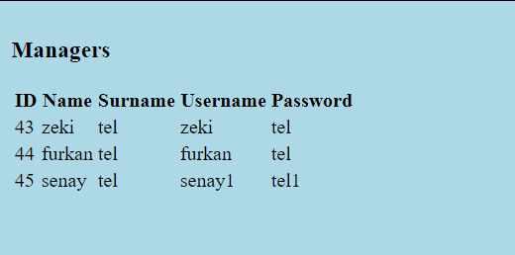
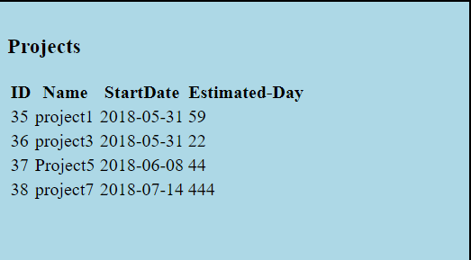
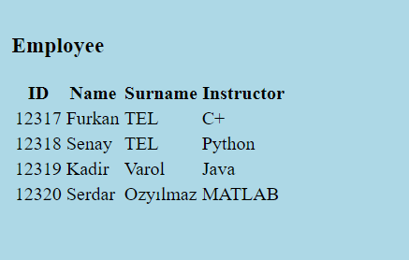

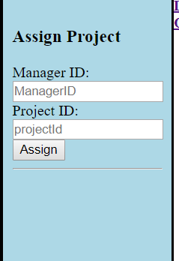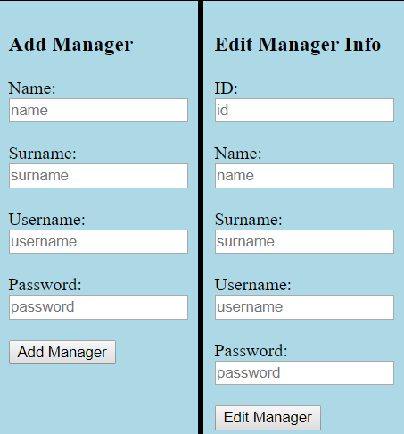
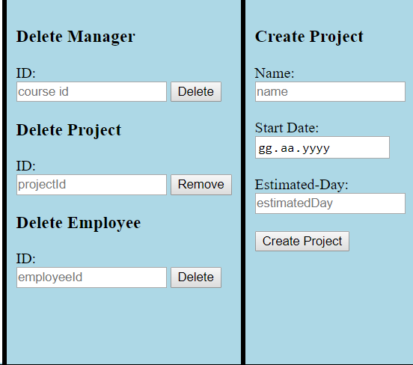
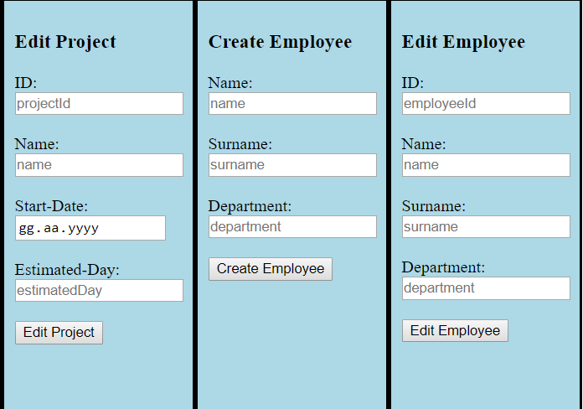

Until this point. Each screenshot is belong to admin page.You see that the abilities of the admin with operational forms.
The manager page screen shots is below.
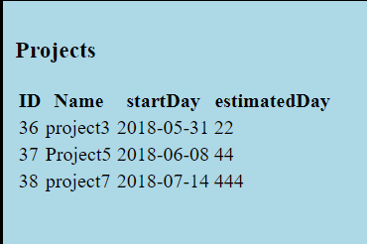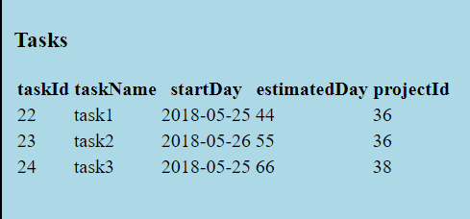
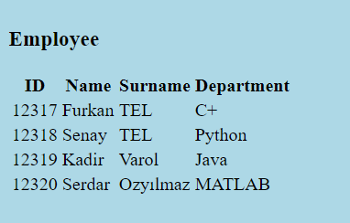
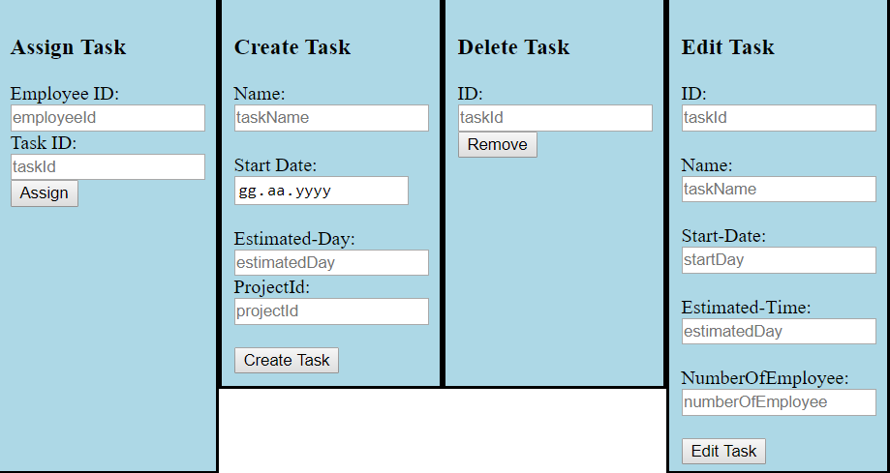

4 ) Database :
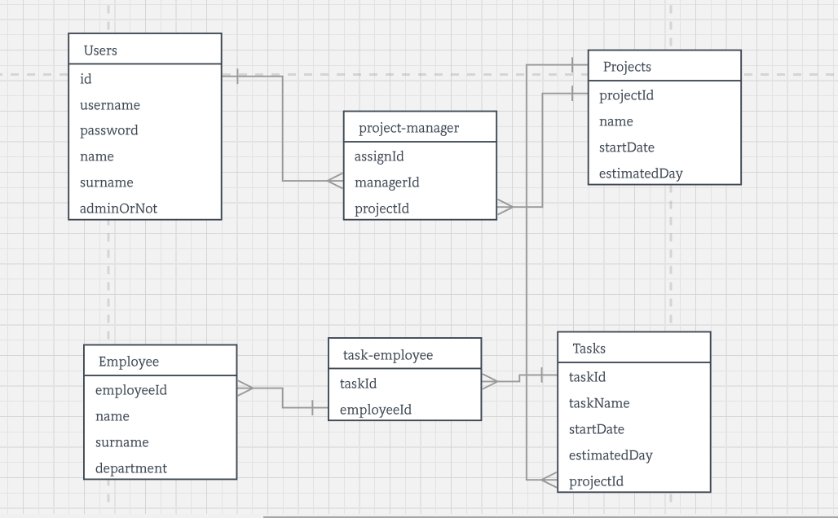
5 ) Conclusion :

This is a great real-life database system, since it works perfectly with a well-designed system, like "phpMyAdmin" or "MySQL". This works perfectly
fine. I tried to design it against hacking. I tried a lot to SQL inject inside,
but could not manage it. It is very safe to use, since as methods, POST is
preferred against GET method. We could also hash password, but it would
be costly by means of implementing and time. I tried to do it as convenient as
possible. I find this project better than older ones, since this is a real product
that we can actually use. In terms of eficiency, it is not bad. Also, employees
and admins cannot enter to eachother's accounts, which I implemented with
extra effort. In terms of safety, I found this program pretty safe against SQL
injectors and hacker/leakers. Overally, it works pretty fine.

