COURSE MANAGEMENT SYSTEM

CORE FEATURES:

* **Course Management**: Add, edit, and delete courses.
* **Student Management**: Enroll students, maintain records, and assign grades.
* **Faculty Management**: Assign faculty to courses and manage their workloads.
* **Authentication System**: Role-based access for administrators, students, and faculty.
* **Grade Management**: Record and compute student grades.
* **Reporting System**: Generate detailed reports on grades, class lists, and faculty loads.

PROJECT STRUCTURE:

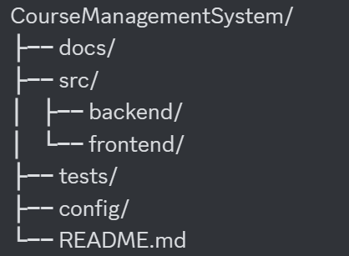

FIRST INITIAL ISSUES:

BRANCHES: