Reference (Youtube tutorial: <https://www.youtube.com/watch?v=3WTtKaIfqnk>)

**Tutorial**

1. Download Apache Jena **Fuseki**

<https://jena.apache.org/download/index.cgi>

2. Extract the downloaded file

3. Change the name of the folder to “**Fuseki**”

4. Move “Fuseki” under “C” drive

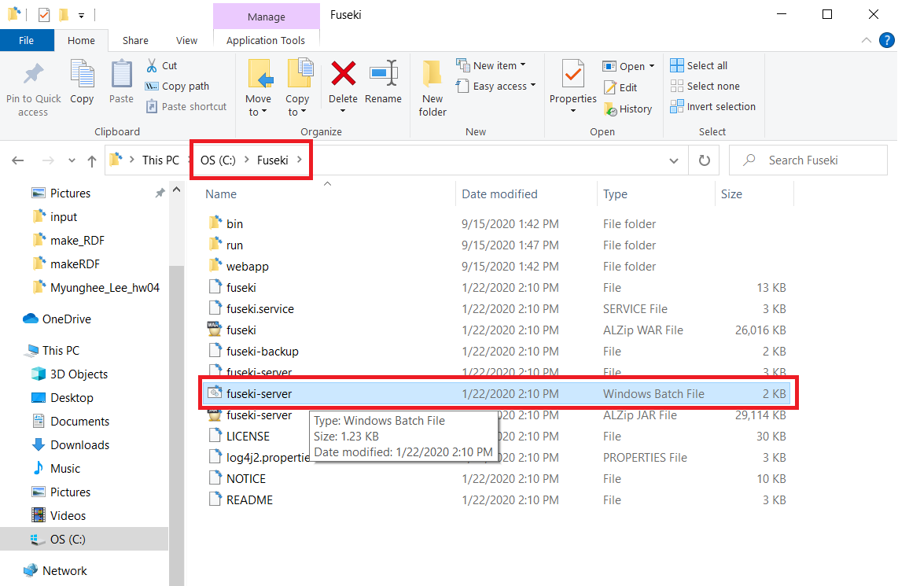

5. Start fuseki-server.bat file (batch file)

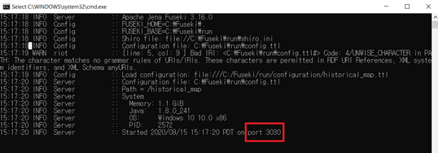

6. Open a web browser and type “**localhost:3030**”

7. Add a new dataset (manage datasets -> add new dataset)

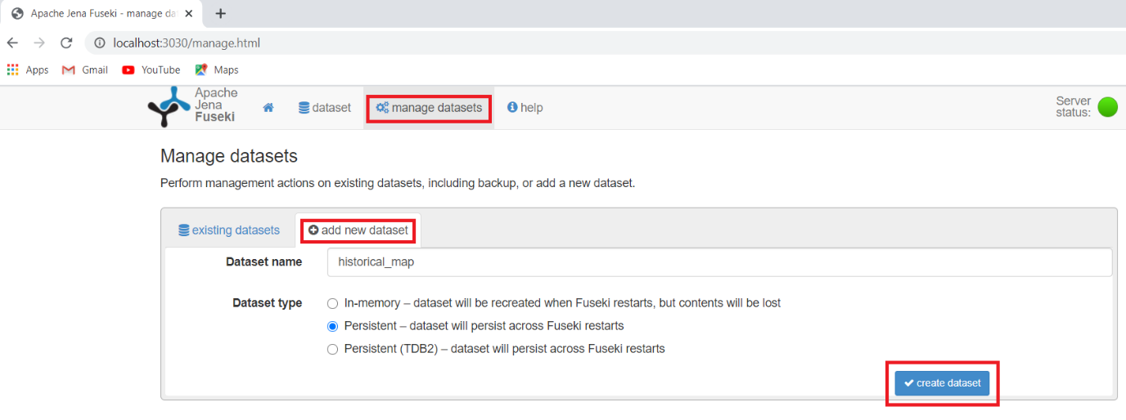

8. Upload ttl file (existing datasets -> upload data -> select files (green button) -> upload now)

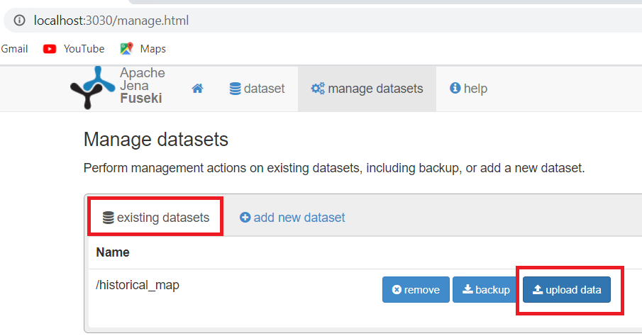

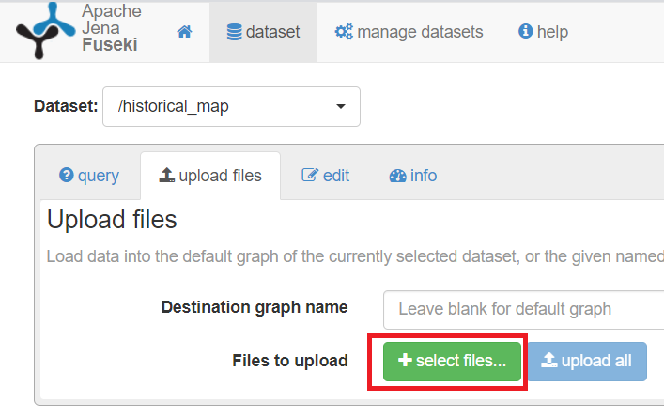

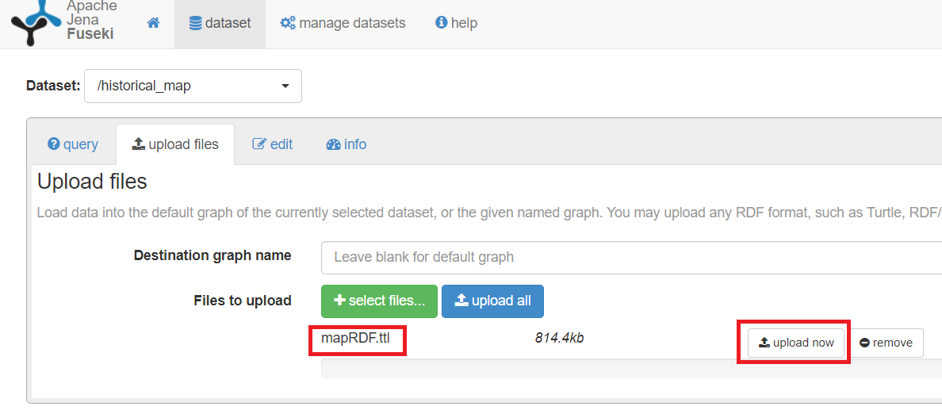

9. Query

In the query tab, write the query and the execute it by clicking the white arrow in the black box.

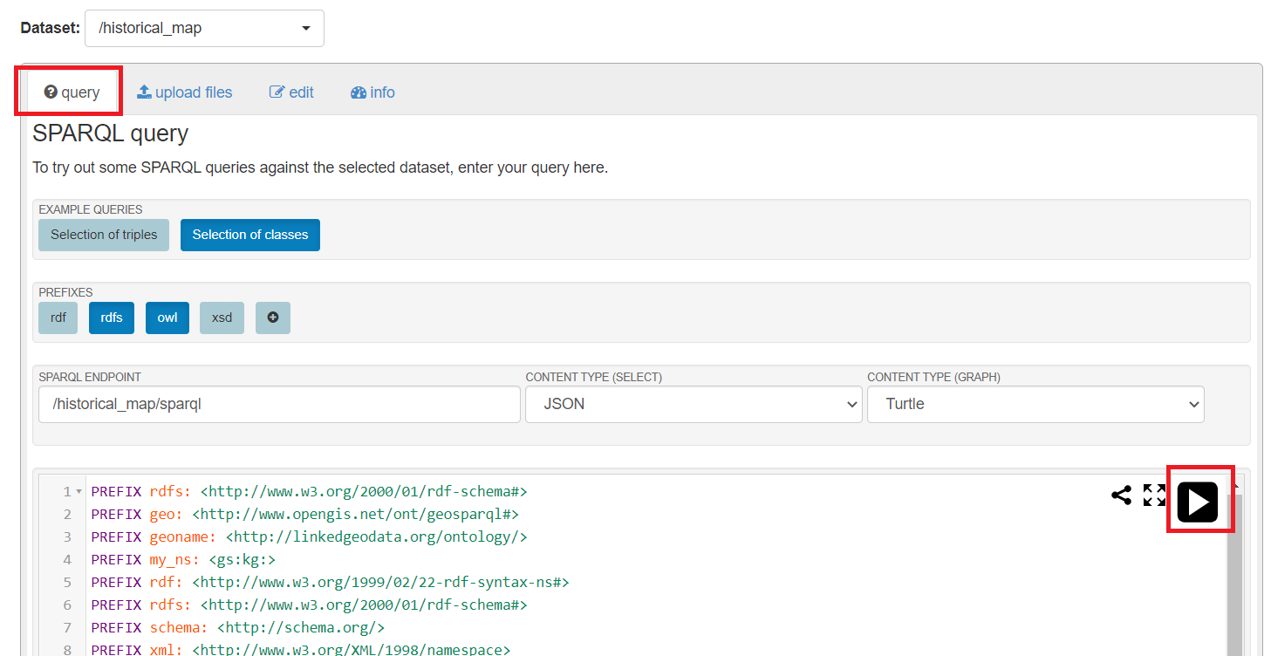

**Sample queries**

|  |
| --- |
| PREFIX rdfs: <http://www.w3.org/2000/01/rdf-schema#>  PREFIX geo: <http://www.opengis.net/ont/geosparql#>  PREFIX geoname: <http://linkedgeodata.org/ontology/>  PREFIX my_ns: <gs:kg:>  PREFIX rdf: <http://www.w3.org/1999/02/22-rdf-syntax-ns#>  PREFIX rdfs: <http://www.w3.org/2000/01/rdf-schema#>  PREFIX schema: <http://schema.org/>  PREFIX xml: <http://www.w3.org/XML/1998/namespace>  PREFIX xsd: <http://www.w3.org/2001/XMLSchema#>  PREFIX rs: <http://spektrum.ctu.cz/ontologies/radio-spectrum#>  SELECT ?label ?uri  WHERE {  <gs:kg:101201496.jpgfeature_id10> rdfs:label ?label;  rdfs:seeAlso ?uri .  } |
| PREFIX rdfs: <http://www.w3.org/2000/01/rdf-schema#>  PREFIX geo: <http://www.opengis.net/ont/geosparql#>  PREFIX geoname: <http://linkedgeodata.org/ontology/>  PREFIX my_ns: <gs:kg:>  PREFIX rdf: <http://www.w3.org/1999/02/22-rdf-syntax-ns#>  PREFIX rdfs: <http://www.w3.org/2000/01/rdf-schema#>  PREFIX schema: <http://schema.org/>  PREFIX xml: <http://www.w3.org/XML/1998/namespace>  PREFIX xsd: <http://www.w3.org/2001/XMLSchema#>  PREFIX rs: <http://spektrum.ctu.cz/ontologies/radio-spectrum#>  SELECT ?map_name ?node ?uri  WHERE {  ?map_name geo:sfOverlaps ?node .  ?node rdfs:label "ARGYLE STREET";  rdfs:seeAlso ?uri.  } |