CV Maxing: A Human-in-the-Loop, Evidence-Grounded Multi-Agent Assistant for Tailoring CVs to Job Postings
José Amado, Afonso Carvalho, Joana Vilas Boas
Department of Informatics Engineering, University of Coimbra, Portugal
Project Proposal – Human-Centered Artificial Intelligence (HCAI) 2026/2027

Abstract
Tailoring a CV to each job posting is slow, and delegating it to a large language model (LLM) is fast but untrustworthy: models readily add keywords, figures and skills that the candidate never claimed. We propose CV Maxing, a human-centered multi-agent system that structures a CV and a job posting, reviews the evidence the CV offers for each stated requirement, pro-actively asks the candidate targeted questions about the gaps it finds, and renders a tailored CV through a fixed template. Every statement in the output must be traceable to the original CV or to an explicit answer from the candidate, who may skip any question and reviews the result. The project addresses the HCAI topics of human-in-the-loop control, mixed-initiative human–AI cooperation, and trustworthy, transparent AI. It will be evaluated on synthetic CVs and public job postings for extraction accuracy, agreement with human annotators, faithfulness of the generated CV and gains over automatic baselines, complemented by a user study of usability, control and trust.

1 Problem and Motivation
Job seekers are routinely advised to tailor their CV to each application, and with good reason: screening is increasingly skills-based, with 70% of the employers surveyed by NACE reporting skills-based hiring practices, including at the screening stage [Gray, 2026]. A CV that buries relevant evidence, or words it differently from the posting, can therefore fail even when the candidate is suitable. Tailoring by hand, however, is time-consuming and error-prone [Zinjad et al., 2024].
LLMs appear to remove this cost, but they replace it with a trust problem. Asked to “optimize” a CV for a posting, a general-purpose model is prone to hallucination [Ji et al., 2023]: it may introduce skills, figures or responsibilities that have no support in the source. For the candidate this is misrepresentation, with real consequences if it surfaces in an interview. The candidate, moreover, stays passive: the tool neither explains its judgment nor asks for what it does not know.
The problem we address is therefore: how can an AI assistant improve the way a CV communicates a candidate’s real evidence for a specific job, without inventing anything and while leaving the candidate in control? It is interesting because full automation is cheap here but structurally insufficient. The information needed to close most gaps (was SQL actually used in that project?) exists only in the candidate’s memory, so the system must cooperate with the person rather than generate on their behalf. It is important because recruitment directly affects people’s livelihoods, and because candidates are the stakeholders least served by recruitment AI, which is built mostly for employers.

2 Background
Matching CVs to jobs. Research on person–job fit has concentrated on the employer side. Li et al. [2020] use context-aware transformers to predict competence levels and to match CVs with job descriptions, and Gan et al. [2024] propose an LLM-agent framework that summarizes and grades CVs for screening. LLM judgments are not a reliable ground truth, however: Varshney and Ganuthula [2025] find that LLM screeners differ significantly from human experts and adapt very differently to the same contextual information. This calls for semantic rather than keyword matching, and for treating a reviewer’s output as fallible advice.
Bias, trust and regulation. Algorithmic hiring raises well-documented fairness concerns [Fabris et al., 2025]; for instance, language models used for CV retrieval favored white-associated names in 85.1% of the cases tested by Wilson and Caliskan [2024]. Human oversight is not automatically a remedy: the recruiters studied by Lacroux and Martin-Lacroux [2022] declared more trust in human experts, yet were swayed more by algorithmic recommendations when these were inconsistent with the candidate’s profile. The EU AI Act accordingly classes recruitment AI as high-risk and requires transparency and human oversight [European Union, 2024].
Candidate-side tools. The closest work is ResumeFlow [Zinjad et al., 2024], an off-the-shelf LLM pipeline that extracts details from the posting and from the CV and generates a tailored CV, with dedicated metrics for alignment and hallucination. It is fully automatic: the candidate is not consulted during generation, and hallucination is measured after the fact rather than prevented by design.
Human-centered AI. Shneiderman [2020] argues that reliable, safe and trustworthy systems combine high automation with high human control. Horvitz’s [1999] principles for mixed-initiative interfaces recommend engaging the user in dialog to resolve key uncertainties instead of guessing, and the guidelines of Amershi et al. [2019] ask systems to make clear why they did what they did and to support efficient correction. Finally, LLM applications that ingest external content are exposed to indirect prompt injection [Greshake et al., 2023], which matters for a system that reads web pages and uploaded PDFs. To our knowledge, no candidate-side tool treats truthfulness and candidate control as design constraints rather than as post-hoc metrics; this is the gap CV Maxing targets.

3 Goals
The aim is to design, build and evaluate CV Maxing, an assistant that helps a candidate tailor a CV to one job posting under three constraints: nothing is invented, every judgment is backed by evidence, and the candidate decides. The specific goals are:
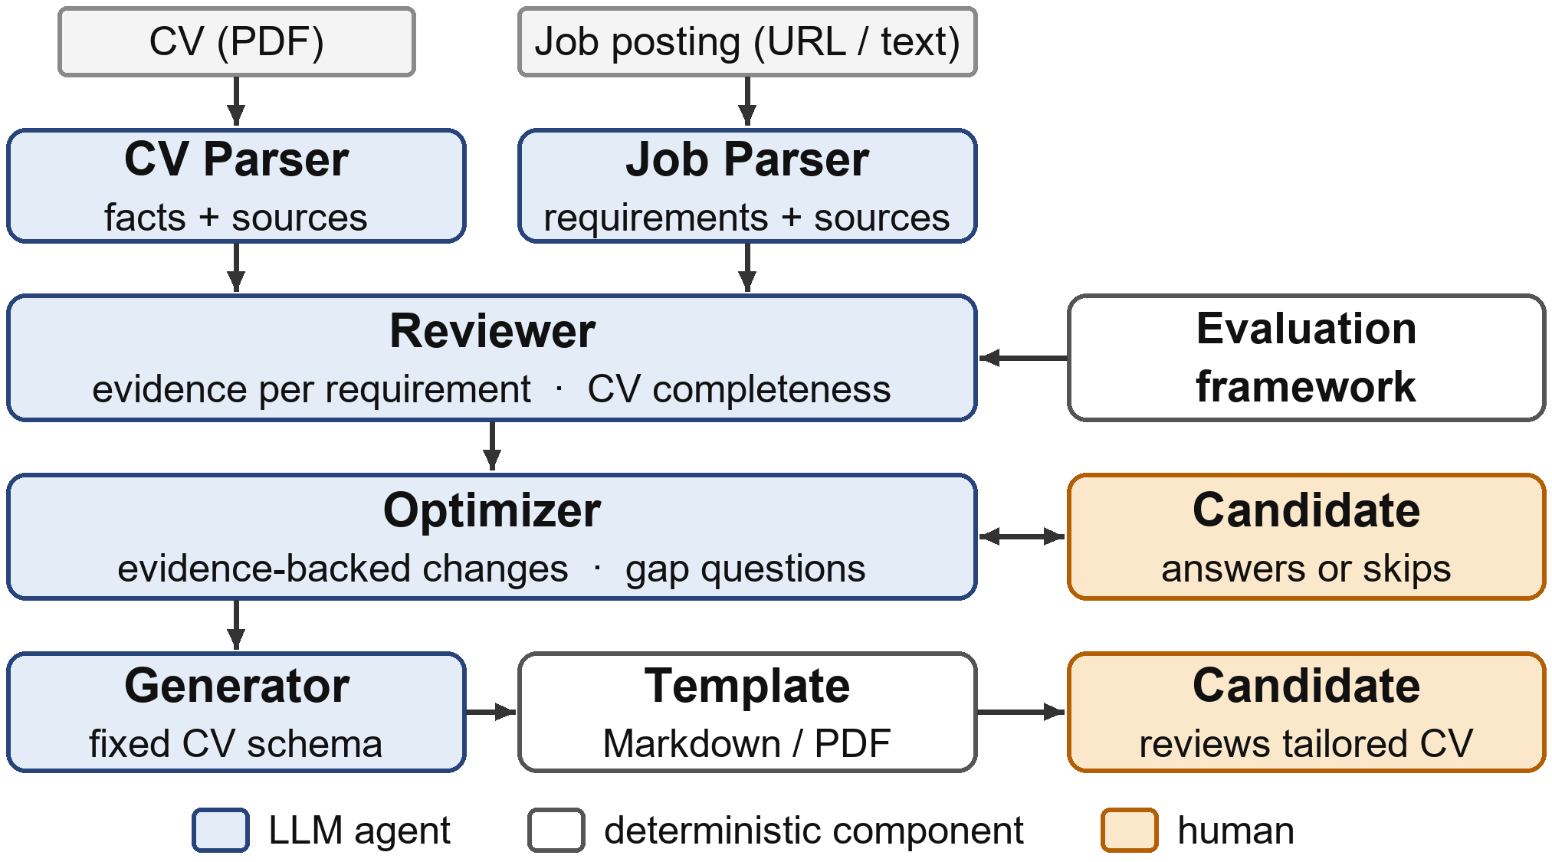
Figure 1: The CV Maxing pipeline. The candidate answers or skips gap questions and reviews the tailored CV.
G1 Evidence-based review. For each requirement stated in the posting, classify the CV’s evidence as satisfied, weak, absent or uncertain, quoting the supporting text. The system issues no hiring decision and no probability of being hired.
G2 Pro-active cooperation. Turn gaps into focused questions to the candidate, never treating absence of evidence as absence of the skill. Every question can be skipped.
G3 Faithful generation. Produce a tailored CV in which each statement is traceable to the original CV or to a candidate answer.
G4 Transparency and control. Expose an audit trail of proposed changes, with rationale and provenance, that the candidate can accept, edit or reject.
The work will be considered successful if, on the evaluation set, (i) generated CVs contain no unsupported facts; (ii) the Reviewer reaches substantial agreement with human annotators (Cohen’s κ ≥ 0.6); (iii) the full system improves requirement coverage significantly over the original CV and over a no-interaction ablation; and (iv) users rate it above the usual SUS benchmark of 68 and report feeling in control. The expected contributions are an open-source human-in-the-loop pipeline, a research-based framework for assessing CV–job evidence, and an empirical comparison of interactive and fully automatic CV tailoring.

4 Approach
CV Maxing is a pipeline of five LLM agents orchestrated with CrewAI (Figure 1). Each agent has a single responsibility and must return an object validated against a Pydantic schema.
The CV Parser and the Job Parser turn the PDF and the posting (URL or pasted text) into structured records. They extract only what is explicitly stated, keep the original text, and attach to every item the section and sentence it came from; the Job Parser also separates required from preferred requirements.
The Reviewer applies an evaluation framework that we derived from recruiter guidance and the literature. The framework ranks criteria, from required skills and relevant experience down to keywords and presentation, but lets their importance depend on the posting and on the candidate’s career stage. It grades evidence on a scale from no evidence, through mentioned and supported, to strongly demonstrated, so that a skill merely listed weighs less than one shown in a project. The Reviewer outputs a status, the evidence and its reasoning for each requirement, plus a separate check of CV completeness. It is deliberately qualitative: the LLM assigns no numeric score.
The Optimizer works in two phases. First, using only CV evidence, it proposes atomic changes, each recording the current text, the proposed text, a rationale, its evidence source (CV, candidate, or both) and a flag requiring human approval. Second, it asks the candidate one focused question per open gap. Answers are logged with a resolution (supported, unsupported, not applicable or unresolved); a “no” or a skipped question never becomes a claim.
The Generator maps the validated facts into a fixed CV schema, and a deterministic template renders the Markdown and PDF output. Because the LLM never writes the document freely, the room for fabrication is narrow and every field can be audited.
We rely on off-the-shelf LLMs without fine-tuning. A first prototype already runs this pipeline end to end. During the semester we plan to (i) add per-change accept, edit and reject controls and show the Reviewer’s reasoning in the interface; (ii) add a deterministic coverage indicator, computed outside the LLM from literal and sentence-embedding matching, as a reproducible baseline; (iii) add an automatic check that every output statement is supported by the CV or by an answer; (iv) harden the agents against prompt injection; and (v) tune the number and quality of questions to limit user fatigue.

5 Materials (including Data)
Data. No model is trained, so data are needed only for development and evaluation. Job postings: about 30 postings for data-related roles (data scientist, analyst and engineer; machine learning engineer) from public Kaggle and Hugging Face datasets and company career pages, plus synthetic ones. CVs: to avoid processing personal data, we will write synthetic CVs. For each of about ten candidate profiles we first define a fact sheet (the ground truth about the fictional candidate) and then produce controlled variants: strong, weak, missing required skills, poorly presented, relevant experience poorly described, and keyword-misaligned. The fact sheet lets us answer the system’s questions consistently and decide objectively whether an output statement is fabricated. The authors will independently annotate gold structured fields and requirement-level evidence labels for a subset, and inter-annotator agreement will be reported. Real CVs will be used only in the user study, with informed consent.
Tools. Python; CrewAI for agent orchestration; LLMs accessed through OpenRouter, with the model as an experimental factor; Pydantic schemas; pdfplumber and Docling (PDF extraction); Beautiful Soup (job pages); Jinja2 and Playwright (rendering); FastAPI with a web interface; Sentence Transformers (matching baseline); Docker; and GitHub.

6 Evaluation
Extraction. Field-level precision, recall and F1 of both parsers against the gold annotations, plus the rate of extracted fields with no support in the source.
Review. Requirement-level status compared with human labels (accuracy, macro-F1, Cohen’s κ) and with the deterministic matching baseline, to test whether LLM reasoning adds information beyond keyword and embedding similarity.
Faithfulness. Each statement of a generated CV is labeled as supported by the CV, supported by an answer, or unsupported; the fabrication rate is the share of unsupported statements. Any coverage gain obtained through unsupported content counts as a failure.
Tailoring effect. Requirement coverage and evidence strength before and after tailoring, under three conditions: a single-prompt LLM baseline, CV Maxing without questions (ablation), and the full interactive system. Paired differences will be tested with the Wilcoxon signed-rank test, and repeated runs will quantify run-to-run consistency. A small set of adversarial postings and CVs will probe resistance to prompt injection.
User study. Ten to fifteen students will tailor their own CV to a posting of their choice. We will collect the System Usability Scale [Brooke, 1996], Likert items on perceived control, transparency, trust and usefulness, and interaction logs (questions answered or skipped; changes accepted, edited or rejected; time on task). Blinded evaluators will also judge whether the original or the tailored CV better supports the application.
Results will be reported as tables (precision, recall, F1, κ), box plots of coverage per condition, bar charts of fabrication rate and SUS distributions, together with a qualitative analysis of failure cases. The main threats to validity are the synthetic data, the small sample and LLM non-determinism, which we mitigate with controlled variants, paired designs and repeated runs.

References
[Amershi et al., 2019] Saleema Amershi, Dan Weld, Mihaela Vorvoreanu, Adam Fourney, Besmira Nushi, Penny Collisson, Jina Suh, Shamsi Iqbal, Paul N. Bennett, Kori Inkpen, Jaime Teevan, Ruth Kikin-Gil, and Eric Horvitz. Guidelines for human-AI interaction. In Proceedings of the 2019 CHI Conference on Human Factors in Computing Systems, pages 1–13, 2019.
[Brooke, 1996] John Brooke. SUS: A “quick and dirty” usability scale. In Usability Evaluation in Industry, pages 189–194. Taylor & Francis, London, 1996.
[European Union, 2024] European Union. Regulation (EU) 2024/1689 of the European Parliament and of the Council laying down harmonised rules on artificial intelligence (Artificial Intelligence Act). Official Journal of the European Union, L series, 12 July 2024.
[Fabris et al., 2025] Alessandro Fabris, Nina Baranowska, Matthew J. Dennis, David Graus, Philipp Hacker, Jorge Saldivar, Frederik Zuiderveen Borgesius, and Asia J. Biega. Fairness and bias in algorithmic hiring: A multidisciplinary survey. ACM Transactions on Intelligent Systems and Technology, 16(1), 2025.
[Gan et al., 2024] Chengguang Gan, Qinghao Zhang, and Tatsunori Mori. Application of LLM agents in recruitment: A novel framework for resume screening. arXiv preprint arXiv:2401.08315, 2024.
[Gray, 2026] Kevin Gray. Employer use of skills-based hiring practices grows. National Association of Colleges and Employers (NACE), January 2026. https://naceweb.org/job-market/trends-and-predictions/employer-use-of-skills-based-hiring-practices-grows.
[Greshake et al., 2023] Kai Greshake, Sahar Abdelnabi, Shailesh Mishra, Christoph Endres, Thorsten Holz, and Mario Fritz. Not what you’ve signed up for: Compromising real-world LLM-integrated applications with indirect prompt injection. In Proceedings of the 16th ACM Workshop on Artificial Intelligence and Security, pages 79–90, 2023.
[Horvitz, 1999] Eric Horvitz. Principles of mixed-initiative user interfaces. In Proceedings of the SIGCHI Conference on Human Factors in Computing Systems, pages 159–166, 1999.
[Ji et al., 2023] Ziwei Ji, Nayeon Lee, Rita Frieske, Tiezheng Yu, Dan Su, Yan Xu, Etsuko Ishii, Ye Jin Bang, Andrea Madotto, and Pascale Fung. Survey of hallucination in natural language generation. ACM Computing Surveys, 55(12):1–38, 2023.
[Lacroux and Martin-Lacroux, 2022] Alain Lacroux and Christelle Martin-Lacroux. Should I trust the artificial intelligence to recruit? Recruiters’ perceptions and behavior when faced with algorithm-based recommendation systems during resume screening. Frontiers in Psychology, 13:895997, 2022.
[Li et al., 2020] Changmao Li, Elaine Fisher, Rebecca Thomas, Steve Pittard, Vicki Hertzberg, and Jinho D. Choi. Competence-level prediction and resume & job description matching using context-aware transformer models. In Proceedings of the 2020 Conference on Empirical Methods in Natural Language Processing (EMNLP), pages 8456–8466, 2020.
[Shneiderman, 2020] Ben Shneiderman. Human-centered artificial intelligence: Reliable, safe & trustworthy. International Journal of Human–Computer Interaction, 36(6):495–504, 2020.
[Varshney and Ganuthula, 2025] Aryan Varshney and Venkat Ram Reddy Ganuthula. Signal or noise? Evaluating large language models in resume screening across contextual variations and human expert benchmarks. arXiv preprint arXiv:2507.08019, 2025.
[Wilson and Caliskan, 2024] Kyra Wilson and Aylin Caliskan. Gender, race, and intersectional bias in resume screening via language model retrieval. In Proceedings of the AAAI/ACM Conference on AI, Ethics, and Society, 7(1):1578–1590, 2024.
[Zinjad et al., 2024] Saurabh Bhausaheb Zinjad, Amrita Bhattacharjee, Amey Bhilegaonkar, and Huan Liu. ResumeFlow: An LLM-facilitated pipeline for personalized resume generation and refinement. In Proceedings of the 47th International ACM SIGIR Conference on Research and Development in Information Retrieval, 2024.

