CV Maxing: A Human-in-the-Loop, Evidence-Grounded Multi-Agent Assistant for Tailoring CVs to Job Postings
José Amado, Afonso Carvalho, Joana Vilas Boas
Department of Informatics Engineering, University of Coimbra, Portugal
Human-Centered Artificial Intelligence 2026/2027

Abstract
Tailoring a CV to each job posting is slow and delegating it to a large language model (LLM) is fast but untrustworthy: models readily add keywords, figures and skills that the candidate never claimed. We propose CV Maxing, a human-centered multi-agent system that structures a CV and a job posting, reviews the evidence the CV offers for each stated requirement, proactively asks the candidate targeted questions about the gaps it finds, and renders a tailored CV through a fixed template. Every statement in the output must be traceable to the original CV or to an explicit answer from the candidate, who may skip any question and review the result. The project addresses the HCAI topics of human-in-the-loop control, mixed-initiative human–AI cooperation, and trustworthy, transparent AI. It will be evaluated on synthetic CVs and public job postings for extraction accuracy, agreement with human annotators, faithfulness of the generated CV and gains over automatic baselines.

1 Problem and Motivation
Job seekers are routinely advised to tailor their CV to each application, and with good reason: screening is increasingly skill-based, with 70% of surveyed employers reporting skills-based hiring practices, including at the screening stage [5]. A CV that buries relevant evidence, or words it differently from the posting, can therefore fail even when the candidate is suitable. Tailoring by hand, however, is time-consuming and error prone.
LLMs appear to remove this cost, but they replace it with a trust problem. Asked to “optimize” a CV for a posting, a general-purpose model is prone to hallucination: it may introduce skills, figures or responsibilities that have no support in the source. For the candidate this is misrepresentation, with real consequences if it surfaces in an interview. The candidate, moreover, stays passive: the tool neither explains its judgment nor asks for what it does not know.
The problem we address is therefore: how can an AI assistant improve the way a CV communicates a candidate’s real evidence for a specific job, without inventing anything and while leaving the candidate in control? It is interesting because full automation is cheap here but structurally insufficient. The information needed to close most gaps exists only in the candidate’s memory, so the system must cooperate with the person rather than generate on their behalf. It is important because recruitment directly affects people’s livelihoods, and because candidates are the stakeholders least served by recruitment AI, which is built mostly for employers.

2 Background
Matching CVs to jobs. Research on person–job fit has concentrated on the employer side: context-aware transformers have been used to predict competence levels and to match CVs with job descriptions [7]. LLM judgments are not a reliable ground truth, however: LLM screeners differ significantly from human experts and adapt very differently to the same contextual information [8]. This calls for semantic rather than keyword matching [6][7], and for treating a reviewer’s output as fallible advice.
Bias, trust and regulation. Algorithmic hiring raises well-documented fairness concerns, and human oversight is not automatically a remedy: recruiters declared more trust in human experts yet were swayed more by algorithmic recommendations when these were inconsistent with the candidate’s profile [9]. The EU AI Act accordingly classes recruitment AI as high-risk and requires transparency and human oversight [11].
Candidate-side tools. The closest work is ResumeFlow, an off-the-shelf LLM pipeline that extracts details from the posting and from the CV and generates a tailored CV, with dedicated metrics for alignment and hallucination. It is fully automatic: the candidate is not consulted during generation, and hallucination is measured after the fact rather than prevented by design.
Human-centered AI. Human-centered AI holds that reliable, safe and trustworthy systems combine high automation with high human control. Principles for mixed-initiative interfaces recommend engaging the user in dialog to resolve key uncertainties instead of guessing, and guidelines for human–AI interaction ask systems to make clear why they did what they did and to support efficient correction. Finally, LLM applications that ingest external content are exposed to indirect prompt injections, which matters for a system that reads web pages and uploaded PDFs. To our knowledge, no candidate-side tool treats truthfulness and candidate control as design constraints rather than as post-hoc metrics. This is the gap CV Maxing targets.

3 Goals
The aim is to design, build and evaluate CV Maxing, an assistant that helps a candidate tailor a CV to one job posting under three constraints: nothing is invented, every judgment is backed by evidence, and the candidate decides. The specific goals are:
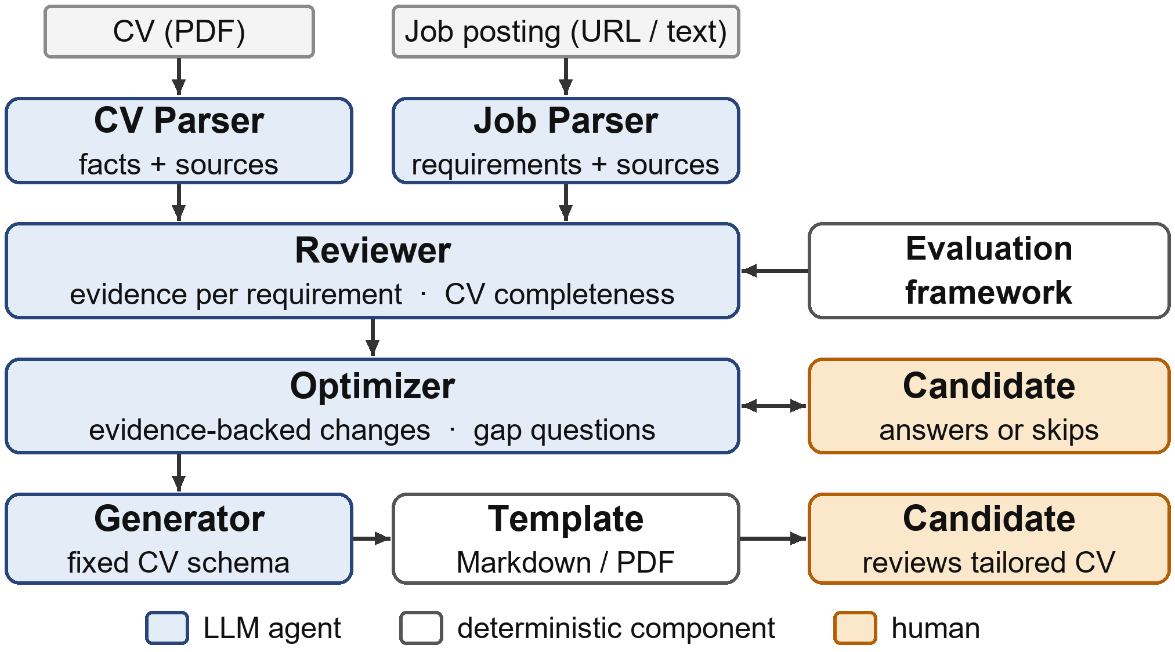
Figure 1: The CV Maxing pipeline. The candidate answers or skips gap questions and reviews the tailored CV.
G1 Evidence-based review. For each requirement stated in the posting, classify the CV’s evidence as satisfied, weak, absent or uncertain, quoting the supporting text. The system issues no hiring decision and no probability of being hired.
G2 Pro-active cooperation. Turn gaps into focused questions to the candidate, never treating absence of evidence as absence of skill. Every question can be skipped.
G3 Faithful generation. Produce a tailored CV in which each statement is traceable to the original CV or to a candidate answer.
The work will be considered successful if, on the evaluation set, (i) generated CVs contain no unsupported facts, (ii) the Reviewer reaches substantial agreement with human annotators and (iii) the full system improves requirement coverage significantly over the original CV and over a no-interaction ablation. The expected contributions are an open-source human-in-the-loop pipeline and a research-based framework for assessing CV–job evidence.

4 Approach
CV Maxing is a pipeline of five LLM agents (with an additional sixth judge agent for later validation) orchestrated with Crew AI (Figure 1). Each agent has a single responsibility and must return an object validated against a Pydantic schema.
The CV Parser and the Job Parser turn the PDF and the posting (URL or pasted text) into structured records. They extract only what is explicitly stated, keep the original text, and attach to every item the section and sentence it came from. The Job Parser also separates required from preferred requirements.
The Reviewer applies an evaluation framework that we derived from recruiter guidance and the literature [1][2][3][4][5][6][7]. The framework ranks criteria, from required skills and relevant experience down to keywords and presentation but let’s their importance depend on the posting and on the candidate’s career stage. It grades evidence on a scale from no evidence, through mentioned and supported, to strongly demonstrated, so that a skill merely listed weighs less than one shown in a project [3][5]. The Reviewer outputs a status, the evidence and its reasoning for each requirement, plus a separate check of CV completeness. It is deliberately qualitative: the LLM assigns no numeric score.
The Optimizer works in two phases. First, using only CV evidence, it proposes atomic changes, each recording of the current text, the proposed text, a rationale, its evidence source (CV, candidate, or both) and a flag requiring human approval. Second, it asks the candidate one focused question per open gap. Answers are logged with a resolution (supported, unsupported, not applicable or unresolved). A “no” or a skipped question never becomes a claim.
The Generator maps the validated facts into a fixed CV schema, and a template renders the Markdown and PDF output. Because the LLM never writes the document freely, the room for fabrication is narrow and every field can be audited.
We rely on off-the-shelf LLMs without fine-tuning. The first prototype already runs from this pipeline end to end. During the semester we plan to (i) add edit controls, (ii) show the Reviewer’s reasoning in the interface and (iii) tune the number and quality of questions to limit user fatigue.

5 Materials
Data. No model is trained, so data is needed only for development and evaluation. Job postings: about 30 postings for various roles from company career pages, plus synthetic ones. CVs: to avoid processing personal data, we will use synthetic CVs. Real CVs will be used only in the user study, with informed consent.
Tools. Python, CrewAI for agent orchestration, LLMs accessed through OpenRouter, with the model as an experimental factor, Pydantic schemas, pdfplumber (PDF extraction); Beautiful Soup (job pages); Jinja2 and Playwright (rendering); FastAPI with a web interface;

6 Evaluation
Judge agent. All results are measured by an independent LLM agent acting as judge, from a different model family than the pipeline and without access to its reasoning. Given the fact sheet, the original CV, the posting and the output under test, it returns structured labels, each with a quoted piece of evidence. Since LLM judgments are not a reliable ground truth [8], we reduce the risk by using a different model family, requiring quoted evidence for every label, and repeating judgments to check their stability.
Faithfulness. The judge labels each statement of a generated CV as supported by the CV, supported by an answer, or unsupported; the fabrication rate is the share of unsupported statements. Any coverage gain obtained through unsupported content counts as a failure.
Tailoring effect. The judge assesses requirement coverage and evidence strength before and after tailoring, under three conditions: a single-prompt LLM baseline, CV Maxing without questions (ablation), and the full interactive system. Paired differences will be tested with the Wilcoxon signed-rank test, and repeated runs will quantify run-to-run consistency. A small set of adversarial postings and CVs will probe resistance to prompt injection.
Results will be reported as box plots of coverage per condition and bar charts of fabrication rate, together with a qualitative analysis of failure cases. The main threats to validity are the synthetic data, LLM non-determinism and the use of an LLM as the only evaluator, which we mitigate with controlled variants, paired designs and repeated runs

References
[1] Microsoft Careers. Transparency FAQ. https://careers.microsoft.com/v2/global/en/transparency.html
[2] LinkedIn. How you match. LinkedIn Talent Solutions blog. https://www.linkedin.com/business/talent/blog/product-tips/linkedin-how-you-match
[3] Indeed. How to read an applicant resume. Indeed Hiring Resources. https://www.indeed.com/hire/c/info/how-to-read-a-resume
[4] SHRM. How to screen resumes efficiently: A beginner’s guide. Society for Human Resource Management. https://www.shrm.org/in/topics-tools/news/blogs/how-to-screen-resumes-efficiently--a-beginner-s-guide
[5] Kevin Gray. Employer use of skills-based hiring practices grows. National Association of Colleges and Employers (NACE), January 2026. https://naceweb.org/job-market/trends-and-predictions/employer-use-of-skills-based-hiring-practices-grows.
[6] Greenhouse. What really happens after you apply for a job? Greenhouse blog. https://my.greenhouse.com/blogs/what-really-happens-after-you-apply-for-a-job
[7] Changmao Li, Elaine Fisher, Rebecca Thomas, Steve Pittard, Vicki Hertzberg, and Jinho D. Choi. Competence-level prediction and resume & job description matching using context-aware transformer models. In Proceedings of the 2020 Conference on Empirical Methods in Natural Language Processing (EMNLP), pages 8456–8466, 2020.
[8] Aryan Varshney and Venkat Ram Reddy Ganuthula. Signal or noise? Evaluating large language models in resume screening across contextual variations and human expert benchmarks. arXiv preprint arXiv:2507.08019, 2025.
[9] Alain Lacroux and Christelle Martin-Lacroux. Should I trust the artificial intelligence to recruit? Recruiters’ perceptions and behavior when faced with algorithm-based recommendation systems during resume screening. Frontiers in Psychology, 13:895997, 2022.
[11] European Union. Regulation (EU) 2024/1689 of the European Parliament and of the Council laying down harmonised rules on artificial intelligence (Artificial Intelligence Act). Official Journal of the European Union, L series, 12 July 2024.

