V: Navigate Figma Design files

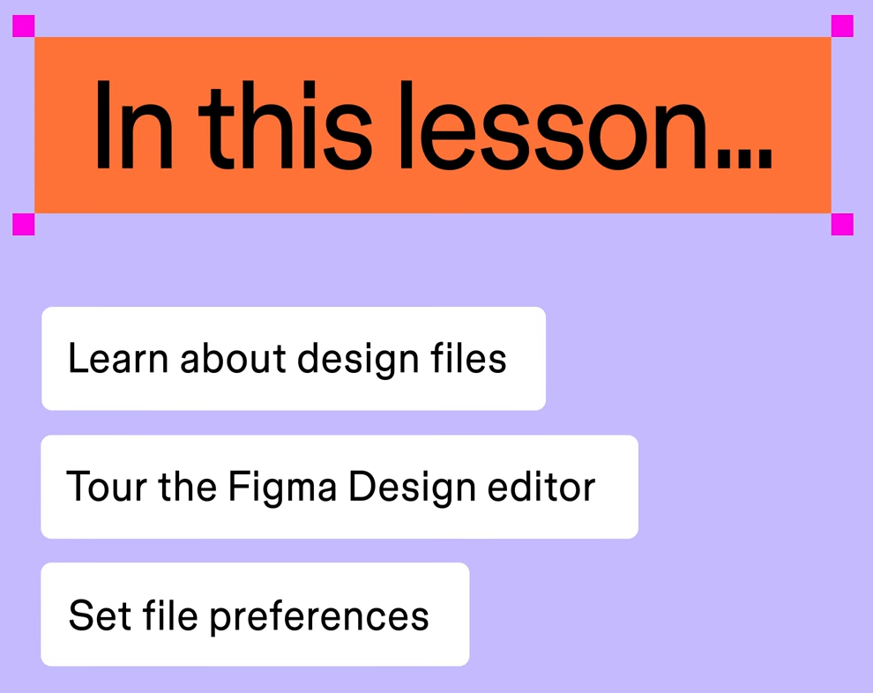

1: Design files:
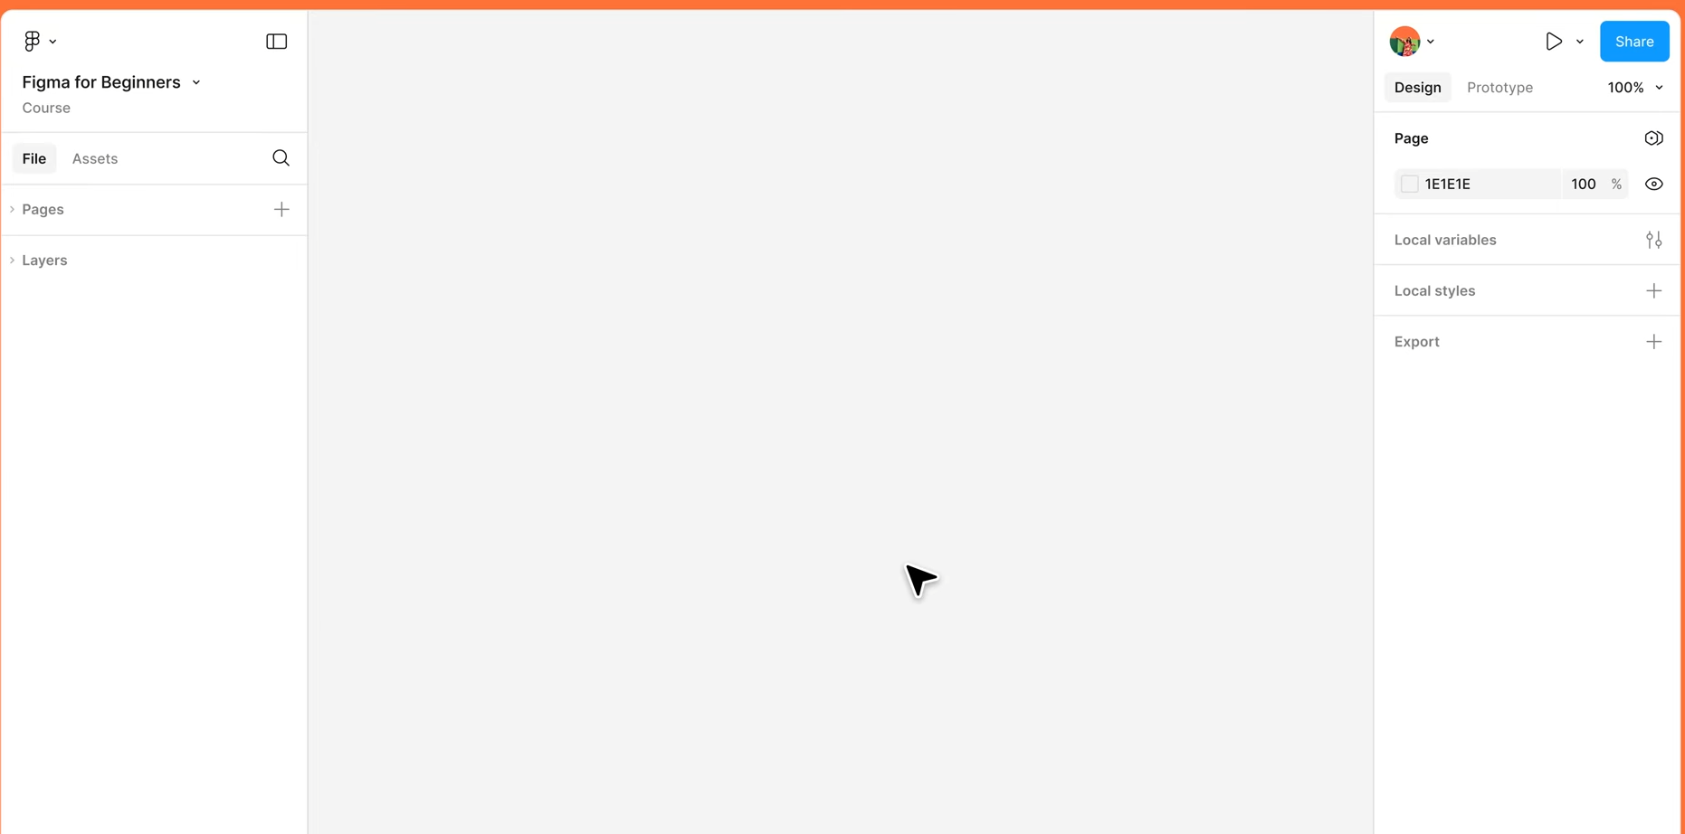
Design file gives you the tools to create / share / prototype your designs
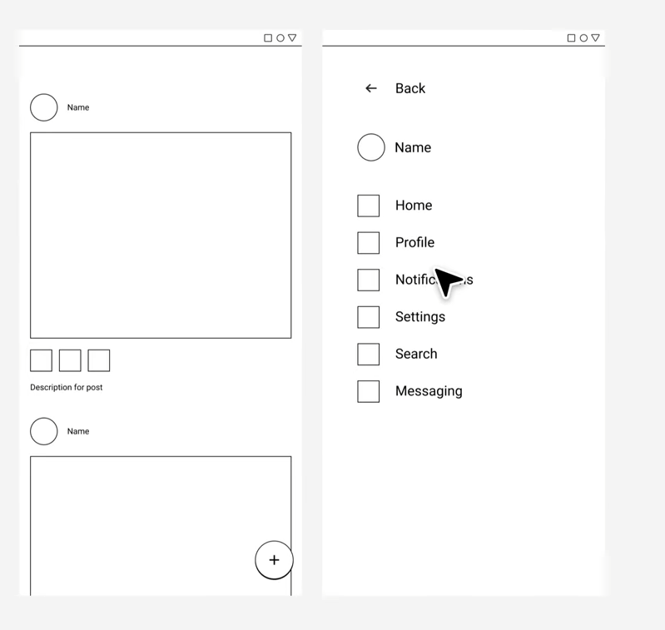

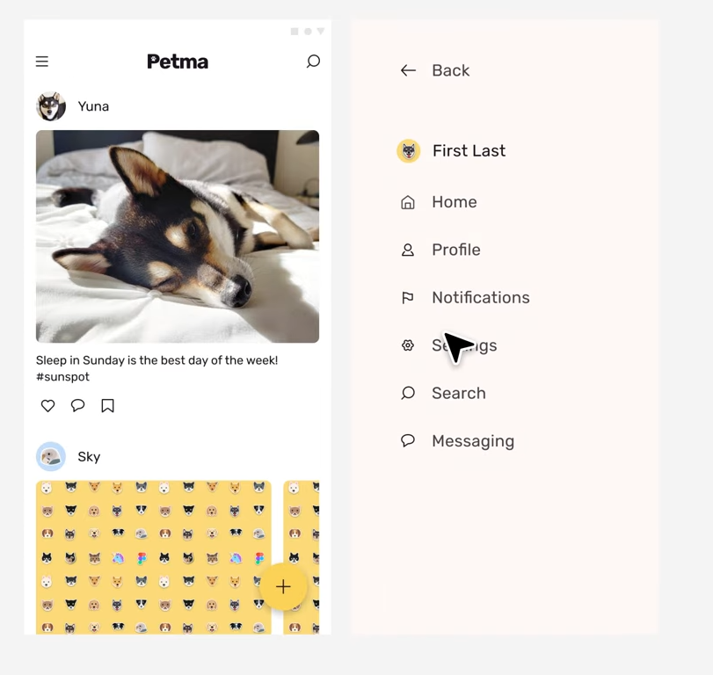

You can create individual files to explore solution, to specific problems,

-- Or use a single file, to manage the entire design process:
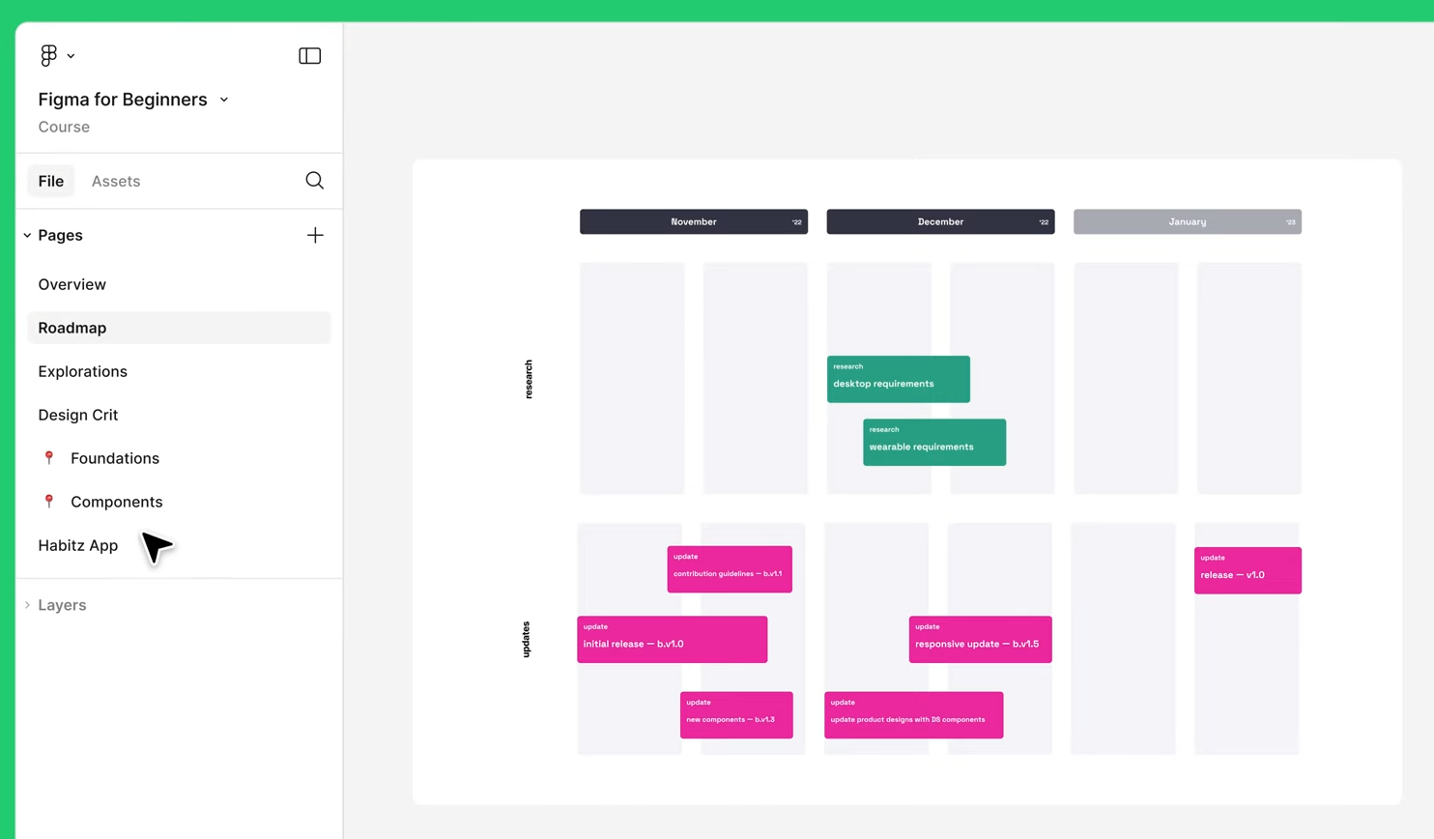
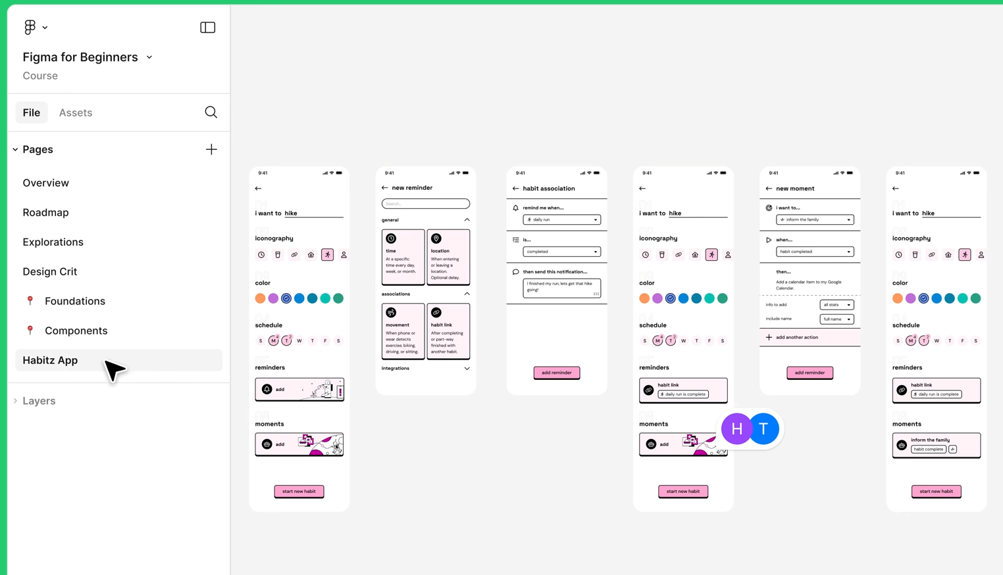

Design files are live, and always up to date,

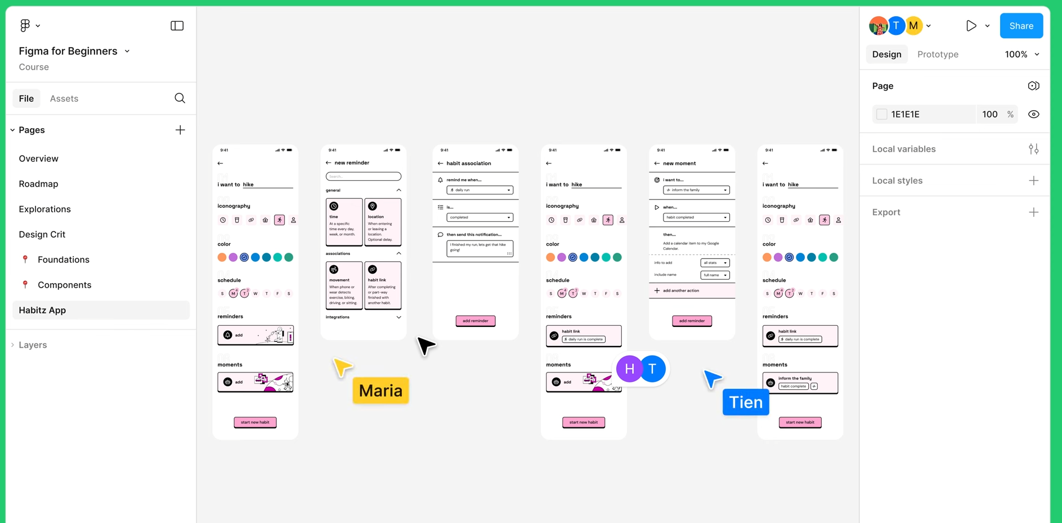
Meaning multiple people, can work on the same file at the same time,
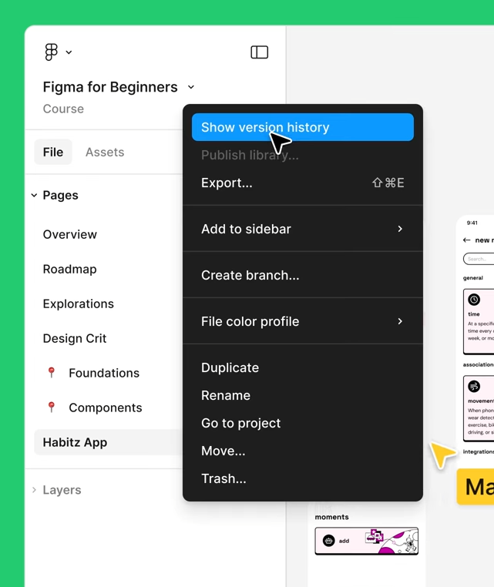
Your work is always backed up,

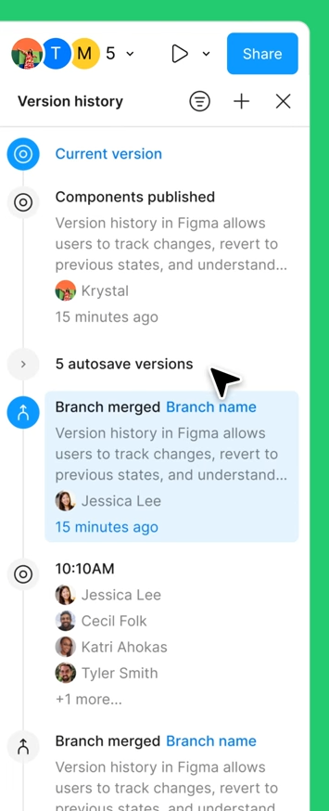
2: Tour the interface

4 main areas:
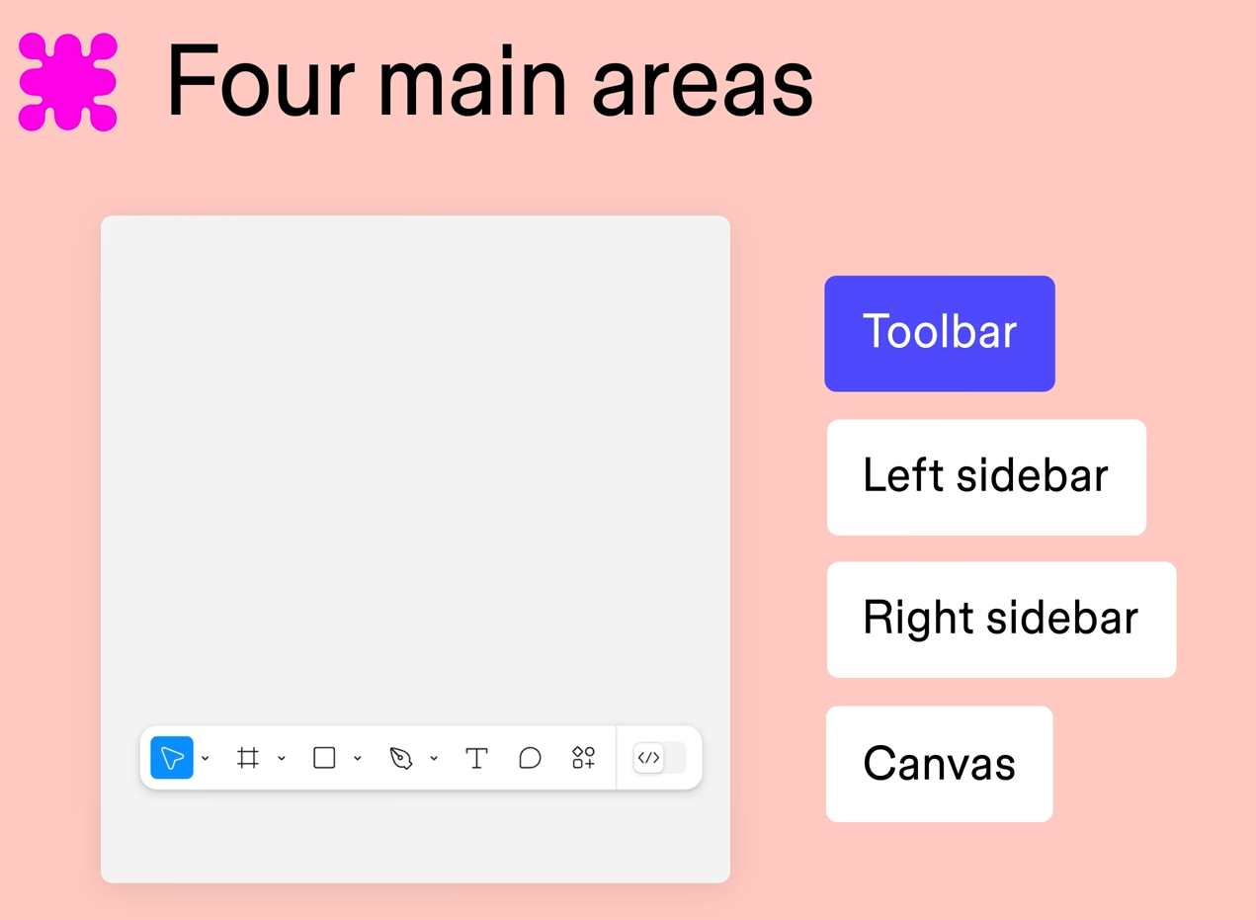
Tool bar: find the creation and navigation tools
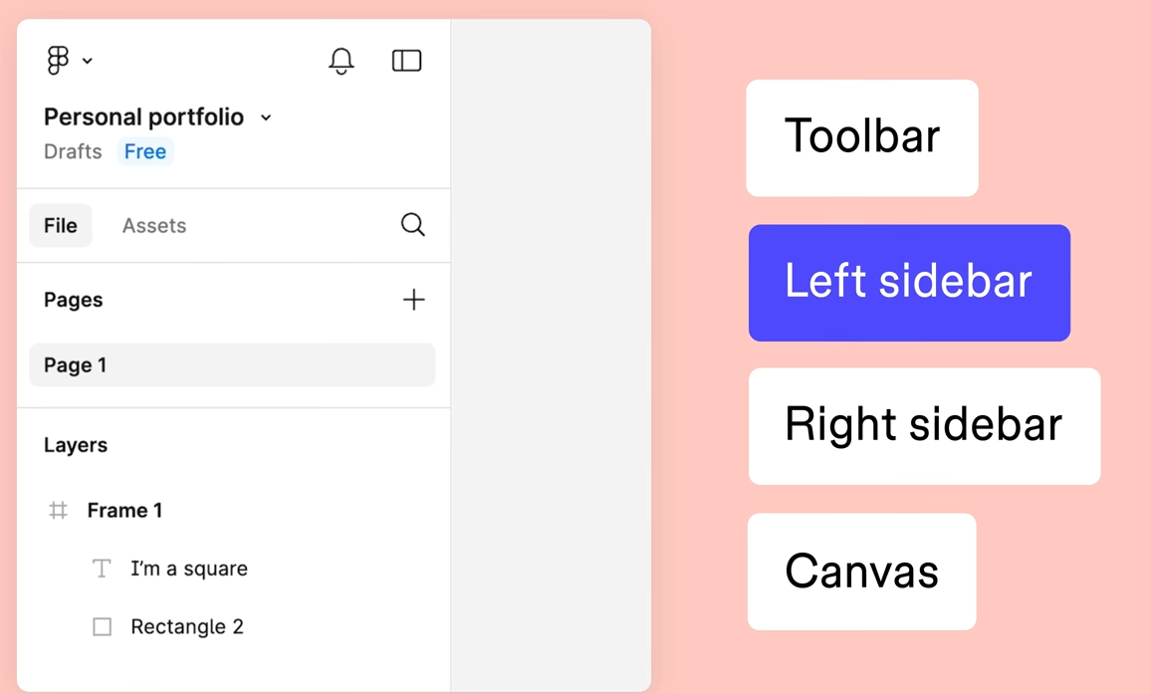
Left: Access pages, layers and components

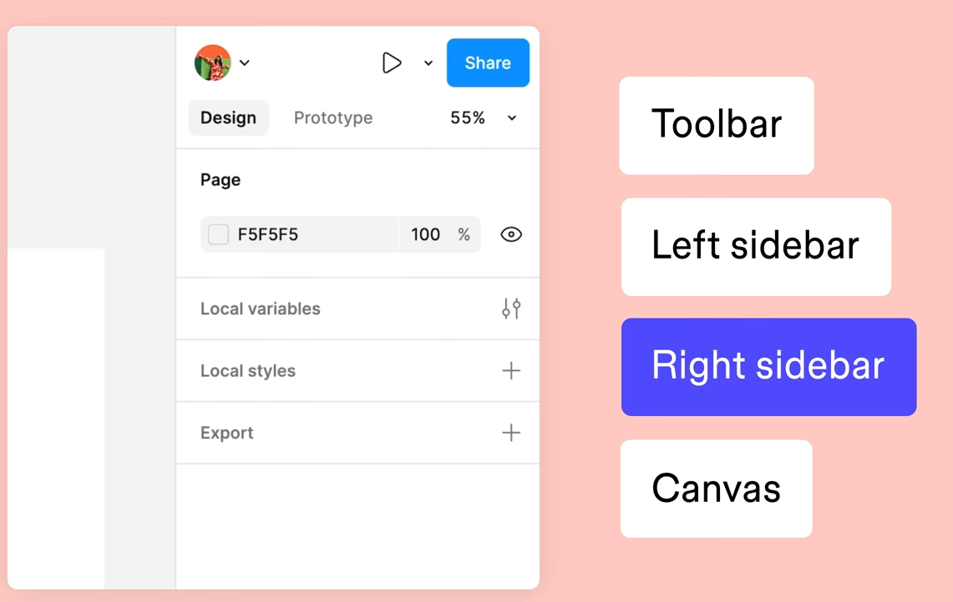
Right: Adjust object properties, export content and add prototype connections
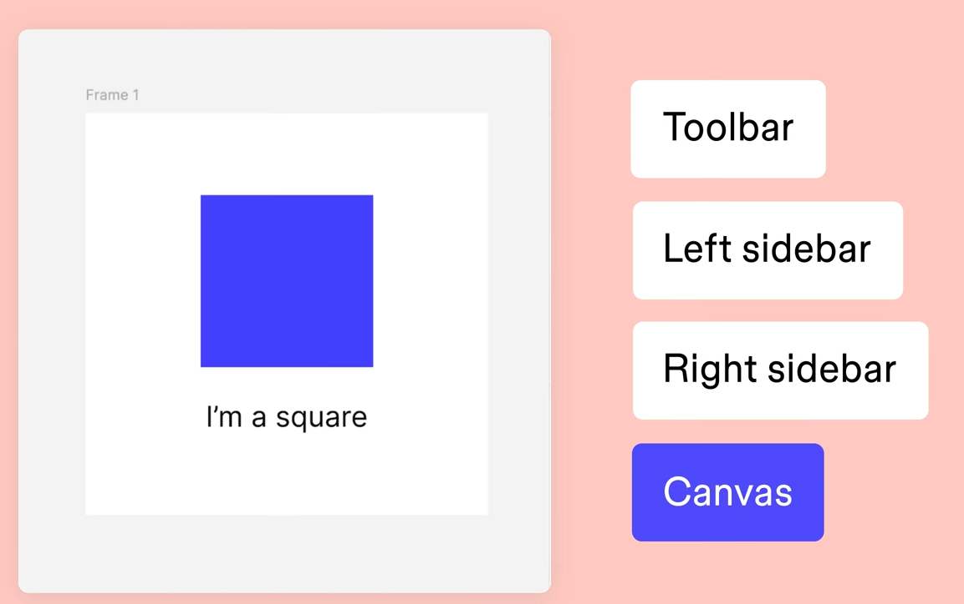
Canvas: build and refine your designs

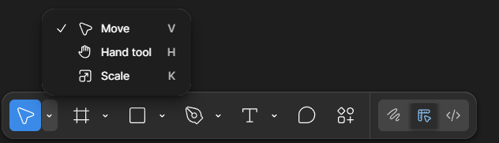
Toolbar lets you find tool that lets you move around the canvas:
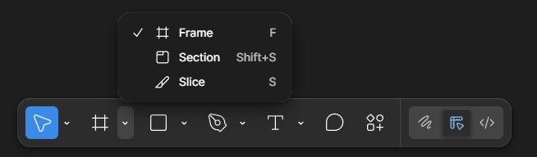
Create layers like frames
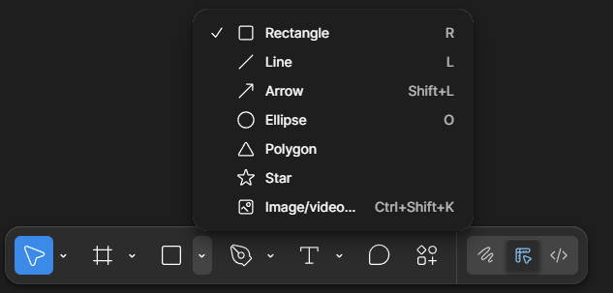
Basic shapes:
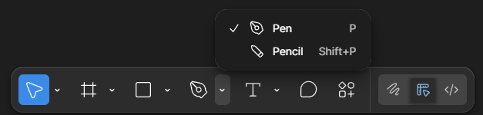
Custom vector paths:
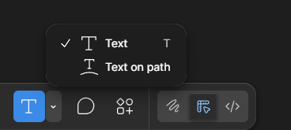
Text
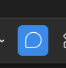
Comments:
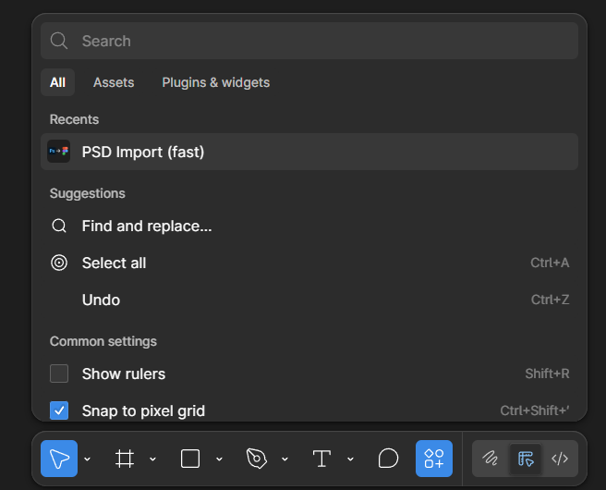
Action menu:

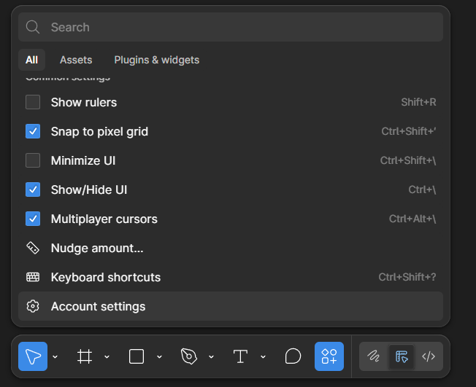

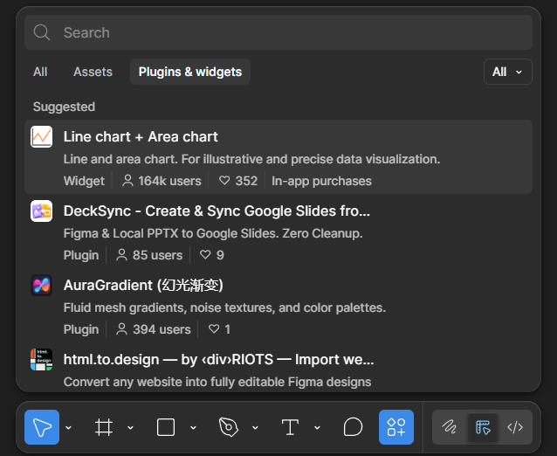

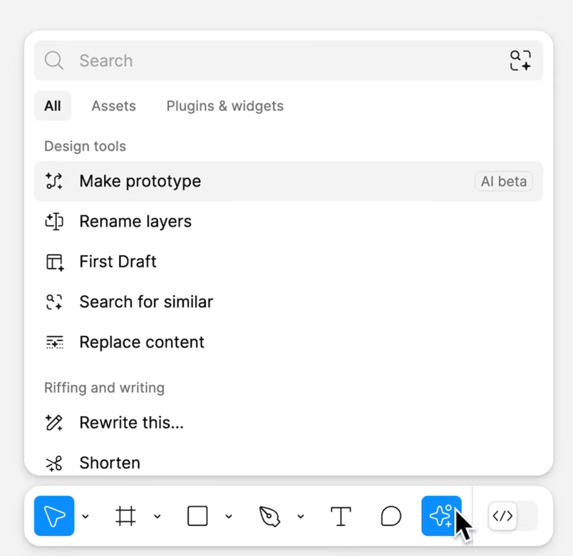
AI tools if you are on a paid plan:

-- Left sidebar, navigation panel:
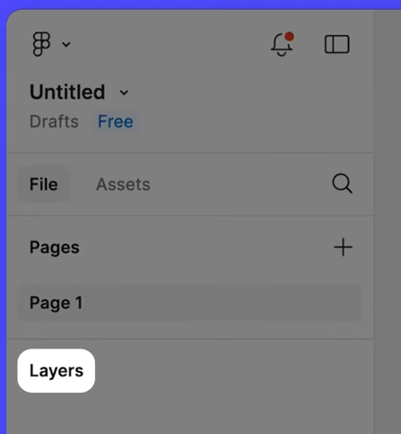

Layers, pages,
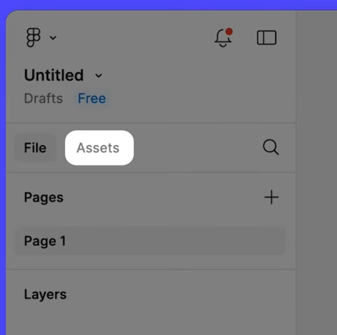
And components in your file:
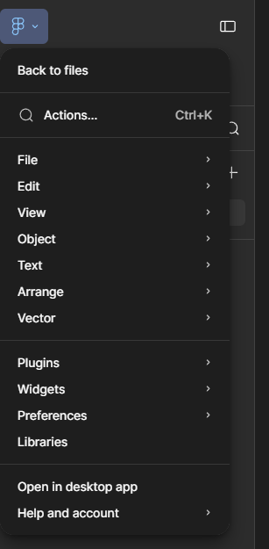
Main menu:
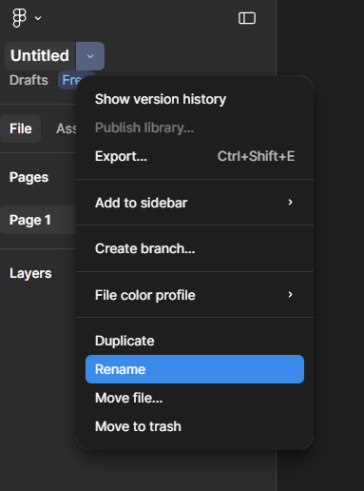
File menu:
- note the show version history button:
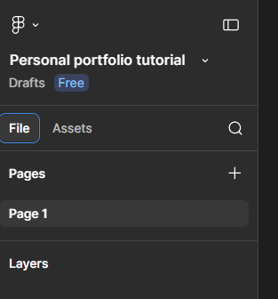
File tab: Pages/ layers to your file:
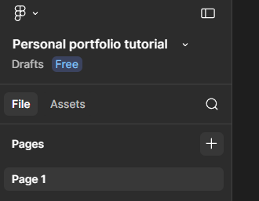
Move around pages or add a new one:
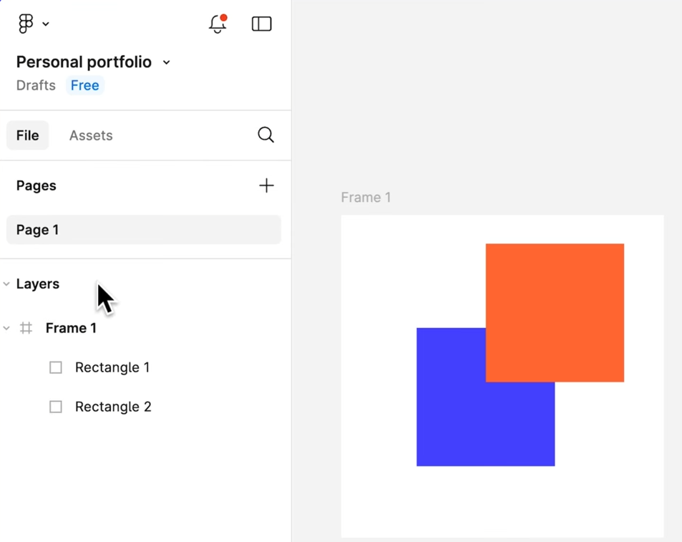

The layer displays every layer on the canvas:

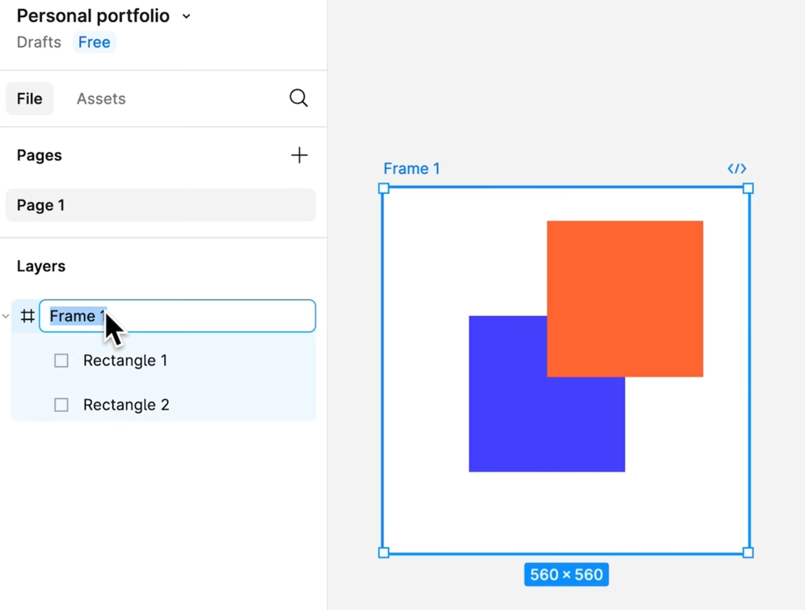
Rename
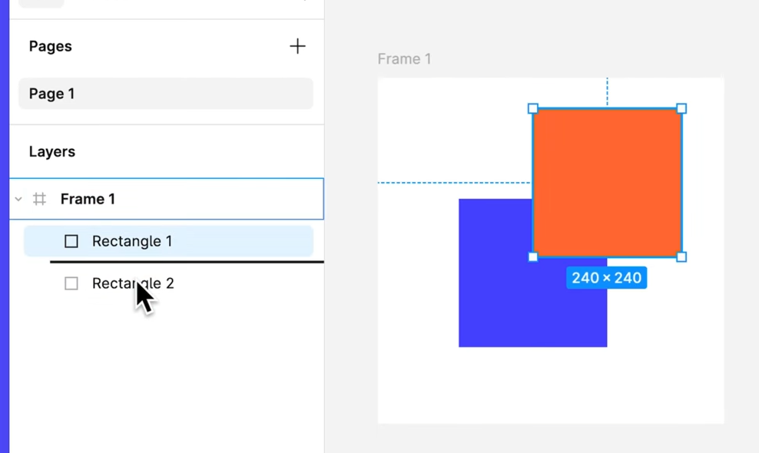
Reorder:
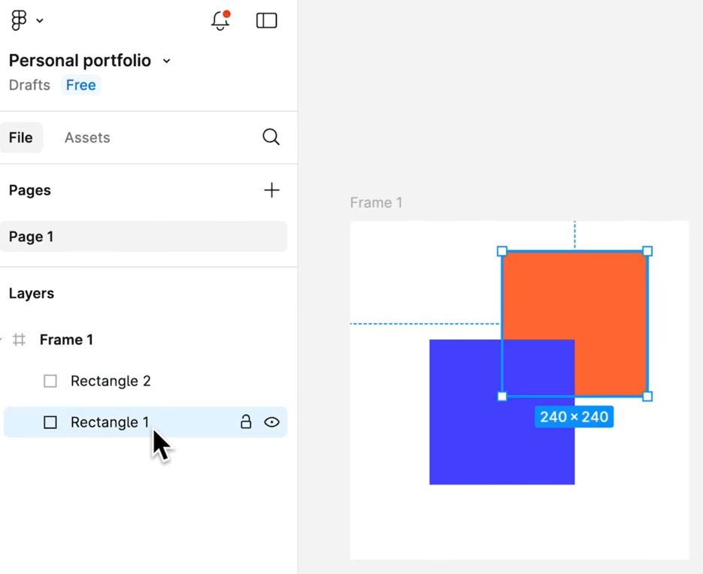

And view the layer hierarchy
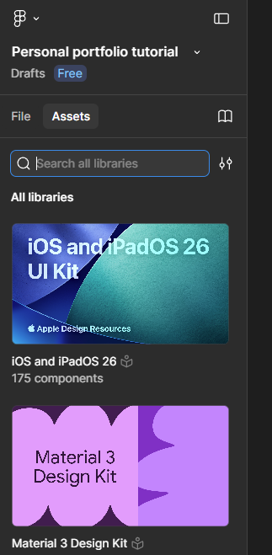
The asset tab:
Gives you access to your components:
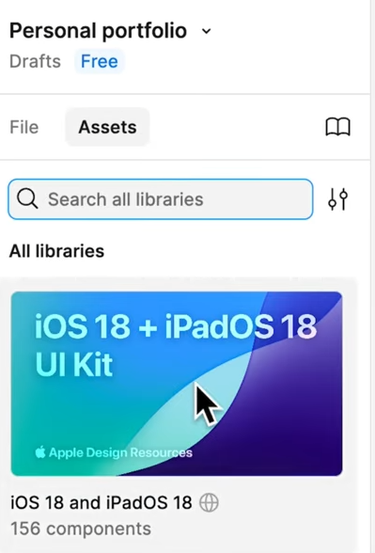

Components are reusable designs elements
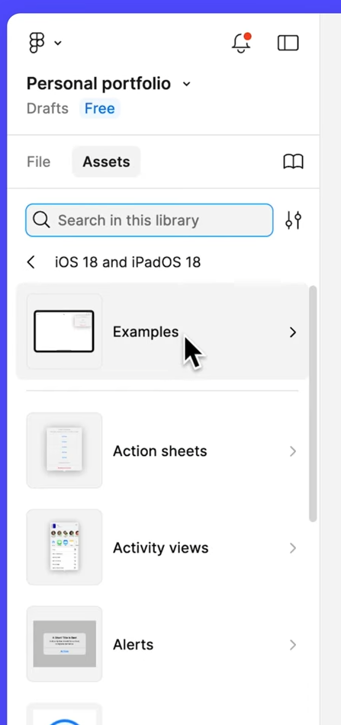

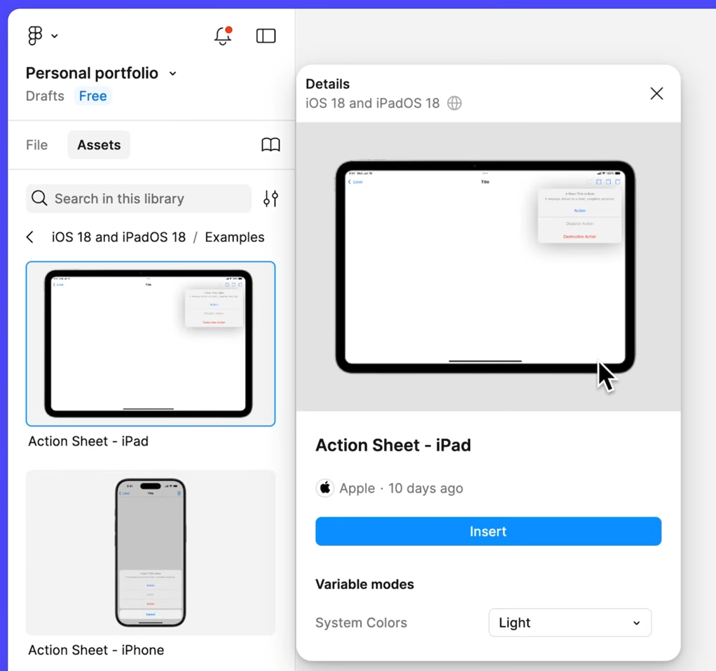

Powerful feature in figma design:

- We will learn more about components, and create a few of our own later.

Right side bar / properties panel:
Access information about your design:
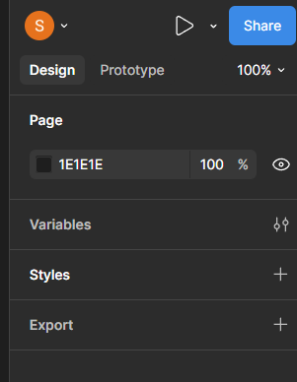

Design tab:
Lets you view / add /remove, or change object properties within your design:
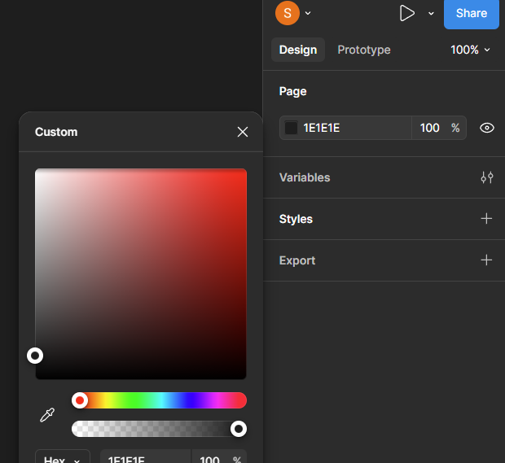

Change the background colour of the canvas:
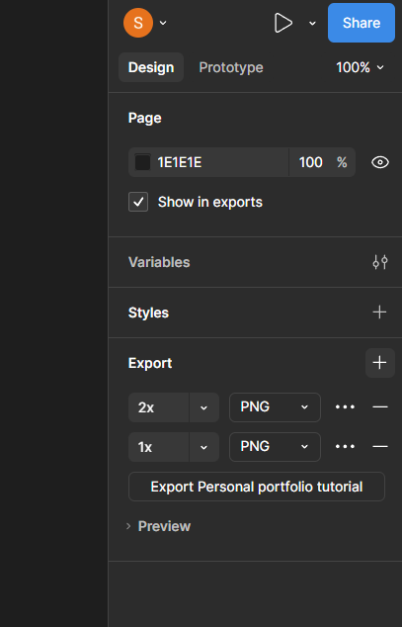
Or export all the content on your current page:

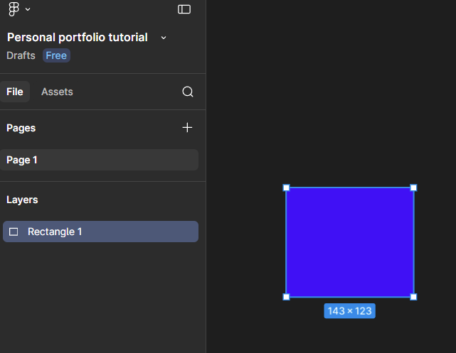Draw a rect:
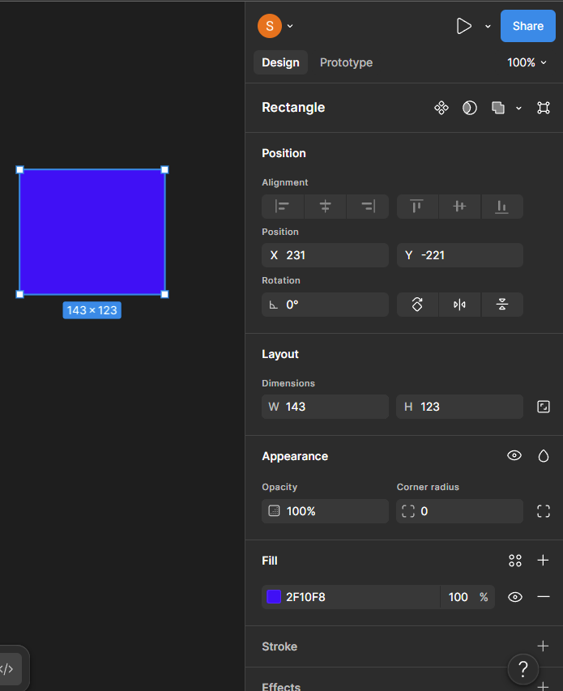
Can view and modify the layer’s properties
It will change depending on what you selected (it will be different for text )
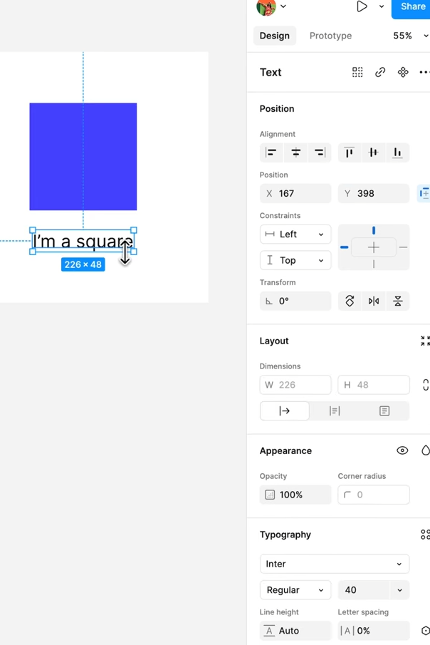
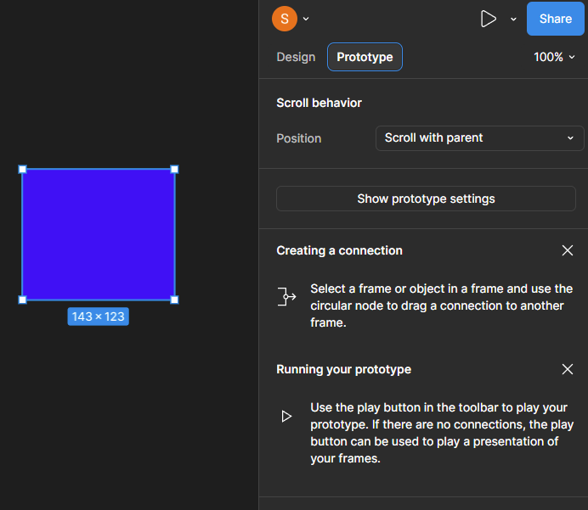
Prototype tab:
This is where you will add prototype connections when you are ready to make your designs interactive:

--

