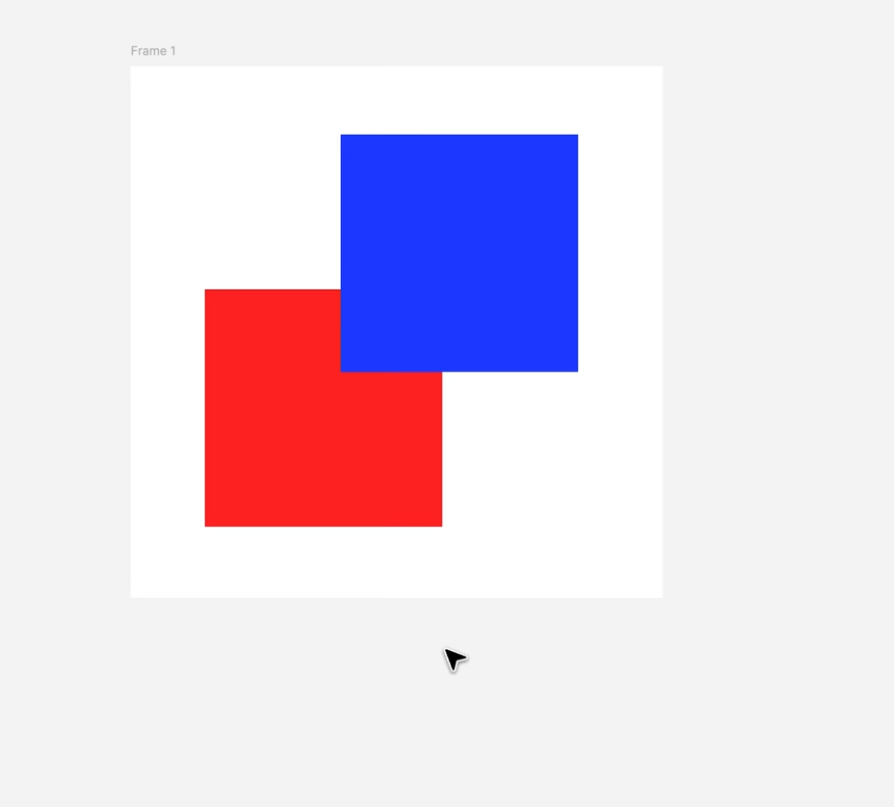
The middle canvas:
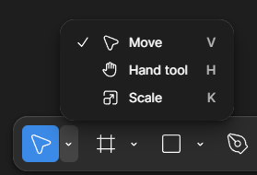
Move: select and move things on the canvas:
Or press (V):
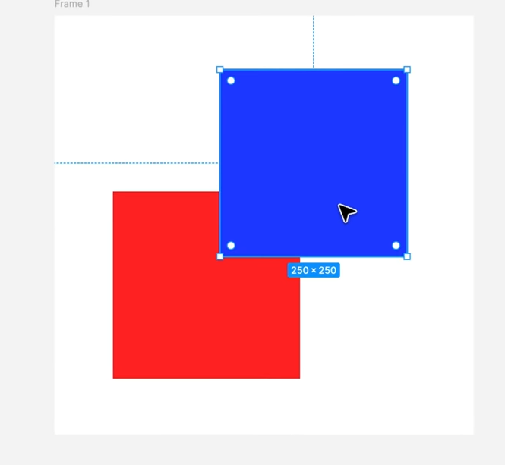

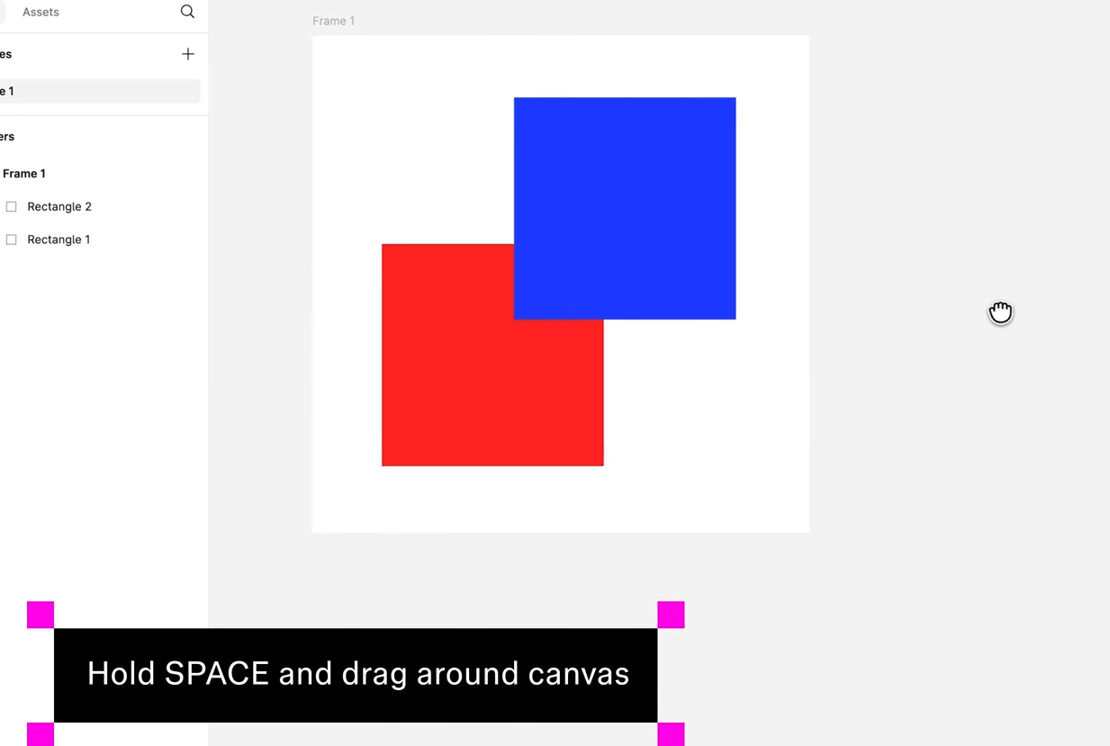

To move around the canvas:
(or scroll button drag):
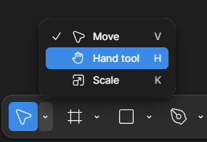
Or use the Hand tool to do with, without any shortcuts:
Zoom:
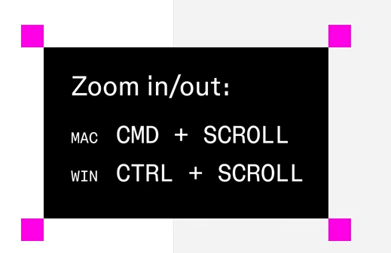

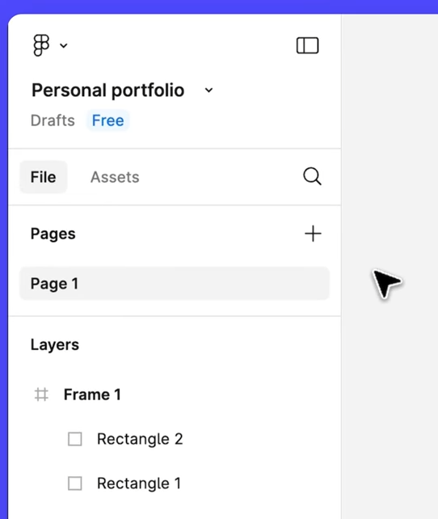

We can create more pages to organize:
Pages are like different rooms and house:
Each page has their own canvas:

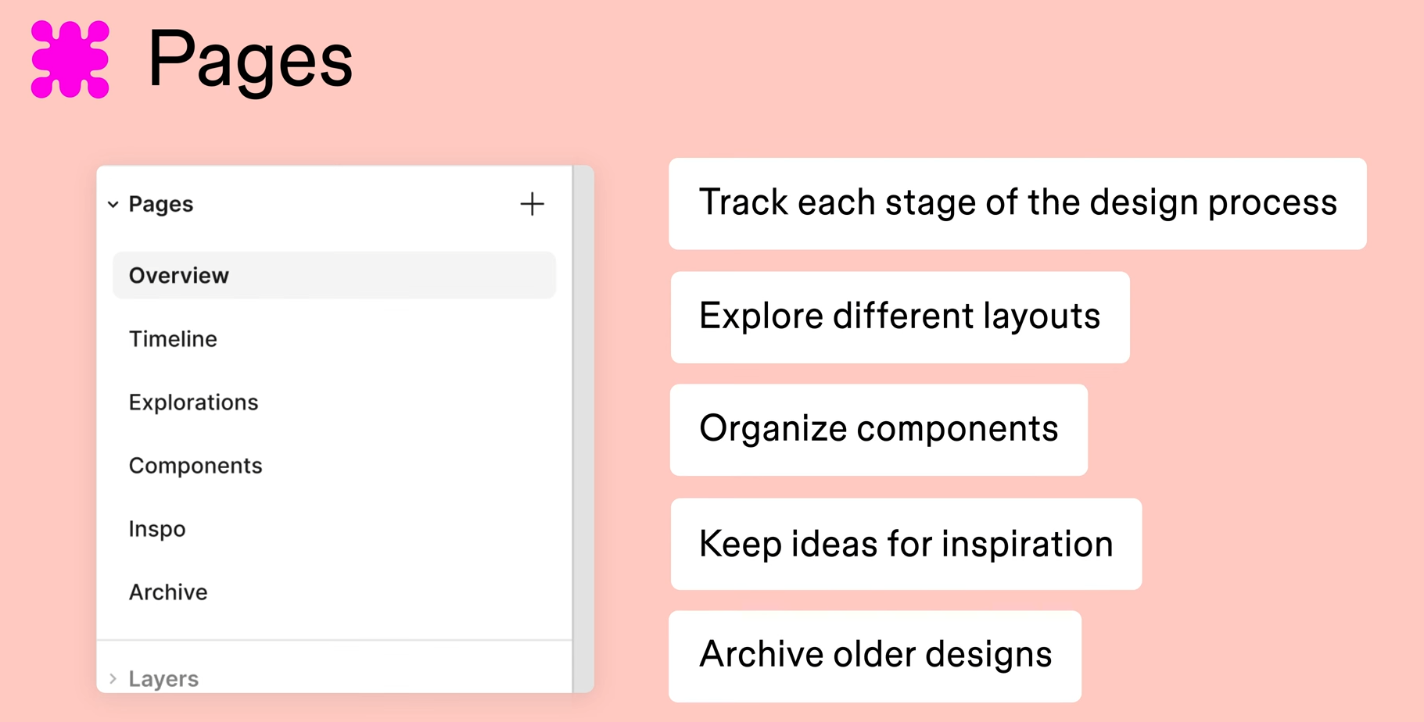

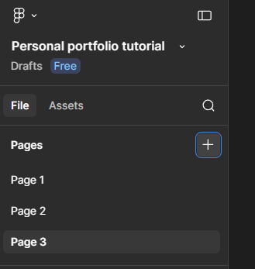

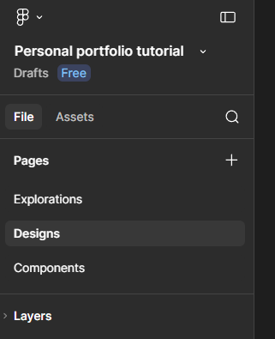
Explorations: we will use this page as our design playground, as we build out the elements of our portfolio,
Designs: Where we put our final designs together
Components: Organize our main components as we build them throughout the course

--

