**עבודה עם Git ו GitHub ב VSCode**

Git: Download and install Git from : **https://git-scm.com/**

GitHub Account:* Create a free account at : [**https://github.com/**](https://github.com/)

Recommended VS Code Extensions for Git and GitHub :

1. GitLens — Git supercharged:

Provides powerful Git capabilities directly within VS Code, including blame annotations, code authorship visualization, and enhanced commit history.



2. GitHub Pull Requests and Issues:

Allows you to review and manage GitHub pull requests and issues directly from VS Code.

3. Git Graph:

Visualizes your Git repository's history in a clear and intuitive graph.

Setting up Git in VS Code

1. Verify Git Installation:

Open a terminal or command prompt.

Type git --version and press Enter.

If Git is installed, you'll see the version number.

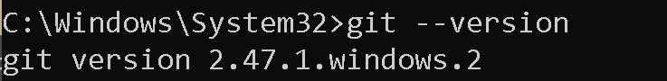

2. Configure Git User Information:

Open a terminal or command prompt.

Set your username: git config --global user.name "Your GitHub Username"

Set your email: git config --global user.email [your.email@example.com](mailto:your.email@example.com)



Cloning a GitHub Repository

1. Open VS Code.

2. Open the Command Palette: (Ctrl+Shift+P or Cmd+Shift+P).

3. Type "Git: Clone" and select it.

4. Enter the repository URL: (e.g. https://github.com/zeldner/firstVSCodeGitGitHub).

5. Choose a local directory where you want to clone the repository.

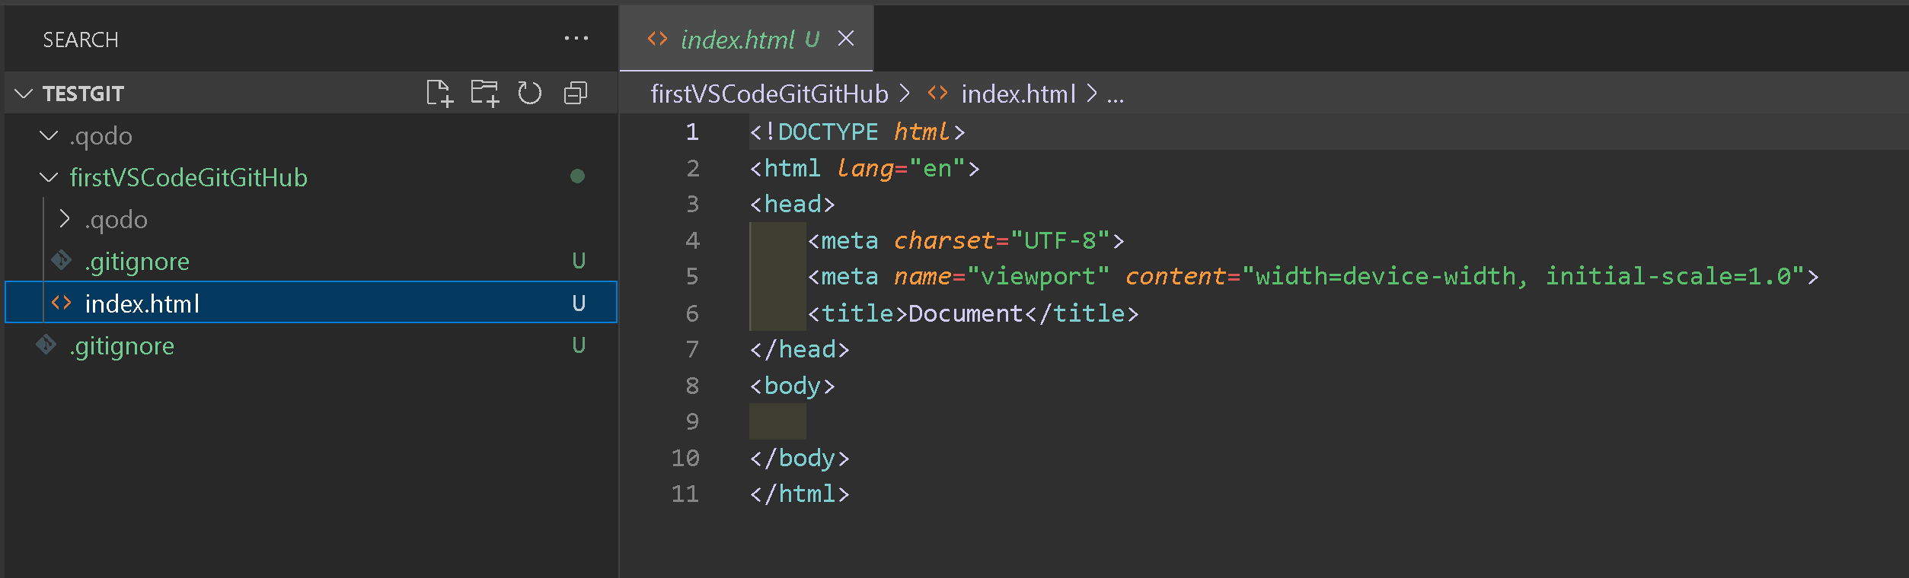

Making Changes and Committing (with GitLens)

1. Open the cloned folder* in VS Code (File > Open Folder).

2. Make changes to your files.

3. View Changes (Enhanced with GitLens):

Use GitLens's blame annotations to see who last modified each line.

Use the Git Graph extension to view the changes in a graphical format.

Click the Source Control icon (the Git icon on the left sidebar).

You'll see the changed files in the "Changes" section.

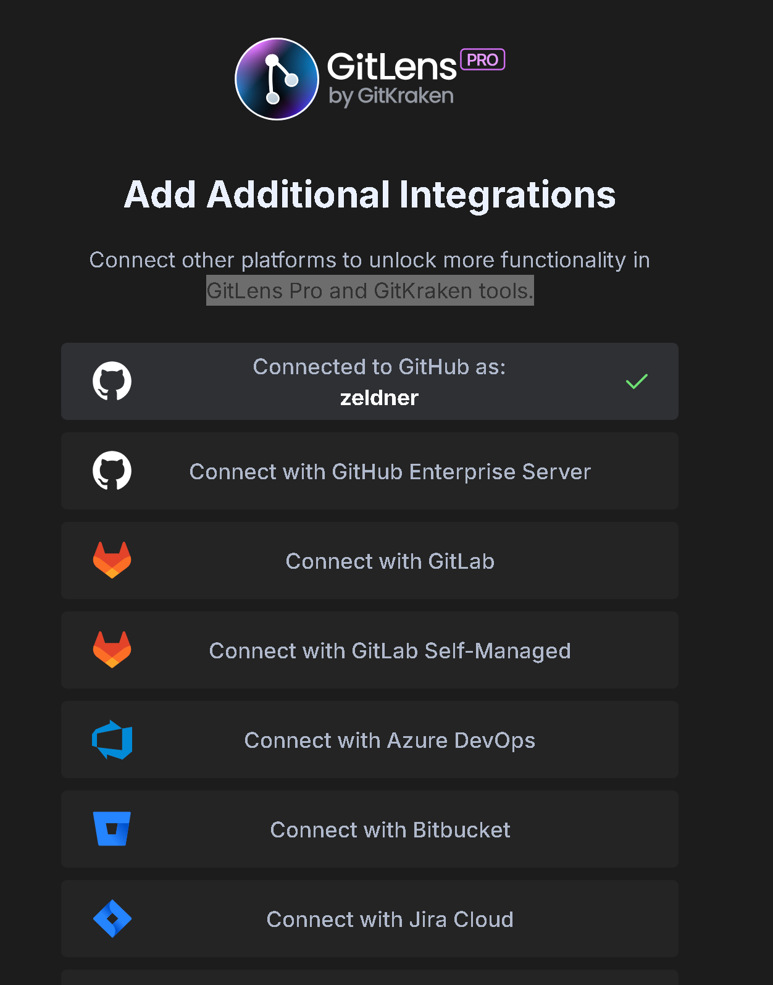

4. Stage Changes:

Click the "+" icon next to the files you want to commit, or click the "+" icon at the top of the "Changes" section to stage all changes.

5. Commit Changes:

Enter a descriptive commit message in the "Message" box.

Click the checkmark icon (Commit) above the message box.

