**LoRa**

Тема: **LoRa** (Long Range), The things Network

Lora is a Low Power Wide Area Network standard, also called LPWAN. This term consists of 3 parts. The first is Low Power, the second is Wide Area and the third is Network.

Low Power Wide Area Network

The difference between a normal small device and an **IOT**[1] (Internet of Things) device is its capability to connect to the internet. And because we expect millions of them, we need a network to connect all of them. This network has to be based od standards because the network itself and the IOT devices will not be built by the same company. Bes it always an international standard accepted by everybody.

Low Power Wide Area Network

The **ESP8266**[2] devices can connect to our Wi-Fi network which is part of a LAN (local area network). Its reach is limited to a few meters around our access point. Wide area networks need to bridge much more bigger distances. This is necessary for IOT devices, because we want to use them everywhere. (AM radio stations – big transceivers – easy to bridge big distances with high power, emitting kilowatts of energy)

Low Power Wide Area Network

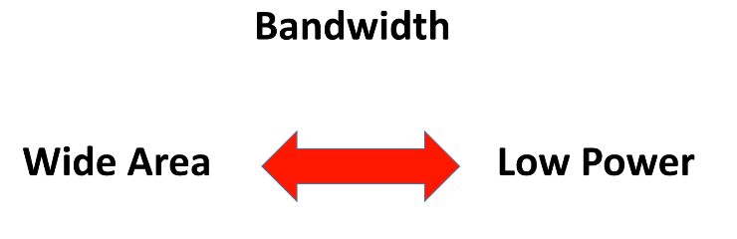Working on batteries limits the power of transmission. Here is the problem. If you want kilometers of reach, but not have power to spend. That’s where band[3]width comes in.

Bandwidth

The physical laws say that if we want to create radio connections for a certain distance, we can either increase transmission power or decrease the bandwidth of the channel.

Bandwidth and maximum capacity of channel are directly related. The smaller the bandwidth, the lower the capacity of our channel.

Defining Bandwidth

Bandwidth is measured in Hertz, bPS or MbPS. Data transmitted per unit time.

$$\frac{Data}{Time}→bPS(bits per second) or MbPS(megabits per second)$$

As bandwidth increases the speed of connection also increases. (Why can’t we increase the bandwidth infinitely so as to get an infinite speed? Bandwidth = very high -> Speed = very high). Bandwidth is not only directly related to speed it is also inversely related to the range hence as the bandwidth increases the range decreases hence just in case you have a Wi-Fi router with a higher bandwidth you may have a higher speed of connection, but the range of the connection will be low.

The electromagnetic band in the bandwidth can be used in two different ways namely **baseband** and **broadband**.

**Baseband [**Ethernet**]** uses the whole band to transmit just one signal of information.

* *Baseband Transmission* - Digital waveforms traveling over a baseband channel without further conversion into analog waveform by modulation.

1. Internet of Things – Everything connected to the Internet; Network of connected devices
2. ESP8266 – Low cost Wi-Fi microchip
3. Bandwidth – Frequency range over which a signal span itself; Capacity for transmission