
Data Dictionary User Guide 1.0
Draft, 2003 December 29
This version:
DataDictionaryUserGuide.doc
Previous version:
N/A
Editor:
Kim Bartkus, HR-XML Consortium
Kathi Dolan, Manpower, Inc.
Contributors:
Members of the HR Data Dictionary Committee
Copyright statement
©2001-2003 HR-XML. All rights reserved. No part of this publication may be reproduced, stored in a retrieval system, or transmitted, in any form or by any means, electronic, mechanical, photocopying, recording, or otherwise, without the prior written permission of the publisher. Printed in the United States of America.
Abstract
This document describes the content and the steps necessary to maintain a consistent HR Data Dictionary.
Status of this Document
The key words "MUST", "MUST NOT", "REQUIRED", "SHALL", "SHALL NOT", "SHOULD", "SHOULD NOT", "RECOMMENDED", "MAY", and "OPTIONAL" in this document are to be interpreted as described in RFC 2119.

Table of Contents
1 Overview 3
2 Component Terminology 3
2.1 Component Name 3
2.2 Status 3
2.3 Definition 4
2.3.1 General Definitions 4
2.3.2 Contextual Definitions 4
2.4 Synonym 4
2.5 Examples 5
2.6 Business Rules 5
2.7 Revision History 5
3 HR Data Dictionary Toolkit 6
3.1 HR Data Dictionary Viewer 6
3.1.1 Search Function (left pane) 7
3.1.2 Summary Information (top right pane) 7
3.1.3 Schema Context 8
3.1.4 Detail Information (bottom right pane) 8
3.2 Compare an XSD to HR Data Dictionary 9
3.2.1 Comparison Request Form 9
3.2.2 Comparison Report 10
3.3 Compare LCDM to HR Data Dictionary 11
3.4 Update HRDD XML Data Wizard 11
3.5 Schema Definitions Table Builder (Bob the Table Builder) 12
3.5.1 Schema Table Request Form 12
3.5.2 Schema Definitions Table 13
4 Guidelines for Using the Data Dictionary 14
4.1 Research existing components 14
4.2 The ‘Compare’ stage 14
4.3 Request changes to Data Dictionary components 14
4.3.1 Change Form Options 14
4.3.2 Committee Review 16
5 Issues List 16
6 Appendix A - Document Version History 16
7 Appendix B – Related Documents 16

Overview
The Data Dictionary is a catalogue of all HR-XML defined vocabularies that are used in the library of HR-XML schemas. Tools have been developed to access the dictionary’s content and should be used during design and development of HR-XML schemas to provide clarity, consistency and improved interoperability across HR-XML specifications.
Schema may contain elements, attributes, and global types. Elements and attributes are defined in the data dictionary. However, global types are designed for reuse within a specific element or attribute and are not defined in the data dictionary. For example, ContactMethodType is a complex global type containing information for contacting a person or entity, including telephone, e-mail and postal address. The StockPlanParticipant schema contains ContactInfo, which uses the ContactMethodType global complex type. In this case, ContactInfo would exist in the data dictionary with a definition, whereas, ContactMethodType would not.
This document contains three primary sections. The first section details the categories of information captured for each element and attribute in the dictionary. The second section outlines the tools that are key to making the dictionary useful. The third section describes the process workgroups should follow to interact with the dictionary on an ongoing basis.

Component Terminology

Component Name
The name of the element or attribute. All names are defined using camel case (see Appendix B – Related Documents, Schema Design Guidelines), with elements starting with a capital letter and attributes with a lower case letter. For example, AccountInfo (element), academicHonors (attribute).

Status
The current status of the component record. Valid statuses are “In Review”, “Approved”, and “Deprecated”.
“In Review” occurs when a new component or change to an existing component record has been requested by the workgroup and not yet approved by the HRDD committee.
“Approved” occurs once the HRDD committee has reviewed and accepted the new or modified component record.
Note on deprecation policy: Certain elements or attributes were deprecated when another component record existed whose definition was more appropriate, or in the event that there were duplicate component names with different definitions. In most cases, the component record with the most appropriate name/definition for the context was retained and the duplicates renamed with a reference (synonym) to the new component name. In some cases however, a duplicate was found to serve a purpose very specific to the context in which it was used. In these situations, both definitions were maintained, but documented which was the “generic” definition and which was “contextual”.

Definition
The definition identifies the purpose and/or function of the component.

General Definitions
To eliminate ambiguity, it is recommended that each component have a single general definition. General definitions should be business-process-neutral so they can be reused across the Consortium’s many schemas.

Contextual Definitions
Because the data dictionary is used to generate documentation for specific business-process schemas, a component may also have a contextual definition. A contextual definition provides additional information, instructions, or guidance for the use of the component within a specific node of a specific schema.
A contextual definition should not refer to a concept fundamentally different from the component’s general definition. Creating a contextual definition is recommended only if the general definition is not sufficient for a reader to understand the use of the component from the general definition alone.
For example, consider the general definition of StartDate: Contains the (inclusive) date, period, or interval the event becomes active or begins. Within the specific node of a schema, additional information may be necessary for an implementer to understand how to correctly use StartDate. Consider an example from the HR-XML Consortium’s Enrollment Schema. For Subscriber/Coverage/TierCoverage/StartDate it might be necessary to add detail and guidance such as: Contains the date that coverage originally began. This original start date does not change as modifications are made to the related subscriber record. The contextual definition refers to the same concept (an inclusive start date), but includes additional, contextual guidance.

Synonym
A reference to another component record whose definition is essentially the same or interchangeable with the original component record. Used primarily with deprecated names, it provides a cross-reference and link to the recommended replacement. Efforts were made to resolve synonyms in favor of one or the other wherever possible to reduce duplications of definition as well as component name.
For example, BankAccountNumber, AccountIdentifier, or BankRoutingNumber may be used in place of the deprecated component AccountNumber. Compensation and BasePay is an example where both components may be interchangeable and neither is deprecated.

Examples
Enumerations or other representative data to add clarity to the definition and increase understanding of how the component is intended to be used.
For example, an enumerated list for a ClaimStatus may include ‘open’, ‘closed’ and ‘pending’. A descriptive example for otherPayCalculation is: “A salesperson may receive 5% of Gross Sales after the first $200,000 or a manufacturer may pay a bonus of .10 for each piece over 1,000.”

Business Rules
Specific requirements pertaining to a business process for the particular component. For example, AttendanceRating has the following business rule: “The rating may be numeric or a string value from a set of enumerations. Numeric ratings are on a scale of 1 to 10, where 1 represents poor attendance and 10 represents the best possible attendance rating.”

Revision History
The most current date the component record was revised and a description of the revision or addition.

HR Data Dictionary Toolkit
The tools for the HR Data Dictionary may be found at: http://ns.hr-xml.org/DataDictionary/. These tools include a viewer, comparisons between the dictionary and schemas, a method for updating the data dictionary, and a definition table builder.

HR Data Dictionary Viewer
The Viewer tool may be found at: http://ns.hr-xml.org/DataDictionary/indexHRDD.html.
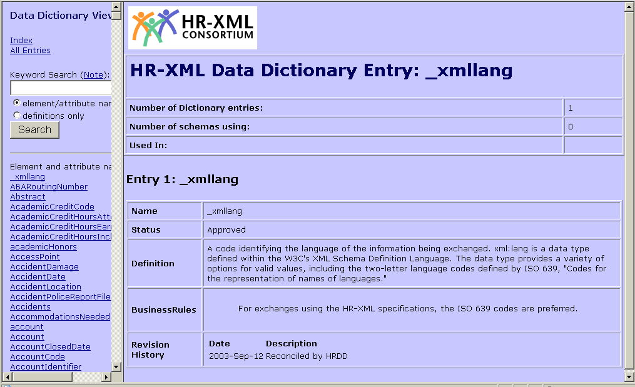
Figure 1: Full Data Dictionary View
Figure 1 is an example of the view displayed when the Data Dictionary Viewer is first selected. It includes functions divided by the left pane, top right pane and bottom right pane.
The left pane allows a search on a specific component name or keyword within a definition. The search feature is not case sensitive.
‘Index’ displays all component names in the left pane. ‘All Entries’ displays the details for all components in the right pane.
The right pane displays detailed information about a component. This is viewed by clicking on the desired component in the left pane.

Search Function (left pane)
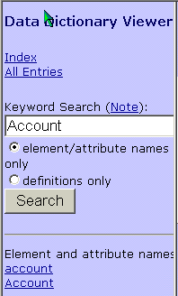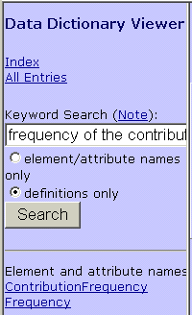
Figure 2: Component Name Search Figure 3: Keyword Search
Figure 2 shows two components found when searching on ‘Account’: the element ‘Account’ and attribute ‘account’. Figure 3 displays two elements found with the keyword definition search using the phrase ‘frequency of the contribution’.

Summary Information (top right pane)
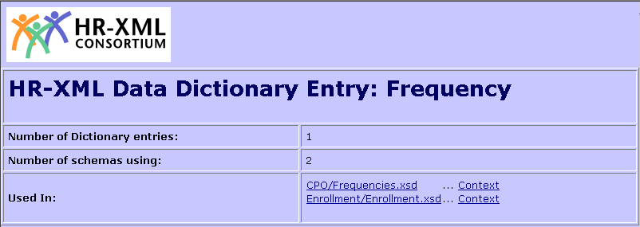
Figure 4: Summary Information
Figure 4 (top right pane) provides summary information about the component. The number of dictionary entries shows how many occurrences of ‘Frequency’ exist in the data dictionary. Typically, this would be one ‘generic’ entry per component name, but may contain additional ‘contextual’ definitions.
The second row shows how many schemas use this component name, followed by the schema names (third row) and context. For example, Frequency is used in the Frequencies and Enrollment schemas. To view the schema code, click on the schema link. The Context link displays information about how the component fits within that schema. See Figure 5 for details.

Schema Context
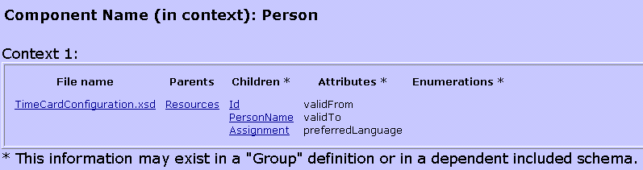
Figure 5: Schema Context
This screen shows details about a component within a particular schema. Figure 5 shows that Person (within TimeCardConfiguration schema) is a direct child of the Resources element. Person contains three child elements (Id, PersonName, and Assignment) and three attributes (validFrom, validTo, and preferredLanguage). This screen may also show allowable enumerations for the component.

Detail Information (bottom right pane)
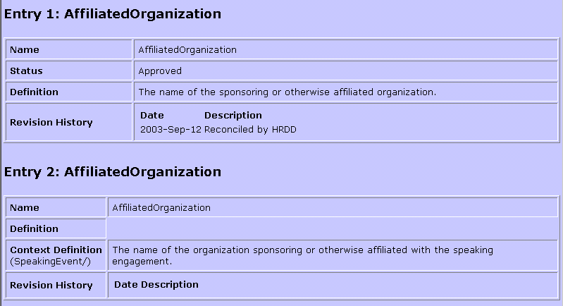
Figure 6: Detail Information
Figure 6 (bottom right pane) shows the details for each dictionary entry. See section 2 Component Terminology for an explanation of each field.
This example shows the ‘generic’ definition followed by a ‘contextual’ definition. The second entry also shows the Xpath for the contextual use. The Xpath is required for contextual use. In this example, the contextual definition would only show up in a schema definition table build when the Xpath equals “SpeakingEvent”. See section 3.5 Schema Definitions Table Builder (Bob the Table Builder) for further information.

Compare an XSD to HR Data Dictionary
The Comparison tool may be found at: http://ns.hr-xml.org/DataDictionary/indexCompareXSD2HRDD.html
This tool provides verification of predefined elements and attributes in the HR Dictionary. The comparison allows a workgroup to determine if existing components may be reused rather than creating new components.

Comparison Request Form
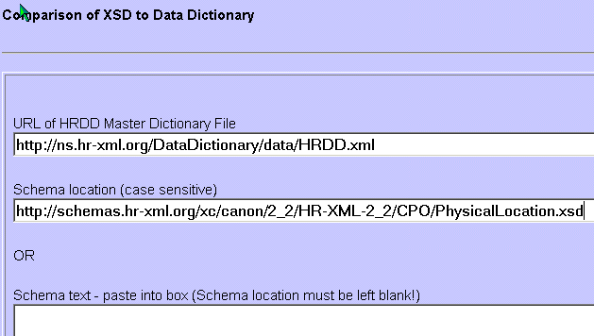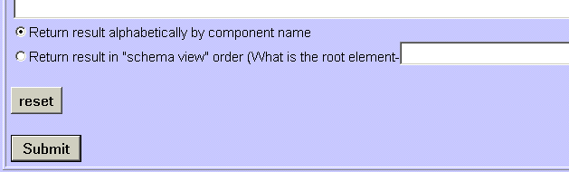
Figure 7: Schema Compare Request Form
The form displayed in figure 7 allows a user to request a comparison of entries in the Data Dictionary to a specific HR-XML schema. The HRDD Master Dictionary File should always be http://ns.hr-xml.org/DataDictionary/data/HRDD.xml. The Schema Location should contain the path of the desired schema to compare. Results may be requested in alphabetical or schema view order. To select the second option, the schema root element must also be included.

Comparison Report
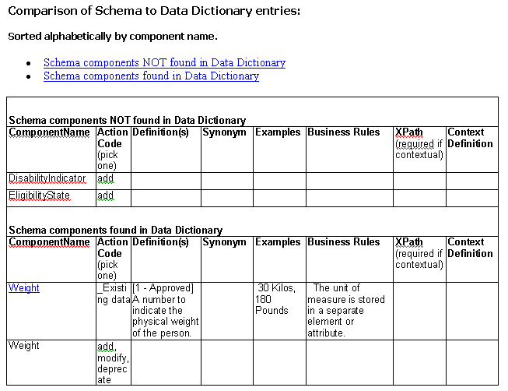
Figure 8: Schema Compare Report
The comparison report in figure 8 displays missing and predefined component definitions. The existing definitions are displayed in the second section with an adjacent row to allow for changes, additions or deprecations. The columns show the component name, action code, definition, synonym, example, business rule, Xpath and context definition. The Xpath is required for a contextual definition.
This worksheet may be a useful working tool for project development. A workgroup may cut and paste it into an Excel spreadsheet and use it to communicate their dictionary modifications to the HRDD committee. It is also a method for quickly identifying which components have missing definitions.

Compare LCDM to HR Data Dictionary
http://ns.hr-xml.org/DataDictionary/indexCompareLCDM2HRDD.html
This tool, intended for the sole use of the HR Data Dictionary committee, is used to compare metadata of all current Consortium schemas against the Master Dictionary file.
The Library Component Dependency Model (LCDM) is essentially the metadata of all current Consortium standards, including the names of all elements and attributes in all schemas.

Update HRDD XML Data Wizard
http://ns.hr-xml.org/DataDictionary/updateHRDDXml.aspx
This tool, intended for the sole use of the HR Data Dictionary committee, is used to update the Data Dictionary from an Excel spreadsheet. This tool is password protected. The following instructions are intended only for members of the HR Data Dictionary committee.
Enter the location of the Excel spreadsheet and upload the file. This loads the spreadsheet data into an XML file. The following message should be displayed: C:\path\WorkingSpreadsheet_Updated.xls successfully uploaded
Click on the ‘Save the XML as the official HRDD.xml’ link to rename the XML file as the HR Data Dictionary file. This will show the HRDD XML metadata. Review as needed. Otherwise, the update process is complete.

Schema Definitions Table Builder (Bob the Table Builder)
The Table Builder tool may be found at: http://ns.hr-xml.org/bob/
This tool generates a 3-column element/attribute tables used in Consortium documentation.

Schema Table Request Form
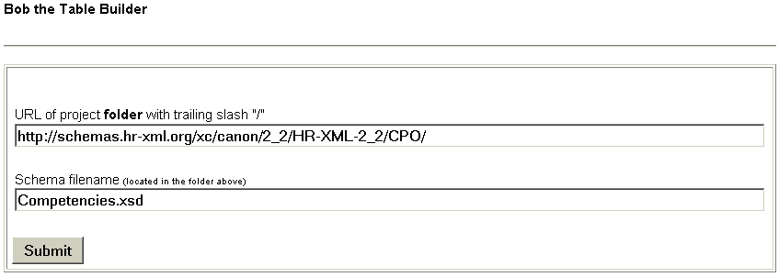
Figure 9: Table Build Request Form – page 1
The request form has two pages as shown in figures 9 and 10. The first page requires the path and full schema file name.
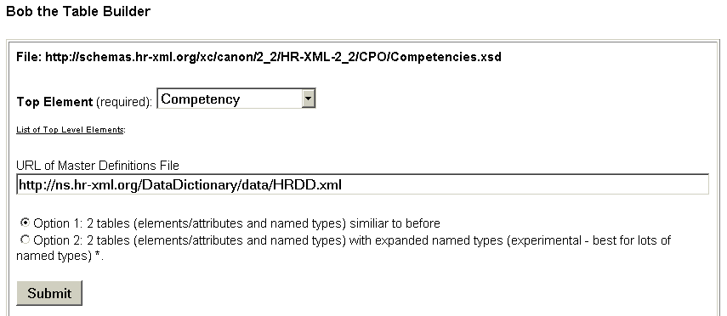
Figure 10: Table Build Request Form – page 2
The second page requires selection of the top schema element desired to display in the table. The Master Definitions File should always be http://ns.hr-xml.org/DataDictionary/data/HRDD.xml. Typically, the option 1 radio button is selected to display the base dictionary information.

Schema Definitions Table
Elements and Attributes  [Global types listed alphabetically in following table.] | ContentModel*  Data type  Occurrence:  Sequence | Choice | All (minOccurs/maxOccurs)  Attributes | Definition
/  Competency | name - xsd:string -  required - xsd:boolean -  CompetencyId - [complexType] - S (0/1)  CompetencyWeight - [complexType] - S (0/*)  UserArea - [see include/import] - S (0/1) | A specific, identifiable, definable, and measurable knowledge, skill, ability and/or other deployment-related characteristic, which a human resource may possess and which is necessary for, or material to, the performance of an activity within a specific business context.
/ Competency/  name | - xsd:string - | A descriptive identifier within a given context.
/ TimeCard/ ReportedTime/ TimeInterval/ ApprovalInfo/  Person | Id - EntityIdType - (see Id group occurrence)  PersonName - [see include/import] - (see Person group occurrence) | Contains various data about a person. Context definition: Container for the person who approved the reported time interval data.
/  [CompetencyWeightType] | xsd:restriction base: xsd:string [Enumerations]: levelOfInterest, skillLevel | Globally scoped data type. See element or attribute declaration for definition.
Figure 11: Schema Definitions Table
Figure 11 shows a sample table used in HR-XML Consortium documentation. The first column displays the component name and path. Note that elements are in black and attributes in red for easy identification. The second column displays the content of the component, including type and cardinality. The information from columns one and two are retrieved from the schema. The third column shows the component definition. The status will be displayed if the component is in review or deprecated. This third column information is retrieved from the Data Dictionary.
In this example, the forth row (Person) contains both a generic and contextual definition.
Note that global types do not have definitions since global complex types are generally designed for reuse with a specific element or attribute (which should have a definition). See row 5 (CompetencyWeightType) in the preceding example.

Guidelines for Using the Data Dictionary
These tools are provided as an initial phase for maintaining the Data Dictionary. Additional tools may be considered in the future. For example, developing an online form, which would allow workgroups to enter data (in review status) directly into the Dictionary. The HR Data Dictionary committee welcomes feedback or suggestions from the project groups.
The HR-XML Standards Lifecycle (see Appendix B – Related Documents, Overview Methodology) will include deliverables review by the HR Data Dictionary committee in addition to the TSC and CPO review. However, coordination with the committee should occur during design and development to allow adequate time for dictionary changes and additions.

Research existing components
It is recommended that workgroups use the HR Data Dictionary Viewer (see section 3.1) as a resource when designing and developing new schemas. This may decrease design and development time for component names since existing component names may already be defined and ready to use.

The ‘Compare’ stage
When new schemas are created, they must be compared to the Data Dictionary to ensure that correct definitions exist for the schema elements and attributes. This may be accomplished by two methods. First, the schema may be compared using the tool Compare an XSD to HR Data Dictionary described in section 3.2. This will display the existing definitions and any missing definitions. Alternately, the Schema Definitions Table Builder (Bob the Table Builder) may be used to identify any dictionary issues, such as incorrect or missing definitions, or duplicate component names.
The HR Data Dictionary committee will work with project workgroups to resolve any issues that are identified.

Request changes to Data Dictionary components
Additions, modifications, or deprecations (all considered to be changes) to component records in the Data Dictionary must be submitted to the HR Data Dictionary committee for review.

Change Form Options
There are two methods that a workgroup may use to communicate changes to the HR Data Dictionary committee. The first method is the Compare Table (see section 3.2 for more details). Figure 12 shows the new and modified definitions in red. Any rows that don’t require changes should be deleted. In the following example, the last two rows (Custodial Parents) would be deleted since no change was necessary.

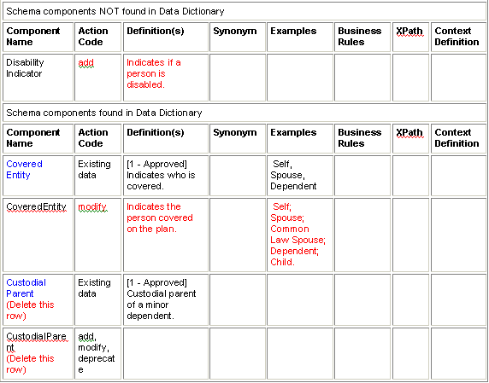
Figure 12: Request Change Using Compare Table
Another method is to make changes to the Schema Definitions Table. Any changes to the third column definitions should be made in a color other than black for easy identification (See Figure 13 below). A workgroup only needs to use one of these methods. It is entirely up to the group to determine which method best fits their needs.
Elements and Attributes  [Global types listed alphabetically in following table.] | ContentModel*  Data type  Occurrence:  Sequence | Choice | All (minOccurs/maxOccurs)  Attributes | Definition
/ Enrollment/ Organization/ Subscriber/ Person/  StudentIndicator | - xsd:boolean - S (0/1) | Indicates whether a person is a full time student.
/ Enrollment/ Organization/ Subscriber/ Coverage/ RateBasedCoverage/ CoverageType/  CoveredEntity | xsd:restriction base: xsd:string [Enumerations]: Self, Spouse, Common Law Spouse, Dependent, Child | Indicates the person covered on the plan.
Figure 13: Request Change Using Schema Definitions Table

Committee Review
After the Data Dictionary committee receives the request, the chairperson will enter the information into an Excel spreadsheet at ‘In Review’ status.
An impact analysis will be done to identify which schemas could be affected by the change. This analysis will include review of the schemas, usage, previous or current associated workgroups, and any other areas, which could be impacted by the change to the component record. If a potential impact is identified, the request detail will be sent to the affected email groups for review. The individuals in the group will have two weeks to review the request and respond to the Data Dictionary committee.
Once reviewed by the committee, the entry will change to ‘Approved’ or ‘Deprecated’ status as required. The Data Dictionary will be periodically updated from the worksheet using the tool described in section 3.4.

Issues List
Issue | Resolution | Rationale

Appendix A - Document Version History
Version | Date | Description
1.0 | 2003-09-22 | Initial draft
1.0 | 2003-10-15 | Updated based on HRDD feedback.

Appendix B – Related Documents
Reference | Link
Schema Design Guidelines | http://schemas.hr-xml.org/xc/canon/TSC/SchemaDesignGuidelines-1_2.pdf
Methodology Overview | http://schemas.hr-xml.org/xc/canon/Consortium/MethodologyOverview-1_2.pdf

