|  |  |
| --- | --- |
| **Topic** | Apache Kafka |
| **Document Name** | KAFKA-EX-02 |
|  |  |

|  |  |  |  |
| --- | --- | --- | --- |
| **Document Difficulty Level** | | | |
| **Beginner** | **Junior** | **Senior** | **Expert** |
| □ | ■ | □ | □ |

# Document History

|  |  |  |  |
| --- | --- | --- | --- |
| Date | Author | Ver | Comments |
| 05.03.2025 | Mennan Tekbir | 1.0 | Initial Draft |
| 05.03.2025 | Mehmet Erdem Önal | 1.1 | Revisions |

# Apache Kafka

## Exercise KAFKA-EX-02:

**Definiton:** Pull & run Kafka container from Docker Hub in your GCP or AWS cloud machine. (You can use confluent oﬀcial docker- [repo](https://github.com/confluentinc/cp-all-in-one/tree/7.5.0-post/cp-all-in-one) ). For being more practical, you can run in your local machine first, and then, you can switch to cloud machine.

**Note:** If you did not get a cloud machine previously, you may simply run it on your local machine.

**Hint:** [Run Apache Kafka using Docker](https://www.youtube.com/watch?v=8ZTTcAWMIAE)

Please provide screenshots to show your work.

## KAFKA-EX-02 Solution:

**Your Answer:**

First, a folder was created to hold the project's files. This folder will contain the Docker Compose configuration file and other necessary files.

The docker-compose.yml file was then created. This file is a configuration file called docker-compose.yml to run Kafka and Zookeeper on Docker. It configures both services (Kafka and Zookeeper) to run on the same network.

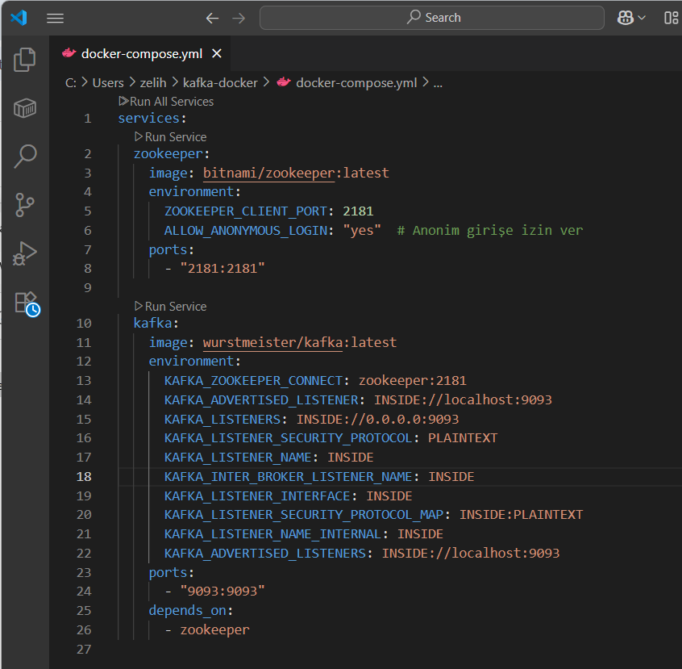

After creating the docker-compose.yml file, we started the containers using the Docker Compose commands to start the Kafka and Zookeeper containers.To test if Kafka is working correctly, we used two different terminal windows to send and receive messages to

KafkaSending Messages (Producer): In order to send messages to Kafka, we started the producer with the following command.

Receiving Messages (Consumer): In order to receive messages from Kafka, we started the consumer with the following command in another terminal

metin, ekran görüntüsü, siyah içeren bir resim

Yapay zeka tarafından oluşturulmuş içerik yanlış olabilir.