|  |  |  |
| --- | --- | --- |
| **Predictor** | **Effect** | **Rationale** |
| *For semi-parametric and parametric models:*  ***Dependent Variable: Survival_days*Status*** | | |
| Age | - | The higher the patient’s age, the weaker their immune system, lower survival chance and time |
| Treatment | +/- | Second treatment may prove more or less effective than standard |
| Cell_type | +/- | Different types of lung cancer will affect survival status and time differently |
| Karnofsky | + | The Karnofsky score rates patient’s general performance, so positive relationship. |
| Diagnosis_months: | - | Longer diagnoses means lower chance of survival, shorter time, or both |
| *Excluded Variables:* prior_chemo: information not necessary since we have months from diagnosis, type of cancer, and age of the patient, and inter | | |

A6 Lung Cancer

1. Explore the km curves and compare across treatments: KM visualization and

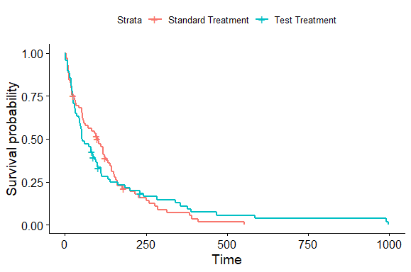

a. The probability of a sampled patient surviving for about 6 months is around 21.24% for the standard treatment or treatment 1 and slightly higher for the test treatment at 21.62%. (Highlighted in light orange)

b. The probability of a sampled patient surviving for about 1 year is around 5.31 % for the standard treatment or treatment 1 and slightly higher for the test treatment at 10.98%. (Highlighted in yellow)

c. The sample mean number of days where a patient can be expected to survive if they are on the standard treatment is about 100 days as opposed to 52 days on the test treatment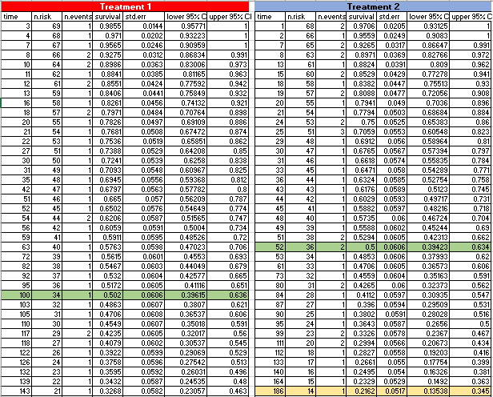 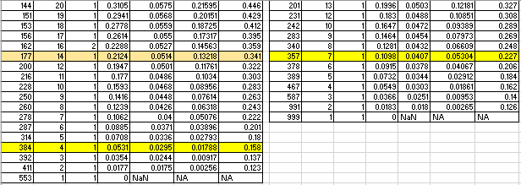

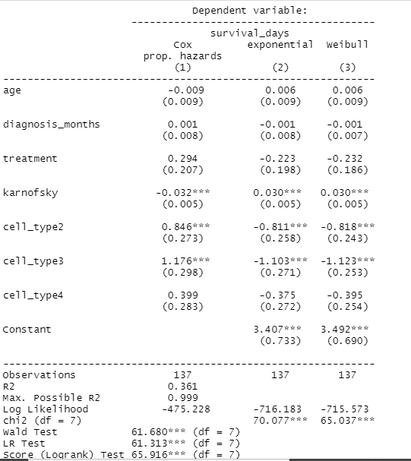

2. Semi-parametric and Parametric(Exponential, and Weibull)

a. **Interpretations were generated using the Cox Proportional Hazard model exp(coeff) column not shown in stargazer output.**

* Age: For every 1 year increase in age, we expect the survival time to decrease by 0.85%.
* Diagnosis_months: For every 1 month increase in months since diagnosis, we expect the survival time to increase by 0.12%
* Treatment: Survival times for patients on treatment 2 were 34% higher on average than those on the standard treatment
* Karnofsky: For every 1 point increase in the karnofsky score, we expect the patient’s survival time to decrease by 3.2%
* Cell_types:
  + Sample patients with cell type 1 or Squamous had the lowest time of survival on average
  + Small cell(2) patients’ survival times were 133% better on average than squamous; second best
  + Adeno cell(3) patient’s survival times were the best! Patient Survival times were 224% better on average than squamous, 91% better than small cell, and 175% better than large cell patients.
  + Large cell(4) patients’ survival times were 49% better on average than squamous; third best