VEHICLE DATA

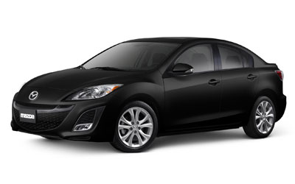 | MAKE | MAZDA
 | MODEL | MAZDA 3
 | PLATE | NS 156-BB
 | YEAR | 2009
 | COLOR | RED
 | FUEL TYPE | BMB
 | CHASIS # | -
 | ENGINE # | -
 | PRICE | 9,000.00 CHF
 | POWER | 78 kW
 | VOLUME | 1600 ccm
 | WEIGHT | 0 kg

