**CHAPTER-1**

**INTRODUCTION**

* 1. **Background of the study**

I worked as a full stack web developer (PHP) intern in Augere Wireless Broadband Bangladesh Limited(QUBEE). Augere Wireless Broadband Bangladesh is engaged in the business of providing high speed broadband wireless access and related services in Bangladesh under the name and style of QUBEE. Their main business is selling internet. They provide internet service with different packages. They have specific plan for each packages. As their business is well established in Bangladeh, they have to maintain it differently. So they use some system for managing their work. I worked here to make a system where they can maintain all of their information about their clients and their product. They were managed this information by Microsoft office(EXCELL). So it’s take’s lot of time to provide information a maintain the whole system. So they decided to make this system to ensure that they don’t need much time to handle this kinds of work.

This is the home screen of this system…

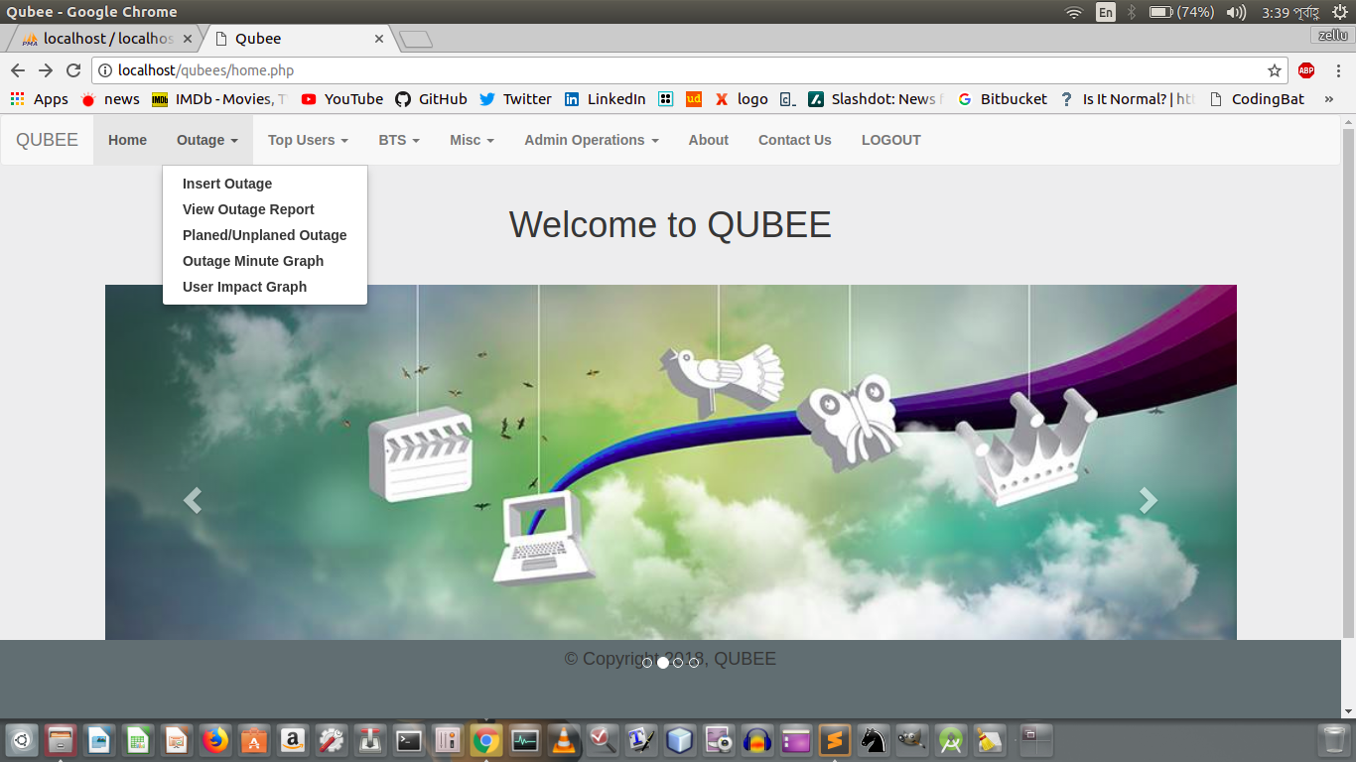

**QUBEE’S WEBSITE**

I am lucky to get the opportunity to complete my internship(2 month) at QUBEE. When I was working at QUBEE I got another opportunity from NexKraft Limited.

NexKraft Limited is a Software Company and having business in ERP and transport software.