**Prenatal Particulate Air Pollution and Neurodevelopment in Urban Children:**

**Identifying Sensitive Windows and Sex Differences**

Yueh-Hsiu Mathilda Chiu, ScD1; Hsiao-Hsien Leon Hsu, ScD2; Brent A. Coull, PhD3,4;

David C. Bellinger, PhD, MSc4,5; Itai Kloog, PhD6; Joel Schwartz, PhD4,7;

Robert O. Wright, MD, MPH2,8; Rosalind J. Wright, MD, MPH1,8

1 Department of Pediatrics, Kravis Children’s Hospital, Icahn School of Medicine at Mount Sinai, New York, NY, USA

2 Department of Preventive Medicine, Icahn School of Medicine at Mount Sinai, New York, NY, USA

3 Department of Biostatistics, Harvard School of Public Health, Boston, MA, USA

4 Department of Environmental Health, Harvard School of Public Health, Boston, MA, USA

5 Department of Neurology Research, Children's Hospital Boston, Harvard Medical School, Boston, MA, USA

6 Department of Geography and Environmental Development, Ben-Gurion University of the Negev, Israel

7 Department of Epidemiology, Harvard School of Public Health, Boston, MA, USA

8 The Mindich Child Health & Development Institute, Icahn School of Medicine at Mount Sinai, New York, NY, USA

**Acknowledgements:** The Asthma Coalition on Community, Environment, and Social Stress (ACCESS) project has been funded by grants R01 ES010932, R01 ES013744, R01 ES21357, P30 ES023515, U01 HL072494, R01 HL080674, EPA RD 83479801, P30 ES000002. The authors declare they have no competing financial interests.

**Short Running Title:** Prenatal PM2.5, sensitive windows & neurodevelopment

**ABSTRACT**

**Background:** Brain growth and structural organization occurs in stages beginning prenatally. Thus, toxins may impact neurodevelopment differently dependent upon exposure timing.

**Objectives:** We implemented innovative methodology to identify sensitive windows for the effects of prenatal fine particulate matter exposure [diameter≤2.5μm (PM2.5)] on children's neurodevelopment.

**Methods:** We assessed 267 full-term (≥37 weeks) urban children’s daily PM2.5 exposure during pregnancy using a validated satellite-based spatio-temporally resolved prediction model. Outcomes included attention (commission errors [CEs], omission errors [OEs], hit reaction times [HRTs] from the Conners' CPT-II), memory (e.g., the composite General Memory [GM] Index and its components - Verbal [VEM] and Visual [VIM] memory, and Attention-Concentration [AC] indices from the Wide Range Assessment of Memory and Learning, 2nd Ed), and IQ (Wechsler Intelligence Scale for Children-IV) assessed at age 6.5 ± 0.98 years. To identify the role of exposure timing we used distributed lag regression models to examine associations between weekly prenatal PM2.5 exposure and neurodevelopment. Sex-specific effects were also examined.

**Results:** Mothers were primarily minorities (60% Hispanic, 25% black); 69% had ≤12 years of education. Adjusting for maternal age, education, race, and smoking, we found associations between higher PM2.5 levels at 20-26 weeks gestation with increased OEs, higher PM2.5 at 33-38 weeks with slower HRTs and higher PM2.5 at 32-38 weeks with lower IQ among boys; significant associations were found in memory domains in girls (higher PM2.5 exposure at 18-25 weeks was associated with reduced VIM scores, greater PM2.5 exposure at 14-21 weeks was associated with reduced GM scores).

**Conclusions:** Increased prenatal PM2.5 exposure at specific time windows was associated with poorer function in several memory and attention domains in these urban children with variable effects based on sex. More definitive determination of time window-specific and sex-specific effects may yield insight into underlying mechanisms and vulnerable subgroups.

**INTRODUCTION**

Cognitive impairment and behavioral problems affect up to 20% of U.S. children, placing a burden on education and healthcare systems (Boulet et al. 2009; Costello et al. 2003; Froehlich et al. 2007; Leonard and Wen 2002; Montes et al. 2012; Perou et al. 2013). Fewer than 25% of childhood neurodevelopmental disabilities have an identifiable genetic or environmental cause, indicating the need for additional research (Bellinger 2007). Identifying the role of environmental factors among the unknown causes will inform strategies to modify risk. Moreover, as loss of early functioning may result in diminished academic and economic productivity that persists over the life span, understanding how maladaptive trajectories are set in early life is a priority. Growing evidence implicates urban ambient air pollution (e.g., traffic-related pollutants, particulate matter) as a developmental neurotoxicant (Block and Calderon-Garciduenas 2009; Genc et al. 2012; Liu and Lewis 2014) with effects starting prenatally, possibly via inflammatory processes that disrupt differentiation and organization of the central nervous system (CNS). The fetal brain may be particularly vulnerable due to its relatively immature immune and inflammatory response systems (Block and Calderon-Garciduenas 2009; Block et al. 2012).

The CNS develops sequentially with different anatomic regions forming at different life stages and specific processes occurring in a timed cascade. Subtle disturbances, even slight disruption in development at an early stage may affect later developmental processes by offsetting the normal trajectory (Weiss 2000). Beginning *in utero*, the brain must form a network of interconnected cells (i.e. neurons) that stretch across different anatomic regions as well as connecting to peripheral tissues (Lavenex and Banta Lavenex 2013; Tau and Peterson 2010). The various structural components of this network may be differentially vulnerable to environmental toxins depending on the anatomic region of the brain affected and the timing of exposure (Rodier 2004). Also, different network components are responsible for different functional domains which are developing at different times (e.g., intelligence, attention, memory); thus, an environmental neurotoxic agent may produce impairment in variable functional domains depending on timing of exposure. Identifying windows of susceptibility for neurotoxicants and the domains being impacted may provide insight into underlying mechanisms. For example, studies of lead exposure suggest enhanced sensitivity around 2 years of age, a life stage that corresponds to when synaptic pruning is most active (Braun et al. 2012; Tau and Peterson 2010). Mechanistically, lead has been shown to induce inappropriate neurotransmitter release which impairs neurotransmission, properties which drive the selection of synapses to be pruned. By adding noise to synaptic pruning, lead disrupts synaptic network organization (Bressler et al. 1999). In contrast, methylmercury which induces oxidative stress even at lower exposure levels is most toxic in fetal life. The immature anti-oxidant mechanisms of the fetus may explain its increased sensitivity to methylmercury-induced oxidative stress and neuroinflammation (Stringari et al. 2008).

*In utero* neurotoxic effects of particulate air pollution and specific prenatal windows of susceptibility associated with this exposure have not been well elucidated. Animal, experimental, and epidemiological studies demonstrate that air pollution effects on neurodevelopment begin *in utero* (Genc et al. 2012; Zanchi et al. 2010). A few human studies have investigated associations between prenatal air pollution and child neurodevelopment outcomes with varied findings (Edwards et al. 2010; Guxens et al. 2012; Guxens et al. 2014; Kim et al. 2014; Perera et al. 2012; Volk et al. 2011), which may be due in part to different approaches to exposure assessment and arbitrary assignment of exposure timing rather than the assessment of sensitive time windows of particular CNS developmental relevance from the data. Specifically, these studies either assessed air pollution in a specific clinically defined trimester or averaged exposure over the entire pregnancy. Measuring exposure in the wrong susceptibility window may lead to underestimated associations; yet, the exact windows are often unknown.

Overlapping epidemiological research documents complex sex-specific neurodevelopmental effects related to other chemicals (e.g., mercury, lead, bisphenol A) (Braun et al. 2011; Engel et al. 2010; Hamadani et al. 2011; Sagiv et al. 2012; Tatsuta et al. 2014). Recent animal studies have suggested that there may be sex differences in the association between prenatal air pollution and neurodevelopment in the offspring (Bolton et al. 2014; Dada et al. 2014). Like those seen with other chemical toxins, sex-specific air pollution effects are likely to vary in relation to timing of exposure and brain region affected although this has not been previously studied.

To begin to address these gaps, we leveraged data on daily exposures to particulate matter with a diameter ≤2.5 µm (PM2.5) measured over gestation, and applied advanced statistical methods [e.g., distributed lag models (DLMs)] to more precisely identify the sensitive windows of prenatal particulate air pollution exposure on a range of children’s neurodevelopmental outcomes (IQ, attention, and memory) in an ethnically mixed lower-SES inner city population. We also examined effect modification by sex. We hypothesized that the sensitive windows would vary for the different neurodevelopmental domains and that there would be sex-specific associations.

**METHODS**

Participants were from the Asthma Coalition on Community, Environment and Social Stress (ACCESS) project, a pregnancy cohort originally funded to recruit 500 mother-child pairs and designed to examine independent and interactive effects of early life stress and physical toxins on childhood respiratory health (Wright et al. 2008). In brief, English- or Spanish-speaking pregnant women (≥18 years old) receiving care at Brigham & Women's Hospital (BWH), Boston Medical Center (BMC), and affiliated community health centers were enrolled at 28.4 ± 7.9 weeks gestation between August 2002 and January 2007. Research assistants approached women receiving prenatal care on select clinic days, 78% of those approached who were eligible agreed to enroll. There were no significant differences on race/ethnicity, education, and income between women enrolled and those who declined; n=455 gave birth to a live born infant and continued follow-up. Neurocognitive testing in children was conducted between March 2012 to February 2014 during which time n=310 families were re-contacted and agreed to participate. Among these families, n=9 were unable to ultimately be scheduled despite an average of 11 attempts, n=5 children were unable to adequately cooperate with the testing protocol, n=28 were born pre-term (<37 weeks), and n=1 was *a priori* excluded from analyses given an IQ score more than two standard deviations below the mean, resulting in n=267 included in our analysis. Characteristics of included (maternal age 26±5 years, 69% with high school education or less, 25% black, 60% Hispanic, and 55% male) versus excluded (maternal age 27±6 years, 62% with high school education or less, 29% black, 55% Hispanic, and 52% male) participants were not significantly different. Procedures were approved by the human studies committees at BWH and BMC. Written consent was obtained from mothers; assent was obtained for children age 7 years or older.

**Prenatal PM2.5 Levels**

Individuals’ prenatal exposure to PM2.5, an index of ambient pollution from traffic and other sources, was estimated based on residence over the duration of pregnancy (i.e., at enrollment and updated if they moved) using a hybrid satellite based spatio-temporal prediction model. The model incorporated Moderate Resolution Imaging Spectroradiometer (MODIS) derived Aerosol Optical Depth (AOD) measurements at a 10 km spatial resolution. The model combines the AOD data with traditional Land Use Regression (LUR) predictors to yield residence-specific estimates of daily PM2.5 as detailed elsewhere (Kloog et al. 2011). The model was run using day-specific AOD data calibrated against ground monitor-based PM2.5 measurements derived from 78 monitoring stations covering New England. The model incorporated traditional LUR (traffic density, point sources, etc) and meteorological variables (temperature, wind speed, visibility, elevation, distance to major roads, percent of open space, point emissions and area emissions). The AOD-PM2.5 relationship was calibrated daily using data from grid cells with both monitor and AOD values using mixed models with random slopes for day, nested within regions. For locations on days without AOD data (due to cloud coverage, snow, etc.), the model was fit with a thin plate spline of latitude and longitude and a random intercept for each cell (similar to universal kriging) to impute predictions at these missing locations. The “out of sample” ten-fold cross validation R2 for daily values were 0.83 and 0.81 for days with and without available AOD data, respectively. To reduce potential noise caused by day-to-day variation of PM2.5, for each participant individual exposure levels were aggregated into weekly averages for each week during gestation.

**Neurocognitive Measurements**

All neurodevelopmental tests were administered in children at age 6.5 ± 0.98 years.

***Children's Intelligence quotient (IQ):*** Child intelligence was assessed using the full-scale IQ score on the Wechsler Intelligence Scale for Children (WISC)-IV (Wechsler 2003), which can be completed without reading or writing skills in children at ages 6-16 years. The WISC-IV standardization sample is representative of the March 2000 U.S. Census data based on age, sex, race, ethnicity, parent education level, and geographic locations (Wechsler 2003), and has been widely used in culturally diverse populations.

***Attention:*** Attention was assessed with the Conners' Continuous Performance Test-II (CPT-II) (Conners 2000). The CPT does not have reading or literacy requirements and can be administered to children as young as age 6 years. The test consists of letters flashing in succession and at variable rates on the screen. The child was instructed to push the space bar as quickly as possible in response to each letter except for "X". This test assesses response inhibition (commission errors, CEs) as well as vigilance (omission errors, OEs). Outcomes included OEs (failing to respond to a target), CEs (erroneously responding to a non-target), and hit reaction time (HRT; mean reaction time for all target responses) expressed as standardized percentiles representing the performance of the study subject relative to the performance by children of the same age in the normative sample (Conners 2000). Higher percentiles indicate worse performance (e.g., more errors or slower reaction time) related to inattentiveness. The CPT has been widely used and prior studies have found that reaction times are sensitive indicators of exposures to toxicants (White et al. 2009).

***Memory:*** We assess memory with the Wide Range Assessment of Memory & Learning, 2nd Edition (WRAML-2) (Sheslow and Adams 2003), a widely used standardized test normed for children aged 5-17 years among racially diverse groups. This test evaluates immediate and delayed memory ability along with the acquisition of new learning. The WRAML-2 yields an overall composite General Memory Index (GM) and its components (Verbal Memory Index [VEM], Visual Memory Index [VIM], and Attention/Concentration Index [AC] All measures are expressed as age-standardized scores. Lower percentiles indicate poorer memory functioning.

**Covariates**

Maternal age, race, and educational status were ascertained at enrollment; information about child’s sex, date of birth, gestational age at birth, and birth weight were obtained by medical record review. Women reported on smoking at enrollment and in the third trimester and were classified as prenatal smokers if they reported smoking at either visit. Mothers also reported postnatal smoking at each 3-month postpartum interview. Children's blood lead levels were assessed using a portable blood lead analyzer (LeadCare® II, Magellan Diagnostics, Inc.) on the day of neurodevelopment testing.

**Statistical Analysis**

Analyses included 267 singleton full-term (≥37 weeks gestation) children. In order to explore sensitive windows for effects of prenatal PM2.5 in relation to neurodevelopmental outcomes, we constructed an exposure lag space (Gasparrini et al. 2010) using weekly averages of daily predictions from our spatio-temporal PM2.5 prediction model throughout that participant’s gestational period. We fit distributed lag models (DLMs) to estimate the time-varying association between a given neurodevelopmental outcome and estimated PM2.5 level during a given week in pregnancy. Specifically, we fit the linear distributed lag model $Y_{i}=β_{0}+\sum_{j=1}^{n}{[α_{j}{AP}_{ij}]}{+β}_{1}x_{1i}+β_{2}x_{2i}+…+ε_{i}$, where ${AP}_{ij}$ is the estimated PM2.5 level in week *j* of pregnancy and $x_{1i}$, …, $x_{pi}$ are the confounders for subject i. Confounders included maternal age, race, education and smoking status in all models, as well as child's sex in models not stratified by sex. Without additional structure on the $α_{j}$ coefficients, the estimates of the week-specific effects are typically unstable due to collinearity among the weekly pollution averages. Therefore, we fit constrained DLMs that assume these effects $α_{j}$ are a smooth function of j (week), such that $α_{j}$ = h(j). We modeled this smooth function using b-splines with 4 degrees of freedom. A sensitive window is identified when the estimated pointwise 95% confidence bands do not include zero. Next, to assess whether the sensitive window of prenatal PM2.5 exposure on childhood neurodevelopment was different between boys and girls, sex-stratified DLMs were run to assess potential sex-specific associations. To demonstrate how the estimate of an association between PM2.5 exposure and outcome would have differed from that based on the entire pregnancy and had the sensitive windows been identified *a priori*, we then also estimated sex-specific associations between prenatal PM2.5 levels averaged across the sensitive windows identified by the DLMs in relation to neurodevelopmental outcomes using multivariable linear regression models, adjusting for maternal age, education, race, and prenatal/postnatal maternal smoking. We also performed sensitivity analyses by additionally including averaged postnatal PM2.5 levels over the first 2 years of life (which were correlated with prenatal exposure levels; Spearman’s *r*=0.82, *p*<0.001), blood lead level assessed on the day of neurodevelopment tests, and birth weight for gestational age into the model. DLMs were implemented using the *dlnm* package in *R* (version 3.0.1, Vienna, Austria) (Gasparrini et al. 2010), and other analyses were performed in SAS (version 9.1.3, SAS Institute Inc., Cary, NC).

**RESULTS**

Most mothers were ethnic minority (60% Hispanic, 25% African American), had ≤ 12 years of education (69%), and were nonsmokers prenatally (81%); the distribution of covariates did not differ by children's sex (Table 1). Table 2 summarizes the distribution of the neurocognitive domain scores and ambient PM2.5 exposure levels by sex. Prenatal PM2.5 levels were similar for boys and girls, and there was also no significant sex difference in terms of gestational age at birth, maternal age at enrollment, and children's age at neurocognitive testing (Tables 1-2).

***Distributed Lag Models (DLMs)***

Figure 1shows the associations between prenatal PM2.5 and child IQ using DLMs for all children as well as stratified by sex, adjusting for maternal age, race/ethnicity, education, pre- and postnatal maternal smoking. “Sensitive windows” graphically appear as a bump during which exposure is significantly associated with neurophenotype. We observed significant associations between increased PM2.5 exposure and lower children's IQ scores (lower scores indicate poorer functioning) around late pregnancy (32-38 weeks of gestation) in boys but not in girls. When models were run in boys and girls together, we did not find significant associations between prenatal PM2.5 and attention domains. However, when stratified by sex, we observed several sexually dimorphic results. Significant associations were observed between higher PM2.5 levels in mid-pregnancy (20-26 weeks of gestation) and increased omission errors, and between higher PM2.5 exposures in late pregnancy (33-38 weeks of gestation) and slower HRTs among boys (Figure 2; higher percentiles of attention domains indicate less favorable performance); no association was found with commission errors (see Supplemental Material, Figure S1). On the other hand, we observed significant associations between higher PM2.5 levels in early-to-mid pregnancy and adverse memory performances only among girls. Specifically, higher exposure to PM2.5 at 18-25 weeks gestation was associated with reduced VIM (18-25 weeks window), AC (8-19 weeks window), and GM (14-21 weeks window) scores among girls (Figure 3); no association was found with VEM (see Supplemental Material, Figure S2).

***Multivariable-adjusted Models Using PM2.5 Levels at Identified Sensitive Windows***

To further assess associations at the "sensitive windows" identified by the DLMs, we also fit multivariable linear regression models using PM2.5 levels averaged over the period that significant associations were shown in the DLMs. That is, using the pointwise 95% CI bounds as a guide, we restricted the model to just those time points when the association was significant and repeated the analysis using a more conventional linear regression approach. As most results were sexually dimorphic, these models are sex-stratified adjusting for maternal age, race, education, and prenatal/postnatal maternal smoking. Figure 4 shows results of the domains where the DLMs suggested a sensitive window among boys, including full-scale IQ (lower score indicates poorer functioning) and two attention domains (omission errors and HRT; higher percentiles indicate poorer performance). The effect estimates of PM2.5 averaged across the sensitive windows in multivariable-adjusted linear models were in a less favorable direction in boys for these domains, albeit only the effect estimate for full-scale IQ achieved statistical significance while that for HRT was marginally significant (omission errors β=2.02, 95% CI=-0.62–4.66; HRT β=1.80, 95% CI=-0.98–2.78; IQ β=-2.05, 95% CI=-3.97– -0.13), while no significant associations were found in girls (Figure 4A). Figure 5 shows the results of the three WRAML-2 memory domain subscales (VIM, AC, and GM; lower percentiles indicate poorer memory functioning) where the DLMs suggested a sensitive window among girls. We found significant associations in girls during the sensitive windows for these three memory domain subscales (VIM β=-2.56, 95% CI=-4.77– -0.34; AC β=-4.84, 95% CI=-8.00– -1.69; GM β=-2.88, 95% CI=-5.17– -0.59), while no significant associations were found in boys (Figure 5A). While sex-stratified analyses suggested differences in these associations between boys and girls, the PM2.5 × sex interactions were not statistically significant in the interaction models, potentially due to small cell sizes. When using PM2.5 averaged over the entire pregnancy period, no significant associations were found in any neurodevelopmental measures (Figures 4B and 5B), primarily due to a loss of efficiency in health effect estimation that results from using the entire pregnancy. That is, the point estimates between the two analyses are not very different but the uncertainty of the effect estimates are much larger for the analyses using the entire pregnancy as compared to that using a more refined window.

Finally, sensitivity analyses additionally including postnatal PM2.5 levels, blood lead level assessed on the day of neurodevelopment tests, and birth weight for gestational age did not materially change these results.

**DISCUSSION**

To our knowledge, this is the first study to leverage a combination of weekly PM2.5 exposure estimates and distributed lag models in order to objectively define windows of vulnerability to particulate air pollution during gestation in relation to early childhood neurodevelopment. Notably, our findings suggest that the sensitive windows vary based on the neurocognitive domain being examined and by sex. While animal studies have suggested that there may be sex differences in the association between prenatal air pollution and neurodevelopment in the offspring (Bolton et al. 2014; Dada et al. 2014), no human study to date has examined sex-specific associations in this context. Our findings suggest that boys were more susceptible than girls to PM2.5 exposure later in pregnancy in relation to full-scale IQ and in mid- and late-pregnancy in relation to attention performance indices, whereas girls were more susceptible to PM2.5 exposure around early and mid-pregnancy in regards to memory-related performance.

These data add to a growing literature linking prenatal air pollution to children's neurodevelopment. Perera et al. measured PAH using 48-hour personal sampling during the third trimester of pregnancy in a New York City cohort and found significant associations with mental developmental delays measured by the Bayley Scales of Infant Development–Revised at age 3 years (Perera et al. 2006), decreased full-scale IQ at 5 years of age (Perera et al. 2009), as well as increased attention problems in 6-7 years olds which were also related to maternal and DNA adducts specific to benzo[a]pyrene (BaP) measured at birth (Perera et al. 2012). Edwards et al. (Edwards et al. 2010) found that PAH measured by 48-hour personal sampling during the second or third trimester was significantly associated with lower IQ scores at 5 years of age. Guxens and colleagues (Guxens et al. 2012) estimated prenatal NO2 levels using LUR models in four regions in Spain and found that the NO2 levels averaged over the pregnancy were associated with decreased mental development index measured by Bayley Scales of Infant Development in children around 14 months of age. These authors also recently conducted a meta-analysis pooling data from six European birth cohorts, and found that NO2 averaged over pregnancy estimated by LUR was associated with delayed psychomotor development in children aged 1-6 years old (Guxens et al. 2014). Kim et al. (Kim et al. 2014) found significant relationships of higher prenatal PM10 levels estimated by inverse distance weighting modeling with both delayed mental and psychomotor developmental index at 6-24 months of age. Guxens et al. (Guxens et al. 2014) also reported a marginally significant inverse association between higher average PM2.5 levels during pregnancy estimated by LUR models with poorer psychomotor development in children at 1-6 years of age, albeit not with general cognition.

To our knowledge, this is the first study to use data driven statistics to define susceptibility windows, removing much of the subjectivity that currently guides the decision of when to measure environmental exposure. The advantage of implementing a statistical method that resolves the pattern of associations across time is apparent. Our approach is based on the data *per se* rather than assigning *a priori* exposure time points arbitrarily, e.g., using clinically defined trimesters, in order to more definitively identify sensitive windows for effects on neurodevelopment. Obviously, this approach is aided by an air pollution model with weekly temporal resolution across pregnancy. However, if other exposure metrics could generate similar temporally resolved data the same techniques could be applied.

More refined estimation of the time window in which air pollution has the greatest impact may provide insights into underlying mechanisms as well as the etiology of sex-specific neurotoxic effects. While the mechanisms linking air pollution exposure and neurodevelopment are not completely understood, neuroinflammation is increasingly thought to play a central role. Animal studies demonstrate that particulate air pollution induces neuroinflammatory processes which may subsequently disrupt neurodevelopment in offspring (Allen et al. 2014; Bolton et al. 2014; Bolton et al. 2012; Hougaard et al. 2008). In addition, neuroinflammation may disturb normal programmed cell death as neuroapoptosis is part of normal neural differentiation which occurs around mid-to-late pregnancy in multiple brain regions (Tau and Peterson 2010). Increased neuroinflammation from PM has been linked to structural changes in the brain with smaller brain volume and reduced thickness of the prefrontal cortex (Semmler et al. 2005), which in turn, has been linked to attention deficit disorders (Hauser et al. 2014). The prefrontal cortex is rich in dopaminergic neurons and disruption of dopaminergic pathways through inflammation may also play a role. Neuroinflammation has been linked to activation of memory related kinase (Yao et al. 2014) as well as neuroapoptosis in the hippocampus which is important to memory (Semmler et al. 2005; Stark et al. 2002). Neuroinflammation induced by air pollution may disrupt the development of hippocampus fields CA1-3 as well as the proliferation of granule neurons within the hippocampus (Bayer et al. 1993). Brain inflammatory responses may reduce the capacity to provide brain-derived neurotrophic factor (BDNF) needed for memory-related plasticity processes at hippocampal synapses (Patterson 2014). Moreover, animal studies of PM exposure consistently demonstrate microglial activation in response to exposure. Microglia are resident macrophages in the CNS and play a critical role in neural development, synaptic plasticity, and neurobehavior. Morphological differences in neuronal dendritic spines (representing the number of synapses formed) and microglial colonization have been demonstrated in the hippocampus, frontal cortex, amygdala and pre-optic area during early development. Pro-inflammatory environmental toxins may activate microglia altering production of cytokines and chemokines that disrupt neurodevelopment. Between 20 to 28 weeks, myelination (the maturation of nerve cells whereby a layer of myelin forms around the axons allowing nerve impulses to travel faster) begins first in white matter in subcortical and later in cortical regions gradually increasing during pregnancy (Tau and Peterson 2010). Disrupted myelination in prefrontal cortical regions may also result from neuroimmune activation. Studies also suggest that synaptogenesis (the formation of synapses between neurons in the nervous system) in the fetal brain begins in mid-pregnancy (Tau and Peterson 2010), and disruption in these processes has been linked with altered spatial and trace memory (Ramirez-Amaya et al. 2001; Shors 2004). Other data suggest that neuroinflammation during mid-to-late pregnancy disrupts both the size and the structure as well as the programming processes in the fetal brain, including neuroapoptosis, myelination as well as the synaptic pruning and the maturation of the Ventral Tegmental Area (VTA) (Donev and Thome 2010; Gillies et al. 2014). The VTA is the site of dopaminergic neuron cell bodies that project to the frontal and prefrontal cortex. The VTA is critical to reward behaviors, motivation and attention.

Sex hormones influence these complicated processes which may contribute to sex differences in their disruption by pro-inflammatory triggers such as air pollution (Melcangi et al. 2008). Sex difference in microglial colonization of the CNS have been observed, with males generally showing a more activated morphology (Schwarz et al. 2012). The neuron-glial signaling cascade may respond to pro-inflammatory triggers such as particulate air pollution differently in males and females due to the bidirectional communication between the neuroendocrine (e.g., sex steroids) and immune systems during fetal development (Morale et al. 2001). These differences in immune response have been posited to explain differences in psychiatric disease prevalence by sex. Our findings suggest that associations with prenatal air pollution were stronger in boys for the attention measures as well as full-scale IQ. Notably, in another prospective urban Boston birth cohort, we previously reported an association between increased postnatal early childhood traffic-related air pollution (black carbon) exposure and attention problems that was more evident in school-aged boys compared to girls (Chiu et al. 2013). In contrast to our finding for attention, we found that associations between prenatal PM2.5 and memory domains were more evident in girls. To our knowledge, no previous studies have assessed sex differences on the association between prenatal air pollution and memory domains. As mentioned above, the adverse association between prenatal PM2.5 and memory might be partially due to disruption in the development of hippocampus neurons (Bayer et al. 1993) . Visual memory is a component of spatial memory which is another sexually dimorphic trait, but differs from attention in that girls tend to have poorer performance than boys. Girls may be more vulnerable at baseline to prenatal air pollution on visual memory performance and the neuroinflammtion from PM exposure may exacerbate this sensitivity. Studies also suggest that testosterone may enhance hippocampal neurogenesis via increased cell survival in the dentate gyrus through an androgen-dependent pathway which suggests a protective mechanism for boys (Spritzer and Galea 2007). A recent animal study, however, has suggested that male mice might be more susceptible to loss of hippocampal volumes (Dada et al. 2014). Further research in the role of PM-induced neuroinflammation on sexually dimorphic development is clearly needed. Joint animal/epidemiologic research may be more efficient than isolated research approaches, as epidemiology can define the proper susceptibility window, then animal research can use that information to efficiently study mechanism while focusing on exposure windows that are more relevant in humans. For example, by examining the developmental processes that occur in the anatomical regions critical for each functional domain during the identified developmental window in epidemiological research, we may be able to target animal studies to induce similar timed exposures while studying induced biological changes.

There are several strengths of this study. First, we were able to estimate particulate air pollution exposure on a daily basis for each woman over gestation using a validated state-of-the-art hybrid spatio-temporal LUR model incorporating satellite-derived AOD measures. We then leveraged these exposure estimates to implement a data driven, advanced statistical method to objectively identify susceptibility windows for PM. Second, our study population consists of a lower-SES ethnically mixed inner-city cohort that may be more highly exposed to ambient pollution. Finally, this is the first study to examine sex-specific effects of prenatal particulate air pollution on a range of neurodevelopment domains including global intelligence, attention, and memory. We also acknowledge some limitations. We did not find statistically significant interactions between sex and PM2.5 likely due to our sample size, albeit results were significant in stratified analyses for several test outcomes. Also, while we were able to control for postnatal air pollution exposure as well as several factors known to be important in children’s cognitive development, we did not have data on dietary and other environmental factors that may co-vary with air pollution such as noise exposure. Further studies in larger samples may therefore consider sex-specific joint or interactive associations among these additional factors. Finally, our results may be more applicable to lower SES racial/ethnic minority populations which may not represent the overall population of the U.S.. More studies are needed to replicate these findings and understand the underlying mechanisms. Susceptibility windows likely reflect several biological vulnerabilities within these anatomic regions, perhaps related to gene expression, protein modification, upstream DNA modifications or permeability of the blood brain barrier.

In summary, this study objectively elucidated sensitive prenatal time windows as well as sex differences on the association between prenatal PM2.5and neurodevelopmental outcomes in early childhood. Our findings suggest that advanced statistical methods when combined with highly temporally resolved exposure data can identify susceptibility windows to environmental exposures that may enhance our ability to find effects and identify vulnerable groups. This information should be employed in a multi-stage approach coupled with animal studies that can leverage epidemiologic data on susceptibility windows to further our understanding of brain growth and structural development during gestation. Increased exposure to prenatal particulate air pollution may have sex-specific time-dependent effects on childhood neurodevelopment, and the effects may vary for different cognitive or behavioral domains that reflect different underlying pathways.

|  |  |  |  |  |  |  |  |  |
| --- | --- | --- | --- | --- | --- | --- | --- | --- |
| **Table 1**. Participant characteristics: ACCESS study | | | | | | | | |
|  | **All children (n=267)** | |  | **Boys (n=148)** | |  | **Girls (n=119)** | |
| **Race/Ethnicity** |  |  |  |  |  |  |  |  |
| Black | 66 | 24.7 |  | 36 | 24.3 |  | 30 | 25.2 |
| Hispanic | 160 | 59.9 |  | 86 | 58.1 |  | 74 | 62.2 |
| White/Other | 41 | 15.4 |  | 26 | 17.6 |  | 15 | 12.6 |
| **Maternal education** (n, %) |  |  |  |  |  |  |  |  |
| >12 yrs | 84 | 31.5 |  | 45 | 30.4 |  | 39 | 32.8 |
| ≤12 yrs | 183 | 68.5 |  | 103 | 69.6 |  | 80 | 67.2 |
| **Maternal smoking status** (n, %) |  |  |  |  |  |  |  |  |
| Never smoked | 215 | 80.5 |  | 121 | 81.8 |  | 94 | 79.0 |
| Smoked prenatally, but not postnatally | 14 | 5.2 |  | 8 | 5.4 |  | 6 | 5.0 |
| Did not smoke prenatally, but smoked postnatally | 14 | 5.2 |  | 8 | 5.4 |  | 6 | 5.0 |
| Smoked both pre- and postnatally | 24 | 9.0 |  | 11 | 7.4 |  | 13 | 10.9 |
| **Gestational age at birth** (weeks; mean, SD) | 39.0 | 1.8 |  | 38.9 | 1.9 |  | 39.1 | 1.8 |
| **Child's age at cognitive test** (year; median, IQR) | 6.5 | 6.0-7.1 |  | 6.4 | 6.0-7.1 |  | 6.5 | 6.0-7.2 |
| **Maternal age at enrollment** (years; median, IQR) | 26 | 23-32.2 |  | 26 | 23-31.3 |  | 27 | 23.2-33.3 |
|  | | | | | | | | |

|  |  |  |  |  |  |  |  |  |
| --- | --- | --- | --- | --- | --- | --- | --- | --- |
| **Table 2**. Neurocognitive test results and averaged prenatal PM2.5 exposure levels by sex | | | | | | | | |
|  | **All children** | |  | **Boys** | |  | **Girls** | |
| ***Variables*** | Median | IQR |  | Median | IQR |  | Median | IQR |
| Averaged prenatal PM2.5 level (µg/m3) | 11.3 | 10.5-12.0 |  | 11.2 | 10.4-11.9 |  | 11.6 | 10.6-12.0 |
| **Intelligence quotient; IQ (WISC-IV) a** |  |  |  |  |  |  |  |  |
| Full-scale IQ score | 94 | 87-102 |  | 93 | 86-102 |  | 95 | 88-103 |
| **Attention domains (CPT-II) b** |  |  |  |  |  |  |  |  |
| Omission error percentile | 91.8 | 62.0-99.0 |  | 92.6 | 58.8-99.0 |  | 91.6 | 67.0-99.0 |
| Commission error percentile | 70.9 | 45.9-86.5 |  | 77.8 | 52.1-88.1 |  | 68.5 | 44.2-85.4 |
| Hit reaction time percentile | 79.3 | 44.7-94.0 |  | 74.9 | 38.5-94.1 |  | 81.5 | 51.3-93.9 |
| **Memory domains (WRAML-2) c** |  |  |  |  |  |  |  |  |
| Verbal Memory Index percentile | 42 | 21-63 |  | 42 | 21-55 |  | 50 | 27-70 |
| Visual Memory Index percentile | 27 | 12-50 |  | 34 | 8-58 |  | 24 | 12-50 |
| Attention/Concentration Index percentile | 50 | 27-73 |  | 50 | 24-73 |  | 50 | 27-73 |
| General Memory Index percentile | 37 | 16-55 |  | 34 | 14-55 |  | 37 | 17-55 |
| a Lower score in full-scale IQ indicates more adverse functioning  b Higher percentile in CPT-II measures indicates worse performance  c Lower percentile in WRAML-2 measures indicates poorer memory functioning | | | | | | | | |

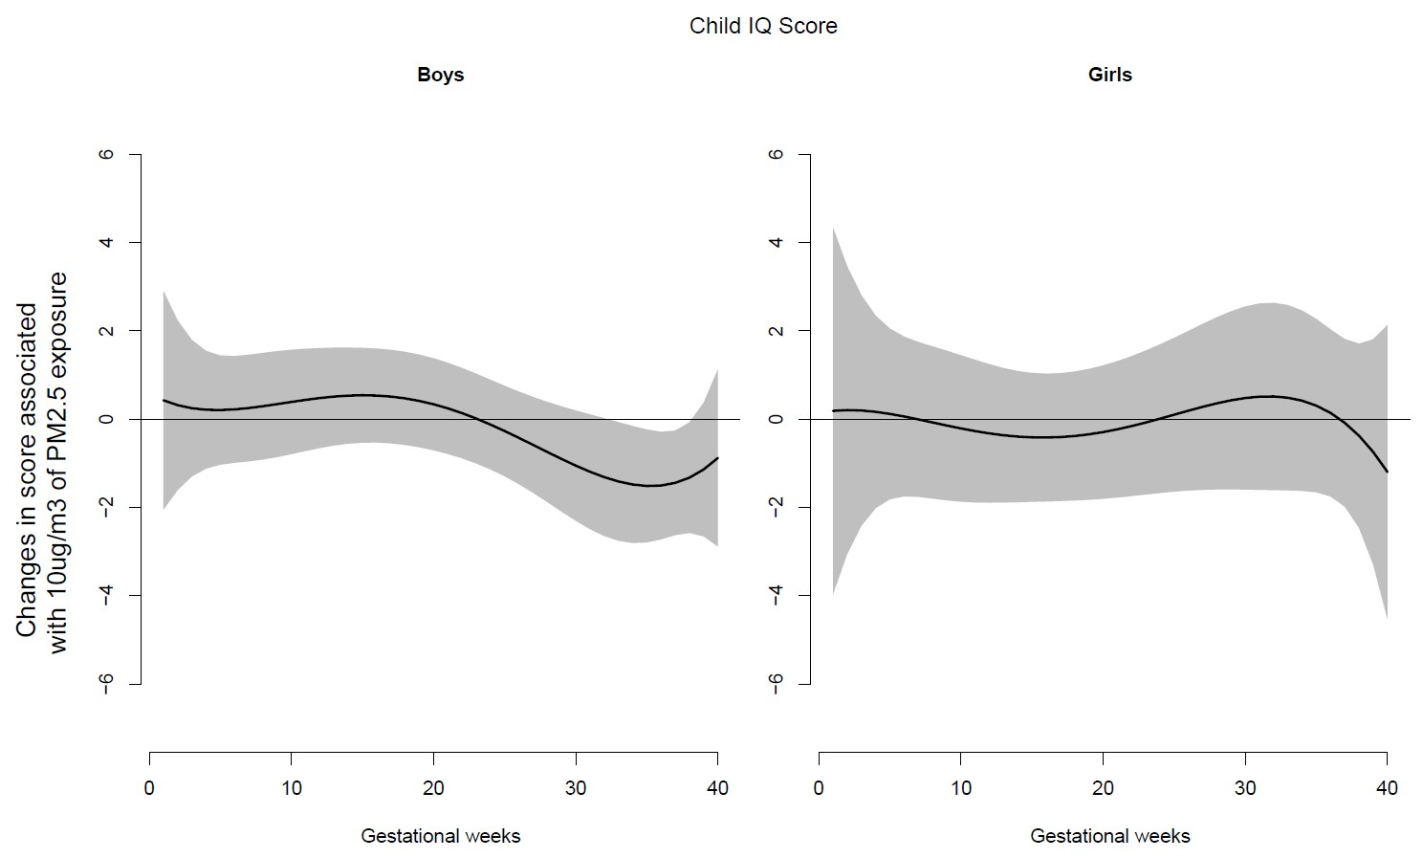

**Figure 1. Sex-specific associations between weekly prenatal PM2.5 levels over gestation and full-scale IQ**

This figure demonstrates PM2.5 exposure over pregnancy and full-scale IQ scores (WISC-IV) using distributed lag models assuming week-specific effects. Models were adjusted for maternal age, race, education, and prenatal/postnatal maternal smoking. The y-axis represents the change in full-scale IQ percentile associated with a 10 μg/m3 increase in PM2.5; the x- axis is gestational age in weeks. Lower IQ scores indicate less favorable functioning. Solid lines show the predicted change in the IQ percentile. Gray areas indicate 95% CIs. A sensitive window is identified when the estimated pointwise 95% CI does not include zero.

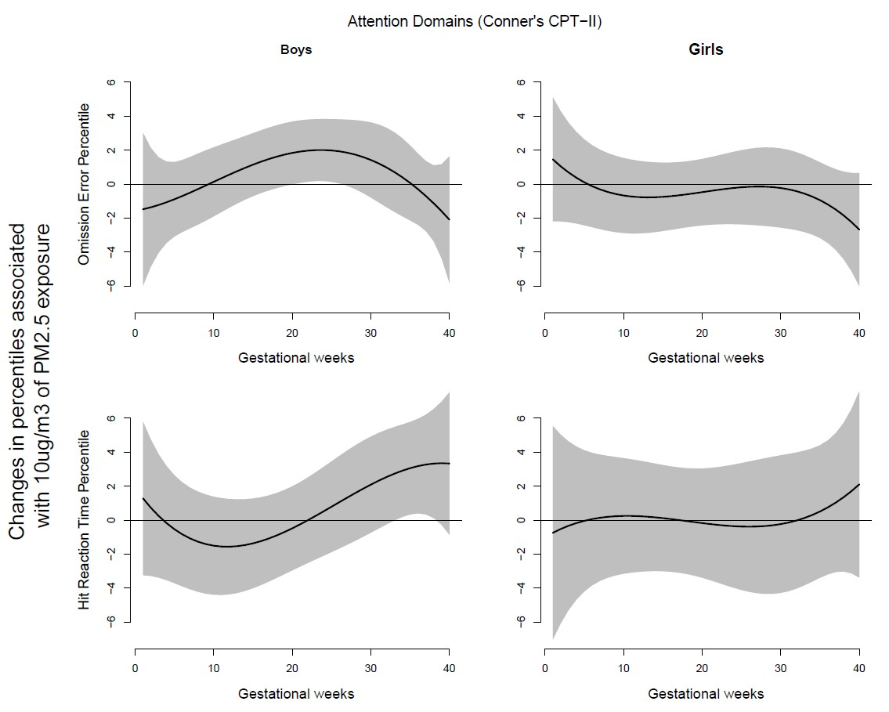

**Figure 2. Sex-specific associations between weekly prenatal PM2.5 levels over gestation and attention domains**

This figure demonstrates PM2.5 exposure over pregnancy and attention domains (CPT-II) using distributed lag models assuming week-specific effects. Models were adjusted for maternal age, race, education, and prenatal/postnatal maternal smoking. The y-axis represents the change in attention domain score percentile associated with a 10 μg/m3 increase in PM2.5; the x-axis is gestational age in weeks. Higher percentiles in attention domains indicate less favorable performance. Solid lines show the predicted change in each test score percentile. Gray areas indicate 95% CIs. A sensitive window is identified when the estimated pointwise 95% CI does not include zero.

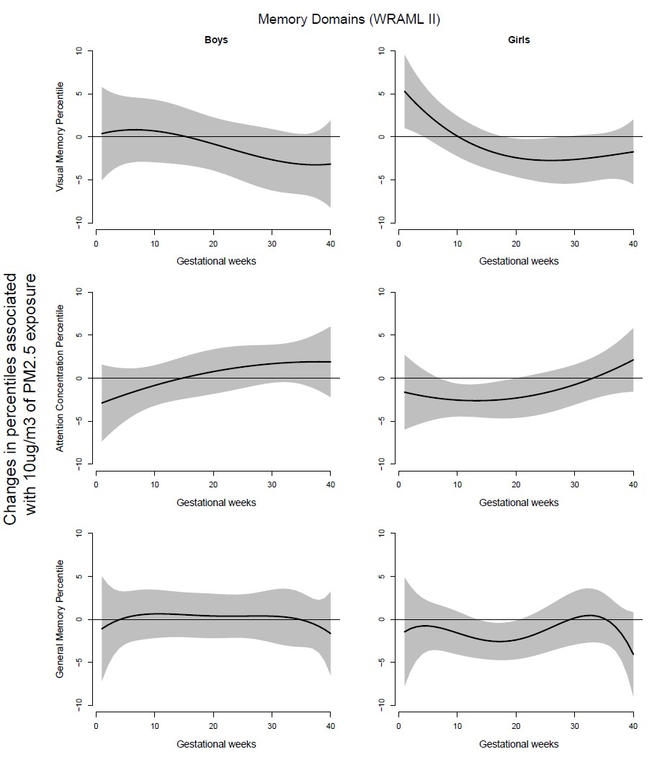

**Figure 3. Sex-specific associations between weekly prenatal PM2.5 levels over gestation and memory domains**

This figure demonstrates PM2.5 exposure over pregnancy and memory domains (WRAML-2) using distributed lag models assuming week-specific effects. Models were adjusted for maternal age, race, education, and prenatal/postnatal maternal smoking. The y-axis represents the change in memory domain score percentile associated with a 10 μg/m3 increase in PM2.5; the x-axis is gestational age in weeks. Lower percentiles in memory domains indicate less favorable performance. Solid lines show the predicted change in each test score percentile. Gray areas indicate 95% CIs. A sensitive window is identified when the estimated pointwise 95% CI does not include zero.

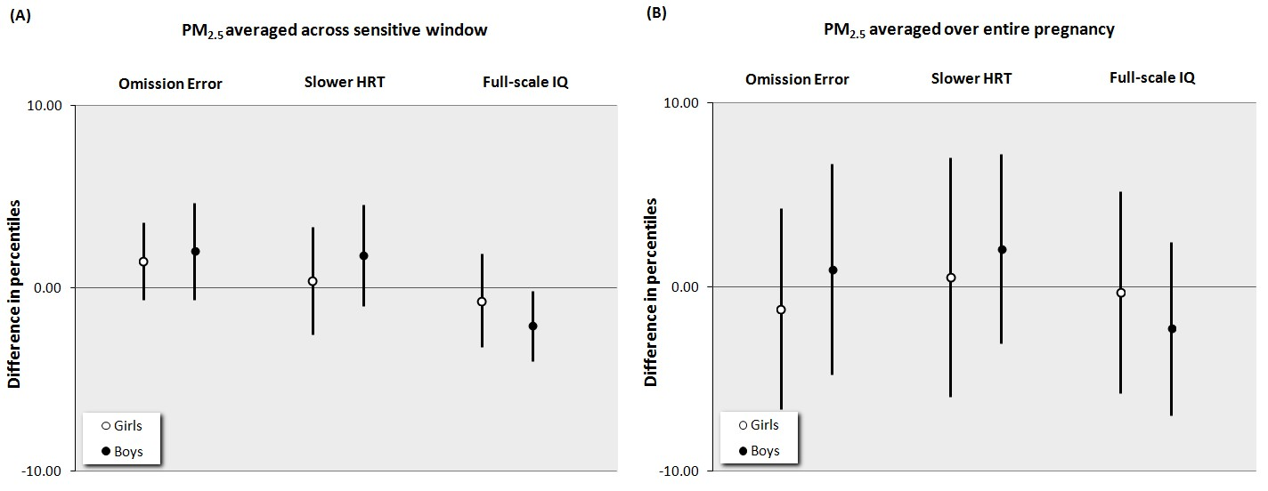

**Figure 4. Sex-specific associations between PM2.5 exposure over gestation and attention domains and IQ: Comparing models based on levels averaged over pregnancy vs. identified sensitive windows**

This figure demonstrates estimated sex-specific associations and associated 95% CIs between prenatal PM2.5 levels and each attention related domain (Conner's CPT) and full-scale IQ (WISC-IV) percentiles, obtained from multivariate regression models in which the prenatal PM2.5 levels were (A) averaged across the sensitive windows identified by DLMs and (B) averaged over gestation. Higher percentiles indicate more omission errors or slower HRT (indicators of inattentiveness), whereas lower full-scale IQ indicates poorer composite intellectual performance. Models were adjusted for maternal age, race, education, and prenatal/postnatal maternal smoking.

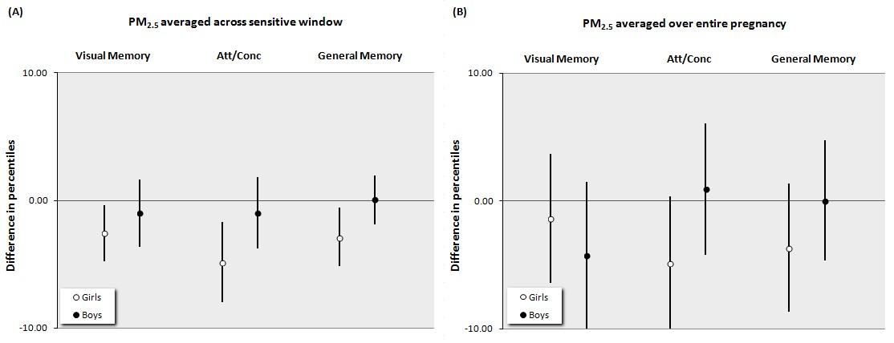

**Figure 5. Sex-specific associations between PM2.5 exposure over gestation and memory domains: Comparing models based on levels averaged over pregnancy vs. identified sensitive windows**

This figure demonstrates estimated sex-specific associations and associated 95% CIs between prenatal PM2.5 levels and each memory-related domain (WRAML-2) percentiles, obtained from multivariate regression models in which the prenatal PM2.5 levels were (A) averaged across the sensitive windows identified by DLMs and (B) averaged over gestation. Lower percentiles indicate less favorable memory related performance. Models were adjusted for maternal age, race, education, and prenatal/postnatal maternal smoking.

**REFERENCES**

Allen JL, Liu X, Pelkowski S, Palmer B, Conrad K, Oberdorster G, et al. 2014. Early postnatal exposure to ultrafine particulate matter air pollution: persistent ventriculomegaly, neurochemical disruption, and glial activation preferentially in male mice. Environ Health Perspect 122:939-945.

Bayer SA, Altman J, Russo RJ, Zhang X. 1993. Timetables of neurogenesis in the human brain based on experimentally determined patterns in the rat. Neurotoxicology 14:83-144.

Bellinger DC. 2007. Children's cognitive health: the influence of environmental chemical exposures. Altern Ther Health Med 13:S140-144.

Block ML, Calderon-Garciduenas L. 2009. Air pollution: mechanisms of neuroinflammation and CNS disease. Trends Neurosci 32:506-516.

Block ML, Elder A, Auten RL, Bilbo SD, Chen H, Chen JC, et al. 2012. The outdoor air pollution and brain health workshop. Neurotoxicology 33:972-984.

Bolton JL, Auten RL, Bilbo SD. 2014. Prenatal air pollution exposure induces sexually dimorphic fetal programming of metabolic and neuroinflammatory outcomes in adult offspring. Brain Behav Immun 37:30-44.

Bolton JL, Smith SH, Huff NC, Gilmour MI, Foster WM, Auten RL, et al. 2012. Prenatal air pollution exposure induces neuroinflammation and predisposes offspring to weight gain in adulthood in a sex-specific manner. FASEB J 26:4743-4754.

Boulet SL, Boyle CA, Schieve LA. 2009. Health care use and health and functional impact of developmental disabilities among US children, 1997-2005. Arch Pediatr Adolesc Med 163:19-26.

Braun JM, Hoffman E, Schwartz J, Sanchez B, Schnaas L, Mercado-Garcia A, et al. 2012. Assessing windows of susceptibility to lead-induced cognitive deficits in Mexican children. Neurotoxicology 33:1040-1047.

Braun JM, Kalkbrenner AE, Calafat AM, Yolton K, Ye X, Dietrich KN, et al. 2011. Impact of early-life bisphenol A exposure on behavior and executive function in children. Pediatrics 128:873-882.

Bressler J, Kim KA, Chakraborti T, Goldstein G. 1999. Molecular mechanisms of lead neurotoxicity. Neurochem Res 24:595-600.

Chiu YH, Bellinger DC, Coull BA, Anderson S, Barber R, Wright RO, et al. 2013. Associations between traffic-related black carbon exposure and attention in a prospective birth cohort of urban children. Environ Health Perspect 121:859-864.

Conners CK. 2000. Conners' Continuous Performance Test II: Computer Program for Windows Technical Guide and Software Manual. North Tonawanda, NY.

Costello EJ, Mustillo S, Erkanli A, Keeler G, Angold A. 2003. Prevalence and development of psychiatric disorders in childhood and adolescence. Arch Gen Psychiatry 60:837-844.

Dada T, Rosenzweig JM, Al Shammary M, Firdaus W, Al Rebh S, Borbiev T, et al. 2014. Mouse model of intrauterine inflammation: sex-specific differences in long-term neurologic and immune sequelae. Brain Behav Immun 38:142-150.

Donev R, Thome J. 2010. Inflammation: good or bad for ADHD? Atten Defic Hyperact Disord 2:257-266.

Edwards SC, Jedrychowski W, Butscher M, Camann D, Kieltyka A, Mroz E, et al. 2010. Prenatal exposure to airborne polycyclic aromatic hydrocarbons and children's intelligence at 5 years of age in a prospective cohort study in Poland. Environ Health Perspect 118:1326-1331.

Engel SM, Miodovnik A, Canfield RL, Zhu C, Silva MJ, Calafat AM, et al. 2010. Prenatal phthalate exposure is associated with childhood behavior and executive functioning. Environ Health Perspect 118:565-571.

Froehlich TE, Lanphear BP, Epstein JN, Barbaresi WJ, Katusic SK, Kahn RS. 2007. Prevalence, recognition, and treatment of attention-deficit/hyperactivity disorder in a national sample of US children. Arch Pediatr Adolesc Med 161:857-864.

Gasparrini A, Armstrong B, Kenward MG. 2010. Distributed lag non-linear models. Stat Med 29:2224-2234.

Genc S, Zadeoglulari Z, Fuss SH, Genc K. 2012. The adverse effects of air pollution on the nervous system. J Toxicol 2012:782462.

Gillies GE, Virdee K, McArthur S, Dalley JW. 2014. Sex-dependent diversity in ventral tegmental dopaminergic neurons and developmental programing: A molecular, cellular and behavioral analysis. Neuroscience 282C:69-85.

Guxens M, Aguilera I, Ballester F, Estarlich M, Fernandez-Somoano A, Lertxundi A, et al. 2012. Prenatal exposure to residential air pollution and infant mental development: modulation by antioxidants and detoxification factors. Environ Health Perspect 120:144-149.

Guxens M, Garcia-Esteban R, Giorgis-Allemand L, Forns J, Badaloni C, Ballester F, et al. 2014. Air pollution during pregnancy and childhood cognitive and psychomotor development: six European birth cohorts. Epidemiology 25:636-647.

Hamadani JD, Tofail F, Nermell B, Gardner R, Shiraji S, Bottai M, et al. 2011. Critical windows of exposure for arsenic-associated impairment of cognitive function in pre-school girls and boys: a population-based cohort study. Int J Epidemiol 40:1593-1604.

Hauser TU, Iannaccone R, Ball J, Mathys C, Brandeis D, Walitza S, et al. 2014. Role of the medial prefrontal cortex in impaired decision making in juvenile attention-deficit/hyperactivity disorder. JAMA Psychiatry 71:1165-1173.

Hougaard KS, Jensen KA, Nordly P, Taxvig C, Vogel U, Saber AT, et al. 2008. Effects of prenatal exposure to diesel exhaust particles on postnatal development, behavior, genotoxicity and inflammation in mice. Part Fibre Toxicol 5:3.

Kim E, Park H, Hong YC, Ha M, Kim Y, Kim BN, et al. 2014. Prenatal exposure to PM10 and NO2 and children's neurodevelopment from birth to 24 months of age: mothers and Children's Environmental Health (MOCEH) study. Sci Total Environ 481:439-445.

Kloog I, Koutrakis P, Coull BA, Lee HJ, Schwartz J. 2011. Assessing temporally and spatially resolved PM2.5 exposures for epidemiological studies using satellite aerosol optical depth measurements. Atmos Environ 45:6267-6275.

Lavenex P, Banta Lavenex P. 2013. Building hippocampal circuits to learn and remember: insights into the development of human memory. Behav Brain Res 254:8-21.

Leonard H, Wen X. 2002. The epidemiology of mental retardation: challenges and opportunities in the new millennium. Ment Retard Dev Disabil Res Rev 8:117-134.

Liu J, Lewis G. 2014. Environmental toxicity and poor cognitive outcomes in children and adults. J Environ Health 76:130-138.

Melcangi RC, Garcia-Segura LM, Mensah-Nyagan AG. 2008. Neuroactive steroids: state of the art and new perspectives. Cell Mol Life Sci 65:777-797.

Montes G, Lotyczewski BS, Halterman JS, Hightower AD. 2012. School readiness among children with behavior problems at entrance into kindergarten: results from a US national study. Eur J Pediatr 171:541-548.

Morale MC, Gallo F, Tirolo C, Testa N, Caniglia S, Marletta N, et al. 2001. Neuroendocrine-immune (NEI) circuitry from neuron-glial interactions to function: Focus on gender and HPA-HPG interactions on early programming of the NEI system. Immunol Cell Biol 79:400-417.

Patterson S. 2014. Immune dysregulation and cognitive vulnerability in the aging brain: Interactions of microglia, IL-1beta, BDNF and synaptic plasticity. Neuropharmacology.

Perera FP, Li Z, Whyatt R, Hoepner L, Wang S, Camann D, et al. 2009. Prenatal airborne polycyclic aromatic hydrocarbon exposure and child IQ at age 5 years. Pediatrics 124:e195-202.

Perera FP, Rauh V, Whyatt RM, Tsai WY, Tang D, Diaz D, et al. 2006. Effect of prenatal exposure to airborne polycyclic aromatic hydrocarbons on neurodevelopment in the first 3 years of life among inner-city children. Environ Health Perspect 114:1287-1292.

Perera FP, Tang D, Wang S, Vishnevetsky J, Zhang B, Diaz D, et al. 2012. Prenatal polycyclic aromatic hydrocarbon (PAH) exposure and child behavior at age 6-7 years. Environ Health Perspect 120:921-926.

Perou R, Bitsko RH, Blumberg SJ, Pastor P, Ghandour RM, Gfroerer JC, et al. 2013. Mental health surveillance among children - United States, 2005-2011. MMWR Surveill Summ 62:1-35.

Ramirez-Amaya V, Balderas I, Sandoval J, Escobar ML, Bermudez-Rattoni F. 2001. Spatial long-term memory is related to mossy fiber synaptogenesis. J Neurosci 21:7340-7348.

Rodier PM. 2004. Environmental causes of central nervous system maldevelopment. Pediatrics 113:1076-1083.

Sagiv SK, Thurston SW, Bellinger DC, Altshul LM, Korrick SA. 2012. Neuropsychological Measures of Attention and Impulse Control among 8-Year-Old Children Exposed Prenatally to Organochlorines. Environ Health Perspect 120:904-909.

Schwarz JM, Sholar PW, Bilbo SD. 2012. Sex differences in microglial colonization of the developing rat brain. J Neurochem 120:948-963.

Semmler A, Okulla T, Sastre M, Dumitrescu-Ozimek L, Heneka MT. 2005. Systemic inflammation induces apoptosis with variable vulnerability of different brain regions. J Chem Neuroanat 30:144-157.

Sheslow D, Adams W. 2003. Wide Range Assessment of Memory and Learning Second Edition administration and technical manual. Lutz, FL: Psychological Assessment Resources.

Shors TJ. 2004. Memory traces of trace memories: neurogenesis, synaptogenesis and awareness. Trends Neurosci 27:250-256.

Spritzer MD, Galea LA. 2007. Testosterone and dihydrotestosterone, but not estradiol, enhance survival of new hippocampal neurons in adult male rats. Dev Neurobiol 67:1321-1333.

Stark CE, Bayley PJ, Squire LR. 2002. Recognition memory for single items and for associations is similarly impaired following damage to the hippocampal region. Learn Mem 9:238-242.

Stringari J, Nunes AK, Franco JL, Bohrer D, Garcia SC, Dafre AL, et al. 2008. Prenatal methylmercury exposure hampers glutathione antioxidant system ontogenesis and causes long-lasting oxidative stress in the mouse brain. Toxicol Appl Pharmacol 227:147-154.

Tatsuta N, Nakai K, Murata K, Suzuki K, Iwai-Shimada M, Kurokawa N, et al. 2014. Impacts of prenatal exposures to polychlorinated biphenyls, methylmercury, and lead on intellectual ability of 42-month-old children in Japan. Environ Res 133:321-326.

Tau GZ, Peterson BS. 2010. Normal development of brain circuits. Neuropsychopharmacology 35:147-168.

Volk HE, Hertz-Picciotto I, Delwiche L, Lurmann F, McConnell R. 2011. Residential proximity to freeways and autism in the CHARGE study. Environ Health Perspect 119:873-877.

Wechsler D. 2003. Wechsler intelligence scale for children, fourth edition (WISC-IV): Administration and scoring manual. San Antonio, TX: The Psychological Corporation.

Weiss B. 2000. Vulnerability to pesticide neurotoxicity is a lifetime issue. Neurotoxicology 21:67-73.

White RF, Campbell R, Echeverria D, Knox SS, Janulewicz P. 2009. Assessment of neuropsychological trajectories in longitudinal population-based studies of children. J Epidemiol Community Health 63 Suppl 1:i15-26.

Wright RJ, Suglia SF, Levy J, Fortun K, Shields A, Subramanian S, et al. 2008. Transdisciplinary research strategies for understanding socially patterned disease: the Asthma Coalition on Community, Environment, and Social Stress (ACCESS) project as a case study. Cien Saude Colet 13:1729-1742.

Yao G, Yue H, Yun Y, Sang N. 2014. Chronic SO inhalation above environmental standard impairs neuronal behavior and represses glutamate receptor gene expression and memory-related kinase activation via neuroinflammation in rats. Environ Res 137C:85-93.

Zanchi AC, Fagundes LS, Barbosa F, Jr., Bernardi R, Rhoden CR, Saldiva PH, et al. 2010. Pre and post-natal exposure to ambient level of air pollution impairs memory of rats: the role of oxidative stress. Inhal Toxicol 22:910-918.