Effects of prenatal community violence and ambient air pollution on childhood wheeze in an urban population

Yueh-Hsiu Mathilda Chiu, ScD ¹
Brent A. Coull, PhD ^{2,3}
Michelle J. Sternthal, PhD ³
Itai Kloog, PhD ³
Joel Schwartz, PhD ^{3,4}
Sheldon Cohen, PhD ⁵
Rosalind J. Wright, MD, MPH ^{1,6}

¹ Dept of Pediatrics, Icahn School of Medicine at Mount Sinai, New York, NY, USA
² Dept of Biostatistics, Harvard School of Public Health, Boston, MA, USA
³ Dept of Environmental Health, Harvard School of Public Health, Boston, MA, USA
⁴ Dept of Epidemiology, Harvard School of Public Health, Boston, MA, USA
⁵ Dept of Psychology, Carnegie Mellon University, Pittsburgh, PA, USA
⁶ Dept of Preventive Medicine, Icahn School of Medicine at Mount Sinai, New York, NY, USA

Corresponding Author: Rosalind J. Wright, One Gustave L. Levy Place, Box 1198, New York, NY 10029, USA. Telephone: +1 (212) 241-5287; Fax: +1 (212) 289-8569; E-mail: rosalind.wright@mssm.edu

Acknowledgements: The Asthma Coalition on Community, Environment, and Social Stress (ACCESS) project has been funded by grants R01 ES010932, U01 HL072494, and R01 HL080674 (Wright RJ, PI), and biostatistical support (Coull, BA) was funded by ES000002. The authors declare they have no competing financial interests.

Short Running Title: Prenatal community violence, pollution, and urban wheeze

Total word count: 3641
ABSTRACT (Abstract word count: 249)
Background: Mothers’ prenatal exposures to psychosocial stress and physical toxins influence children’s respiratory health, albeit few studies consider these factors together. Objectives: To concurrently examine the effects of prenatal community-level psychosocial (exposure to community violence, ECV) and physical (ambient air pollution) toxins on repeated wheeze in 708 urban children followed to age 2 years. Methods: Multi-item ECV was reported by mothers at mid-to-late pregnancy and summarized into a continuous score. We estimated individual prenatal exposure to black carbon (BC) using land-use regression (LUR) modeling and particulate matter (PM_{2.5}) combining LUR and satellite modeling. Mothers reported child’s wheeze every 3 months. We examined effects of ECV and air pollutants on repeated wheeze (≥2 episodes) using multivariable-adjusted logistic regression. Interactions between ECV and pollutants were examined. Results: Mothers were primarily Black (29%) and Hispanic (55%) with lower education (62% with ≤12 years); 87 children (12%) had repeated wheeze. In models examining concurrent exposures, ECV [odds ratio (OR) 1.95 (95% CI: 1.13-3.36), highest vs. lowest tertile] and BC [OR 1.84 (95% CI: 1.08-3.12), ≥median vs. <median BC] were independently associated with wheeze adjusting for gender, season of birth, maternal atopy, education, race, and cockroach antigen. Associations were similar when considering PM_{2.5} as the pollution indicator. An additive interaction between higher ECV with more modest BC levels was suggested (p=0.08). Conclusions: Prenatal ECV and traffic-related air pollution were independently associated with repeated wheeze. Place-based psychosocial stressors may impact host resistance such that physical pollutants may have adverse effects, even at relatively lower levels.
Key words: community violence, prenatal, stress, repeated wheeze, ambient air pollution
INTRODUCTION
The increased burden of wheezing respiratory illnesses and asthma in lower-socioeconomic status (SES) urban communities may, in part, be related to differential environmental exposures, including psychosocial stressors and physical toxins, which cluster in more socially disadvantaged communities. Candidate factors receiving increasing attention include community violence and ambient air pollution.

Studies linked community violence with increased asthma prevalence, higher hospitalization rates for asthma, more symptom days, and increased risk of wheezing in 2-3year olds. Higher lifetime community violence exposure was associated with increased childhood asthma risk in a prospective, multi-level analysis adjusted for individual-level factors (e.g., SES, race, smoking) and neighborhood indicators (neighborhood disadvantage, social disorder, collective efficacy). While various mechanisms may underlie this association, a leading framework conceptualizes community violence as a chronic psychological stressor taxing individuals living in high-risk communities. Effects of maternal stress on respiratory outcomes may begin in pregnancy, although prenatal community violence has not been studied specifically.

Studies also linked ambient air pollution exposure in childhood to respiratory morbidity including asthma and lung development. Evidence suggests a role for particulate and other traffic-related components (e.g., black carbon) in particular.. More recent studies link air pollution exposure during pregnancy, including fine particulate matter and polycyclic aromatic hydrocarbons, with wheeze, lower respiratory infections, and reduced lung function in children.

Studies including concurrent measures of the psychosocial and physical environmental factors that may co-vary in lower-SES urban communities are needed to assess whether they have independent effects on child respiratory health or whether an adverse social environment is confounded by increased physical toxins in the environment. Moreover, co-occurring psychosocial and physical exposures may combine to influence or modify respiratory health risk (i.e., cumulative effects). Studies examining interactions between chronic stress and air pollution exposures on asthma expression remain sparse and have focused on older children or adolescents. The nature of interactions in these earlier work have been inconsistent, possibly because the studies vary in regard to children's developmental stage and how the exposures were measured.

We examined the effects of both prenatal maternal exposure to community violence (ECV), a neighborhood-level stressor, and ambient air pollutants [black carbon (BC), a surrogate of traffic particles, and ambient particulate matter (PM_{2.5})] on repeated wheeze risk in urban children followed up to 2 years, adjusting for sociodemographics, health behaviors, and potential confounders. We also examined the joint or interactive effects of prenatal ECV and air pollution exposures on wheeze. We hypothesized that there would be independent effects of ECV and ambient pollutants on child wheeze and that those children born to mothers with higher exposure to both ECV and ambient pollutants would be more likely to wheeze compared with children born to mothers with low exposure to both factors.

MATERIALS AND METHODS
Participants were from a pregnancy cohort examining independent and interactive effects of early life psychosocial stress and physical toxins on urban childhood asthma risk. In brief, English- or Spanish-speaking pregnant women (>18 years old) receiving care at Brigham & Women's Hospital (BWH), Boston Medical Center (BMC), and affiliated clinics were enrolled mid-to-late pregnancy (mean±SD of gestation = 28.4±7.9 weeks) between August 2002 and December 2009. Among women approached, 989 of those who were eligible (78.1%) agreed to enroll. There were no significant differences on race/ethnicity, education, and income between women enrolled and those who declined. Of these, 955 gave birth to a live born infant and continued follow-up. Procedures were approved by the human studies committees at BWH and BMC. Written consent was obtained in the participants’ primary language.

Exposure to Community Violence (ECV): Within two weeks of enrollment, mothers completed the My Exposure to Violence questionnaire assessing hearing gunshots, witnessing and/or experiencing fights, knife attacks, and/or shootings in their neighborhood. Acceptable internal consistency, test-retest reliability, and validity have been described. Events reported in the past year indicated exposure proximate to and during the pregnancy hereafter termed prenatal ECV. The multi-item survey was summarized into a continuous scale using Rasch modeling with higher scores indicating greater severity of violence exposure (e.g., witnessing a knifing or shooting compared to pushing or shoving fights) as well as greater frequency.

Air Pollution: Prenatal exposure to BC was estimated based on residence over the pregnancy (i.e., enrollment and updated if they moved) using validated spatio-temporal land-use regression (LUR) models as detailed elsewhere. In brief, the BC model was built using data of 24-hr measures of BC based on >6021 pollution measurements from >2079 unique exposure days at 82 monitoring locations in greater Boston (three-quarters residential, one-quarter commercial or governmental sites). Predictions were based on meteorological and other characteristics e.g. weekday/weekend) of a particular day, geographic information system (GIS)-based measures [e.g., traffic density within 100 meters (m), population density, distance to major roadway, percent urbanization), and BC levels measured from a central monitor (representing overall area concentration on a particular day). The cumulative traffic density was recorded once per location, indicating the sum of traffic counts on all road segments within 100 meters multiplied by the length of each road segment. Spline regression methods were used to allow factors to nonlinearly predict exposure and thin-plate splines captured additional spatial variability. Separate models were fit for the cold (November-April) and warm (May-October) seasons; the R² of the model over both seasons was 0.82. The locations of major roadways, monitoring sites, participants’ residences, and the heterogeneity of the predicted BC levels are shown in Figure 1.

Prenatal PM_{2.5} exposure was estimated by using a novel exposure model developed recently for assessing temporally-and spatially-resolved PM_{2.5} exposures for epidemiological studies, as detailed elsewhere. This method utilizes Moderate Resolution Imaging Spectroradiometer (MODIS) satellite-derived Aerosol Optical Depth (AOD) measurements to predict daily PM_{2.5} concentration levels at a 10 x 10 km spatial resolution since 2000 across New England. As the model is based on daily physical measurements of a surrogate for PM_{2.5} concentrations in each grid cell, it benefits both from the spatial resolution of LUR models and the spatio-temporal resolution of satellite models. The model was run using day-specific calibrations of AOD data using ground PM_{2.5} measurements from 78 monitoring stations and land use regression and meteorological variables (temperature, wind speed, visibility, elevation, distance to major roads, percent of open space, point emissions and area emissions). To estimate PM_{2.5} concentrations in each grid cell on each day, the AOD-PM_{2.5} relationship was calibrated for each day using data from grid cells with both monitor and AOD values using mixed models with random slopes for day and nested regions. A second model was used to estimate exposures on days when AOD measures were not available (due to cloud coverage, snow, etc.). The model was fit with a smooth function of latitude and longitude and a random intercept for each cell (similar to universal kriging) that takes advantage of associations between grid cell AOD values and PM_{2.5} data from monitors located elsewhere, and associations with available AOD values in neighboring grid cells. The “out of sample” ten folds cross validation R² for daily values was 0.83 and 0.81 for days with and without available AOD data, respectively. The locations of major roadways, participants’ residences, the spatial resolution for AOD data, and the heterogeneity of the predicted PM_{2.5} levels are shown in Figure 2.

Children’s Repeated Wheeze
At approximately 3-month intervals starting from birth, maternal-reported wheeze in children was ascertained up to age 24 months through interviews. Mothers were asked, “Since we last spoke with you on (date), has your infant/child had wheezing or whistling in the chest?”. Two or more episodes constituted repeated wheeze. Of the 708 children, 449 (63.4%) never wheezed, 172 (24.3%) wheezed once, and 50 (7.1%), 25 (3.5%), 10 (1.4%), and 2 (0.3%) had 2, 3, 4, and 5 wheeze episodes, respectively.

Covariates
Maternal age, race, educational status, history of atopy (ever having clinician-diagnosed asthma, eczema, and/or hay fever), and pre-pregnancy height and weight were ascertained by self-report at enrollment; child’s gender, season of birth, and birthweight were reported postnatally. Maternal body mass index (BMI) was calculated as weight divided by height squared (kg/m²). Given complex patterns of prenatal smoking, we asked about smoking during the pregnancy at baseline and in the third trimester; women were classified as prenatal smoking if they reported smoking at either visit. Mothers reported postnatal smoking and whether others smoked in the home at each 3-month postpartum interview.

Lower-SES populations exposed to higher violence and pollution may also be exposed to increased household allergens. Settled dust was collected within 2 weeks of enrollment from the mother’s bedroom using a standardized protocol. Cockroach allergens (Blatella Germanica, Bla g 1 and Bla g 2) were analyzed using a monoclonal antibody-based Enzyme-Linked Immunosorbent Assay (mAB ELISA) (Indoor Biotechnologies, Charlottesville, Va). High exposure was defined as Bla g 1 and/or Bla g 2 >2 U/g.

Analysis
Those completing two or more postnatal interviews up to 24 months for whom air pollution indicators were derived were included in the analyses (n=708 mother-child pairs). Characteristics of included (maternal age 27±6 years, 62% with ≤ high school education, 29% Blacks, 55% Hispanics, 52% boys) versus excluded subjects (maternal age 26±5 years, 64% with ≤ high school education, 38% Blacks, 48% Hispanics, 53% boys) were not significantly different. Missingness on covariates was approximately 5%, thus missing indicators were used in multivariate analyses.

The prenatal ECV score (range: -0.68 to 3.53) was categorized as low, medium, and high using cutoffs at the 33rd and 67th percentile to enhance interpretability and address potential non-linearity. Given ties, low (n=358), medium (n=149), and high (n=201) categories were unequal. Ambient pollution indicators (BC, PM_{2.5}) were a priori categorized into “high” and “low” groups based on a median split as there is no established health-relevant cutoff.

To evaluate the independent effects of prenatal ECV and air pollution on child repeated wheeze, we performed multivariate logistic regressions including both in the same model and then adjusted for child’s gender, maternal demographic variables previously correlated with community violence and pollution exposures (e.g., maternal race/ethnicity, education level), atopy-related factors (season of birth, maternal atopy), and cockroach allergen exposure. BC and PM_{2.5} were considered in separate model as they were moderately correlated (r=0.54). Variables that may be in the pathway between ECV and/or pollution were also considered, including maternal BMI, pre- and postnatal tobacco smoke exposure, and child’s birthweight adjusting for gestational age . To ensure these results were not affected by the chosen ECV and air pollutant cutpoints, we also explored exposure-response relationships using continuous indicators by implementing Generalized Additive Models (GAMs) with smooth penalized spline terms.

In stratified analyses, we examined effect modification on the association between prenatal ECV and children’s repeated wheeze by ambient pollutant level. We also fit interaction terms of ECV by median split BC or PM_{2.5} to examine effects on both the multiplicative and additive scales. The former was examined by including a product term between ECV and pollution levels. The latter was examined by calculating the Relative Excess Risk due to Interaction (RERI; RERI=0 indicates no interaction on an additive scale); confidence intervals (CIs) were calculated using the first bootstrap percentile method. GAMs were implemented using the MGCV package in R (version 2.13.0, Vienna, Austria). SAS (version 9.1.3, SAS Institute Inc., Cary, NC) was used for other analyses.

RESULTS
Most mothers were ethnic minority (55% Hispanic, 29% African American), low SES (62% having ≤ 12 years of education), and nonsmokers (80%); 87 children (12%) had repeated wheeze (Table 1). Spearman’s correlations between ECV and pollutants were modest (Table 2).

ECV, Air Pollution, and Wheeze
Table 3 summarizes logistic regression models. The ORs for repeated wheeze comparing high and medium to low prenatal ECV groups suggested an exposure-response relationship, in both the univariate model and when adjusted for prenatal BC or PM_{2.5} levels. Effects of BC and PM_{2.5} were borderline nonsignificant in unadjusted models. In the model adjusting for sociodemographics, atopy, and cockroach exposure, the highest level of prenatal ECV remained significantly associated with repeated wheeze, and higher-level air pollution exposures (both BC and PM_{2.5}) were now also significantly related to wheeze. Further inclusion of potential pathway variables (e.g. maternal smoking, BMI, and gestational-age-adjusted birthweight) did not alter these findings (data not shown). Other significant predictors of repeated wheeze included male gender and maternal atopy. Results from the GAMs for the continuous ECV score and air pollution indicators supported linear exposure-response relationships (Figure 3).

Stratified Analyses
In stratified analyses, we observed significant associations between high prenatal ECV and increased repeated wheeze in the low BC (adjusted OR=2.87, 95% CI: 1.33-7.32) and low PM_{2.5} groups (adjusted OR=3.63, 95% CI: 1.43-9.52) but not in the high BC (adjusted OR=1.31, 95% CI: 0.59-2.93) or high PM_{2.5} groups (adjusted OR=1.51, 95% CI: 0.71-3.21) (Figure 4), albeit multiplicative interactions were not significant (p>0.20 for both). The RERI for high ECV by low BC was 0.26 (95% CI: -0.09, 1.83; p=0.08), indicating that the OR for repeated wheeze in those with high ECV and low BC is 0.26 more than if there were no interaction on the additive scale. The additive interaction between ECV and PM_{2.5} was not significant (p=0.33)

DISCUSSION
To our knowledge, this is the first prospective study to concurrently assess associations between prenatal exposure to neighborhood-level psychosocial (i.e., community violence) and physical toxins (i.e., ambient pollution) in relationship to early childhood wheeze. Children born to mothers reporting higher levels of community violence exposure prenatally were more likely to have repeated wheeze, even when adjusting for a number of child (i.e., gender, season of birth, birthweight) and maternal (i.e., race, education, BMI, atopic history) factors, as well as other environmental factors (i.e., ambient BC or PM_{2.5}, cockroach allergen, maternal smoking). Moreover, in models considering ECV and the air pollution (either BC or PM_{2.5}) indicators together, air pollution independently predicted increased repeated wheeze in these urban children. These findings suggest that an adverse psychosocial environment (community violence) is not simply a surrogate of a more toxic physical environment (e.g., increased traffic-related pollution), or vice versa. Rather, both contribute to respiratory health in these urban children.

These data add to growing evidence linking community violence to childhood respiratory health. Previous studies have suggested an association between community violence assessed postnatally (i.e., during the child’s lifetime) and heightened respiratory morbidity. Berz and colleagues found an association between witnessing violence in the community or home and increased repeated wheeze by age 2-3 years, adjusting for gender, maternal asthma, smoking and social support. Increased neighborhood violence exposure was associated with more symptom days among 9-12 year old asthmatics , elevated asthma prevalence in early- to middle-school aged children , and reduced lung function at age 6 years . Recently, we demonstrated a prospective association between higher lifetime community violence exposure and childhood asthma risk adjusting for sociodemographics, smoking, domestic violence, neighborhood disadvantage, social disorder and collective efficacy . The current study is the first to consider prenatal exposure to community violence in relation to children’s respiratory health.

Previous studies have also found that exposure to traffic-related air pollution during early childhood (i.e., postnatally) may be associated with children’s asthmatic symptoms and reduced lung function , whereas fewer studies have focused on air pollution exposures during the prenatal period. Thus, the independent effect of prenatal ambient pollution exposure on early childhood wheeze adjusting for prenatal community violence and other covariates is another important finding in this study.

Furthermore, evidence suggests that psychosocial and physical pollutants may combine to affect health. A few studies have assessed interactions between stress and traffic-related air pollutants and respiratory health showing cumulative impact. A study of early school-aged children (aged 5-9 years) suggested a stronger association between traffic-related pollution and new onset asthma risk among children of parents reporting higher perceived stress. Our group found that traffic-related nitrogen dioxide (NO₂) based on a LUR model interacted with violence exposure to predict increased asthma risk in urban children (mean age 6.8 years); those with both high pollution and violence exposures were at greatest risk. Another study of asthmatic children aged 9-18 years by Chen et al. found that the association between higher family stress and asthma exacerbations was stronger when NO₂ levels derived using a LUR model were more modest. Similar to Chen and colleagues, we observed that the association between higher prenatal community violence exposure and repeated wheeze was stronger in children born to mothers with more modest prenatal air pollution exposures. Stratified analyses demonstrated that mothers reporting higher levels of violence in their neighborhood who were exposed to BC and PM_{2.5} below the median level were more likely to have children with repeated wheeze when compare to mothers exposed to low ECV at the same level of pollution. One possible explanation is that the effect of prenatal traffic-related air pollution on wheeze in these infants might be of significant magnitude to lead to a saturation effect, i.e., the additional risk conferred by prenatal ECV beyond the highest level of air pollution exposure could not be detected. It is worth noting that the studies mentioned above varied on key aspects [e.g., how stress and air pollution were measured, children’s developmental stage (prenatal, early childhood, adolescence)] making it challenging to compare results more directly across studies. Nonetheless, these data add support to the hypothesis that place-based psychosocial stressors may impact host resistance such that physical pollutants may have adverse effects, even at relatively lower levels. The small sample size in the stratified groups may account for the borderline nonsignificant (p=0.08) additive interaction for BC and ECV. More research in larger samples is needed to further elucidate potential interactive effects between stressors such as violence in these urban communities and ambient pollution in relation to childhood respiratory morbidity.

Prenatal exposure to psychosocial stress and ambient pollutants may impact anatomy and/or physiological functioning of the lung and interrelated systems. Programming effects may result from toxin-induced shifts in key regulatory systems including both central and peripheral components of neuroendocrine pathways and autonomic nervous system (ANS) functioning which, in turn, influence the immune system starting in utero. Environmental factors, including air pollutants and stress, may permanently organize these systems toward trajectories of enhanced pediatric disease risk (e.g., asthma, reduced lung function). These factors may operate through incompletely overlapping mechanisms described below that thus result in independent as well as cumulative (interactive) effects.

For example, prenatal stress may disrupt maternal physiology [e.g., hypothalamic-pituitary-adrenal axis (HPA), sympathetic-adrenal-medullary system], which then may potentiate the developing fetal immune system (e.g., by upregulating maternal and feto-placental Th2 cytokine production). Among various stress domains, traumatic stressors such as community violence may be more likely to result in lasting biobehavioral sequelae in the mothers (e.g., psychopathology, neurohormonal disruption) and intergenerational effects compared with other stressor types. Evidence suggests community violence exposure is an independent predictor of anxiety and depression in urban minority women of childbearing age and links community violence and its psychological correlates to disrupted HPA functioning in urban women and children. Living in a community with higher crime and violence might alter mothers’ health behaviors, such as smoking, which may subsequently impact childhood wheeze. Prenatal stress may contribute to poor fetal growth and low birthweight, another factor linked to child wheeze.. Adjusting for birthweight and maternal smoking in these analyses did not substantially affect the findings, however.

Air pollution may contribute to early airway remodeling through associations with asthma development and consequent effects on lung function. In addition, exposure to pollutants such as PM are associated with airway remodeling independent of asthma. Pathways involved in the remodeling process that may be targets of air pollution effects include xenobiotic metabolism, mitochondrial biogenesis, epithelial lung repair and regeneration, and neural plasticity. There is preliminary evidence that ambient pollutants may influence HPA axis functioning as well. Disruptions in HPA axis functioning have been linked to a host of environmental chemicals, e.g., benzene, carbon monoxide, heavy metals. Particulate matter and ozone influence inflammatory cytokine production in the pituitary. Transplacental exposure to polycyclic aromatic hydrocarbons (PAHs) may lead to disturbances of the pituitary-adrenocortico-placental system in pregnancy and the HPA axis over the life course.

Strengths of this study include the use of prospective data, the focus on the prenatal period, the reasonably large lower SES, ethnically mixed, inner-city cohort, and available data on many important confounders and potential pathway variables. In addition, we used advanced methodology (i.e., item response theory) to summarize the validated multi-item measure of community violence exposure. Traffic-related air pollution was estimated using validated spatiotemporal land-use regression models adding satellite-derived AOD data when estimating PM_{2.5}.

We also acknowledge some limitations. It is possible that mothers experiencing higher levels of community violence might be less likely to notice their children’s health symptoms if overwhelmed by their own stress, or conversely tend to over-report children’s symptoms if they are more vigilant overall. It is however reassuring that standard variables related to repeated wheeze in other studies were associated in the expected direction in our data (i.e., male gender, maternal atopy). Nonetheless, while maternal-reported repeated wheeze is a reasonable surrogate for those who may be more likely to develop asthma later on, it will be important to examine the relationship between prenatal maternal community violence exposure and more definitive outcomes as these children grow up (i.e., physician-diagnosed asthma, lung function) and see if relationships hold. Future studies would also be enhanced by assessing biomarkers of potential pathways through which both social and physical environmental stressors might associate with respiratory health (e.g., cortisol disruption, autonomic imbalance, immunomodulation, oxidative stress). In addition, future studies using larger samples may enhance the power to detect interactions between community violence and physical environmental factors such as air pollution in the urban environment. While we examined other environmental factors that may co-vary with both ECV and ambient pollutants (i.e., cockroach allergen), we cannot rule out the potential for unmeasured confounding. Also, we were unable to adjust for postnatal ECV and postnatal BC exposures given the high correlation with prenatal levels (Spearman’s r=0.72 for ECV, and r=0.96 for BC; both p<0.0001).

In summary, we found independent effects of increased community violence and higher exposure to traffic-related air pollutants in the prenatal period on repeated wheeze in these urban children. There was also a suggestion for an interaction on an additive scale. Because these factors tend to cluster in the most socially disadvantaged communities, research that considers psychosocial stress and physical environmental toxins concurrently, including joint effects, may better inform the etiology of growing asthma disparities.

Table 1. Participant characteristics (708 mother-child pairs)
Categorical Variables | n | %
Repeated wheeze until age 2 years ª
No | 621 | 87.7
Yes | 87 | 12.3
Child’s gender
Female | 343 | 48.5
Male | 365 | 51.5
Race/ethnicity
Hispanic | 391 | 55.2
Black | 203 | 28.7
White/Other | 104 | 14.7
Missing | 10 | 1.4
Season of birth
Winter | 190 | 26.8
Summer | 152 | 21.5
Spring | 155 | 21.9
Fall | 211 | 29.8
Maternal education
>12 yrs | 233 | 32.9
≤12 yrs | 442 | 62.4
Missing | 33 | 4.7
Maternal atopy ^{b}
No | 429 | 60.6
Yes | 243 | 34.3
Missing | 36 | 5.1
Maternal smoking
Never smoked | 569 | 80.4
Smoked prenatally, but not postnatally | 34 | 4.8
Did not smoke prenatally, but smoked postnatally | 37 | 5.2
Smoked both pre- and postnatally | 68 | 9.6
Continuous Variables
Maternal BMI (kg/m²; mean, SD) | 28.8 | 6.1
Maternal age at enrollment (years; mean, SD) | 27.2 | 6.0
Gestational age at birth (weeks; mean, SD) | 39.0 | 3.1
Birthweight percentile adjusting for gestational age (mean, SD) | 43.7 | 31.2
Exposure to community violence (ECV) in past 1 year (mean, SD) ^{c} | 0.06 | 0.90
Prenatal BC level (µg/m³; median, IQR) | 0.38 | 0.30 - 0.50
Prenatal PM_{2.5} level (µg/m³; median, IQR) | 11.22 | 10.25 - 11.89
Bla g 1 (U/g; median, IQR) | 0.20 | 0.20-0.40
Bla g 2 (U/g; median, IQR) | 0.50 | 0.50-0.95
ª Repeated wheeze (≥2 episodes) reported by mothers at each 3-month postpartum interview up to age 2 years.
^{b} Ever self-reported doctor-diagnosed asthma, eczema, and/or hay fever.
^{c} Assessed using the My Exposure to Violence survey; multi-item survey summarized into a continuous score using Rasch modeling.

Table 2. Spearman’s Correlations between prenatal community violence and physical environmental exposures
 | Rasch ECV score |  | BC Level |  | PM2.5 Level |  | Household Bla g 1
 | r | p | r | p | r | p | r | p
BC Level | 0.14 | <.001 | -- | -- | -- | -- | -- | --
PM2.5 Level | -0.04 | 0.31 | 0.54 | <.001 | -- | -- | -- | --
Household Bla g 1 | -0.04 | 0.38 | 0.17 | <.001 | 0.14 | <.001 | -- | --
Household Bla g 2 | -0.03 | 0.54 | 0.13 | <.001 | 0.06 | 0.19 | 0.78 | <.001

Table 3. Maternal exposure to community violence and ambient air pollution during pregnancy and repeated wheeze in children: Logistic Regression Models
 | Univariate Model ª |  |  |  | Multivariable-adjusted Model ^{b}
 |  |  |  |  | BC Model |  |  |  | PM_{2.5} Model
Variables | OR | 95%CI |  |  | OR | 95%CI |  |  | OR | 95%CI
Community-level stress
Prenatal community violence
Low | Ref | -- | -- |  | Ref | -- | -- |  | Ref | -- | --
Medium | 1.44 | 0.79 | 2.62 |  | 1.34 | 0.71 | 2.52 |  | 1.41 | 0.75 | 2.68
High | 2.08 | 1.25 | 3.46 |  | 1.95 | 1.13 | 3.36 |  | 2.15 | 1.24 | 3.71
Ambient air pollution ^{d}
Prenatal BC exposure
Low (≤median) | Ref | -- | -- |  | Ref | -- | --
High (>median) | 1.61 | 0.98 | 2.66 |  | 1.84 | 1.08 | 3.12
Prenatal PM_{2.5} exposure
Low (≤median) | Ref | -- | -- |  |  |  |  |  | Ref | -- | --
High (>median) | 1.51 | 0.95 | 2.41 |  |  |  |  |  | 2.02 | 1.2 | 3.4
Demographic characteristics
Child's gender
Female | Ref | -- | -- |  | Ref | -- | -- |  | Ref | -- | --
Male | 2.05 | 1.28 | 3.28 |  | 2.49 | 1.51 | 4.12 |  | 2.49 | 1.51 | 4.13
Race/ethnicity
Hispanic | Ref | -- | -- |  | Ref | -- | -- |  | Ref | -- | --
Black | 1.11 | 0.66 | 1.87 |  | 0.8 | 0.45 | 1.41 |  | 0.87 | 0.49 | 1.56
White/Other | 1.54 | 0.84 | 2.83 |  | 1.07 | 0.55 | 2.12 |  | 1.22 | 0.61 | 2.43
Maternal Education
>12 yrs | Ref | -- | -- |  | Ref | -- | -- |  | Ref | -- | --
≤12 yrs | 0.62 | 0.39 | 0.98 |  | 0.62 | 0.37 | 1.04 |  | 0.62 | 0.37 | 1.04
Atopy related factors
Season of Birth
Winter | Ref | -- | -- |  | Ref | -- | -- |  | Ref | -- | --
Spring | 1.26 | 0.64 | 2.47 |  | 1.11 | 0.55 | 2.26 |  | 1.13 | 0.56 | 2.29
Summer | 1.13 | 0.57 | 2.26 |  | 1.07 | 0.52 | 2.2 |  | 1.2 | 0.58 | 2.48
Fall | 1.61 | 0.88 | 2.95 |  | 1.75 | 0.93 | 3.29 |  | 1.97 | 1.04 | 3.74
Maternal atopy ^{c}
No | Ref | -- | -- |  | Ref | -- | -- |  | Ref | -- | --
Yes | 2.09 | 1.31 | 3.34 |  | 1.83 | 1.12 | 3 |  | 1.85 | 1.13 | 3.04
Household allergens
Cockroach allergen level ^{e}
Low (≤2 U/g) | Ref | -- | -- |  | Ref | -- | -- |  | Ref | -- | --
High (>2 U/g) | 0.74 | 0.33 | 1.66 |  | 0.73 | 0.3 | 1.76 |  | 0.67 | 0.28 | 1.62
ª Univariate (unadjusted) logistic regressions predicting repeated wheeze. Each variable listed in the table was the independent variable in the separated univariate models.
^{b} Multivariable-adjusted logistic regressions predicting repeated wheeze.
^{c} Ever self-reported doctor-diagnosed asthma, eczema, and/or hay fever.
^{d} BC median=0.38 µg/m³; PM_{2.5} median=11.22 µg/m³
^{e} High cockroach allergen was defined as Bla g 1 and/or Bla g 2 levels > 2 U/g.

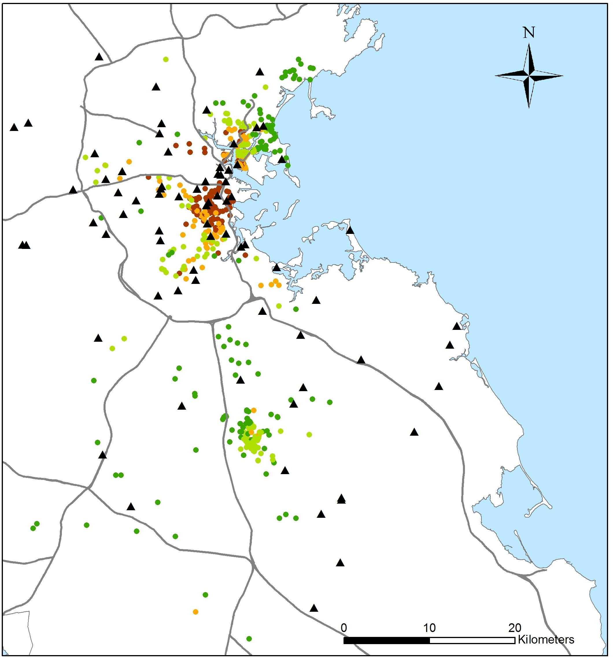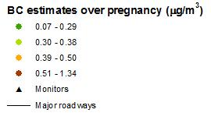

Figure 1. Predicted BC levels for ACCESS study participants

This figure shows predicted BC levels for study participants during the gestation period.
In addition, the locations of monitoring sites used in the model to predict BC levels are presented as black triangles.

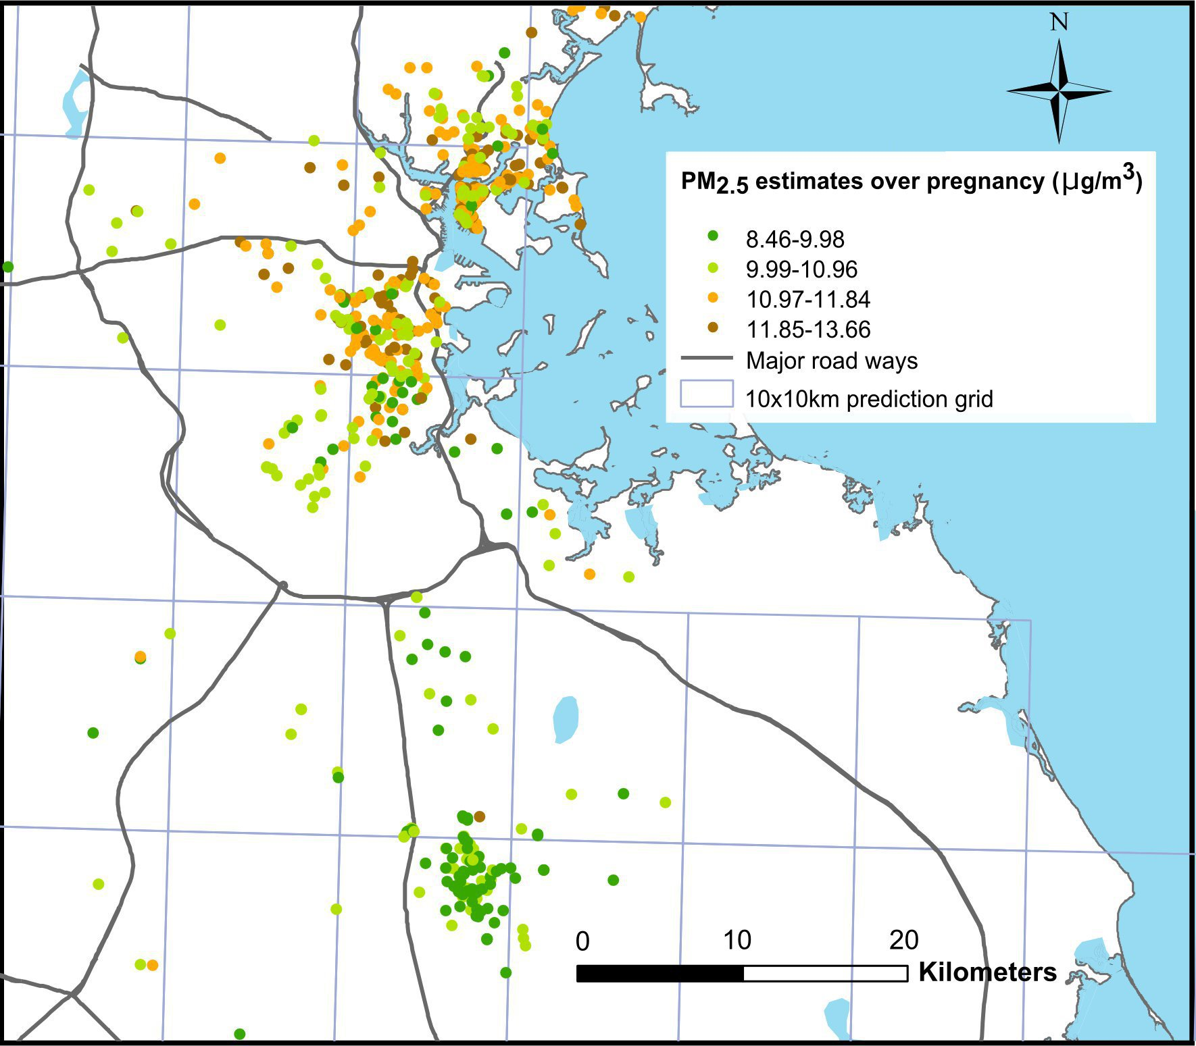

Figure 2. Predicted PM_{2.5} levels for ACCESS study participants during pregnancy

This figure shows predicted PM_{2.5} levels for study participants during the gestation period. The grids indicates the 10km x 10km AOD grid used to predict daily PM_{2.5} levels

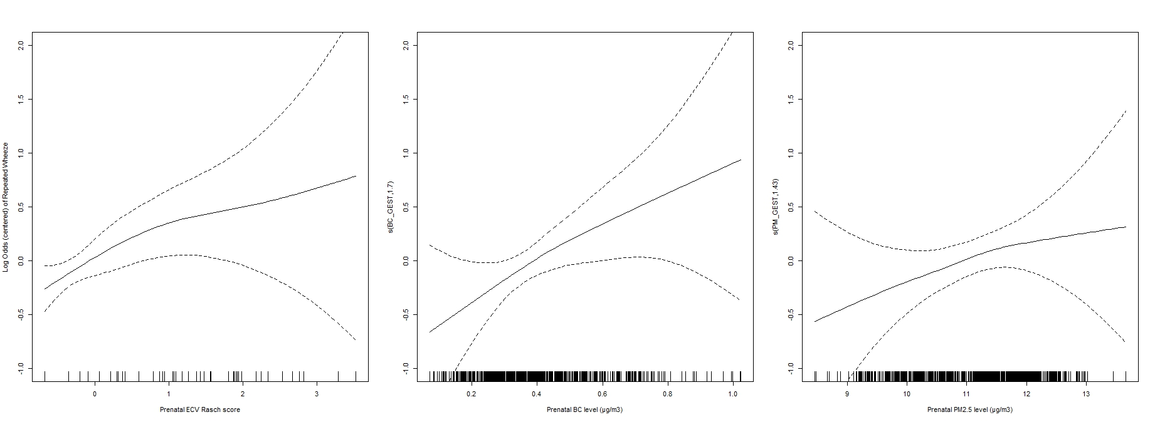
(A)
(B)
(C)

Figure 3. Exposure-responses of prenatal maternal ECV and prenatal air pollution with children’s repeated wheeze

Penalized spline curves using GAMs demonstrating the relationship of (A) prenatal maternal ECV, (B) prenatal BC level (µg/m³), and (C) prenatal PM_{2.5} level (µg/m³), with log odds of children’s repeated wheeze by age 2 years. Solid lines depict the penalized spline curve while dotted lines indicate the 95% confidence bounds. Models were adjusted for child’s gender, season of birth, maternal race, education, atopy, and household cockroach allergens.

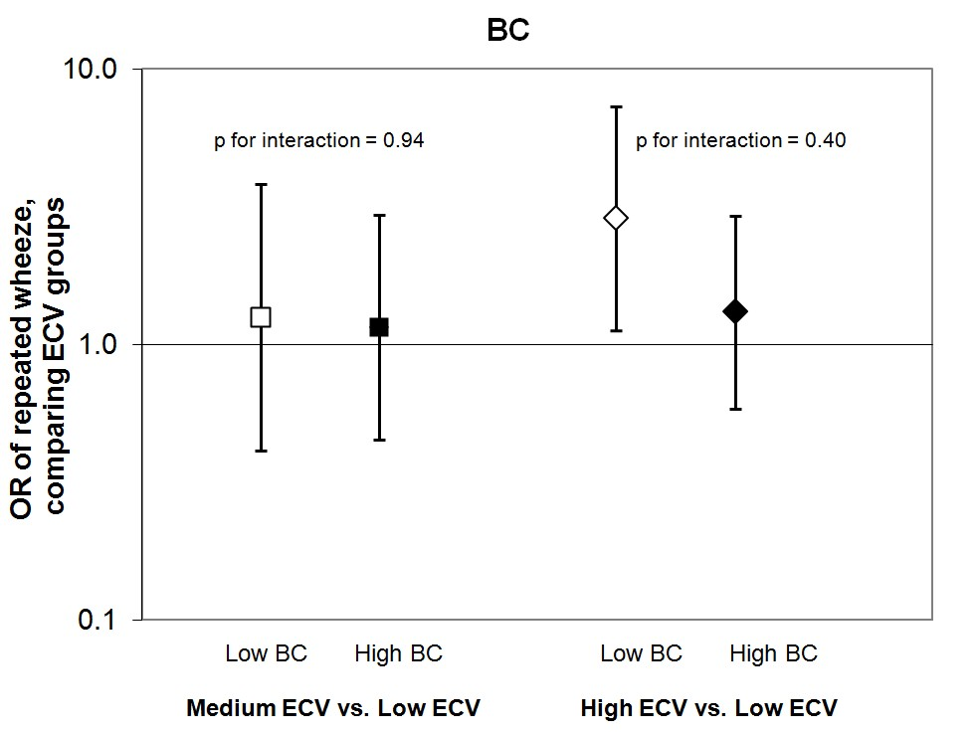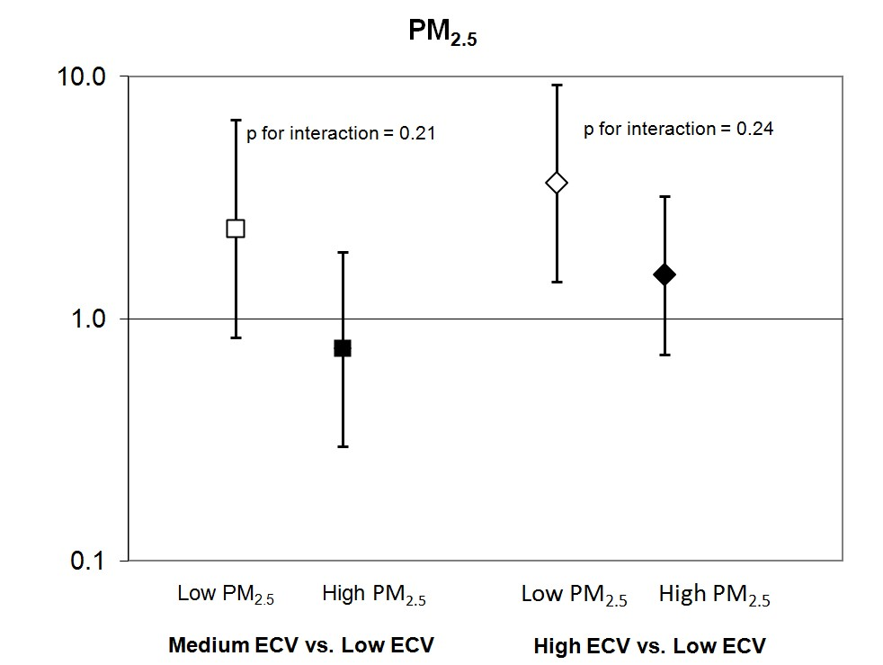

Figure 4. Associations between prenatal maternal ECV and children’s repeated wheeze in analyses stratified by air pollutant levels

This figure demonstrates ORs and 95% CIs for repeated wheeze comparing medium vs. low ECV groups (squares) and high vs. low ECV groups (diamonds), stratified by (A) BC median level (0.38 µg/m³) and (B) PM_{2.5} median level (11.22 µg/m³). The solid markers indicate the ORs for participants exposed to higher levels (> median) of air pollution and the hollow markers indicate the ORs for participants exposed to lower levels (<median) of air pollution. Models were adjusted for child’s gender, season of birth, maternal race, education, and atopy.

REFERENCES
1. Cruz AA, Bateman ED, Bousquet J. The social determinants of asthma. Eur Respir J. 2010;35(2):239-242.
2. Williams DR, Sternthal M, Wright RJ. Social determinants: taking the social context of asthma seriously. Pediatrics. 2009;123 Suppl 3:S174-S184.
3. Gupta RS, Zhang X, Springston EE, Sharp LK, Curtis LM, Shalowitz M, et al. The association between community crime and childhood asthma prevalence in Chicago. Ann Allergy Asthma Immunol. 2010;104(4):299-306.
4. Swahn MH, Bossarte RM. The associations between victimization, feeling unsafe, and asthma episodes among US high-school students. Am J Public Health. 2006;96(5):802-804.
5. Wright RJ, Mitchell H, Visness CM, Cohen S, Stout J, Evans R, et al. Community violence and asthma morbidity: the Inner-City Asthma Study. Am J Public Health. 2004;94(4):625-632.
6. Berz JB, Carter AS, Wagmiller RL, Horwitz SM, Murdock KK, Briggs-Gowan M. Prevalence and correlates of early onset asthma and wheezing in a healthy birth cohort of 2- to 3-year olds. J Pediatr Psychol. 2007;32(2):154-166.
7. Sternthal MJ, Jun HJ, Earls F, Wright RJ. Community violence and urban childhood asthma: a multilevel analysis. Eur Respir J. 2010;36(6):1400-1409.
8. Wright RJ. Health effects of socially toxic neighborhoods: the violence and urban asthma paradigm. Clin Chest Med. 2006;27(3):413-421.
9. Prenatal maternal stress and early caregiving experiences: implications for childhood asthma risk. Paediatr Perinat Epidemiol. 2007;21 Suppl 3:8-14.
10. Clark NA, Demers PA, Karr CJ, Koehoorn M, Lencar C, Tamburic L, et al. Effect of early life exposure to air pollution on development of childhood asthma. Environ Health Perspect. 2010;118(2):284-290.
11. McConnell R, Berhane K, Gilliland F, Molitor J, Thomas D, Lurmann F, et al. Prospective study of air pollution and bronchitic symptoms in children with asthma. Am J Respir Crit Care Med. 2003;168(7):790-797.
12. Salam MT, Islam T, Gilliland FD. Recent evidence for adverse effects of residential proximity to traffic sources on asthma. Curr Opin Pulm Med. 2008;14(1):3-8.
13. Ryan PH, Bernstein DI, Lockey J, Reponen T, Levin L, Grinshpun S, et al. Exposure to traffic-related particles and endotoxin during infancy is associated with wheezing at age 3 years. Am J Respir Crit Care Med. 2009;180(11):1068-1075.
14. Gauderman WJ, Avol E, Gilliland F, Vora H, Thomas D, Berhane K, et al. The effect of air pollution on lung development from 10 to 18 years of age. N Engl J Med. 2004;351(11):1057-1067.
15. Kim JJ, Smorodinsky S, Lipsett M, Singer BC, Hodgson AT, Ostro B. Traffic-related air pollution near busy roads: the East Bay Children's Respiratory Health Study. Am J Respir Crit Care Med. 2004;170(5):520-526.
16. Jedrychowski W, Perera FP, Maugeri U, Mrozek-Budzyn D, Mroz E, Flak E, et al. Early wheezing phenotypes and severity of respiratory illness in very early childhood: study on intrauterine exposure to fine particle matter. Environ Int. 2009;35(6):877-884.
17. Jedrychowski WA, Perera FP, Spengler JD, Mroz E, Stigter L, Flak E, et al. Intrauterine exposure to fine particulate matter as a risk factor for increased susceptibility to acute broncho-pulmonary infections in early childhood. Int J Hyg Environ Health. 2013.
18. Miller RL, Garfinkel R, Horton M, Camann D, Perera FP, Whyatt RM, et al. Polycyclic aromatic hydrocarbons, environmental tobacco smoke, and respiratory symptoms in an inner-city birth cohort. Chest. 2004;126(4):1071-1078.
19. Morello-Frosch R, Shenassa ED. The environmental "riskscape" and social inequality: implications for explaining maternal and child health disparities. Environ Health Perspect. 2006;114(8):1150-1153.
20. Chen E, Schreier HM, Strunk RC, Brauer M. Chronic traffic-related air pollution and stress interact to predict biologic and clinical outcomes in asthma. Environ Health Perspect. 2008;116(7):970-975.
21. Clougherty JE, Levy JI, Kubzansky LD, Ryan PB, Suglia SF, Canner MJ, et al. Synergistic effects of traffic-related air pollution and exposure to violence on urban asthma etiology. Environ Health Perspect. 2007;115(8):1140-1146.
22. Shankardass K, McConnell R, Jerrett M, Milam J, Richardson J, Berhane K. Parental stress increases the effect of traffic-related air pollution on childhood asthma incidence. Proc Natl Acad Sci USA. 2009;106(30):12406-11211.
23. Wright RJ, Suglia SF, Levy J, Fortun K, Shields A, Subramanian S, et al. Transdisciplinary research strategies for understanding socially patterned disease: the Asthma Coalition on Community, Environment, and Social Stress (ACCESS) project as a case study. Cien Saude Colet. 2008;13(6):1729-1742.
24. Selner-O'Hagan MB, Kindlon DJ, Buka SL, Raudenbush SW, Earls FJ. Assessing exposure to violence in urban youth. J Child Psychol Psychiatry. 1998;39(2):215-224.
25. Brennan RT, Molnar BE, Earls F. Refining the measurement of exposure to violence (ETV) in urban youth. J Comm Psychol. 2007;35(5):603-618.
26. Suglia SF, Ryan L, Wright RJ. Creation of a community violence exposure scale: accounting for what, who, where, and how often. J Trauma Stress. 2008;21(5):479-486.
27. Gryparis A, Coull BA, Schwartz J, Suh HH. Semi-parametric latent variable regression models for spatio-temporal modeling of mobile source particles in the greater Boston area. J R Stat Soc Ser C Appl Stat. 2007;56(2):183-209.
28. Kloog I, Koutrakis P, Coull BA, Lee HJ, Schwartz J. Assessing temporally and spatially resolved PM2.5 exposures for epidemiological studies using satellite aerosol optical depth measurements. Atmos Environ. 2011;45:6267-6275.
29. Pickett KE, Rathouz PJ, Kasza K, Wakschlag LS, Wright R. Self-reported smoking, cotinine levels, and patterns of smoking in pregnancy. Paediatr Perinat Epidemiol. 2005;19(5):368-376.
30. Rauh VA, Chew GR, Garfinkel RS. Deteriorated housing contributes to high cockroach allergen levels in inner-city households. Environ Health Perspect. 2002;110 Suppl 2:323-327.
31. Kitch BT, Chew G, Burge HA, Muilenberg ML, Weiss ST, Platts-Mills TA, et al. Socioeconomic predictors of high allergen levels in homes in the greater Boston area. Environ Health Perspect. 2000;108(4):301-307.
32. Oken E, Kleinman KP, Rich-Edwards J, Gillman MW. A nearly continuous measure of birth weight for gestational age using a United States national reference. BMC Pediatr. 2003;3:6.
33. Wood SN. Generalized additive models: An introduction with R. Florida: Chapman & Hall/CRC; 2006.
34. Knol MJ, van der Tweel I, Grobbee DE, Numans ME, Geerlings MI. Estimating interaction on an additive scale between continuous determinants in a logistic regression model. Int J Epidemiol. 2007;36(5):1111-1118.
35. Suglia SF, Ryan L, Laden F, Dockery DW, Wright RJ. Violence exposure, a chronic psychosocial stressor, and childhood lung function. Psychosom Med. 2008;70(2):160-169.
36. Morello-Frosch R, Lopez R. The riskscape and the color line: examining the role of segregation in environmental health disparities. Environ Res. 2006;102(2):181-196.
37. Wright RJ. Psychological stress: a social pollutant that may enhance environmental risk. Am J Respir Crit Care Med. 2011;184(7):752-754.
38. Perinatal stress and early life programming of lung structure and function. Biol Psychol. 2010;84(1):46-56.
39. Kiecolt-Glaser JK, McGuire L, Robles TF, Glaser R. Psychoneuroimmunology: psychological influences on immune function and health. J Consult Clin Psychol. 2002;70(3):537-547.
40. Frodl T, O'Keane V. How does the brain deal with cumulative stress? A review with focus on developmental stress, HPA axis function and hippocampal structure in humans. Neurobiol Dis. 2013;52:24-37.
41. Clark C, Ryan L, Kawachi I, Canner MJ, Berkman L, Wright RJ. Witnessing community violence in residential neighborhoods: a mental health hazard for urban women. J Urban Health. 2008;85(1):22-38.
42. Do DP, Diez Roux AV, Hajat A, Auchincloss AH, Merkin SS, Ranjit N, et al. Circadian rhythm of cortisol and neighborhood characteristics in a population-based sample: the Multi-Ethnic Study of Atherosclerosis. Health Place. 2011;17(2):625-632.
43. Suglia SF, Staudenmayer J, Cohen S, Wright RJ. Posttraumatic stress symptoms related to community violence and children's diurnal cortisol response in an urban community-dwelling sample. Int J Behav Med. 2010;17(1):43-50.
44. Ganz ML. The relationship between external threats and smoking in central Harlem. Am J Public Health. 2000;90(3):367-371.
45. Gilliland FD, Li YF, Peters JM. Effects of maternal smoking during pregnancy and environmental tobacco smoke on asthma and wheezing in children. Am J Respir Crit Care Med. 2001;163(2):429-436.
46. Vrekoussis T, Kalantaridou SN, Mastorakos G, Zoumakis E, Makrigiannakis A, Syrrou M, et al. The role of stress in female reproduction and pregnancy: an update. Ann N Y Acad Sci. 2010;1205:69-75.
47. Jeong Y, Jung-Choi K, Lee JH, Lee HY, Park EA, Kim YJ, et al. Body weight at birth and at age three and respiratory illness in preschool children. J Prev Med Public Health. 2010;43(5):369-376.
48. McConnell R, Islam T, Shankardass K, Jerrett M, Lurmann F, Gilliland F, et al. Childhood incident asthma and traffic-related air pollution at home and school. Environ Health Perspect. 2010;118(7):1021-1026.
49. Carlsten C, Dybuncio A, Becker A, Chan-Yeung M, Brauer M. Traffic-related air pollution and incident asthma in a high-risk birth cohort. Occup Environ Med. 2011;68(4):291-295.
50. Carey SA, Ballinger CA, Plopper CG, McDonald RJ, Bartolucci AA, Postlethwait EM, et al. Persistent rhinitis and epithelial remodeling induced by cyclic ozone exposure in the nasal airways of infant monkeys. Am J Physiol Lung Cell Mol Physiol. 2011;300(2):L242-254.
51. Val S, Martinon L, Cachier H, Yahyaoui A, Marfaing H, Baeza-Squiban A. Role of size and composition of traffic and agricultural aerosols in the molecular responses triggered in airway epithelial cells. Inhal Toxicol. 2011;23(11):627-640.
52. Park SJ, Lee KS, Lee SJ, Kim SR, Park SY, Jeon MS, et al. L-2-Oxothiazolidine-4-Carboxylic Acid or alpha-Lipoic Acid Attenuates Airway Remodeling: Involvement of Nuclear Factor-kappaB (NF-kappaB), Nuclear Factor Erythroid 2p45-Related Factor-2 (Nrf2), and Hypoxia-Inducible Factor (HIF). Int J Mol Sci. 2012;13(7):7915-7937.
53. Girodet PO, Ozier A, Bara I, Tunon de Lara JM, Marthan R, Berger P. Airway remodeling in asthma: new mechanisms and potential for pharmacological intervention. Pharmacol Ther. 2011;130(3):325-337.
54. Beers MF, Morrisey EE. The three R's of lung health and disease: repair, remodeling, and regeneration. J Clin Invest. 2011;121(6):2065-2073.
55. Prakash Y, Thompson MA, Meuchel L, Pabelick CM, Mantilla CB, Zaidi S, et al. Neurotrophins in lung health and disease. Expert Rev Respir Med. 2010;4(3):395-411.
56. Gump BB, Stewart P, Reihman J, Lonky E, Darvill T, Parsons PJ, et al. Low-level prenatal and postnatal blood lead exposure and adrenocortical responses to acute stress in children. Environ Health Perspect. 2008;116(2):249-255.
57. Rosati MV, Sancini A, Tomei F, Andreozzi G, Scimitto L, Schifano MP, et al. Plasma cortisol concentrations and lifestyle in a population of outdoor workers. Int J Environ Health Res. 2011;21(1):62-71.
58. Tomei F, Rosati MV, Ciarrocca M, Baccolo TP, Gaballo M, Caciari T, et al. Plasma cortisol levels and workers exposed to urban pollutants. Ind Health. 2003;41(4):320-326.
59. Thomson EM, Kumarathasan P, Calderon-Garciduenas L, Vincent R. Air pollution alters brain and pituitary endothelin-1 and inducible nitric oxide synthase gene expression. Environ Res. 2007;105(2):224-233.
60. Li C, Li X, Suzuki AK, Fujitani Y, Jigami J, Nagaoka K, et al. Effects of exposure to nanoparticle-rich diesel exhaust on adrenocortical function in adult male mice. Toxicol Lett. 2012;209(3):277-281.

