**EARTH’S RADIATION BELT**

**Responsible: Ligia Da Silva**

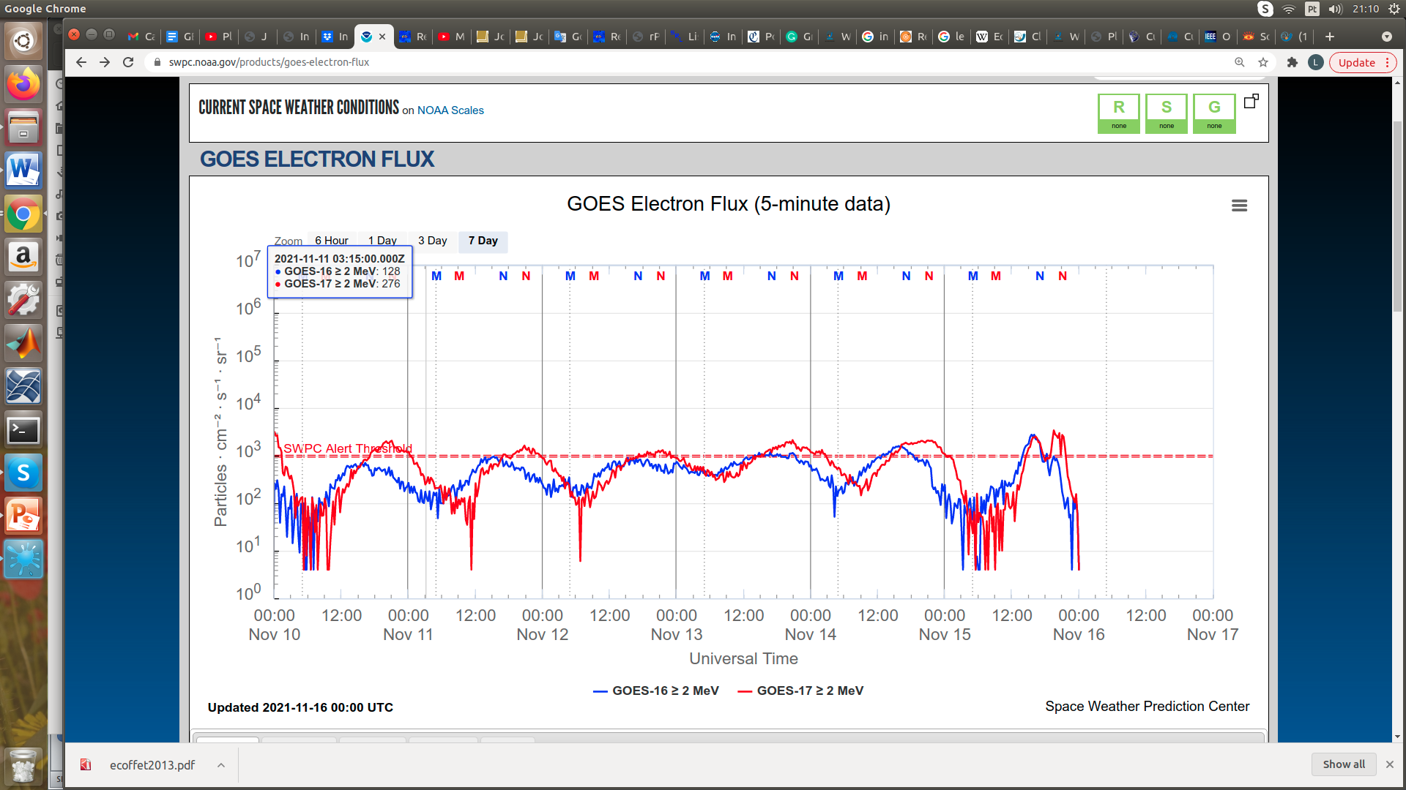

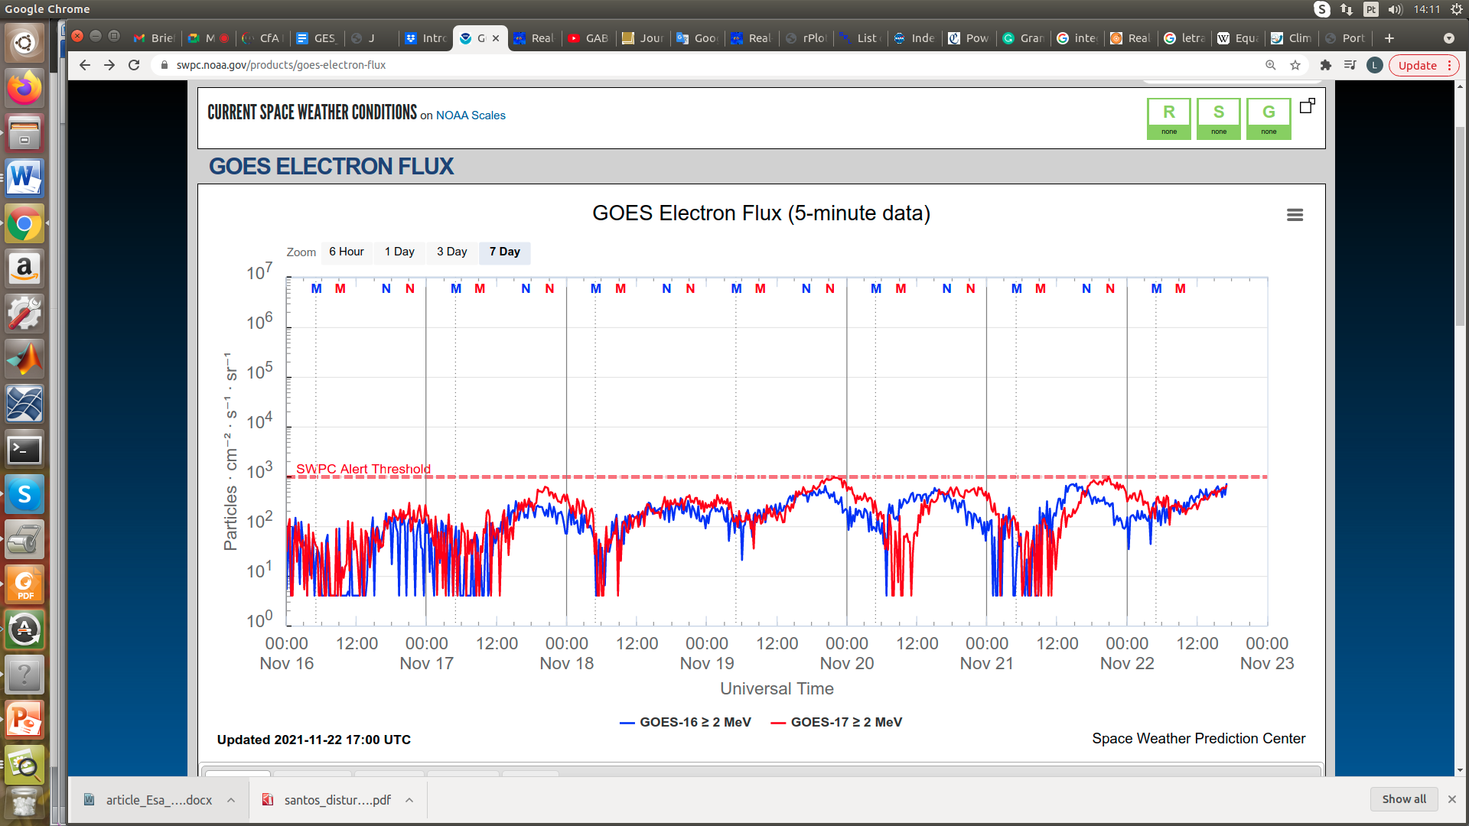

Figure 1: High-energy electron flux (> 2MeV) obtained from GOES-16 and GOES-17 satellite. Source: <https://www.swpc.noaa.gov/products/goes-electron-flux>

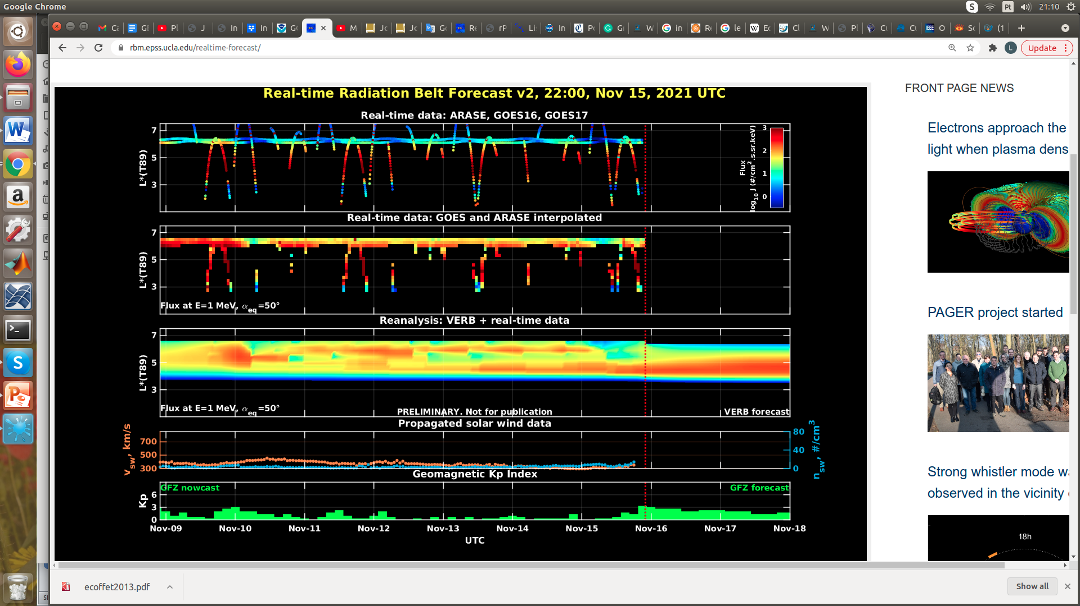

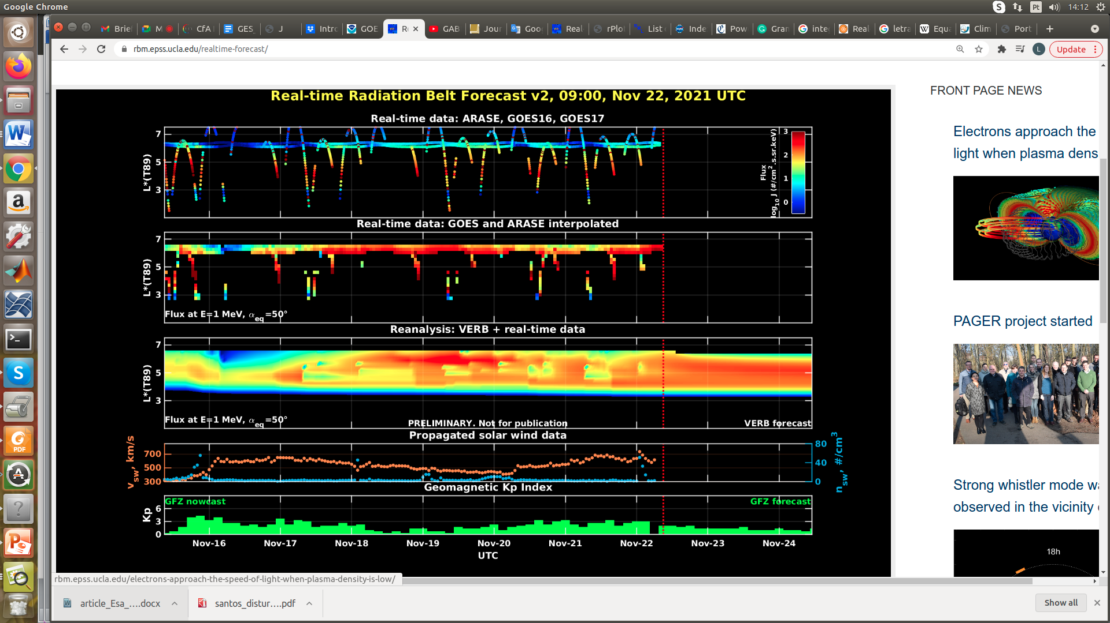

Figure 2: high-energy electron flux data (real-time and interpolated) obtained from ARASE, GOES-16, GOES-17 satellites. Reanalysis’s data from VERB code and interpolated electron flux. Solar wind velocity and proton density data from ACE satellite. Source: <https://rbm.epss.ucla.edu/realtime-forecast/>

**Summary**

High-energy electron flux (>2 MeV) in the outer boundary of the outer radiation belt obtained from geostationary satellite data GOES-16 and GOES-17 (Figure 1) is to be close to 103 particles/(cm2 s sr) almost the entire period analyzed. The first week presented two electron flux decreases (November 10th and 16th), which reach the outer boundary if the outer radiation belt. In the second week, the electron flux starts at around 102 particles/(cm2 s sr), increasing by approximately 1 order of magnitude on November 17th, which persists to this day (November 22nd).

The GOES-16, GOES-17, and Arase satellite data are analyzed and interpolated to observe the high-energy electron flux variability (1 MeV) in the outer radiation belt (Figure 2). Additionally, the VERB code rebuilds this electron considering the Ultra Low Frequency (ULF) waves' radial diffusion. The electron flux decreases observed in the first week reached only L-shell >6.0, while in the second week, the low electron flux reached L-shell >5. The electron flux variability decrease occurred concomitantly with the arrival of high speed streams and the ULF wave activity.