**EARTH’S RADIATION BELT**

**Responsible: Ligia Da Silva**

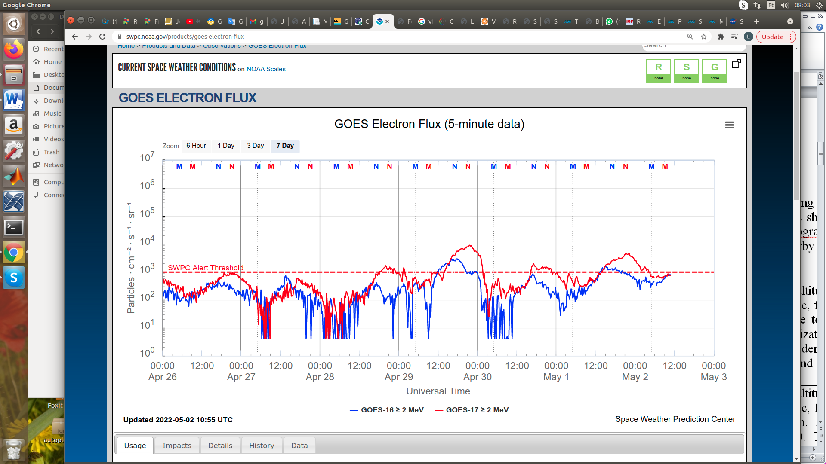

Figure 1: High-energy electron flux (> 2MeV) obtained from GOES-16 and GOES-17 satellite. Source: <https://www.swpc.noaa.gov/products/goes-electron-flux>

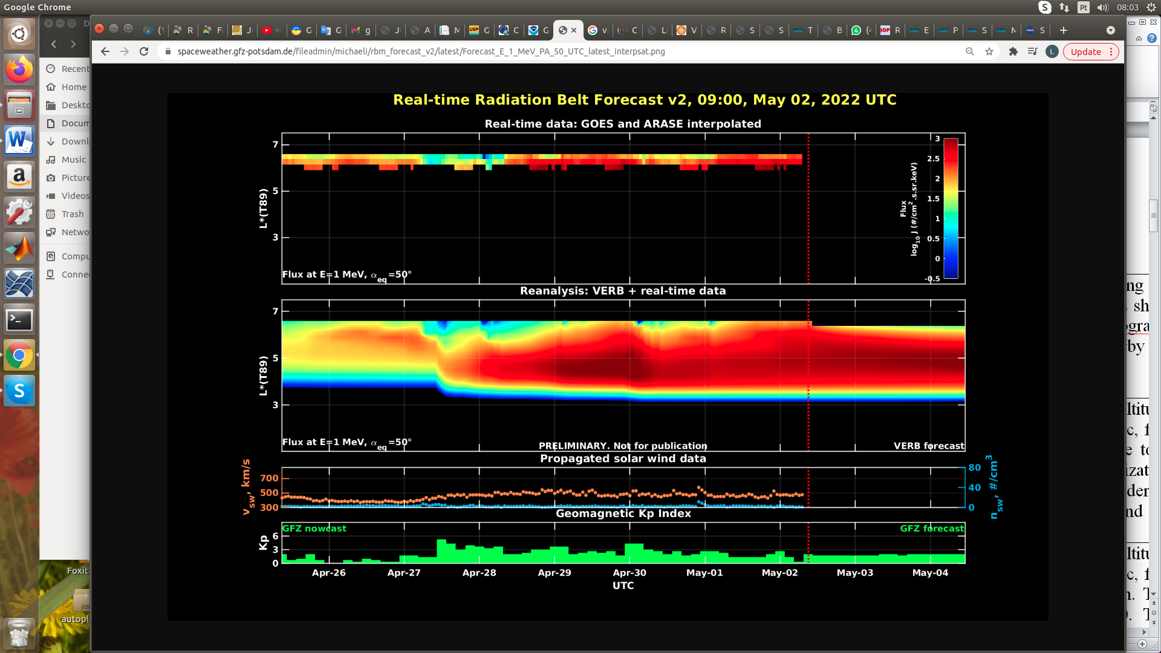

Figure 2: high-energy electron flux data (real-time and interpolated) obtained from ARASE, GOES-16, GOES-17 satellites. Reanalysis’s data from VERB code and interpolated electron flux. Solar wind velocity and proton density data from ACE satellite. Source: <https://rbm.epss.ucla.edu/realtime-forecast/>

**Summary**

High-energy electron flux (>2 MeV) in the outer boundary of the outer radiation belt obtained from geostationary satellite data GOES-16 and GOES-17 (Figure 1) is stable between the thresholds 102 and 103 particles/(cm2 s sr) until the beginning of April 27th. Two electron flux decreases were observed on April 27th and 28th. After the second electron flux decrease, an increase is observed that persists around 103 particles/(cm2 s sr) until today, presenting only one peak that reached 104 particles/(cm2 s sr) at the end of April 29th, followed by a dropout on April 30th.

The GOES-16, GOES-17, and Arase satellite data are analyzed and interpolated to observe the high-energy electron flux variability (1 MeV) in the outer radiation belt (Figure 2). Additionally, the VERB code rebuilds this electron considering the Ultra Low Frequency (ULF) waves' radial diffusion. The simulation (VERB code) shows that the first electron flux decrease observed from April 27th reached L-shell = 5.0, the second (April 28th) reached L-shell = 6.0, and the third (April 30th) L-shell = 6.5. These electron flux variability occurred concomitantly with the arrival of solar wind structures (coronal mass ejections and high-speed streams) and ULF wave activities. However, it is important to point out that the data from the ARASE satellite are not available for the week under analysis to confirm the L-shell level of these electron flux variabilities.