**EARTH’S RADIATION BELT**

**Responsible: Ligia Da Silva**

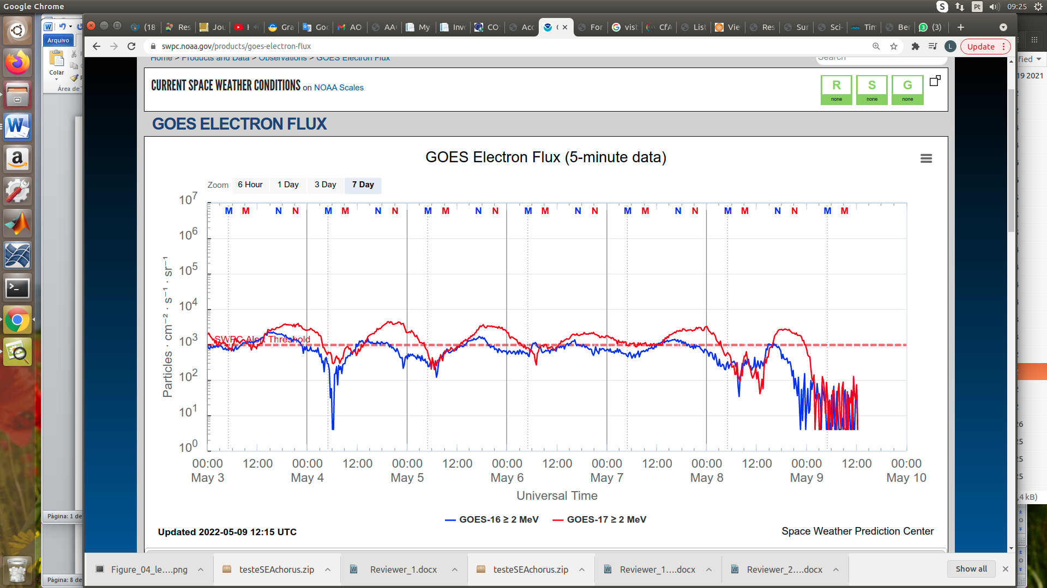

Figure 1: High-energy electron flux (> 2MeV) obtained from GOES-16 and GOES-17 satellite. Source: <https://www.swpc.noaa.gov/products/goes-electron-flux>

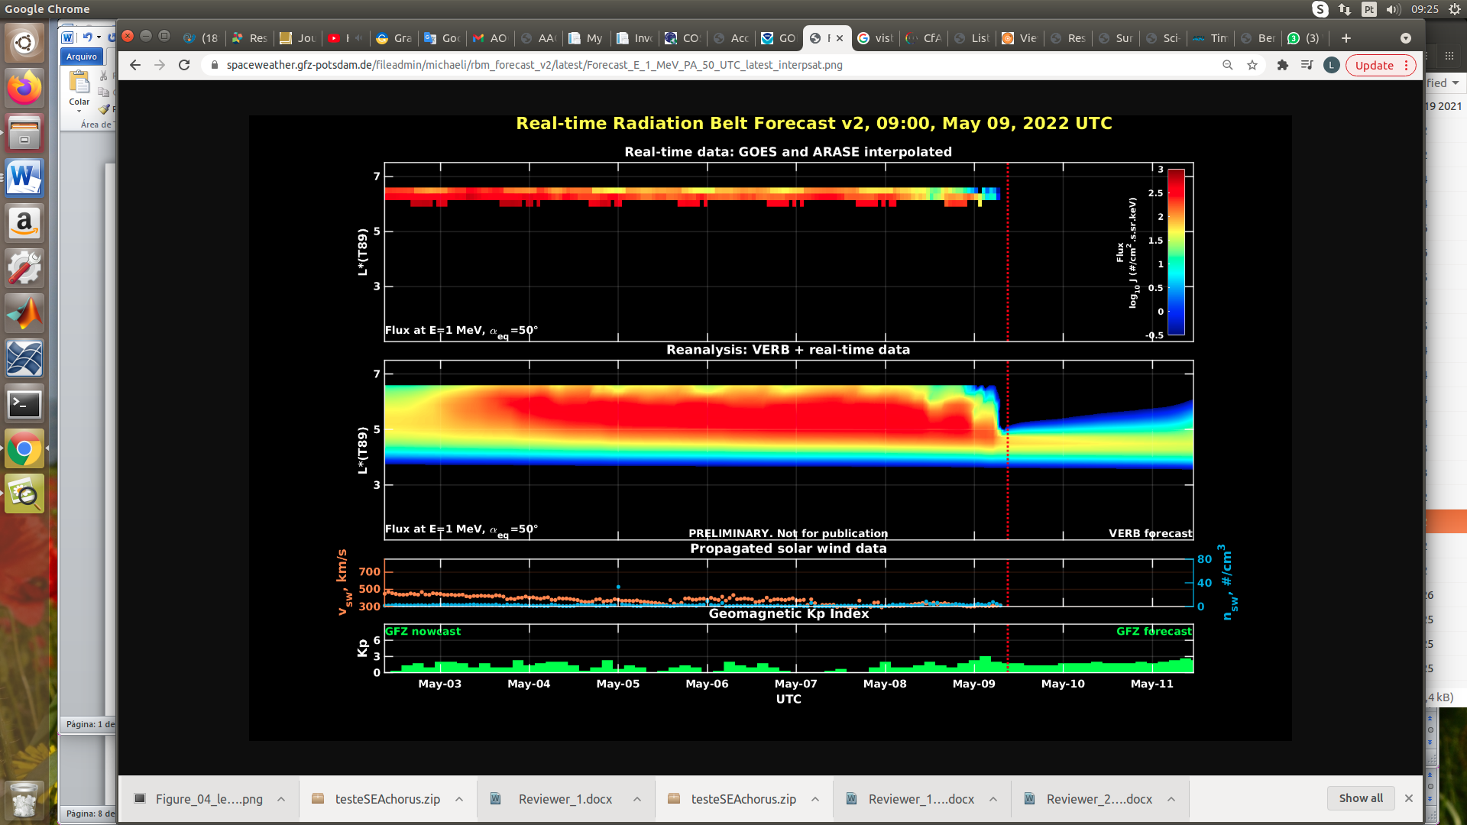

Figure 2: high-energy electron flux data (real-time and interpolated) obtained from ARASE, GOES-16, GOES-17 satellites. Reanalysis’s data from VERB code and interpolated electron flux. Solar wind velocity and proton density data from ACE satellite. Source: <https://rbm.epss.ucla.edu/realtime-forecast/>

**Summary**

High-energy electron flux (>2 MeV) in the outer boundary of the outer radiation belt obtained from geostationary satellite data GOES-16 and GOES-17 (Figure 1) is stable around the threshold 103 particles/(cm2 s sr) throughout the week of analysis. Three electron flux decreases were observed on May 4th, 8th, and 9th, respectively. The first decrease is considerably rapid, returning to the threshold of 103 particles/(cm2 s sr). The second decrease reaches approximately 1 order of magnitude and persists for more than 9n hours. The third electron flux decrease reaches approximately 2 orders of magnitude and persists until the last record.

The GOES-16, GOES-17, and Arase satellite data are analyzed and interpolated to observe the high-energy electron flux variability (1 MeV) in the outer radiation belt (Figure 2). Additionally, the VERB code rebuilds this electron considering the Ultra Low Frequency (ULF) waves' radial diffusion. The simulation (VERB code) shows that the first electron flux decrease occurs only at the outer boundary of the outer radiation belt, the second reaches L-shell = 6.0, and the third reaches L-shell – 5.0. These electron flux variability occurred concomitantly with the arrival of solar wind structures and ULF wave activities. However, it is important to point out that the data from the ARASE satellite are not available for the week under analysis to confirm the L-shell level of these electron flux variabilities.