

Report Lab 2
Computer Network Configuration
RC - L.EIC025 | 1S 2025
Class 08

André Gomes, up202304252
André Pinho, up202307008

Summary
This laboratory work focused on the practical implementation of a complete network infrastructure, ranging from Layer 1 (Physical) to Layer 7 (Application) of the TCP/IP model. The objective was to develop a C-based FTP client and configure a network topology capable of supporting it. The work was divided into two parts: software development and network configuration. In Part 1, we implemented a functional FTP client capable of parsing URLs, resolving hostnames via DNS, and transferring files using the FTP protocol (Active/Passive modes). In Part 2, we built the network infrastructure step-by-step. We started with a single broadcast domain, introduced network segmentation using bridges (VLAN simulation), and implemented routing using both a Linux-based router and a commercial MikroTik router. We further enabled Internet connectivity through Network Address Translation (NAT) and configured DNS. Throughout the experiments, Wireshark was used to capture and analyze traffic, allowing us to verify protocols such as ARP, ICMP, and TCP, and to visualize network congestion and flow control mechanisms.

Introduction
This report intends to present how a simple FTP client was implemented and how a network was configured in order to use said client. The application layer development covers Client-Server concepts as well as the FTP, a protocol which is a part of the TCP/IP suite. The network configuration provides understanding of switching/bridging, IP addresses, routing, ARP, NAT and DNS.

Part 1 - Download application

Architecture
The application, developed in C, consists of two header files, getip.h and clientTCP.h, and the corresponding functions implementation in getip.c and clientTCP.c, a core file, app.c, a makefile and a README.md.
- getip.h/c: ip resolution via the hostname
- clientTCP.h/c TCP communication (connecting, sending commands and receiving replies).
- app.c: URL parsing, program flow, feedback.
- Makefile: ease of compilation, proper clean up.
- README.md: Project description, features, usage examples, …

FTP client flow:
- Parse URL -> Resolve IP -> Connect -> Login -> Passive Mode -> Connect -> Download -> Quit

The URL parsing consists of splitting it into user, pass, host and path. This is done by a call to the function parse_ftp_url.
Given that there are three login options, username and password, username only and anonymous, our code is capable of detecting what is provided and returns the appropriate content, it also displays error messages in case of an improper URL.

IP resolution is handled in the getip.c module via the resolve_hostname_to_ip function. This function utilizes the standard DNS resolver through the gethostbyname() system call.
When a hostname (e.g., ftp.netlab.fe.up.pt) is provided, gethostbyname() returns a pointer to a hostent structure. This structure contains the official name of the host and a list of its network addresses (h_addr_list). The application extracts the first address from this list (h_addr_list[0]) and converts it from binary network byte order into a human-readable IPv4 dotted-decimal string (e.g., 192.168.1.1) using inet_ntoa(). This string is then used by the TCP module to establish the control connection."

The connection is made by calling the function tcp_connect with the resolved ip address and the standard FTP port (21), the result is stored in a socket file descriptor which acts as a handle for the active connection and is used to validate the connection and fetch the appropriate response using tcp_receive_response.

For the login, the user command is first sent via tcp_send_command, using the established socket field descriptor, afterwards the server response is fetched and analysed, this determines whether the the username is all the server requires or it the password must be provided, in the later the password is sent in the same manner the user is and the response is once again analysed for success or failure.

Upon successful login the client enters passive mode, once again tcp_send_command is used to send the command and the response is fetched. This response contains the ip and port for the data connection in the format (ip1,ip2,ip3,ip4,p1,p2), where ip1 to ip4 represent parts of the ip address in order, p1 and p2 allow to calculate the port, port = (p1 x 256) + p2. The decoding and calculation is performed by the parse_pasv_response function which constructs the ip address, stores it in a variable and returns the port.

A new socket file descriptor is created using the ip address and port attained in the last phase, which handles the actual file transfer independently of the command channel.

The RETR command, with the file path is then sent over the control connection to instruct the server to begin transmitting the file

Afterwards the file name is extracted from the user input using extract_filename, a local file is created in binary mode to store the downloaded content and various control variables are set, the data is read from the data socket in a loop using recv and written to the file. The loop ends when recv returns a number smaller than 1, indicating the transfer is complete.

Finally, the quit command is used to close the connection.

For security purposes, all user dependent text field lengths are validated, they all have a maximum size and all copies account for said size. Moreover, all socket file descriptors are closed in case of error.
In order for the user to be aware of the program state, all phases output their result, success and description or error, all tcp responses are printed fully and when downloading, there is an updating percentage and byte count.

The program can be compiled using the Makefile by running make in the root directory, this generates an executable named download.
The program now can be executed by running ./download <ftp_url>.

Example
In order to prove that the application is working, a small video will be downloaded from ftp.gnu.org, providing only a username.
By running ./download ftp://anonymous@ftp.gnu.org/video/FSF_event_small.ogv in the root directory after compilation, the video will be downloaded.

The screenshots in the annexes show the terminal window where the application was compiled and ran and the wireshark log.

Terminal Analysis: The terminal screenshot validates that the ftp_url was properly parsed, shows every server response and that all interactions were successful and the port calculation is correct, as well as the file size extraction.

Wireshark Analysis: "The Wireshark logs captured during the execution validate the protocol implementation:
- Control Connection & Login: The logs show the initial TCP 3-way handshake on port 21. Packet 7 shows the client USER anonymous request, followed by the server's confirmation 230 Login successful in Packet 9.
- Passive Mode: Packet 13 shows the PASV command. The server responds in Packet 15 with code 227 Entering Passive Mode. The parameters (79, 253) correspond to the port 79×256+253=20477, which matches the port used for the data connection.
- Data Request: After establishing the secondary TCP connection (Packet 17), the client creates the RETR ... request in Packet 20. The server accepts this with code 150 Opening BINARY mode... in Packet 23.
- Transfer & Termination: The actual file content is visible as FTP-DATA packets. Once the transfer finishes, the server sends 226 Transfer complete (Packet 1622), and the client closes the session with QUIT (Packet 1625), receiving a final 221 Goodbye (Packet 1627)."
Terminal screenshot Wireshark logs

Part 2 - Network configuration and analysis
This section describes the progressive implementation of a network topology, starting from a single broadcast domain up to a routed network with NAT and DNS, analyzing the protocols involved at each stage. We will explain, for each experiment, its network architecture, objectives, main configuration commands and their use, and finally the relevant logs of the experiment.

Experiment 1: Configure an IP Network
The objective of this experiment was to configure a simple IP network within a single broadcast domain. Two Linux hosts (tux123 and tux124) were connected to a MikroTik switch acting in its default configuration (all ports switched). The goal was to establish connectivity using IPv4 and analyze the Address Resolution Protocol (ARP).
To do so, we first needed to connect the cables from if_e1 of tux123 and tux124 to the switch (ports 1 and 24 respectively in our case) and after configure if_e1 interface of tux123 and if_e1 interface of tux124 (Configuring tux123 and tux124).
Following this we verified the connectivity between the computers by using ping 172.16.120.254 and then we saved the IP and MAC addresses of the network interfaces after running arp -n in tux123 ( IP - 172.16.120.254; MAC - ec:75:0c:c2:3c:ac). In order to observe the ARP mechanism, the ARP table entries were deleted in tux123 ( arp -d 172.16.120.254 ) before initiating the ping. We started the Wireshark capture and using ping 172.16.120.254 we gathered the following log: Log experiencia 1
The log reveals the following sequence of patterns:
- ARP Request: tux123 broadcasts "Who has 172.16.120.254? Tell 172.16.120.1".
- ARP Reply: tux124 replies unicast to tux123 with its MAC address.
- ICMP Echo Request/Reply: Only after resolving the MAC address does the first ICMP Echo Request leave tux123.

Questions:

ARP (Address Resolution Protocol) packets map known IP addresses (Layer 3) to unknown MAC addresses (Layer 2). This is necessary because Ethernet switches and network cards communicate using physical MAC addresses, not IP addresses.
ARP Requests use the sender's MAC/IP as the source and the Broadcast MAC (FF:FF:FF:FF:FF:FF) as the destination because the target's location is unknown. ARP Replies use the target's MAC/IP as the source and the requester's MAC as the destination (unicast) because the requester's identity is now known.
The ping command generates ICMP Echo Request packets and waits for ICMP Echo Reply packets to confirm connectivity.
Ping packets use the specific unicast MAC and IP addresses of the source and destination devices for both Requests and Replies, as the address resolution (ARP) must have already completed successfully for the ping to be sent.
A receiving frame is identified by the EtherType field in the Ethernet header: 0x0806 indicates ARP, and 0x0800 indicates IPv4. If it is IPv4, the "Protocol" field in the IP header identifies the payload, where 1 indicates ICMP.
The frame length is determined physically by the hardware detecting the end of the signal, or logically by reading the "Total Length" field in the IP header and adding the Ethernet overhead (14-byte header + 4-byte FCS).
The loopback interface (lo, usually 127.0.0.1) is a virtual network interface that allows a computer to communicate with itself. It is essential for internal system communication and for testing network applications without needing physical network hardware.

Experiment 2: Implement two bridges in a switch
This experiment was designed in order to make us verify that different networks do not communicate between each other (Unicast Isolation) and to verify how far broadcast packets travel (Broadcast Isolation). To do so, the switch was configured to create two logically separated networks (Broadcast Domains) using Bridges, effectively simulating VLANs.
- Bridge120 (172.16.120.0/24): Ports 1 (tux123 - if_e1) and 24 (tux124 - if_e1).
- Bridge121 (172.16.121.0/24): Port 16 (tux122 - if_e1).
To do this, we needed to make sure the previous computers kept the same configuration and then configured the IP of the new computer (Configuring IP) and saved the IP and MAC addresses (IP - ; MAC - ). After that, we configured the switch by creating two virtual bridges to separate the traffic (GTKTerm Configuring Switch). At this point, we removed the default bridges from the ports 1, 24 and 16 of the switch, in order for these to be able to be added to the new bridges (Adding Bridges).
After this, we tested the Unicast connectivity to check if the networks are isolated (Pings Exp2). The Wireshark capture from these pings verified a successful first ping (Ping from tux123 to tux124 and tux122) because they are in the same bridge. Contrary to this, the second ping failed because they are on different bridges.
The second part of this experiment was the broadcast test and to do so, we recorded using Wireshark in all tux’s and did ping -b 172.16.120.255 from tux123 (Broadcast from 3) to do a broadcast ping in the network 120. The -b flag enables broadcast and the IP ending in .255 is the broadcast address of this subnet. The capture on tux124 (Broadcast 3 to 4) shows the incoming broadcast packets, as it shares bridge120. However, the capture on tux122 (Broadcast 3 to 2) shows no packets from this source. We repeated these steps and in the tux122 we did ping -b 5 172.16.121.255 (Broadcast from 2) and the results showed that neither tux123 (Broadcast 2 to 3) or 124 (Broadcast 2 to 4) acknowledged this communication because tux122 is alone in bridge 121.
With this experiment, we arrived at the conclusion that the bridges successfully isolated the collision and broadcast domains at Layer 2. Tux123 could not communicate with tux122 because they were on different logical switches with no router to forward packets between them.

Questions:

To configure bridge120, we first create the logical bridge interface using the command /interface bridge add name=bridge120. Then, we assign the specific physical ports to this bridge using /interface bridge port add bridge=bridge120 interface=etherX, ensuring these ports were previously removed from any default configuration.
There are two distinct broadcast domains. We conclude this from the logs because broadcast packets sent to 172.16.120.255 were captured on tux124 (which shares bridge120) but were completely invisible on tux122 (which is on bridge121), proving that broadcast traffic is contained within the configured bridge and does not cross to the other.

Experiment 3: Configure a Router in Linux
The main goal of this experiment is to configure tux124 as a Router. To do so, it was physically connected to both bridges (if_e1 to bridge120 and if_e2 to bridge121) and then configured in the GTKTerm in tux122 (exp3_b1). After this we had to configure tux124 to forward traffic between the two interfaces (exp3_b2) and also reconfigure tux123 and tux122 so that each of them can reach the other using tux124 (exp3_b3). At this point we cleaned the ARP tables from all tux’s (arp -d -a) and started recording using Wireshark in tux123 (if_e1) in order to see the results of the following ping’s - exp3_b4. Connectivity was verified in three stages from tux123:
- Local Gateway (Ping 172.16.120.254): The ping succeeded with ttl=64, confirming tux123 and the router's ingress interface share the same Layer 2 segment.
- Remote Gateway Interface (Ping 172.16.121.253): The successful ping demonstrates that tux123 can reach the router's interface, validating the routing path across the device.
- Remote Host (Ping 172.16.121.1): The ping reached tux122 successfully. Crucially, the return ttl=63 confirms the packet traversed exactly one router (tux124).
To analyze the routing process in detail, we proceeded to capture traffic directly on the router (tux124). Two instances of Wireshark were launched simultaneously: one monitoring if_e1 and the other monitoring if_e2. Before initiating traffic, the ARP tables were cleared on all devices to ensure the address resolution process was visible. A ping was then sent from tux123 to tux122. The results are displayed in Ping tux122, where the left window shows the traffic on if_e1 and the right window shows the traffic on if_e2. The captures clearly illustrate the separation of broadcast domains and the routing mechanism:
ARP Resolution:
- On if_e1: tux123 broadcasts an ARP request for its gateway, 172.16.120.254. The router replies with the MAC address of its if_e1 interface.
- On if_e2: After receiving the IP packet destined for the 121 network, the router broadcasts an ARP request on if_e2 to find 172.16.121.1 (tux122). tux122 replies with its MAC address.
ICMP Forwarding:
- Echo Request: The packet from tux123 arrives at the router on if_e1. The router then forwards it out of if_e2 towards tux122.
- Echo Reply: The reply from tux122 is received by the router on if_e2 and is subsequently routed back to tux123 via if_e1.

This confirms that tux124 is correctly forwarding packets between the interfaces and managing ARP resolution independently for each subnet.

Questions:

The routing tables contain direct connection routes (e.g., 172.16.120.0/24) that allow communication with devices on the local link, and gateway routes (default or static) that direct traffic for remote networks to a specific router IP address.
A forwarding table entry contains the Destination Network (target subnet), the Gateway (next hop IP), the Genmask (subnet mask), the Flags (indicating route status), and the Interface (network card) used to transmit the packet.
We observe ARP Requests (broadcast) from the sender to resolve the router's MAC, followed by the router's ARP Reply. On the second interface, the router sends its own ARP Request to resolve the final destination's MAC, followed by the destination's Reply.
ICMP Echo Request and Echo Reply packets are observed to verify end-to-end connectivity. We may also see ICMP Time Exceeded if a loop occurs, or ICMP Redirect if the router detects a more efficient path.
The IP addresses (Source and Destination) remain constant throughout the entire path. The MAC addresses change at each hop: the sender uses the Router's MAC as the destination, and the Router replaces it with the final recipient's MAC for the next leg of the journey.

Experiment 4: Configure a Commercial Router and Implement NAT
In this experiment, we will introduce a commercial MikroTik router (RC) into the network to provide access to the external laboratory network (172.16.1.0/24) and the Internet. The Linux router (tux124) remained active. NAT (Network Address Translation) was implemented on RC to allow the private lab networks to communicate with the outside. Regarding physical connections, we had to connect ether1 of RC to the lab network and ether2 to port 10 of the Switch (bridge 121). We configured the Switch to add port 10 (Configuring Switch) and disconnected the cable from the Switch Console port and connected it to the Console port of the RC. After resetting it we configured the IP addresses on the RC by configuring the LAN interface (ether2) and the WAN interface (ether1) (Configure LAN and WAN interfaces). After this we configured the routes and NAT on the RC, because it needs to be able to identify how the “Internet” and network 120 are accessed (Configure Routes and NAT on the Router). Once the configuration was complete, we updated the routing tables (Update Routes). We verified connectivity by pinging from tux123 to all relevant interfaces (Ping from 3 to server step7 fails; Ping from 3 to Server step5). The results confirmed that tux123 could successfully reach tux122, tux124, and the RC interfaces.
Next, we explored ICMP redirect behavior on tux122. We disabled ICMP redirect acceptance (Disable ICMP Redirects) and changed the routing to use RC as gateway instead of tux124 (Change Gateway to RC). When pinging tux123 from tux122, the Wireshark capture (Ping from 2 to 3 via Router) showed packets being forwarded through RC even though a more direct path existed. We performed a traceroute which confirmed this routing path. We then restored the route through tux124 (Restore Gateway to tux124) and observed the more direct path (Ping from 2 to 3 redirect step 4).To understand ICMP redirects, we removed the route and re-enabled redirect acceptance (Enable ICMP Redirects and Test). When pinging, tux122 initially used the default gateway (RC), but ICMP redirect messages instructed it to use the optimal path through tux124. We then tested connectivity from tux123 to the external FTP server at 172.16.1.10. With NAT enabled, packets successfully traversed the network because RC performed source NAT (Ping from 3 to server). Finally, we disabled NAT (Disable NAT) and attempted the same ping, which failed because return packets could not reach our private network (Ping from 3 to server after disabling NAT). This demonstrated that NAT is essential for allowing private networks to communicate with external networks.

Questions:

A static route is configured using the command /ip route add dst-address=[Destination_Network] gateway=[Next_Hop_IP], which manually defines the path traffic must take to reach a specific remote subnet.
Without ICMP Redirects, packets travel from the host to the Default Gateway and then back to the Router (hairpinning), which is inefficient. With Redirects enabled, the Gateway sends an ICMP Redirect message, telling the host to send subsequent packets directly to the Router, optimizing the path.
NAT is configured using the command /ip firewall nat add chain=srcnat action=masquerade out-interface=[WAN_Interface], which enables the router to translate internal private IP addresses to its single public interface IP.
NAT (Network Address Translation) modifies the IP header of outgoing packets, replacing the private source IP address with the router's public IP address, allowing private devices to communicate with the Internet.
When NAT is disabled, the ping fails because the packets reach the external server with their original private source IP. The external server drops the reply because private IP ranges are not routable on the public Internet and it has no path back to the sender.

Experiment 5: DNS
Domain Name System (DNS) configuration was added to translate human-readable names into IP addresses. The resolvers were configured to use the Lab Gateway (172.16.120.254) as the nameserver. This ensures that DNS queries are sent through the experimental network interface (if_e1) and can resolve both internal lab domains and external internet domains via the router's DNS relay.
The configuration involved editing /etc/resolv.conf to set the nameserver to 172.16.120.254 and ensuring the default route was set to the gateway using route add default gw 172.16.120.254 dev if_e1.
Using the command ping google.com triggered a DNS resolution sequence. We observed an IPv4 UDP packet sent to destination port 53 on the gateway (172.16.120.254) asking for the IP of the hostname. A response packet was received containing the Answer Section with the resolved IP address. Connectivity was only established after this successful resolution, proving the dependency of application-layer services on correct DNS configuration. (Ping google.com)
Questions:
A DNS packet is encapsulated in a UDP datagram (Layer 4), which is inside an IP packet (Layer 3), which is finally inside an Ethernet Frame (Layer 2).
The destination port for DNS queries is typically UDP 53.
The DNS server is running on the Lab Gateway (172.16.120.254), which acts as a DNS relay to forward queries to the appropriate internal or external DNS servers.
We observe a DNS Standard Query (A) packet asking for the IP of the hostname, followed by a Standard Query Response packet containing the "Answer" section with the resolved IP address.
The ARP protocol is still necessary because even after DNS resolves the hostname to an IP address, the computer needs the MAC address of the next-hop gateway to construct the Ethernet frame required to transmit the packet.

Experiment 6: TCP Connections
The experiment analyzed TCP protocol behavior focusing on connection establishment, data transfer, and congestion control using a custom FTP client. We first verified the application functionality by downloading a file from the lab server, confirming correct execution of FTP commands like USER, PASS, PASV, and RETR. (step 2)
FTP utilizes two distinct TCP connections. The Control Connection handles authentication and commands, evidenced by server response code 227 entering passive mode. (step 4 ftp filter)
The Data Connection establishes upon the RETR command. The TCP flow graph shows the standard 3-way handshake (SYN, SYN-ACK, ACK), followed by data transfer segments, and finally the connection termination via FIN-ACK. (step4 tcp) (step 4 all flows)
We analyzed congestion control during a single file download. The Stevens graph shows a linear progression of sequence numbers, indicating stable throughput where the connection saturated available bandwidth without significant packet loss. (step 4 congestion control)
The concurrent flow experiment revealed distinct starvation behavior. Tux3, the established flow, utilized the full 80 Mbps bandwidth immediately and maintained saturation until completion around 11.5 seconds. (sametime final tux3)
In contrast, Tux4 attempted to connect while Tux3 saturated the link. Tux4 suffered starvation with near-zero throughput for the first 11 seconds due to buffer saturation by Tux3. Once Tux3 finished, Tux4's throughput immediately spiked to capture the available bandwidth. ()
The results validate TCP reliability mechanisms but highlight that without fair queuing, established flows can starve new connections.

Questions:

A TCP connection is established using a 3-way handshake. The client initiates the connection by sending a SYN packet, the server replies with a SYN-ACK packet to acknowledge and synchronize sequence numbers, and the client finally confirms with an ACK packet, establishing the session.
The connection is terminated using a 4-way handshake. The client (or server) sends a FIN packet to indicate it has no more data to send. The other side sends an ACK to acknowledge the request, then sends its own FIN when it is ready to close, which is finally acknowledged by the first party with an ACK.
The throughput graph shows distinct phases of TCP congestion control. It begins with the Slow Start phase, where throughput increases exponentially. When packet loss occurs (indicated by a sharp drop in the graph), the protocol reduces the transmission rate and enters Congestion Avoidance, where throughput increases linearly to probe for available bandwidth without causing immediate congestion.
Throughput is controlled by two main window parameters: the Flow Control Window (rwnd), which is advertised by the receiver to prevent buffer overflow, and the Congestion Window (cwnd), which is calculated by the sender to prevent network saturation. The actual transmission rate is determined by the minimum of these two windows.

Conclusions
This project successfully integrated software development with network engineering.
- Application Layer: We learned that protocols like FTP rely on strict state machines (Login -> Passive -> Transfer) and that the application layer is agnostic to the underlying network complexity, relying on DNS and IP routing to function.
- Network Layer: We verified that bridges isolate collision domains but not broadcast domains (unless configured as separate VLANs/bridges), whereas routers completely isolate broadcast domains.
- NAT & Routing: Experiment 4 demonstrated that without NAT, private networks are "invisible" to the outside world. The routing experiments highlighted the importance of correct static routes; a single missing return route prevents two-way communication (as seen in the "No route to host" errors).
- Diagnostics: Tools like ping, traceroute, and Wireshark were indispensable for diagnosing issues like incorrect ARP entries or routing loops.
By completing this lab, we gained a practical understanding of how data moves from a C program, through the socket API, encapsulated into TCP/IP/Ethernet packets, routed across physical devices, and delivered to a destination.

Annexes

Part 1

Terminal
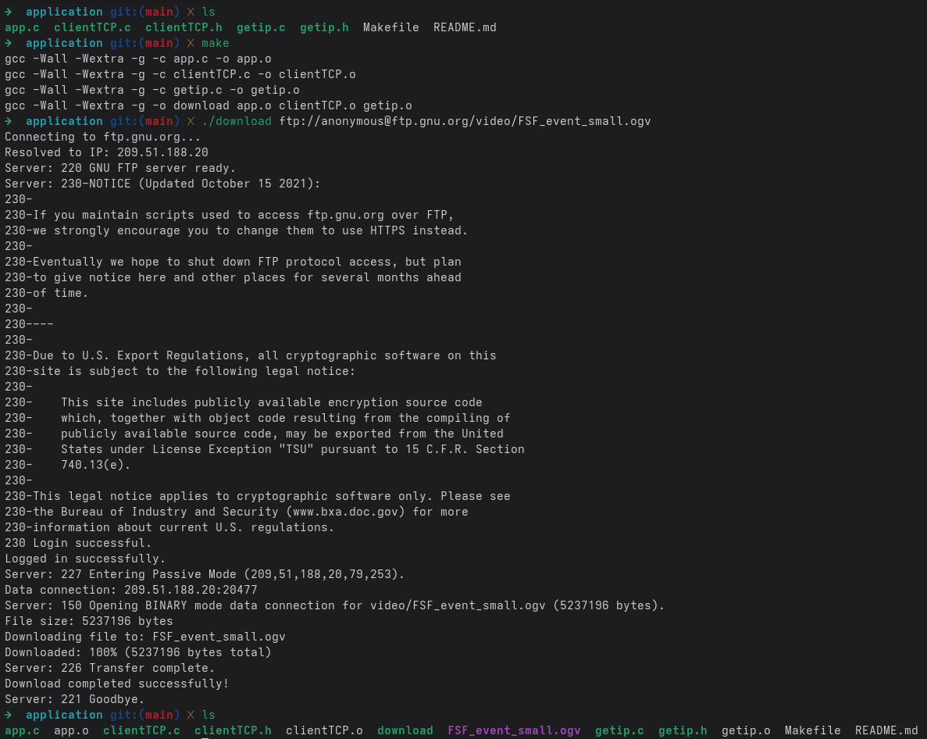

Wireshark
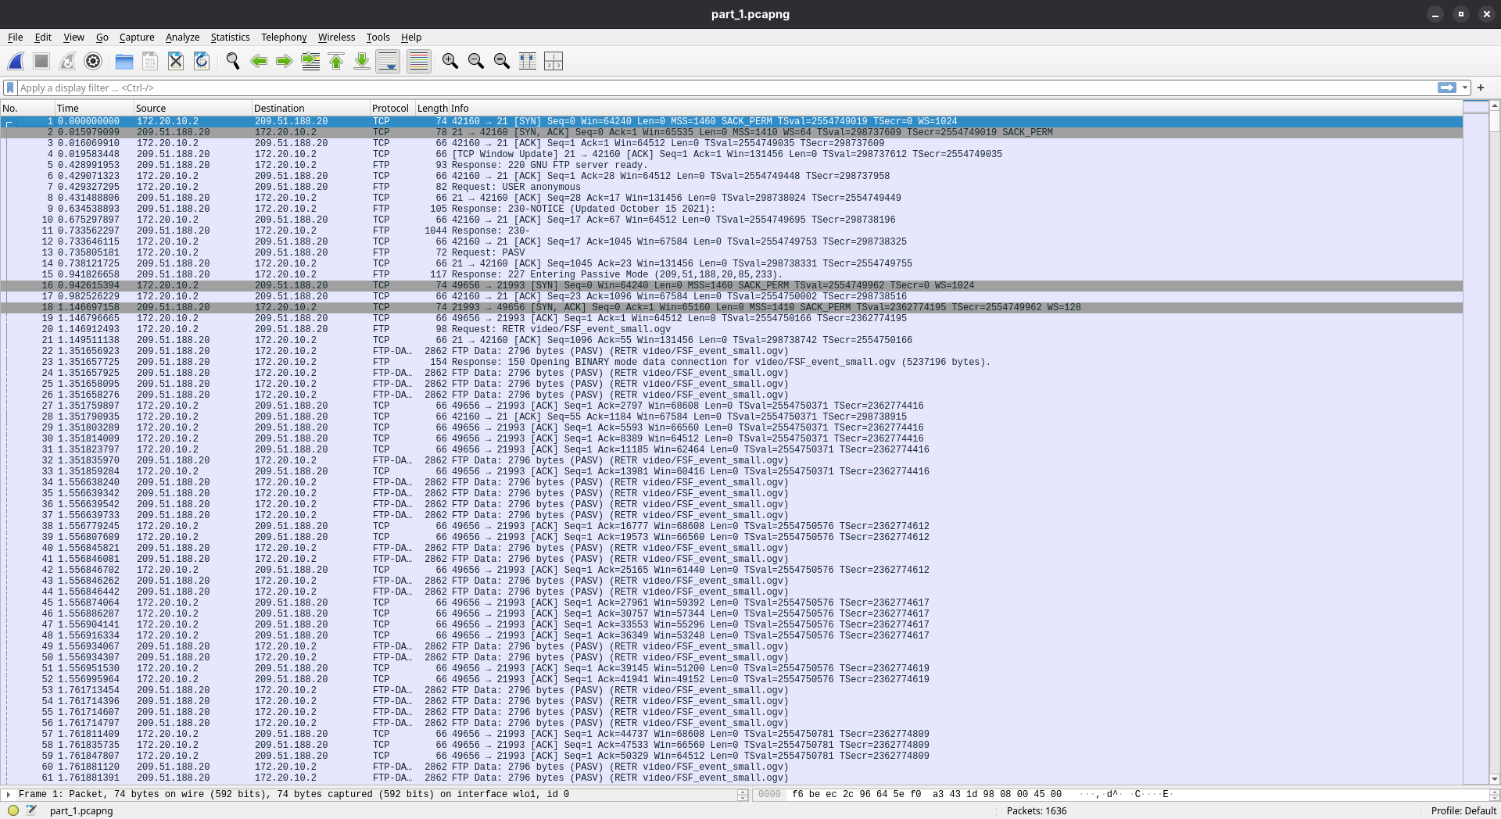

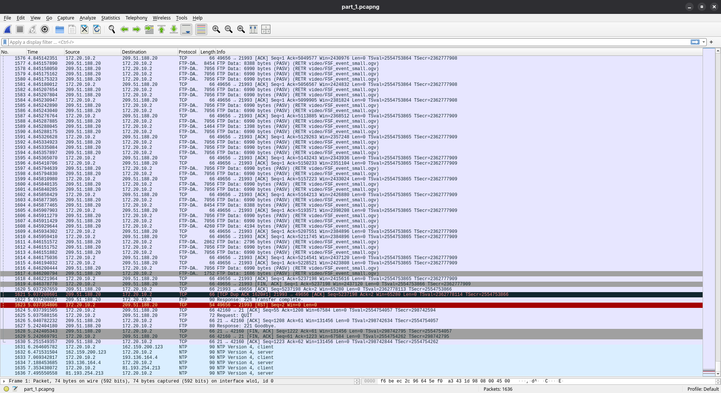

Part 2

Exp 1
Configuring tux123 and tux124
- ifconfig if_e1 172.16.120.1/24 up #from tux123
- ifconfig if_e1 172.16.120.254/24 up #from tux124
Log experiencia 1

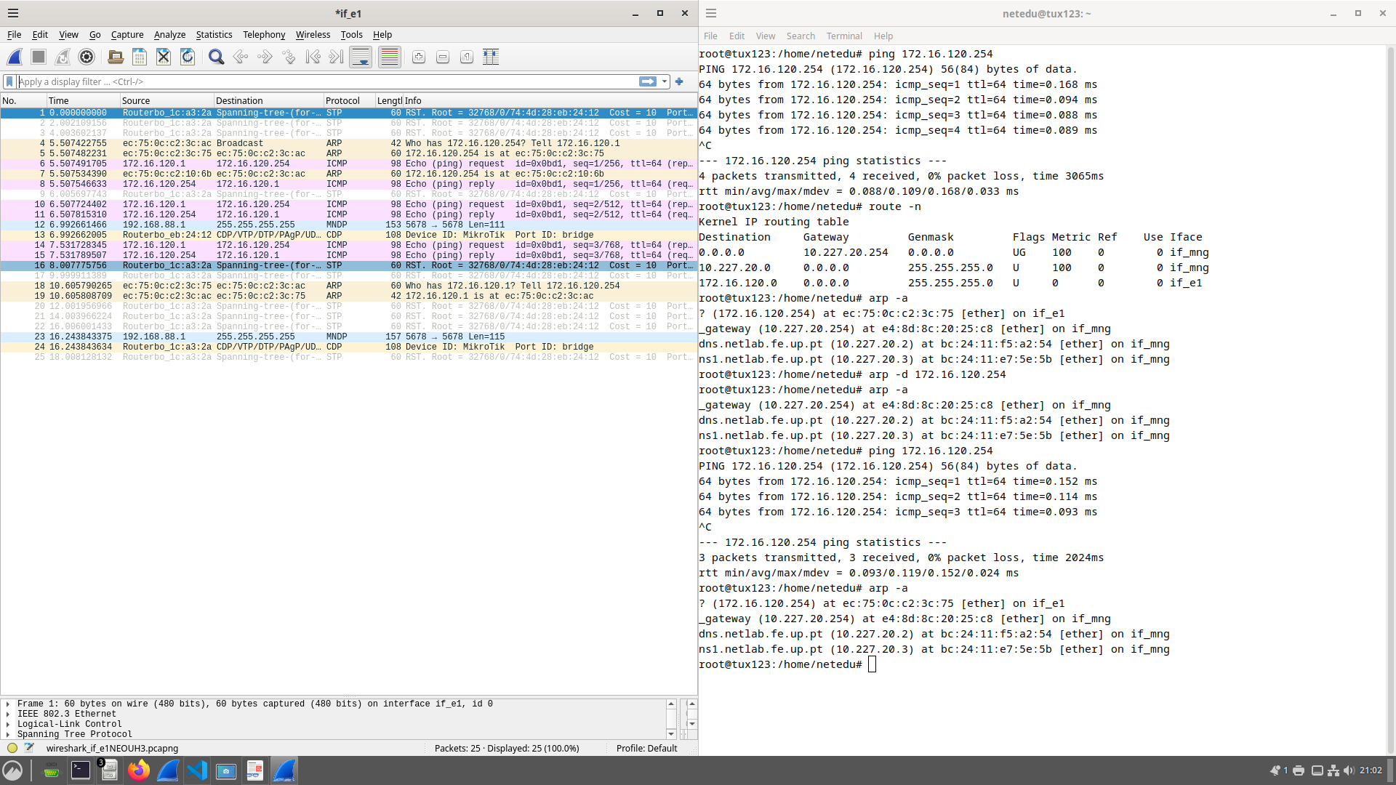

Exp 2
Adding Bridges
- /interface bridge port remove [find interface=ether1]
- /interface bridge port remove [find interface=ether24]
- /interface bridge port remove [find interface=ether16]

- /interface bridge port add bridge=bridge120 interface=ether1
- /interface bridge port add bridge=bridge120 interface=ether24
- /interface bridge port add bridge=bridge121 interface=ether16
GTKTerm Configuring Switch
- /interface bridge add name=bridge120
- /interface bridge add name=bridge121
Configuring IP
- ifconfig if_e1 172.16.121.1/24 up
Pings Exp2
- ping 172.16.120.254 #from tux123
- ping - 172.16.121.1 #from tux 123

Ping from tux123 to tux124 and tux122

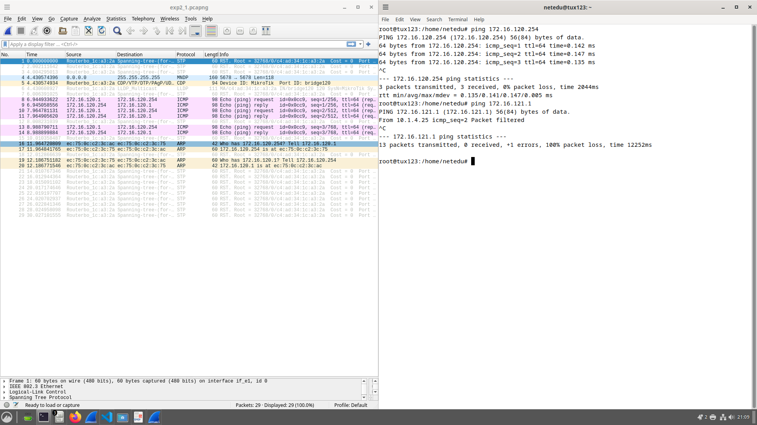

Broadcast 3 to 2

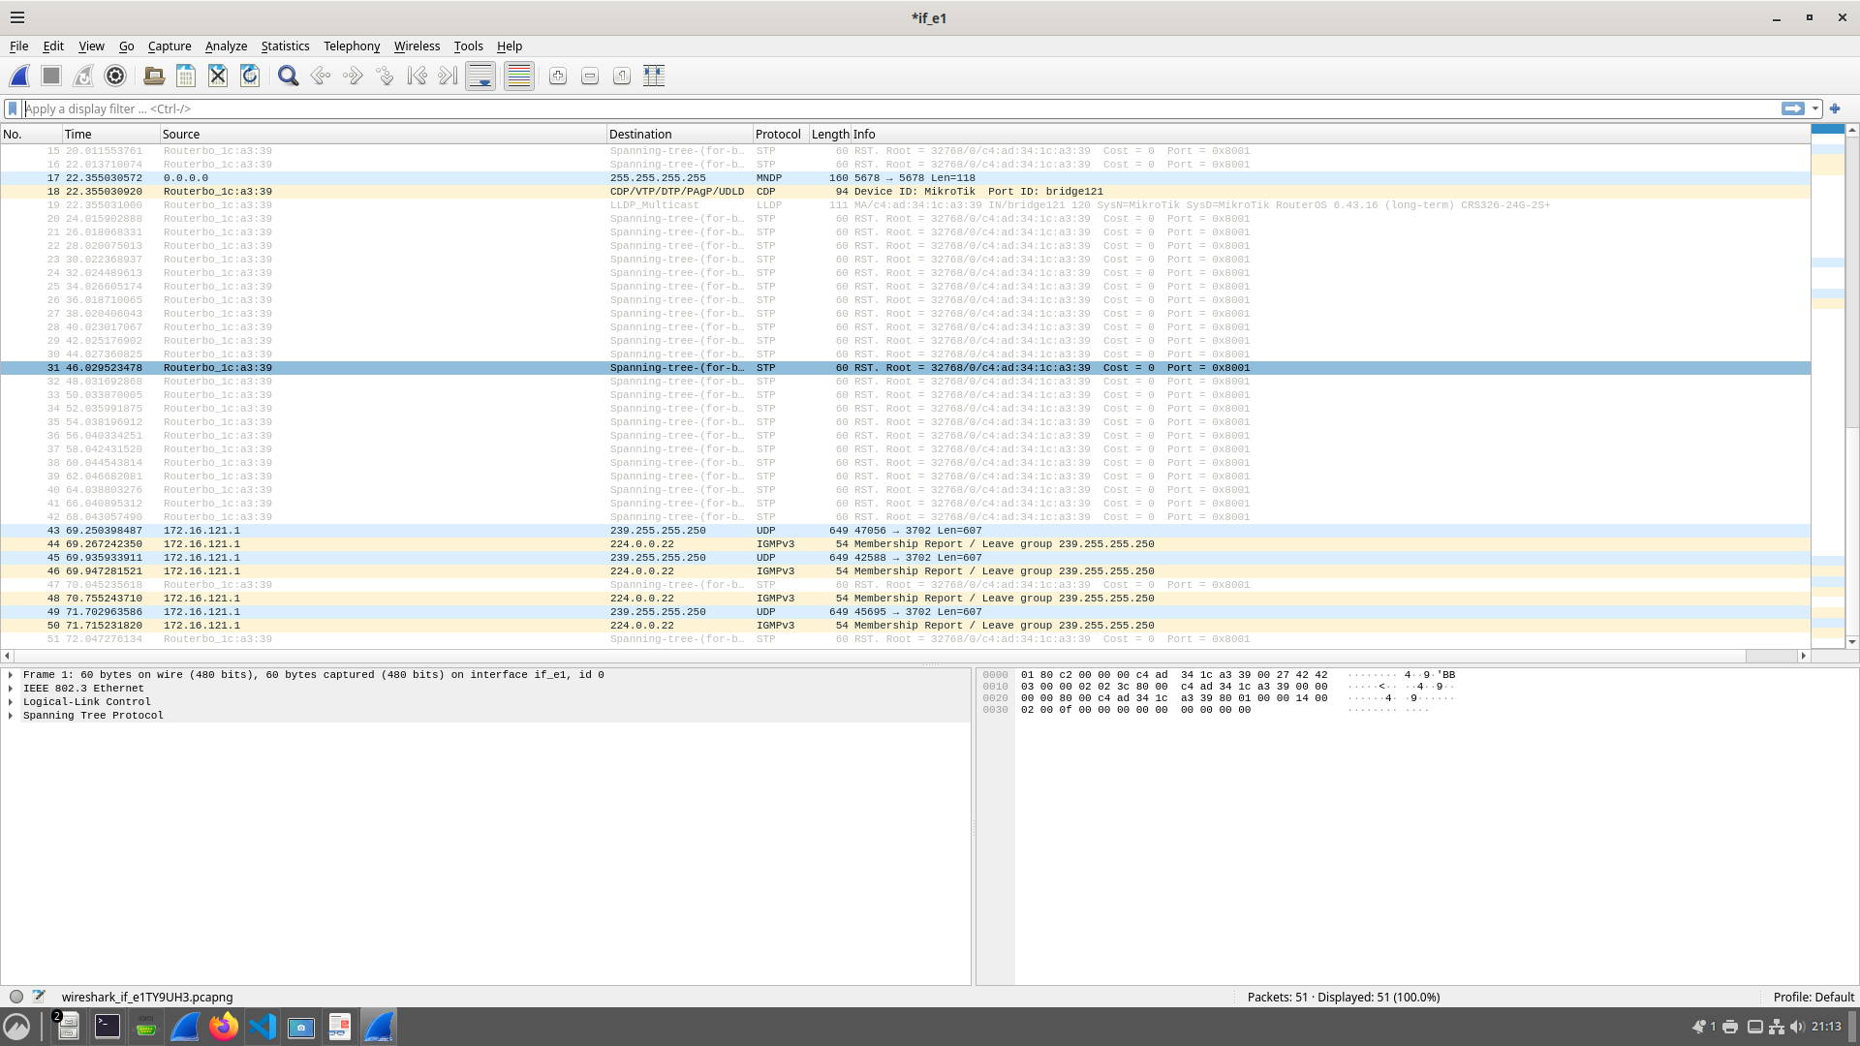

Broadcast from 2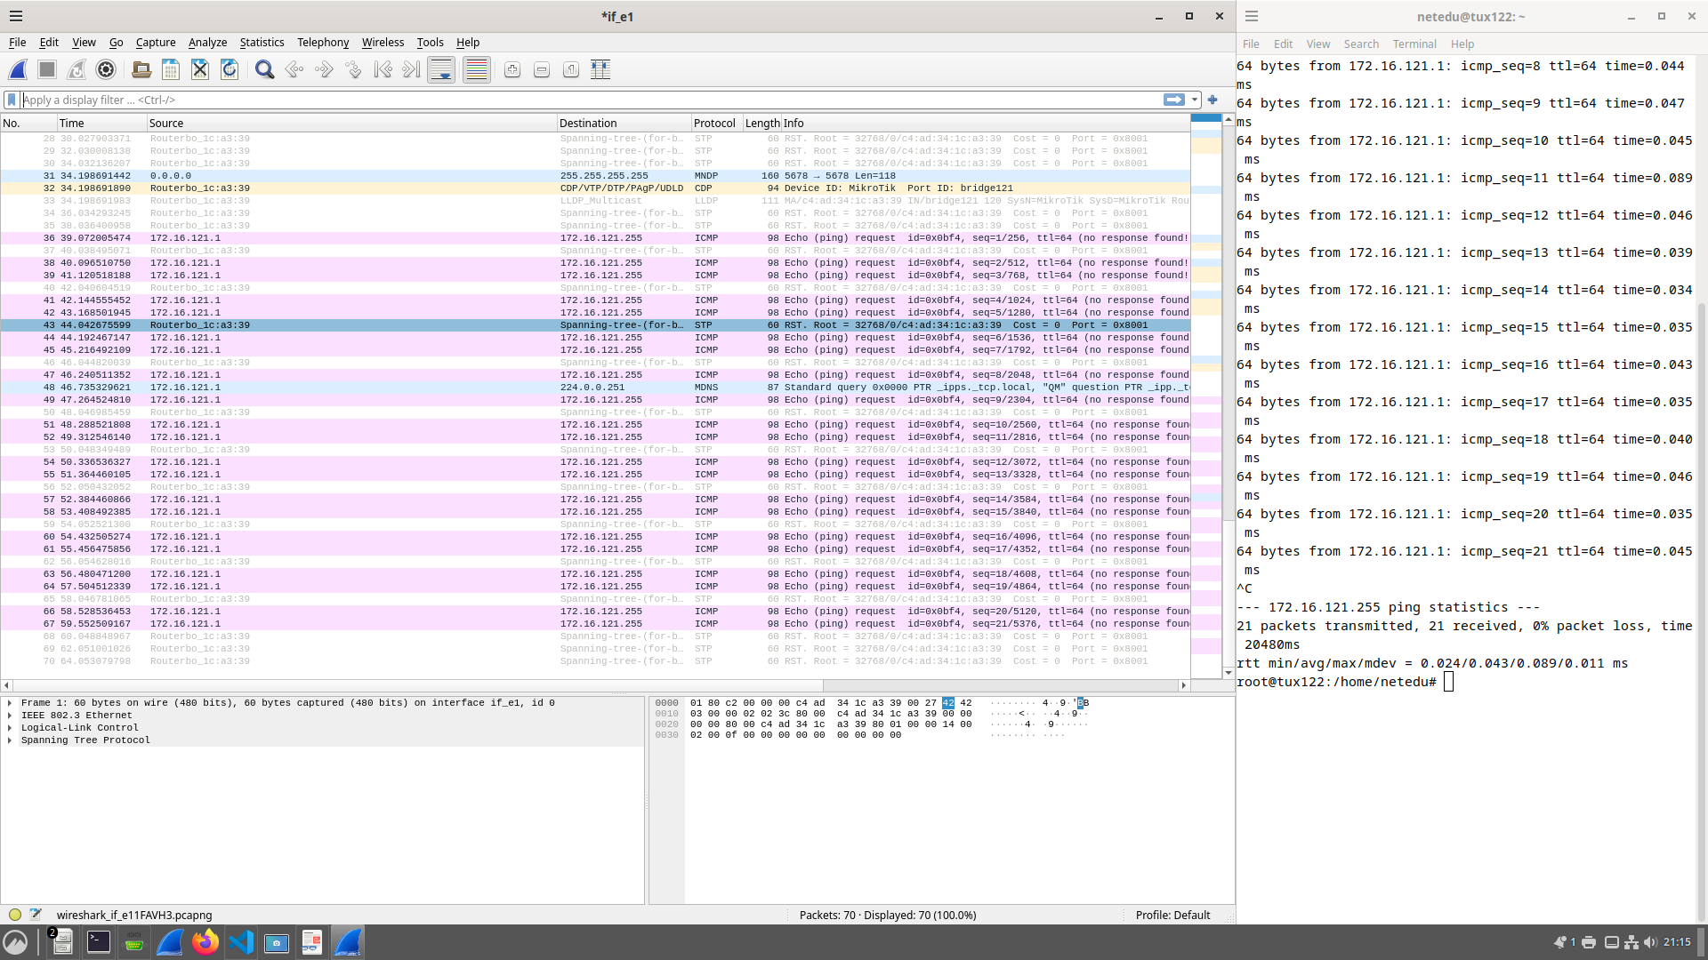

Broadcast from 3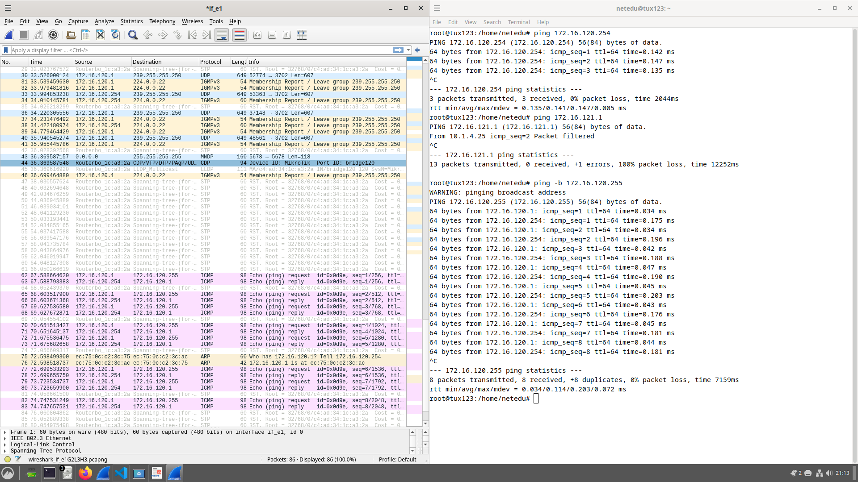

Broadcast 2 to 3

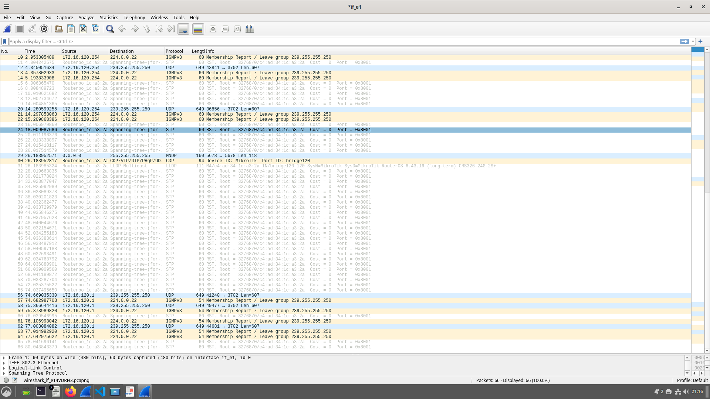

Broadcast 3 to 4

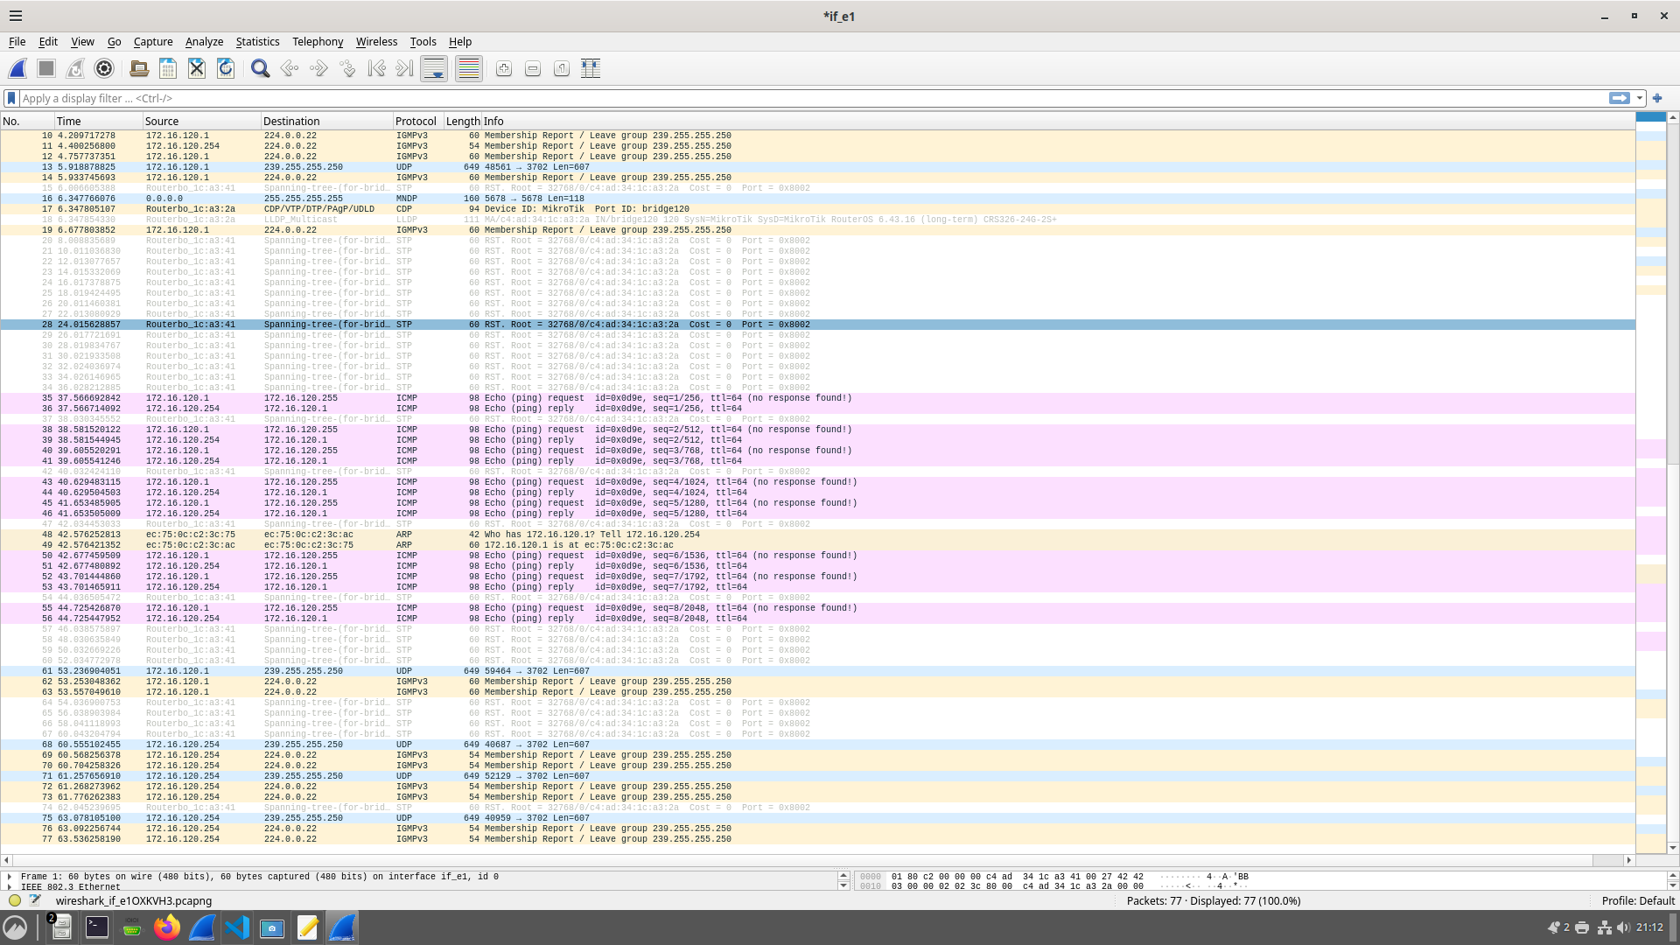
Broadcast 2 to 4

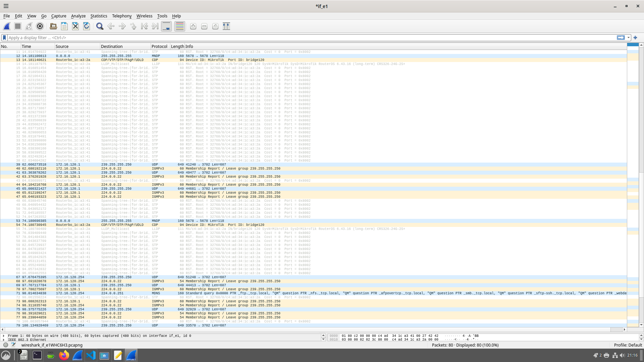

Exp 3
exp3_b1
- /interface bridge port remove [find interface=ether8]
- /interface bridge port add bridge=bridge121 interface=ether8

exp3_b2
- sysctl -w net.ipv4.ip_forward=1
- sysctl -w net.ipv4.icmp_echo_ignore_broadcasts=0
- ifconfig if_e2 172.16.121.253/24 up
exp3_b3
- route add -net 172.16.121.0/24 gw 172.16.120.254 # from tux123
- route add -net 172.16.120.0/24 gw 172.16.121.253 # from tux122
exp3_b4
- ping 172.16.120.254 # from tux123
- ping 172.16.121.253 # from tux123
- ping 172.16.121.1 # from tux123

Ping 172.16.120.254
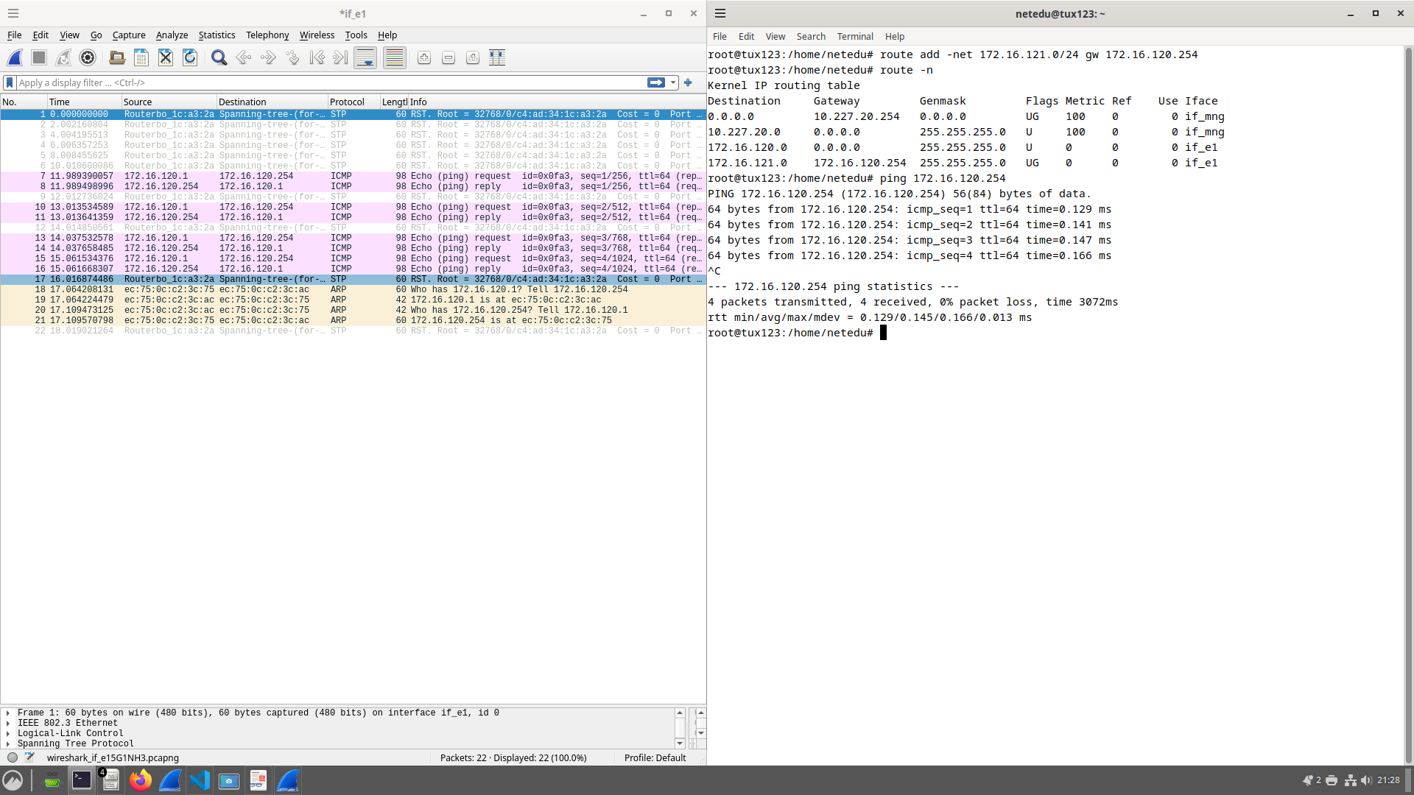

Ping 172.16.121.253
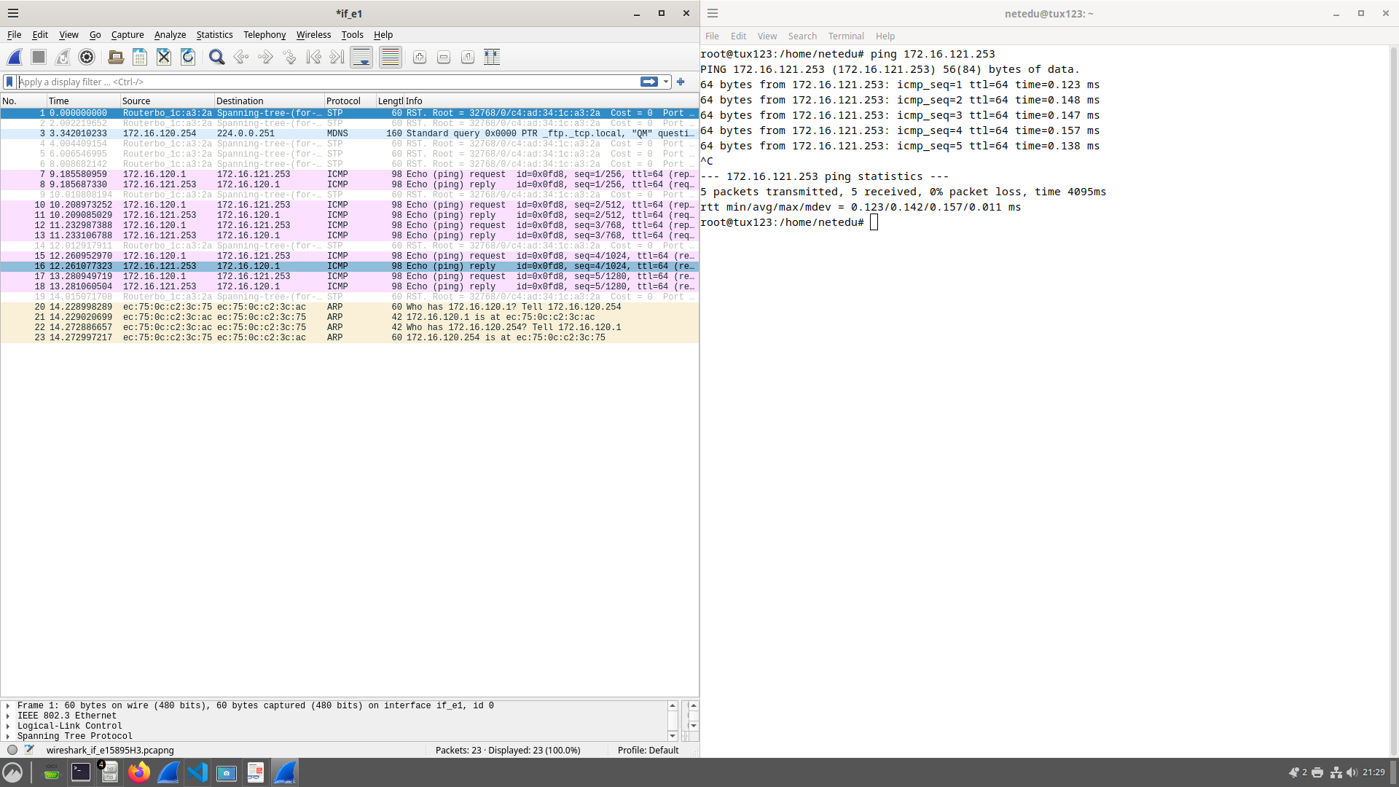

Ping 172.16.121.1
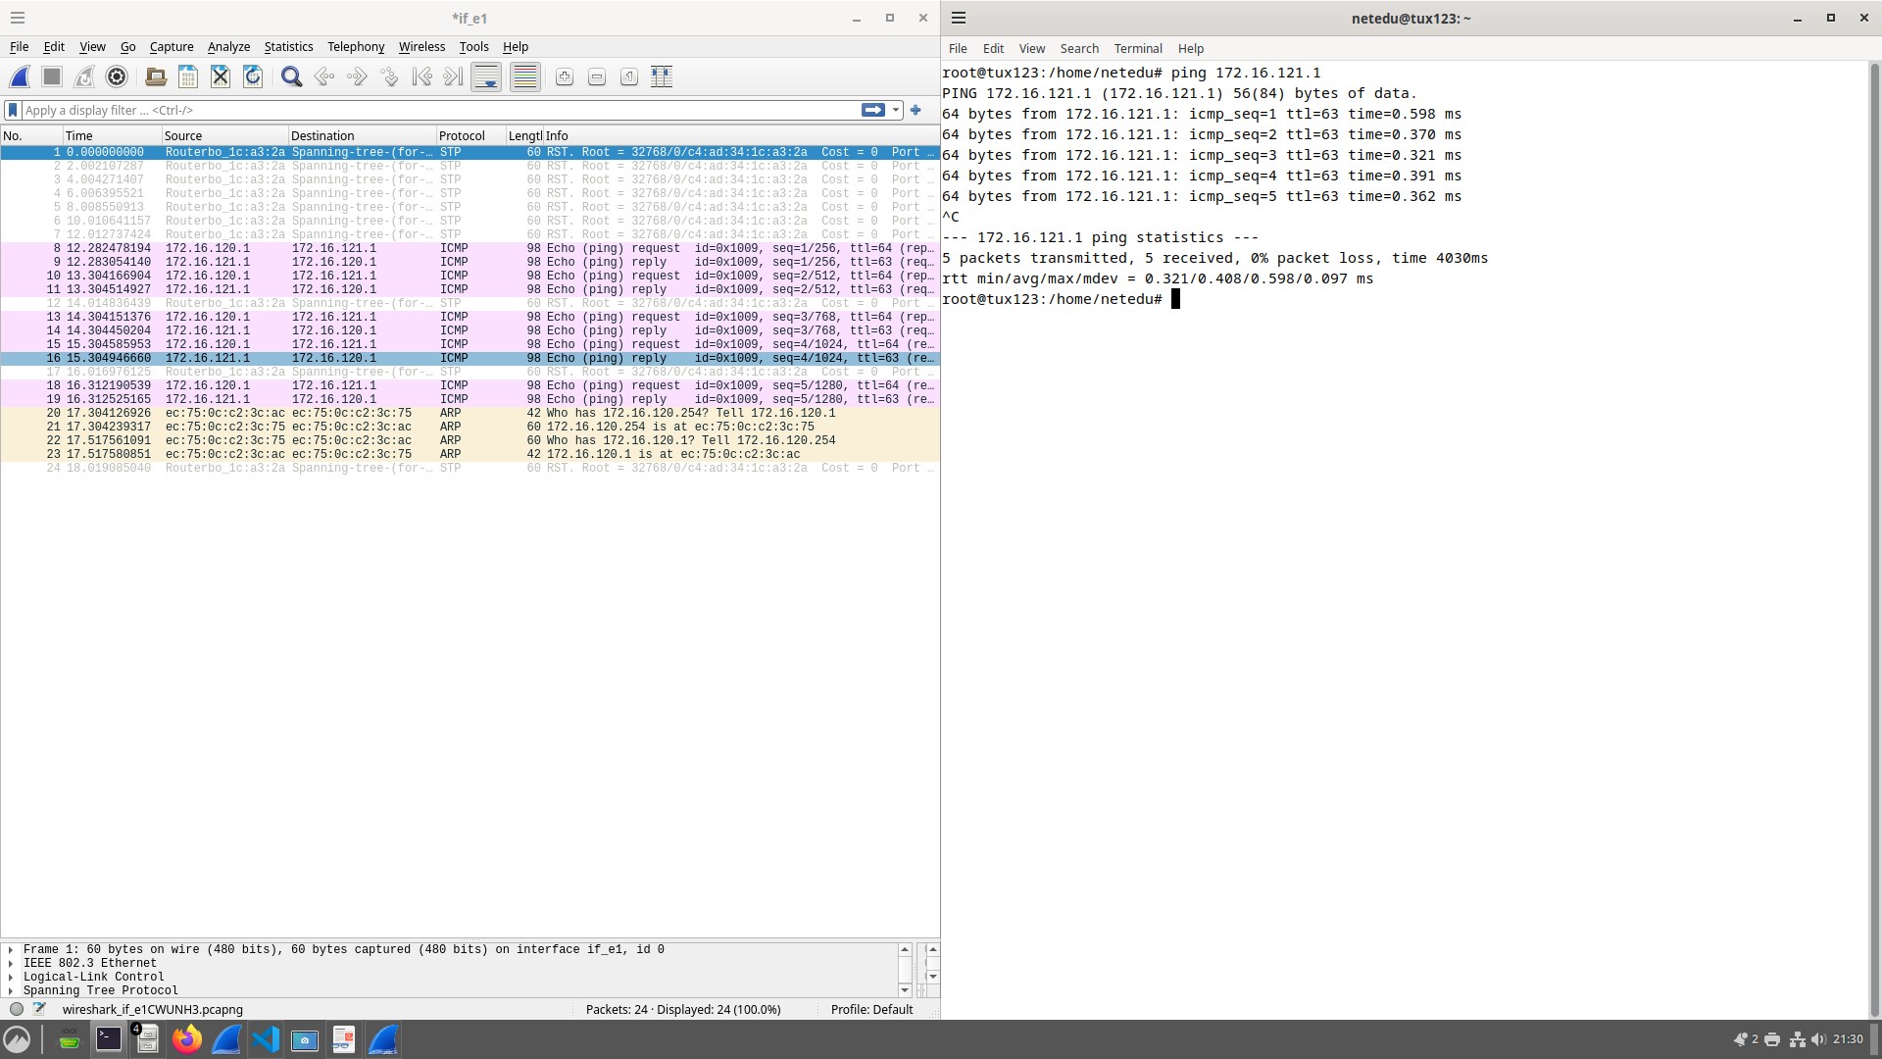

Ping tux122

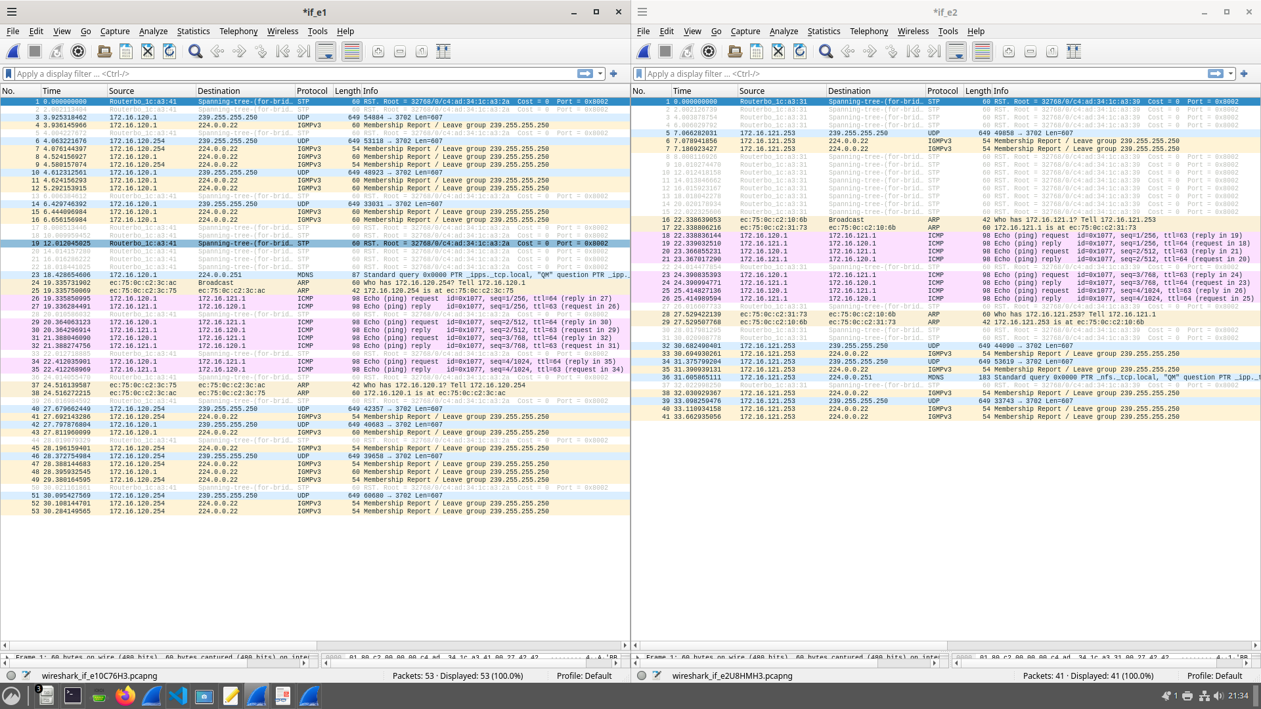

Exp 4
Configuring Switch
- /interface bridge port remove [find interface=ether10]
- /interface bridge port add bridge=bridge121 interface=ether10

Configure LAN and WAN interfaces
- /ip address add address=172.16.121.254/24 interface=ether2
- /ip address add address=172.16.1.12/24 interface=ether1
Configure Routes and NAT on the Router
- /ip route add dst-address=0.0.0.0/0 gateway=172.16.1.254
- /ip route add dst-address=172.16.120.0/24 gateway=172.16.121.253
- /ip firewall nat add chain=srcnat action=masquerade out-interface=ether1
Update Routes
- sudo route del default #from tux122
- sudo route add default gw 172.16.121.254 #from tux122
- sudo route add -net 172.16.120.0/24 gw 172.16.121.253 #from tux122
- sudo route add default gw 172.16.121.254 #from tux124
- sudo route add -net 172.16.121.0/24 gw 172.16.120.254 #from tux123
- sudo route add -net 172.16.1.0/16 gw 172.16.120.254 #from tux123
- sudo route add -net 172.16.1.0/24 gw 172.16.121.254 #from tux124

Disable ICMP Redirects
- sudo sysctl net.ipv4.conf.if_e1.accept_redirects=0 #from tux122
- sudo sysctl net.ipv4.conf.all.accept_redirects=0 #from tux122
Change Gateway to RC
- sudo route del -net 172.16.120.0/24 gw 172.16.121.253 #from tux122
- sudo route add -net 172.16.120.0/24 gw 172.16.121.254 #from tux122
Restore Gateway to tux124
- sudo route del -net 172.16.120.0/24 gw 172.16.121.254 #from tux122
- sudo route add -net 172.16.120.0/24 gw 172.16.121.253 #from tux122
Enable ICMP Redirects and Test
- sudo route del -net 172.16.120.0/24 gw 172.16.121.253 #from tux122
- sudo sysctl net.ipv4.conf.if_e1.accept_redirects=1 #from tux122
- sudo sysctl net.ipv4.conf.all.accept_redirects=1 #from tux122
Disable NAT
- /ip firewall nat remove [find chain=srcnat] #from RC
Ping from 2 to 3 via Router
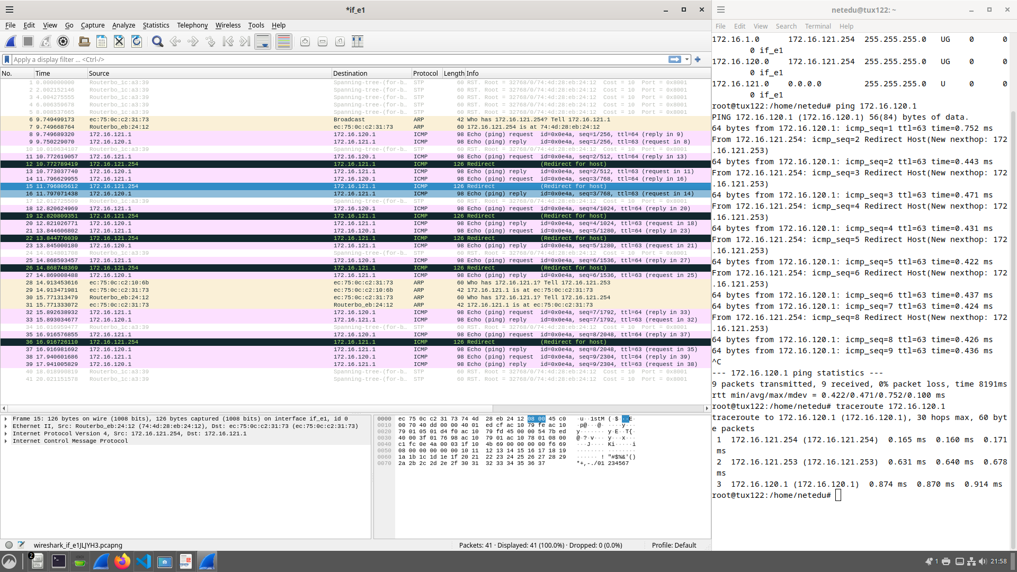

Ping from 2 to 3 redirect step 4
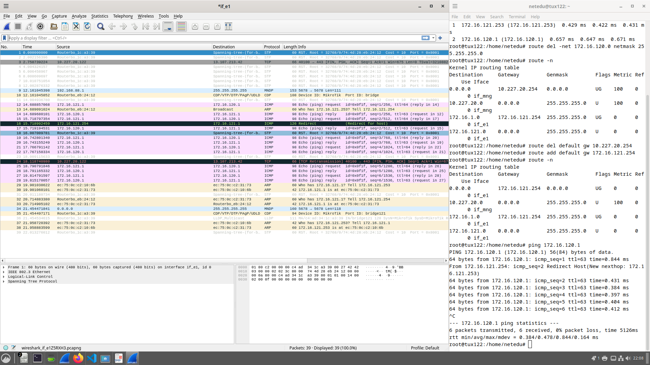

Ping from 3 to 4 Local

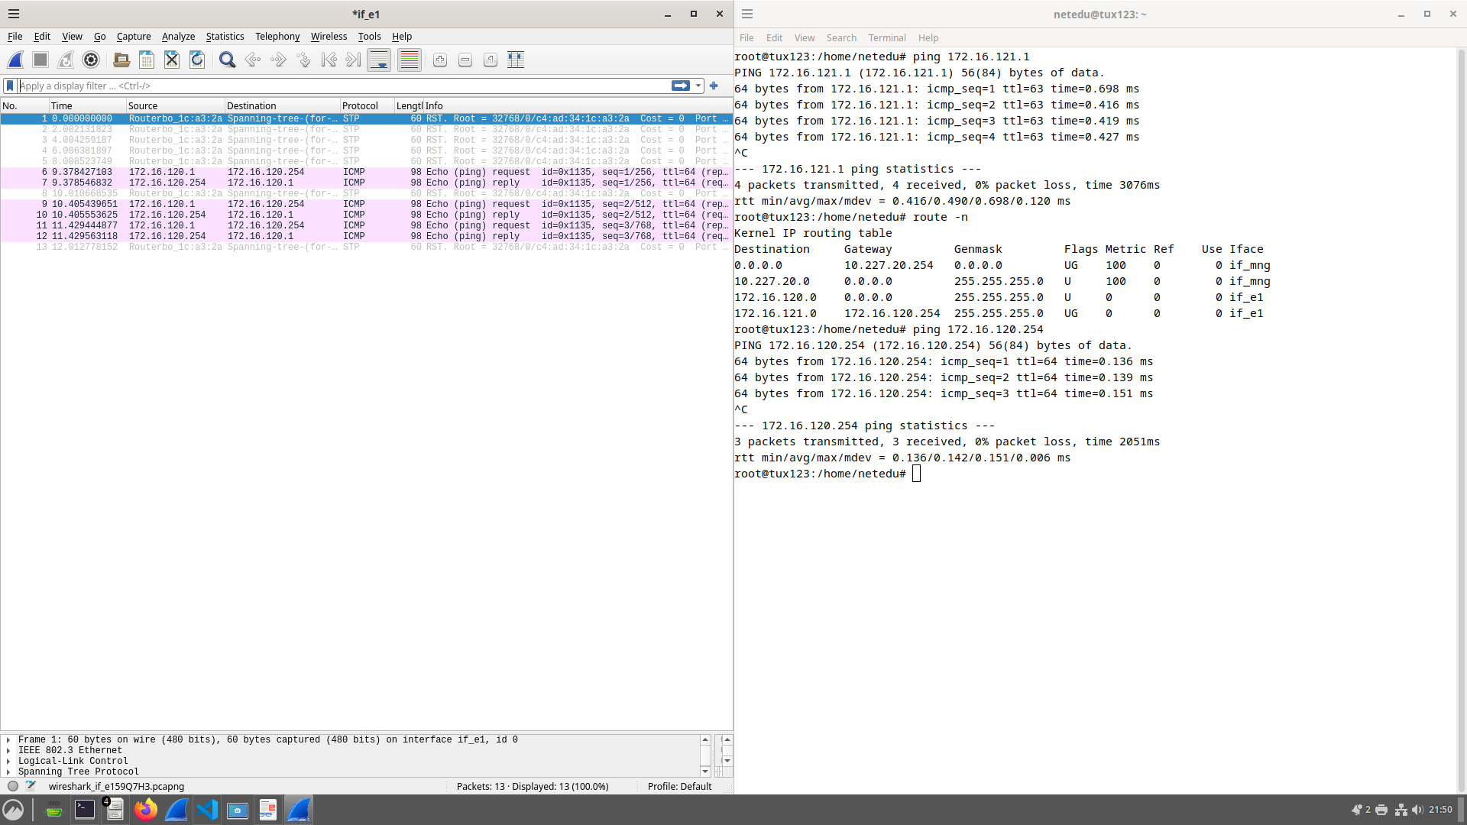

ping from 3 to 4 Remote

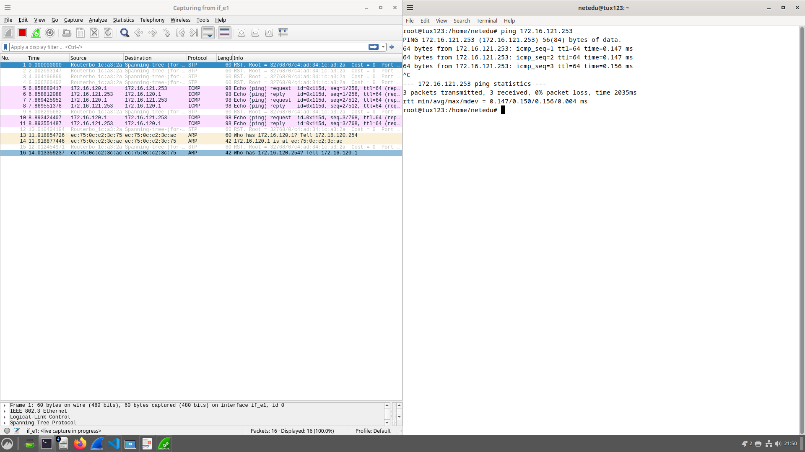

Ping from 3 to 2 via 4
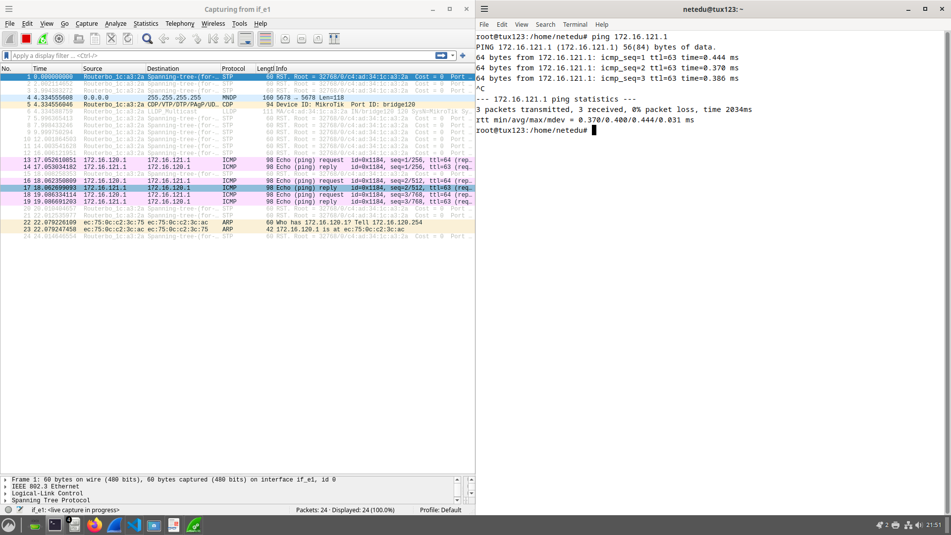

Ping from 3 to Router

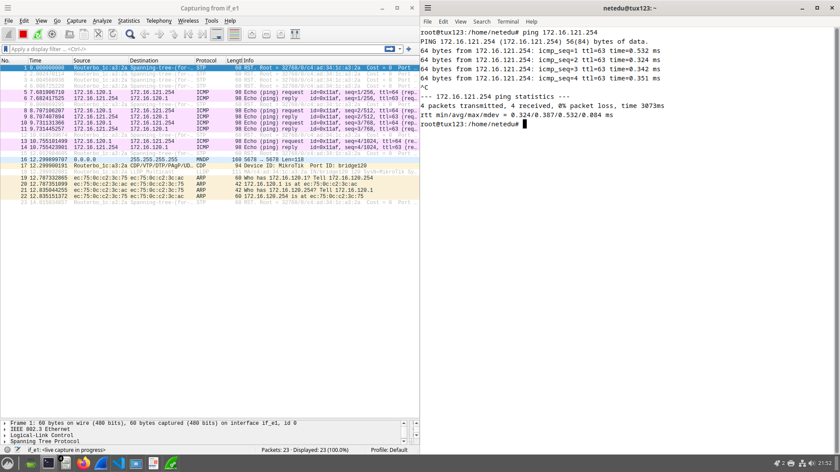

Ping from 3 to Server step5

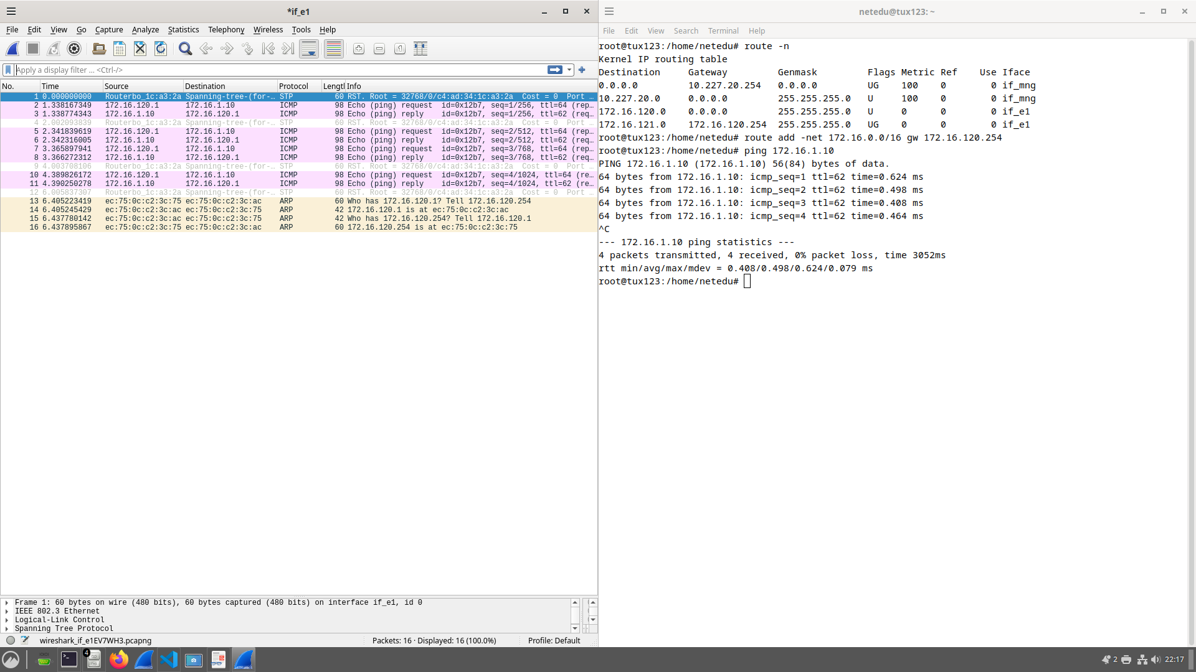

Ping from 3 to server step7 fails
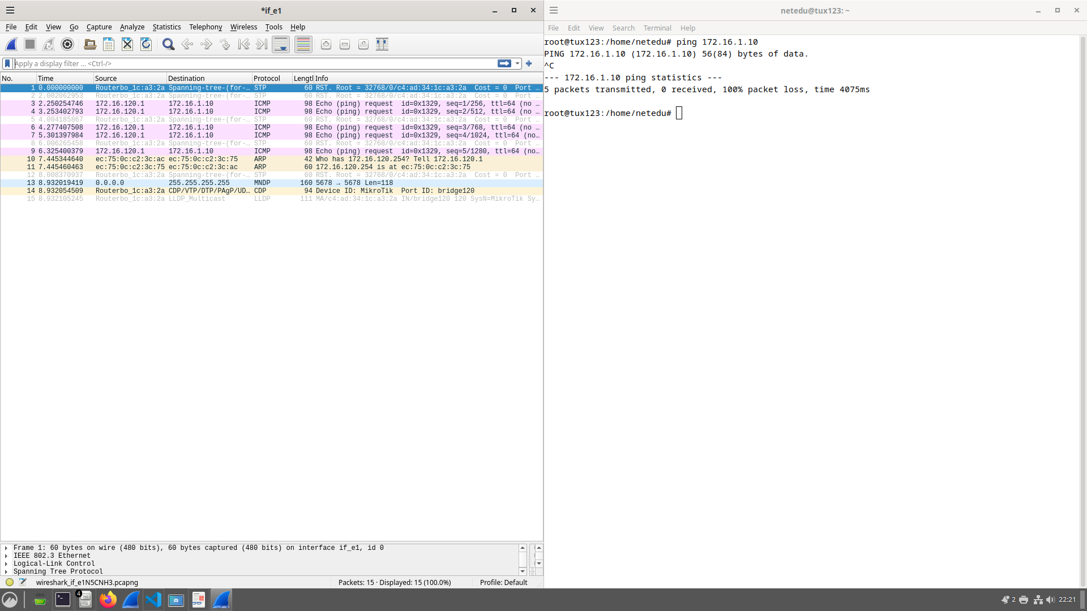

Exp 5

Ping Google.com
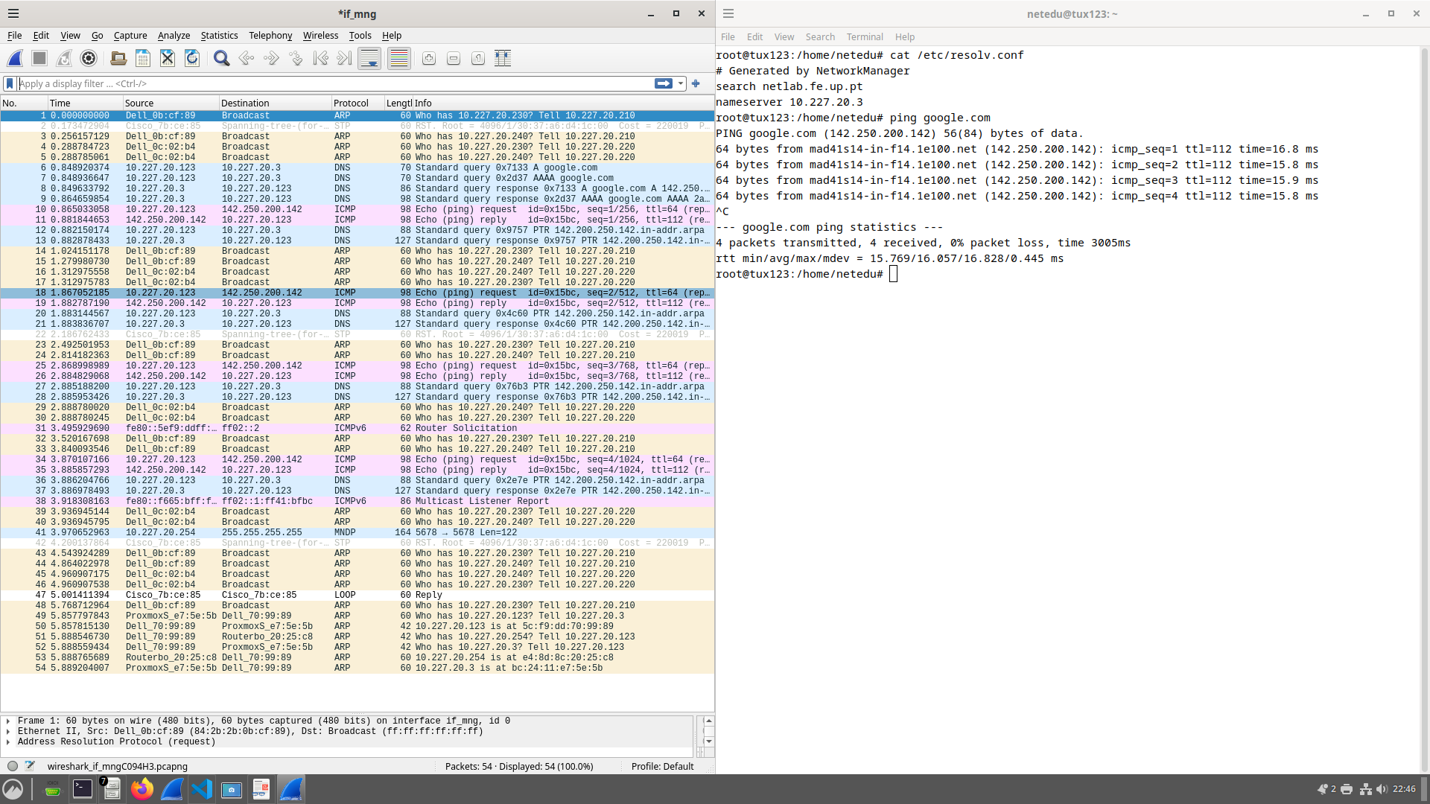

Exp 6
Sametime_final_tux4
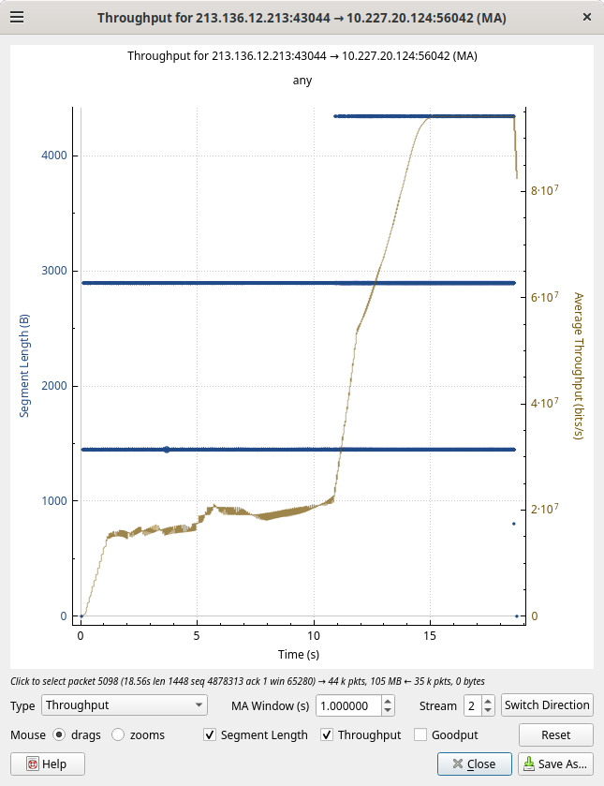

step4 tcp arq
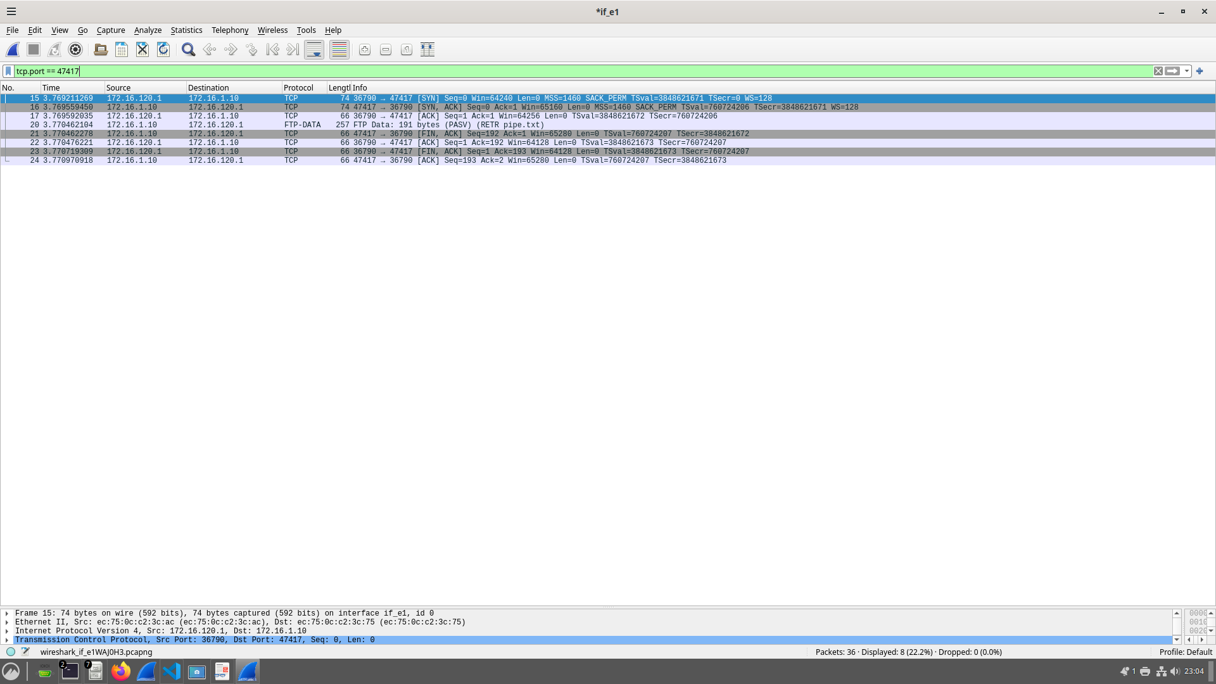

step4 tcp

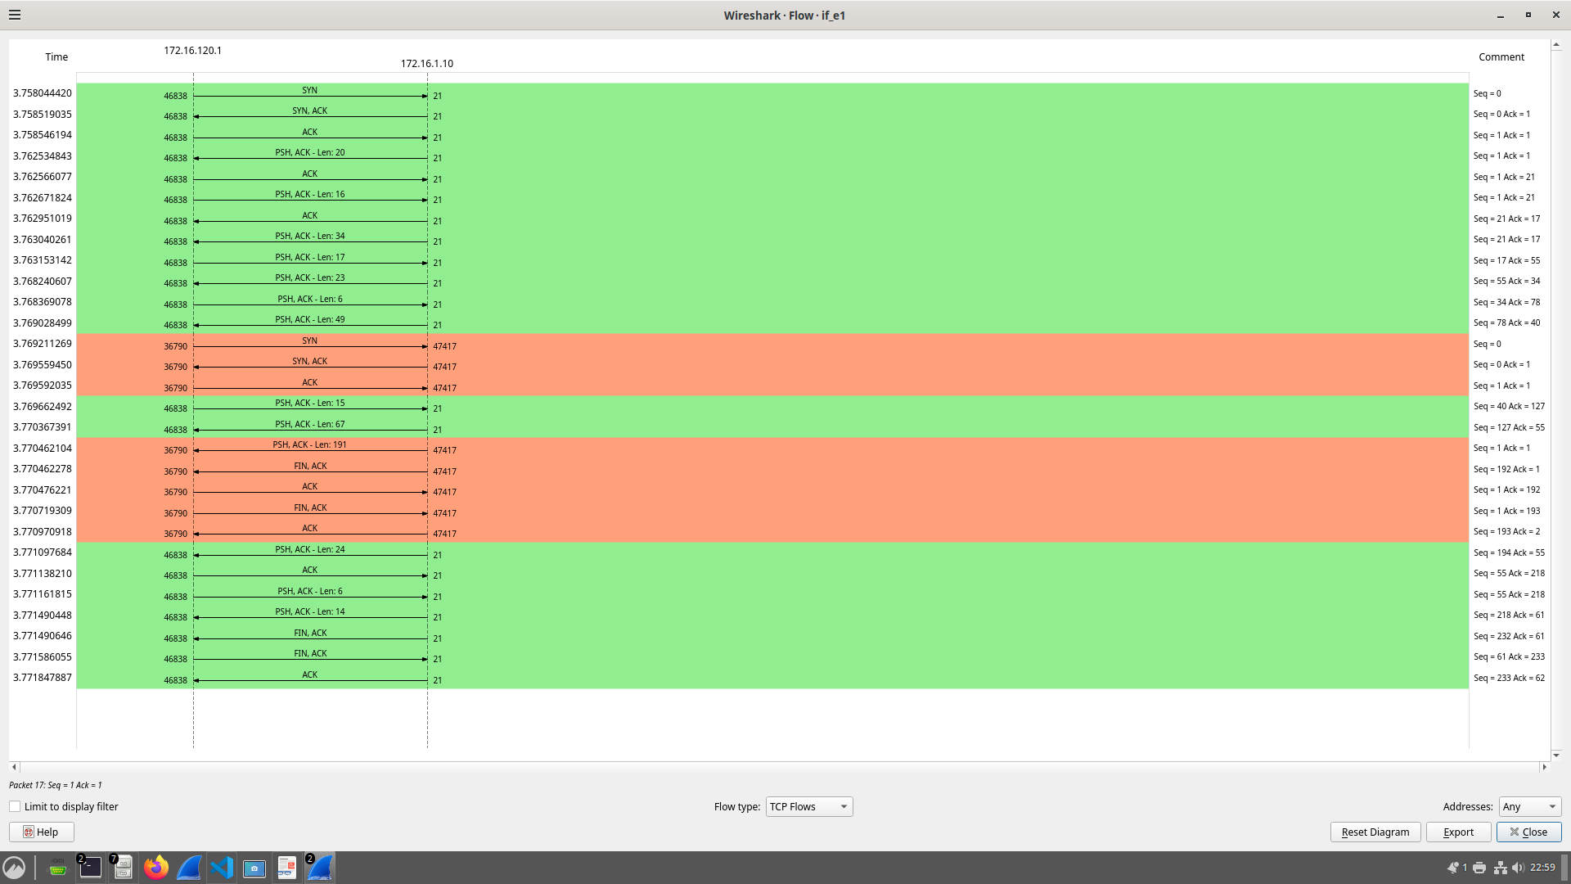

step 4 ftp filter

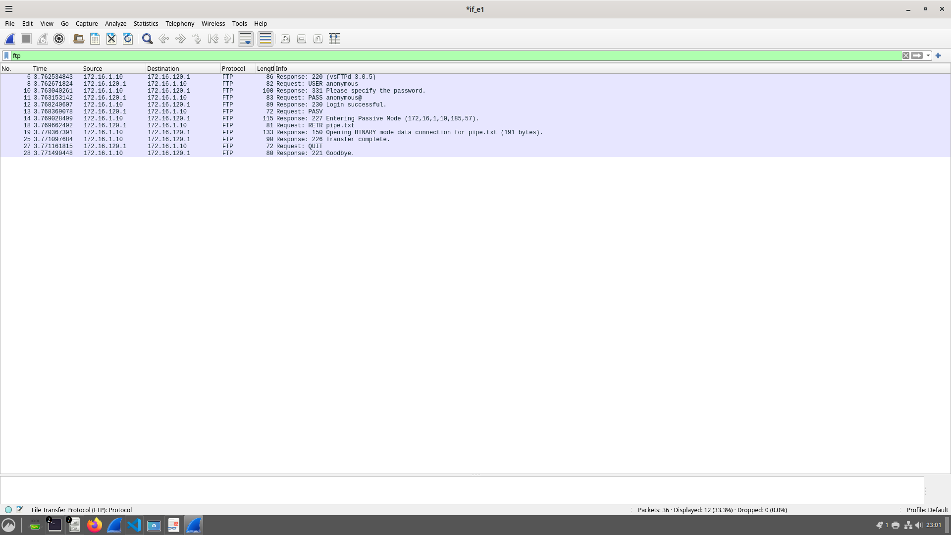

step 4 congestion control

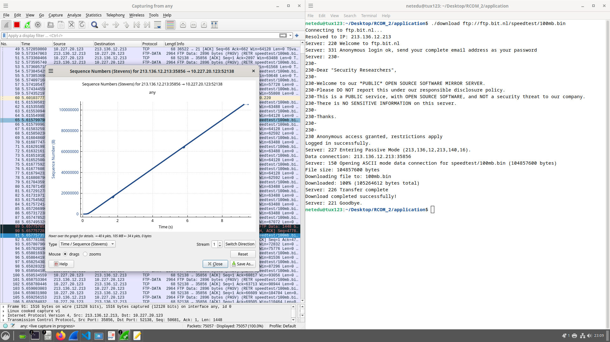

step 4 all flows

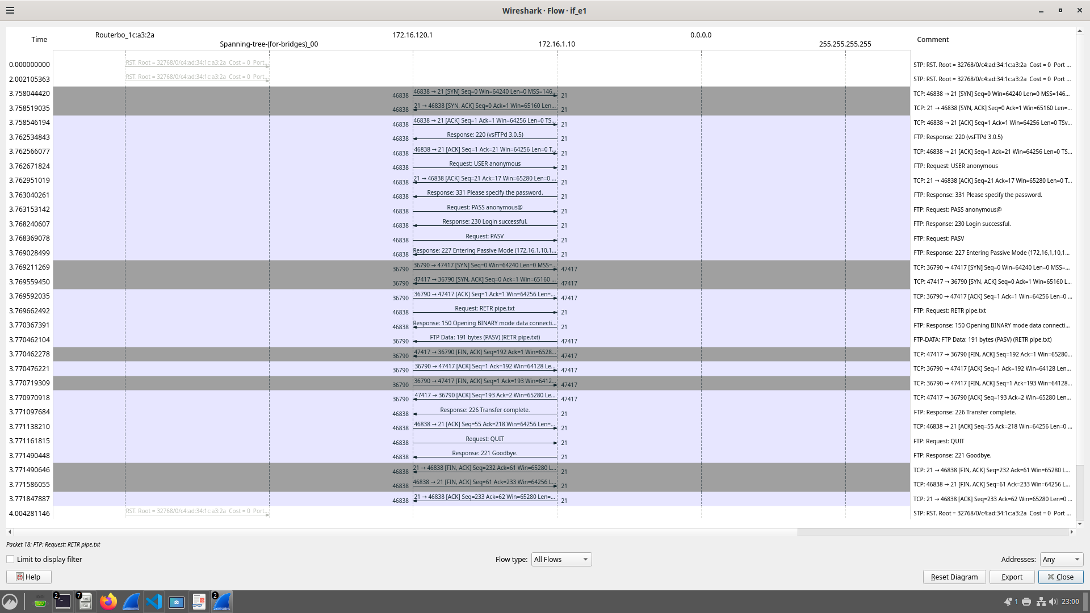

step 2

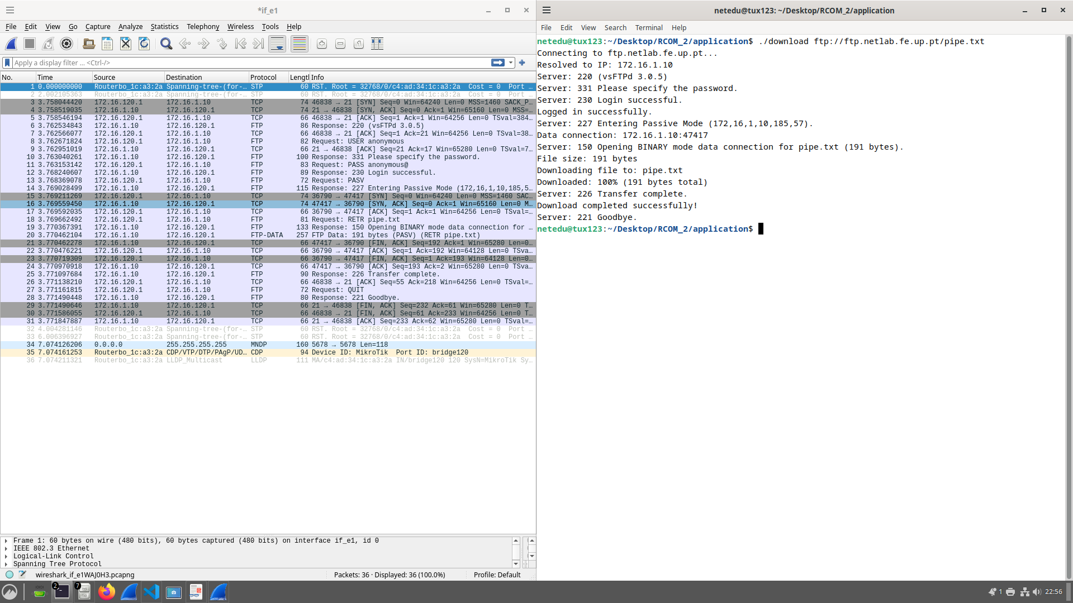

sametime final tux3

