HW8

Zeming Xie

Question 1:

KB: p ⇒ (q ⇒ r)

¬ ((p ∧ q) ⇒ (q ⇒ r)) // add negation of query

Change everything to CNF:

p ⇒ (q ⇒ r) // starting sentence

¬p∨(q ⇒ r) // implication elimination

¬p∨(¬q ∨ r) // implication elimination

¬p∨¬q ∨ r // move negation inwards & distribute ∨ over ∧

¬ ((p ∧ q) ⇒ (q ⇒ r)) // starting sentence

¬ (¬ (p ∧ q) ∨ (q ⇒ r)) // implication elimination

¬¬(p ∧ q) ∧¬(q ⇒ r) // de Morgan

(p ∧ q) ∧¬(q ⇒ r) // double-negation elimination

(p ∧ q) ∧¬(¬q∨r) // implication elimination

(p ∧ q) ∧(¬¬q∧¬r) // de Morgan

(p ∧ q) ∧(q∧¬r) // double-negation elimination

p ∧ q ∧ q ∧ ¬r // distribute ∨ over ∧

p ∧ q ∧ ¬r // factoring

Now the new KB with CNF is:

1: ¬p∨¬q ∨ r

2: p ∧ q ∧ ¬r

3: ¬ (p∨q) ∨ r // de Morgan to 1

4: p ∧ q // and-elimination to 3

5: ¬r // and-elimination to 3

6: r // resolve 3 and 4

7: empty // resolve 5 and 6

Therefore, according to resolution, we can derive the query:

(p ∧ q) ⇒ (q ⇒ r)

Question 2:



Child(x): x is a child Loves(x, y): x loves y

$∀x Child\left(x\right)⟹Loves(x, Santa)$

Reindeer(x): x is a reindeer Loves(x, y): x loves y

$∀x∀y (Loves\left(x, Santa\right) ∧ Reindeer\left(y\right))⟹ Loves(x, y))$

Reindeer(x): x is a reindeer RedNose(x): x has red nose

$Reindeer\left(Rudolph\right)∧RedNose(Rudolph)$

RedNose(x): x has red nose Weird(x): x is weird Clown(x): x is a clown

$∀x RedNose\left(x\right)⟹(Weird\left(x\right) Clown\left(x)\right)$

Clown(x): x is a clown Reindeer(x): x is a reindeer

$∀x Clown\left(x\right)⟹Reindeer\left(x\right)$

Weird(x): x is weird Loves(x, y): x loves y

$∀x Wired\left(x\right)⟹Loves(Scrooge, x)$

Child(x): x is a child



$Child(Scrooge)$

Austinite(x): x is an Austinite Conservative(x): x is conservative

Armadillo(x): x is an armadillo Loves(x, y): x loves y

$∀x∃y \left(Austinite\left(x\right)∧Conservative\left(x\right) ∧Armadillo\left(x\right)\right)⟹Loves\left(x, y\right)$

Wear(x, y): x wears y Aggie(x): x is an aggie

$∀x Wear(x, maroon-and-white shirts)⟹Aggie(x)$

Aggie(x): x is an aggie Dog(x): x is a dog Loves(x, y): x loves y

$∀x ∀y (Aggie\left(x\right)∧Dog\left(y\right))⟹Loves(x, y)$

Armadillo(x): x is an armadillo Dog(x): x is a dog Loves(x, y): x loves y

$∀x ∀y ∀z (Dog\left(y\right)∧Armadillo\left(z\right)∧Loves(x,y))⟹Loves(x, z)$

Austinite(x): x is an Austinite Wear(x, y): x wears y

1. Austinite(Clem) $∧$ Wear(Clem, $maroon-and-white shirts$)

Austinite(x): x is an Austinite Conservative(x): x is conservative

$∃x Conservative\left(x\right)∧Austinite(x)$

Question 3:

1. I(x): x is innocent F(x): x and Victor are friends L(x): x is a liar

Alice: (I(Alice) ∧ F(Barney) ∧ ¬F(Caddy)) ∨ L(Alice)

Barney: (I(Barney) ∧ ¬F(Barney)) ∨ L(Barney)

Caddy: (I(Caddy) ∧ F(Barney)) ∨ L(Caddy)

$∀x F(x) ⟹I(x)$

$$∃x I\left(x\right) ∧(∀y I\left(y\right)⟹(x=y))$$

$$∀x I(x)⟹L(x)$$

1. CNF form of (1)

(I(Alice) ∨ L(Alice)) ∧ (F(Barney) ∨ L(Alice)) ∧ (¬F(Caddy) ∨ L(Alice))

(I(Barney) ∨ L(Barney)) ∧ (¬F(Barney) ∨ L(Barney))

(I(Caddy) ∨ L(Caddy)) ∧ (F(Barney) ∨ L(Caddy))

CNF form of (2)

$$∀x F\left(x\right) I(x)$$

$$∃x I\left(x\right) ∧(∀y I\left(y\right) (x=y))$$

$$∀x I\left(x\right) L(x)$$

1. Either $I\left(Alice\right)$ or $I\left(Barney\right)$ or $I\left(Caddy\right)$
2. F(Caddy) ∨ L(Caddy)
3. It is unsatisfiable

If $I\left(Alice\right)$ then, using second sentence from part(2) we can get I(Barney) and I(Caddy)

Using third sentence from part(2) and I(Barney) and I(Caddy) we can get $L$ (Barney) and

$L$ (Caddy).

Using second and third sentence from part(1) and $L$ (Barney) and $L$ (Caddy) we can get ¬F(Barney) and F(Barney) which is empty, therefore it is not $I\left(Alice\right)$

If $I\left(Barney\right)$ then, using second sentence from part(2) we can get I(Alice) and I(Caddy)

Using third sentence from part(2) and I(Alice) and I(Caddy) we can get $L$ (Alice) and

$L$ (Caddy).

Using first and third sentence from part(1) and $L$ (Alice) and $L$ (Caddy) we can get F(Barney).

Using first sentence from part(2) and F(Barney), we can get $I\left(Barney\right)$

Using the assumption and I(Barney), we get empty, which shows it is not $I\left(Barney\right)$

If $I\left(Caddy\right)$ then, using second sentence from part(2) we can get I(Barney) and I(Alice)

Using third sentence from part(2) and I(Barney) and I(Alice) we can get $L$ (Barney) and

$L$ (Alice).

Using second and first sentence from part(1) and $L$ (Alice) and $L$ (Barney) we can get ¬F(Barney) and F(Barney) which is empty, therefore it is not $I\left(Caddy\right)$

Therefore, all three possible goals are false under resolution. So, the KB is unsatisfiable.

Question 4:

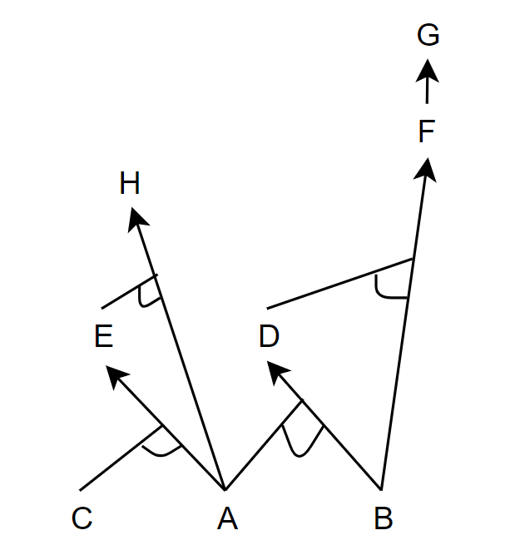

H is true, A and C are true from KB, then we can get E, then from A and E, we can get H

1. 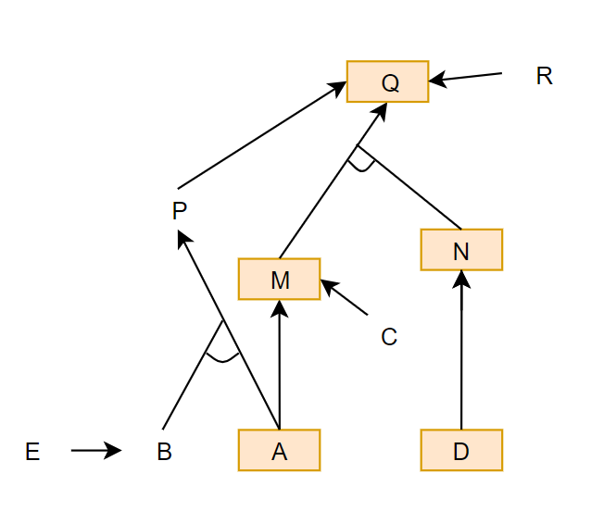

1: P ⇒ Q

2: E ⇒ B

3: R ⇒ Q

4: M ∧ N ⇒ Q

5: A ∧ B ⇒ P

6: A ⇒ M

7: C ⇒ M

8: D ⇒ N

9: D

10: A

11: M // Modus Ponens to 6, 10

12: N // Modus Ponens to 8, 9

13: Q // Modus Ponens to 11, 12, 4

Question 5:

1. 1. 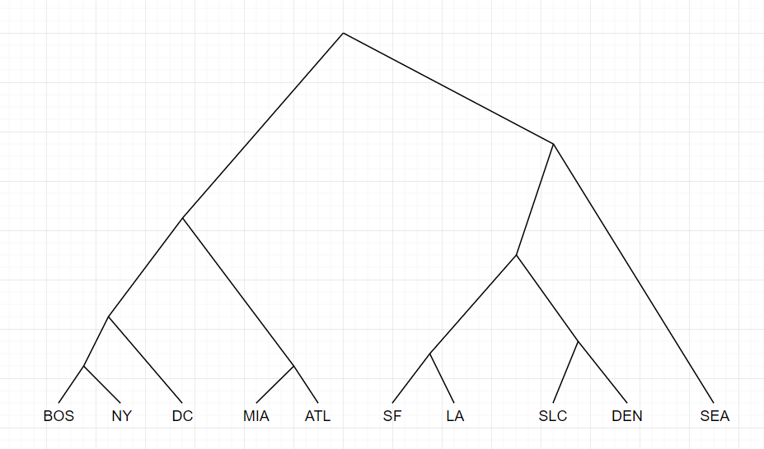
   2. Cluster 1: BOS, NY, DC, MIA, ATL

Cluster 2: SEA

Cluster 3: SF, LA, SLC, DEN

2. C1: BOS, NY, DC

C2: MIA, ATL, SF, LA, SEA, SLC, DEN

1. C1: (41.0, 74.03333333333333)

C2: (37.07142857142857, 106.32857142857144)

1. C1: BOS, NY, DC, MIA, ATL

C2: SF, LA, SEA, SLC, DEN