|  |  |
| --- | --- |
| Стилизованный значок | Steps to install Java module repository |

# Execute REPO INSTALL command

Execute REPO INSTALL command using BaseX GUI.

Enter REPO INSTALL “path” command in input bar of BaseX GUI where “path” is an absolute or relative path of jar file to install.



Example:

REPO INSTALL "D:\workspace\Java\pdf-utils\target\mypdf.jar"

More information about REPO INSTALL command http://docs.basex.org/wiki/Commands#REPO_INSTALL

# Import Module Namespace

Import mypdf.jar library using import module statement.

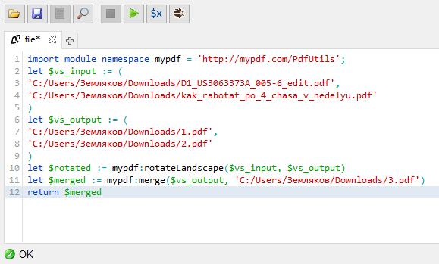

Now, functions ‘rotateLandscape’ and ‘merge’ from “mypdf.jar” is ready to use.

Example:

import module namespace mypdf = 'http://mypdf.com/PdfUtils';

let $vs_input := (

'C:/Users/Земляков/Downloads/D1_US3063373A_005-6_edit.pdf',

'C:/Users/Земляков/Downloads/kak_rabotat_po_4_chasa_v_nedelyu.pdf'

)

let $vs_output := (

'C:/Users/Земляков/Downloads/1.pdf',

'C:/Users/Земляков/Downloads/2.pdf'

)

let $rotated := mypdf:rotateLandscape($vs_input, $vs_output)

let $merged := mypdf:merge($vs_output, 'C:/Users/Земляков/Downloads/3.pdf')

return $merged