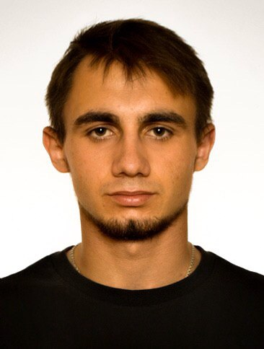Dmytro Lytvynenko

junior python developer

Kharkiv, Kharkiv region

Tel: +38 (099) 669-04-49

GitHub: <https://github.com/kad1m>

Email: [dmytro.lytvynenko@icloud.com](mailto:dmytro.lytvynenko@icloud.com)

LinkedIn: <https://www.linkedin.com/in/dmytro-lytvynenko/>

**Summary**

Nice to meet you. I want to tell you a little about my hobbies and myself. I really like sports and computers and everything related to them. You can familiarize with my professional qualities in my resume. In addition, I love sports, now I do tennis, boxing and go to the gym, but my favorite hobby is riding a BMX. Sports activities force special diets to always be in shape and therefore I adhere to proper nutrition. I would like to conclude that in the future, I am interested in projects related to healthcare; the sphere of finance is also of interest.

**Employment History**

**Self Employed**, Python developer, Kharkiv, Kharkiv Oblast

September 2018 – Present

* Developed blogs;
* Implemented scrum table in my site;
* Work with web camera on site;
* Created Landing page;
* Developed an email newsletter application;
* Developed a cryptocurrency rate monitoring application;

**QArea**, Python QA, Kharkiv, Kharkiv Oblast

April 2019 – August 2019

* Checked functionality for compliance with technical and business requirements;
* Fixed bugs and commit changes;
* Understood how commercial development is going.

**Professional Skills**

* HTML, CSS: Intermediate;
* Python: Intermediate;
* Django: Competent;
* Django Rest: Beginner;
* Javascript: Competent;
* Bootstrap 4: Competent;
* SEO: Intermediate;
* Agile Scrum: Intermediate;
* Github: Competent;

**Languages**

Russian: Native

Ukrainian: Native

English: Conversational

**Education**

**V. N. Karazin Kharkiv National University**

Master's degree, Security of information system and technologies

Graduating December 2019