Blog Post #1

Introduction



Since the first commercial game was introduced over half a century ago, video games have come a long way. Computer scientists working on large, expensive mainframe computers created simple games such as tic-tac-toe and chess in the 1950s. But the first commercially successful video game wasn't created until the 1970s.

Most people have the impression that Pong was the world's first commercial game from Atari, Inc. However, Computer Space was actually the game released in 1971. Video games continued to evolve and improve in the years that followed. The 1980s saw the rise of arcade games such as Pac-Man and Space Invaders, which became cultural phenomena and are still popular today. The early 1990s saw the introduction of home consoles such as the Nintendo Entertainment System and Sega Genesis, which allowed players to enjoy video games in the comfort of their own homes.

Video games evolved as technology advanced. The 2000s saw the rise of online gaming and massively multiplayer games such as World of Warcraft. These games allowed players from all over the world to interact in virtual environments. Today, video games are a multi-billion-dollar industry. And their popularity continues to grow.

Video games are more than just entertaining. They can be used to educate, socialise and relieve stress. Video games have also had a profound impact on popular culture. Characters such as Mario and Lara Croft have become household names. As technology advances, it's exciting to think about what the future holds for video games and the people who play them.

Data-Source

The Dataset can be found on Kaggle.

<https://www.kaggle.com/datasets/arnabchaki/popular-video-games-1980-2023>

This dataset contains mixed collection of video games dating from 1980 to 2023.

Insights

Over time, video games have changed as developers have worked to find fresh and interesting ways to keep players interested. They have achieved this, among other things, by making games in several genres. It's interesting to see which genres have become the most well-known in the gaming business because categories like action, adventure, sports, and puzzle have all become household names.

The top ten video game genres can be identified using information from a well-known dataset of video game statistics.

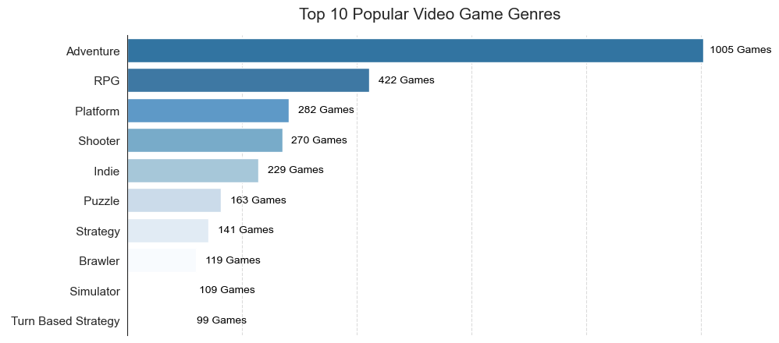

The adventure and RPG genres are the most well-liked, as expected, closely followed by the platform and shooter genres. These subgenres provide gamers a feeling of exhilaration and let them disappear into their own worlds. The top 10 video game genres are an accurate representation of what players want. Along with trying to think of fresh and intriguing genres that can captivate players, developers must keep innovating and making games that cater to these preferences.

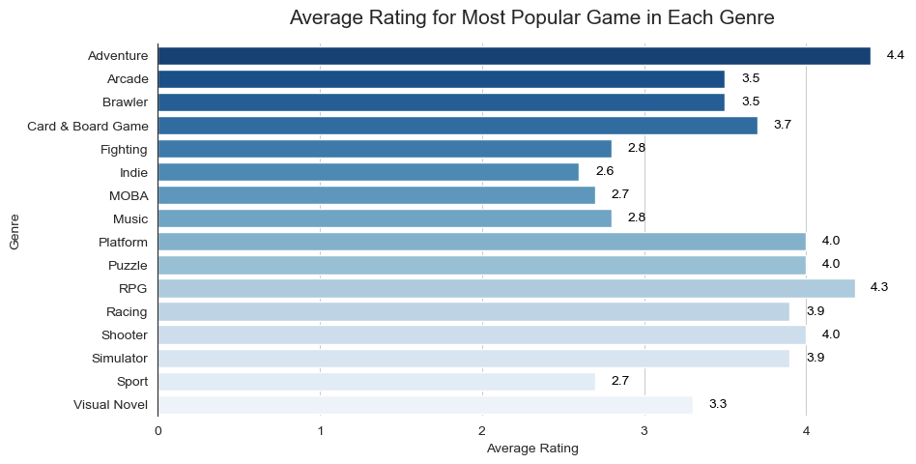

Genres are extremely important in the realm of video games for categorising and classifying games. Players frequently favour a certain genre since it has distinctive qualities that set it apart from others. Video game producers can create new games that appeal to their target audience by taking into account the acclaim and ratings of games in each genre.

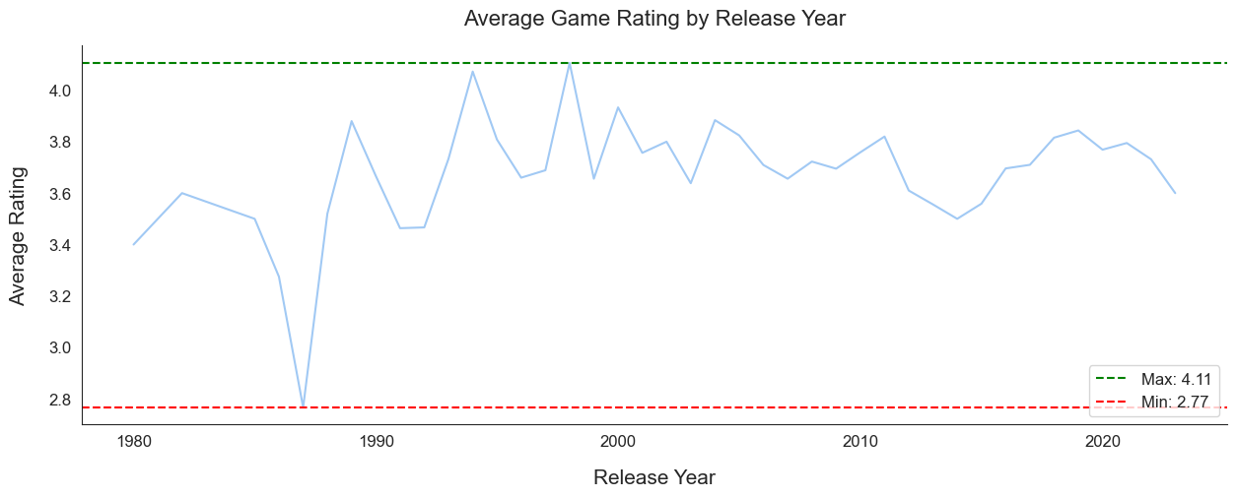

The average rating of video games varied significantly from 1980 to the 1990s, with the late 1980s seeing a major fall. However, since the early 2000s, the average rating has improved in consistency and stability. This evolution over time might be brought on by improvements in game design and technology, shifting consumer preferences, and heightened competition. These elements have caused an overall improvement in game quality and average ratings.

Conclusion

My analysis of well-known video games from 1980 to 2023 produced a number of significant findings.

* The Adventure, RPG, Platform, and Shooter game genres are the most popular, according to our research.
* Some of the most well-known games in these categories are Mario Party Superstars (a card and board game), Chrome Dino (an arcade game), Devil May Cry (a brawler), and Metal Gear Solid 2: Sons of Liberty (an adventure game).
* I also noticed that, from 1980 through the 1990s, there were big swings in the average rating of video games, with a notable fall in the late 1980s. The average rating has, nevertheless, improved in consistency and stability since the 2000s.