Programmable & Explainable Neuro-Symbolic AI
A Symbolic Framework for Governance, Policy, and Responsible AI
Our approach converts opaque neural outputs into transparent, rule-based models that can be inspected, audited, and refined. By embedding governance, accountability, and exception handling into the design, this framework ensures AI systems operate in ways that align with policy mandates and legal standards. It enables responsible Human + AI collaboration, giving institutions confidence that AI can be scaled without sacrificing oversight or trust.

Step 1. Neural Theme Extraction
Extracts recurring patterns from raw text (documents, interviews, or social media) using clustering or key recurring theme modeling prompt. Produces concise pre-symbolic summaries that serve as a traceable foundation for subsequent rule-based analysis.

Step 2. Symbolic Pattern Lifting – From Neural Outputs to Rules
Representative summaries are formalized into partial symbolic rules (Boolean expressions) and expanded into complete symbolic theories using LLMs. These rules are transparent, auditable, and aligned with governance needs, ensuring that patterns are legally interpretable and open to challenge.

Step 3. Pattern Lowering – Accountability and Retraining
Symbolic rules are applied back to the data to generate pseudo-labels, with exception handling to manage edge cases. The enriched dataset is used to retrain the AI, combining neural recognition with rule-based accountability. Outputs remain interpretable, auditable, and correctable—supporting compliance and policy alignment.
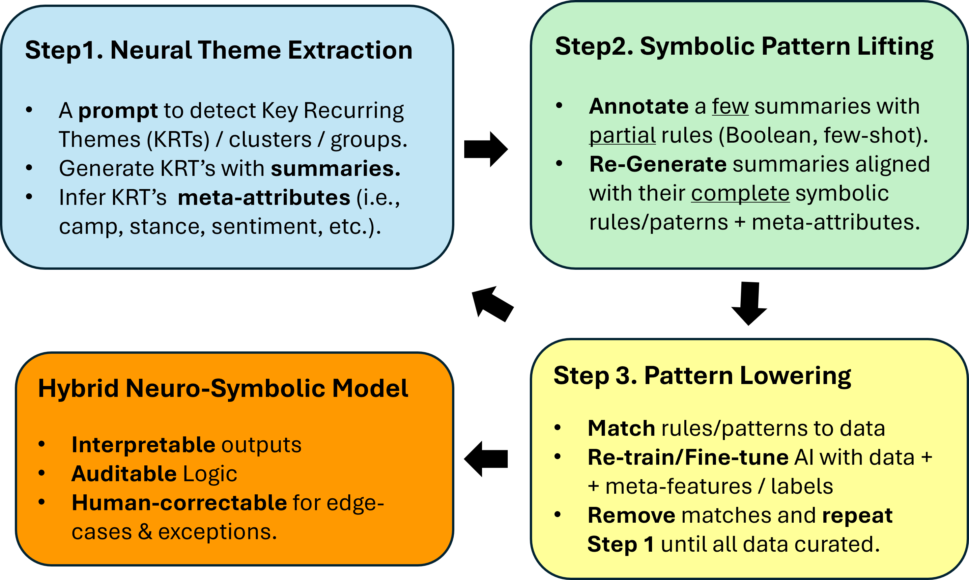
This lifting–lowering workflow operationalizes AI in a form that legal scholars, regulators, and institutions can trust: a hybrid neuro-symbolic system that integrates recognition with reasoning, and scales responsibly under governance and policy mandates.

