MINI PROJECT REPORT

ON

Simple Bank Application

Submitted by
Gottumukkala Jithin Sai
NC.SC.U4CSE24206

For
23CSE111- Object Oriented Programming
II Semester
B.Tech. CSE

School of Computing
Amrita Vishwa Vidyapeetham, Nagercoil

Index

Sl.No. | Chapter Name | Page No.
 | Introduction
 | Problem Statement
 | Objectives
UML diagrams of the project
- Class Diagram
- Use-Case Diagram
- Activity Diagram
- Sequence Diagram
 | Modules of the project
 | Code
 | Output Screenshots
 | Application of the project
 | Limitations of the project
 | Bibliography
 | GitHub link of the project

1. Introduction
The "Simple Bank Application" is a basic console-based Java program that simulates basic banking operations like deposit, withdrawal, and balance checking. It uses core Object-Oriented Programming principles like encapsulation and class design.

2. Problem Statement
There is a need for a simple, lightweight banking system where users can create accounts and perform basic transactions without any complex setup. This project addresses that need through a simple Java console application.

3. Objectives
- To implement a basic banking system.
- To practice Object-Oriented Programming concepts in Java.
- To allow account creation dynamically during deposit/withdrawal.
- To manage multiple bank accounts using a HashMap.
- To perform basic operations like deposit, withdrawal, and balance checking.

4.UML Diagrams
1.Class diagram
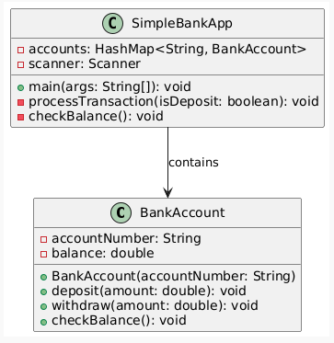

2. Sequence Diagram
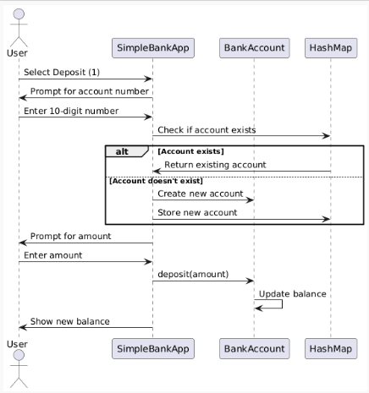

3. State Diagram
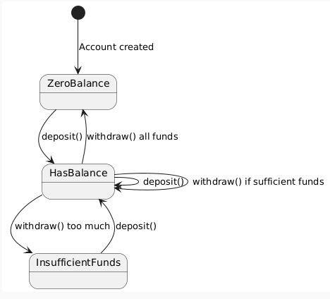

4.Activity Diagram
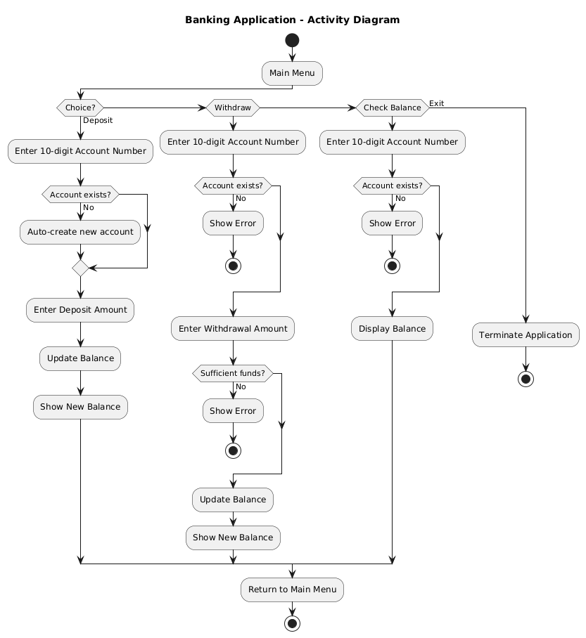

5.Water Flow Diagram
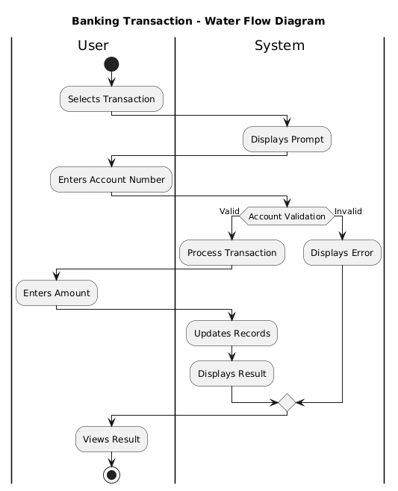

5. Modules of the Project
- BankAccount: Manages individual account details.
- SimpleBankApp: Handles user interactions and transaction processes.

6.Code
SimpleBankApp.java
import java.util.HashMap;
import java.util.Scanner;

class BankAccount {
private String accountNumber;
private double balance;

public BankAccount(String accountNumber) {
this.accountNumber = accountNumber;
this.balance = 0.0;
}

public void deposit(double amount) {
balance += amount;
System.out.printf("₹%.2f deposited. New balance: ₹%.2f%n", amount, balance);
}

public void withdraw(double amount) {
if (amount > balance) {
System.out.println("Insufficient funds!");
} else {
balance -= amount;
System.out.printf("₹%.2f withdrawn. New balance: ₹%.2f%n", amount, balance);
}
}

public void checkBalance() {
System.out.printf("Account %s balance: ₹%.2f%n", accountNumber, balance);
}

public void display() {
throw new UnsupportedOperationException("Unimplemented method 'display'");
}
}

public class SimpleBankApp {
private static HashMap<String, BankAccount> accounts = new HashMap<>();
private static Scanner scanner = new Scanner(System.in);

public static void main(String[] args) {
while (true) {
System.out.println("\n1. Deposit");
System.out.println("2. Withdraw");
System.out.println("3. Check Balance");
System.out.println("4. Exit");
System.out.print("Choose option: ");

int choice = scanner.nextInt();
scanner.nextLine();

switch (choice) {
case 1:
processTransaction(true);
break;
case 2:
processTransaction(false);
break;
case 3:
checkBalance();
break;
case 4:
System.out.println("Thank you for banking with us!");
System.exit(0);
default:
System.out.println("Invalid choice!");
}
}
}

private static void processTransaction(boolean isDeposit) {
System.out.print("Enter 10-digit account number: ");
String accNumber = scanner.nextLine();
if (!accNumber.matches("\\d{10}")) {
System.out.println("Invalid account number! Must be 10 digits.");
return;
}

// Get or create account
BankAccount account = accounts.computeIfAbsent(accNumber, _ -> {
System.out.println("New account created automatically!");
return new BankAccount(accNumber);
});

// Process transaction
System.out.printf("Enter amount to %s: ₹", isDeposit ? "deposit" : "withdraw");
double amount = scanner.nextDouble();
scanner.nextLine(); // consume newline

if (isDeposit) {
account.deposit(amount);
} else {
account.withdraw(amount);
}
}

private static void checkBalance() {
System.out.print("Enter 10-digit account number: ");
String accNumber = scanner.nextLine();

BankAccount account = accounts.get(accNumber);
if (account == null) {
System.out.println("Account not found! Deposit first to create account.");
} else {
account.checkBalance();
}
}
}
BankingApp.java
import java.util.HashMap;
import java.util.Scanner;

public class BankingApp {
private static HashMap<String, BankAccount> accounts = new HashMap<>();
private static Scanner scanner = new Scanner(System.in);

public static void main(String[] args) {
while (true) {
System.out.println("\n===== Banking Application =====");
System.out.println("1. Create New Account");
System.out.println("2. Deposit Money");
System.out.println("3. Withdraw Money");
System.out.println("4. Check Balance");
System.out.println("5. Exit");
System.out.print("Enter your choice: ");

int choice = scanner.nextInt();
scanner.nextLine(); // Consume newline

switch (choice) {
case 1:
createAccount();
break;
case 2:
performTransaction(true);
break;
case 3:
performTransaction(false);
break;
case 4:
checkBalance();
break;
case 5:
System.out.println("Thank you for using our banking services!");
System.exit(0);
default:
System.out.println("Invalid choice! Please try again.");
}
}
}

private static void createAccount() {
System.out.println("\n--- Create New Account ---");

String accountNumber;
while (true) {
System.out.print("Enter 10-digit account number: ");
accountNumber = scanner.nextLine();
if (accountNumber.matches("\\d{10}")) {
break;
}
System.out.println("Invalid account number! Must be exactly 10 digits.");
}

if (accounts.containsKey(accountNumber)) {
System.out.println("Account already exists!");
return;
}

System.out.print("Enter account holder name: ");
BankAccount newAccount = new BankAccount(accountNumber);
accounts.put(accountNumber, newAccount);
System.out.println("Account created successfully!");
newAccount.display();
}

private static void performTransaction(boolean isDeposit) {
String transactionType = isDeposit ? "Deposit" : "Withdraw";
System.out.println("\n--- " + transactionType + " Money ---");

System.out.print("Enter 10-digit account number: ");
String accountNumber = scanner.nextLine();

BankAccount account = accounts.get(accountNumber);
if (account == null) {
System.out.println("Account not found! Please create an account first.");
return;
}

System.out.print("Enter amount to " + transactionType.toLowerCase() + ": ₹");
double amount = scanner.nextDouble();
scanner.nextLine(); // Consume newline

if (isDeposit) {
account.deposit(amount);
} else {
account.withdraw(amount);
}
}

private static void checkBalance() {
System.out.println("\n--- Check Balance ---");

System.out.print("Enter 10-digit account number: ");
String accountNumber = scanner.nextLine();

BankAccount account = accounts.get(accountNumber);
if (account == null) {
System.out.println("Account not found!");
} else {
account.display();
}
}
}

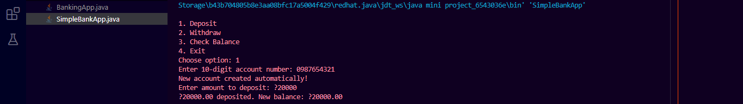
7. Output Screenshots
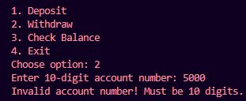

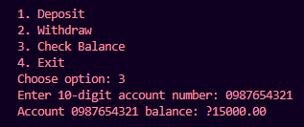
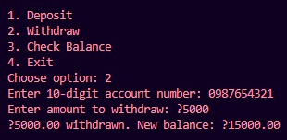
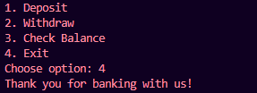

8. Application of the Project
- Useful for basic demonstration of banking operations.
- Educational tool for understanding OOP in Java.
- Forms the foundation for more complex banking or financial applications.

9. Limitations of the Project
- No persistent storage; data lost after program termination.
- No authentication or password protection.
- No transaction history maintained.
- Limited error handling.

10. Bibliography
- Java Documentation
- Oracle Java Tutorials
- StackOverflow
- GeeksforGeeks
11. GitHub Link of the Project
https://github.com/jithinSai23/BankingApplication.git

