Sabeliwe Mkhulisa
ST 10442982
DISD2 GROUP 2
PROG

Section A- ERD diagram
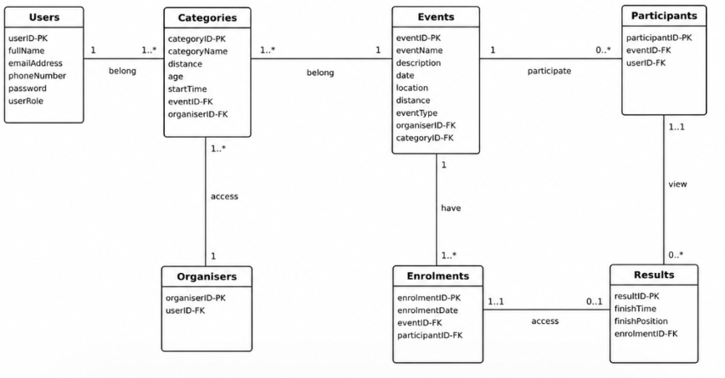

SECTION B
HTTP  Method | Route | Description | Role Required | Request Body | Expected Response
POST | /api/auth/register/ participant | Registers a new participant and creates their linked account in one step. | None (public) | { name, email, username, password } | 201 Created - participant profile and account created  409 Conflict - email or username already in use
POST | /api/auth/register/organiser | Registers a new event organiser. | None (public) | { name, email, password } | 201 Created - organiser profile created  409 Conflict - email already in use
POST | /api/auth/login | Authenticates an organiser or participant and returns an access token. | None (public) | { email or username, password } | 200 OK - token and role returned  401 Unauthorized - invalid credentials
GET | /api/profile | Returns the logged-in user's own profile (organiser or participant). | Any (logged in) | None | 200 OK - profile details  401 Unauthorized
PUT | /api/profile | Updates the logged-in user's own profile details. | Any (logged in) | { name, email } | 200 OK - updated profile  400 Bad Request - invalid data
GET | /api/events | Lists all events so participants can browse what's on offer. | Any (logged in) | CategoryID | 200 OK - array of events
GET | /api/events/{id} | Retrieves the details of a single event. | Any (logged in) | eVENTiD | 200 OK - event details  404 Not Found
POST | /api/events | Organiser creates a new event. | Organiser | { name, eventDate, location, description } | 201 Created - event created  400 Bad Request - invalid data
PUT | /api/events/{id} | Organiser updates an event they created. | Organiser (owner only) | { name, eventDate, location, description } | 200 OK - event updated  403 Forbidden - not the owning organiser  404 Not Found
DELETE | /api/events/{id} | Organiser deletes an event they created. | Organiser (owner only) | oRGANISERid | 204 No Content  403 Forbidden  404 Not Found
GET | /api/categories | Lists categories, so participants can choose one and organisers can review theirs. | Any (logged in) | None | 200 OK - array of categories
POST | /api/categories | Organiser creates a new category. | Organiser | { name } | 201 Created - category created  400 Bad Request
PUT | /api/categories/{id} | Organiser updates a category they manage. | Organiser (owner only) | { name } | 200 OK - category updated  403 Forbidden  404 Not Found
DELETE | /api/categories/{id} | Organiser deletes a category they manage. | Organiser (owner only) | None | 204 No Content  403 Forbidden  404 Not Found

POST | /api/categories/{id}/select | Participants selects this category. Since the relationship is one-to-one, this replaces any category the participant had already selected. | Participant | None | 200 OK – category selection confirmed  404 Not Found - category does not exist
POST | /api/enrollments | Participant creates an enrolment record linking them to an organiser. | Participant | { organiserId, enrollmentDate } | 201 Created - enrolment recorded  400 Bad Request
GET | /api/profile/enrollments | Participant views their own enrolments. | Participant | None | 200 OK - array of the participant's enrolments
GET | /api/organisers/{id}/ enrollments | Organiser views all enrolments linked to them. | Organiser (owner only) | None | 200 OK - array of enrolments  403 Forbidden
POST | /api/results | Organiser captures a result for a participant. | Organiser | { participantId, finishTime } | 201 Created - result recorded  400 Bad Request
GET | /api/profile/results | Participant tracks their own results. | Participant | None | 200 OK - array of the participant's results
GET | /api/organisers/{id}/results | Organiser views the results they have captured. | Organiser (owner only) | None | 200 OK - array of results  403 Forbidden

Section C
created the database, created the user and organizer tables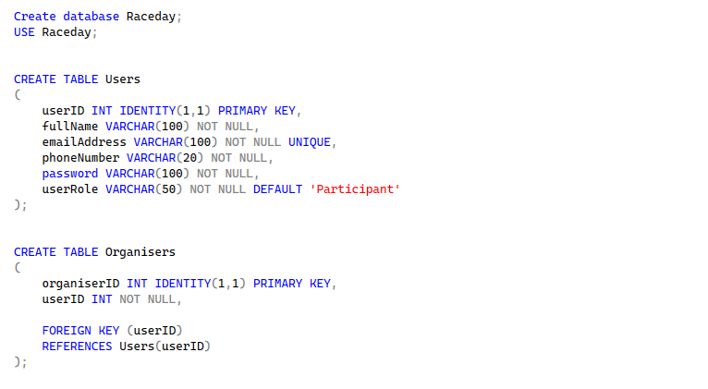
Created the participants and enrollment tables
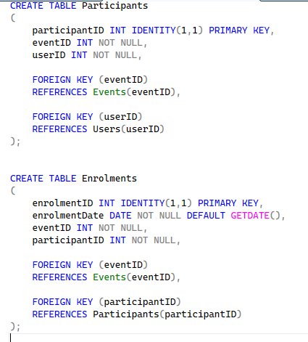
Created the events and Categories
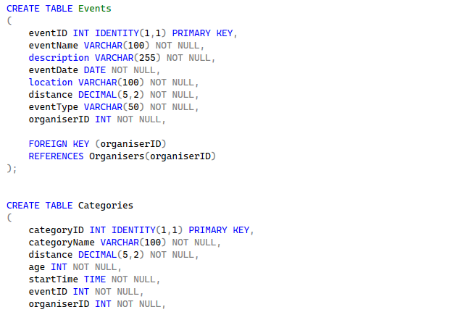
Created the Results and inserted into users
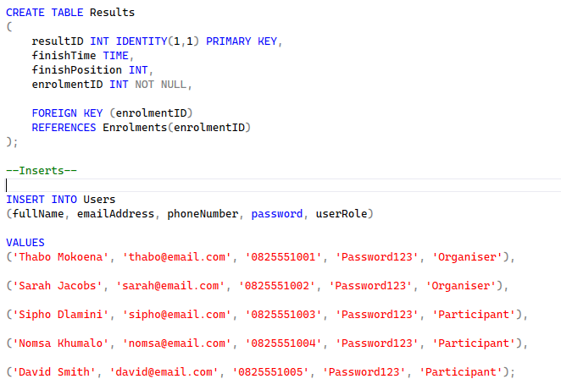

Inserted into Events and Organisers
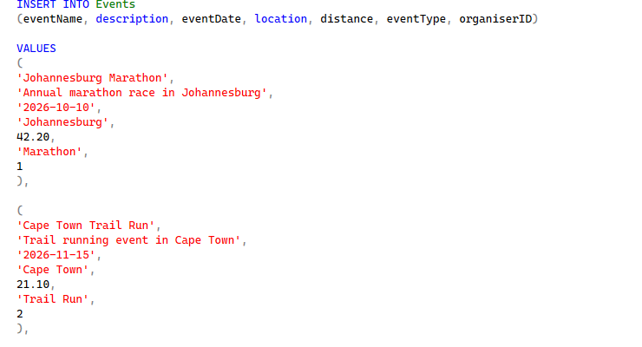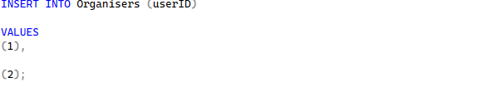
Insert into Categories
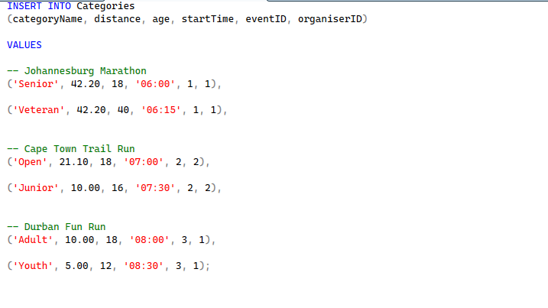
Insert into Participants, Enrolments, Results and display
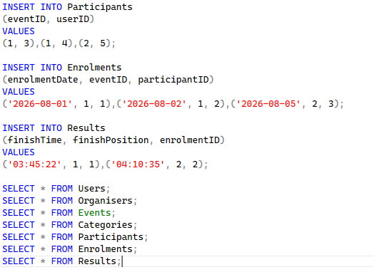

ReadMe
1. Project Overview
RaceDay is a database system designed to manage running events. The system stores information about users, organisers, events, event categories, participants, enrolments and race results. The Entity Relationship Diagram (ERD) shows how these entities are related to one another.
2. Entity Relationship Diagram (ERD)
The ERD is used to plan the structure of the RaceDay database before creating it in Microsoft SQL Server. Each entity represents a table in the database, while primary keys and foreign keys are used to create relationships between the tables.
3. Entities in the RaceDay System
Users
Stores the details of every user in the RaceDay system, including user ID, full name, email address, phone number, password and user role.
Organisers
Stores event organiser information. Each organiser is linked to a user through userID.
Events
Stores race event information, including the event name, description, date, location, distance and event type. Each event is managed by an organiser (Microsoft 2026).
Categories
Stores categories for each event. Categories can be based on age, distance and start time. Each category belongs to an event.
Participants
Links users to events as participants.
Enrolments
Stores information when a participant enrols for an event, including the enrolment date.
Results
Stores race results, including finish time and finish position. Each result is linked to an enrolment.
4. Primary Keys
Each table has a primary key that uniquely identifies every record:
- Users - userID
- Organisers - organiserID
- Events - eventID
- Categories - categoryID
- Participants - participantID
- Enrolments - enrolmentID
- Results - resultID

5. Relationships Between Entities (Microsoft 2026b).
- A User can be an Organiser. The Organisers table uses userID as a foreign key.
- An Organiser can manage one or more Events. Each Event is linked to an organiser using organiserID.
- An Event can have one or more Categories. Each Category is linked to an Event using eventID.
- A User can participate in an Event. The Participants table links a user to an event.
- A Participant can enrol for an Event. The Enrolments table stores the enrolment information.
- An Enrolment can have one Result. The Results table stores the finish time and finish position.

6. Database Constraints
- PRIMARY KEY – uniquely identifies each record in a table (Microsoft 2026a).
- FOREIGN KEY – creates relationships between tables and maintains referential integrity.
- NOT NULL – ensures that important fields cannot be left empty.
- UNIQUE – prevents duplicate values, for example duplicate email addresses.
- DEFAULT – provides a default value when no value is supplied.

7. Database Implementation
The RaceDay database is implemented using Microsoft SQL Server and SQL Server Management Studio (SSMS). The SQL script creates the RaceDayDB database, creates all
tables from the ERD, defines primary keys and foreign keys, and inserts realistic sample data including organisers, participants, events, categories, enrolments and results.
8. Design Note
The relationship between Events and Categories is implemented using eventID in the Categories table. This means that one event can have many categories. This design avoids unnecessary duplication and keeps the relationship simple.
9. Technologies Used (Microsoft 2026):
- Microsoft SQL Server
- SQL Server Management Studio (SSMS)
- Structured Query Language (SQL)

References
Microsoft (2026) SQL Server Management Studio (SSMS). Microsoft Learn. Available at: https://learn.microsoft.com/en-us/ssms/ (Accessed: 4 September 2026).
Microsoft (2026) CREATE TABLE (Transact-SQL). Microsoft Learn. Available at: https://learn.microsoft.com/en-us/sql/t-sql/statements/create-table-transact-sql (Accessed: 4 September 2026).
Microsoft (2026) INSERT (Transact-SQL). Microsoft Learn. Available at: https://learn.microsoft.com/en-us/sql/t-sql/statements/insert-transact-sql (Accessed: 4 September 2026).
Microsoft (2026) CREATE DATABASE (Transact-SQL). Microsoft Learn. Available at: https://learn.microsoft.com/en-us/sql/t-sql/statements/create-database-transact-sql (Accessed: 4 September 2026).
Microsoft (2026) SQL Server Management Studio (SSMS). Microsoft Learn. Available at: Microsoft Learn: SQL Server Management Studio ⁠ (Accessed: 4 September 2026).
Microsoft (2026) CREATE TABLE (Transact-SQL). Microsoft Learn. Available at: Microsoft Learn: CREATE TABLE documentation⁠ (Accessed: 4 September 2026).
Microsoft (2026) INSERT (Transact-SQL). Microsoft Learn. Available at: Microsoft Learn: INSERT documentation⁠ (Accessed: 4 September 2026).

