

**PROJECT MANAGEMENT**

*Assignment (WBS)*

*Project:-Online Shopping*

Group Members:

|  |  |  |
| --- | --- | --- |
| **Roll No.** | **G.R. No.** | **Name** |
| 13 | 17U576 | Umair Mohammed |
| 27 | 17U069 | Mangesh Pimparkar |
| 18 | 17U673 | Yogesh Pachkor |

Guided By:

Prof. Disha Wankhede

***WBS Structure:***

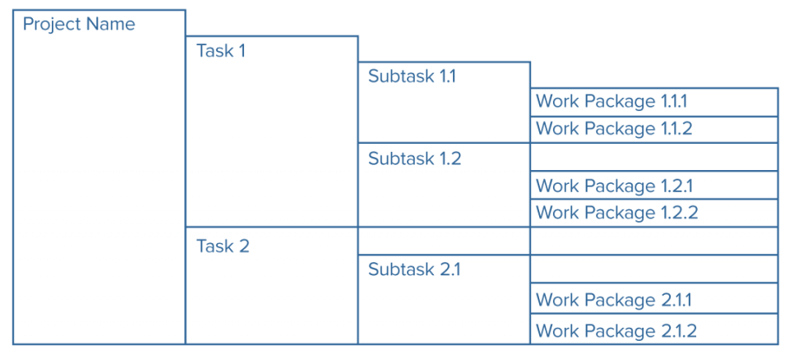

***Introduction:***

***Work Breakdown Structure(WBS):***

* *A Work Breakdown Structure element may be a product, data, service, or any combination thereof. A WBS also provides the necessary framework for detailed cost estimating and control along with providing guidance for schedule development and control*

***Definition:***

*“A work breakdown structure (WBS), in project and systems engineering, is a deliverable oriented decomposition of a project into smaller components” .*

*“A WBS is a product-oriented family tree sub division of the hardware, services and data required to produce the end product”.*

* *A work breakdown structure (WBS), in project and systems engineering, is a deliverable oriented decomposition of a project into smaller components.*
* *A work breakdown structure permits summing of subordinate costs for tasks, materials, etc., into their successively higher level “parent” tasks, materials, etc.*

***Elements of each WBS Element:***

* *The scope of the project, "deliverables" of the project.*
* *Start and end time of the scope of project.*
* *Budget for the scope of the project.*
* *Name of the person related to the scope of project.*

***A practical example of the WBS is:***

* *1.0 Aircraft System*
* *1.1 Air Vehicle*
* *1.1.1 Airframe*
* *1.1.1.1 Airframe Integration, Assembly, Test and Checkout*
* *1.1.1.2 Fuselage*
* *1.1.1.3 Wing*
* *1.1.1.4 Empennage*
* *1.1.1.5 Nacelle*
* *1.1.1.6 Other Airframe Components 1..n (Specify)*
* *1.1.2 Propulsion*
* *1.1.3 Vehicle Subsystems*
* *1.1.4 Avionics*
* *1.2 System Engineering*
* *1.3 Program Management*
* *1.4 System Test and Evaluation*
* *1.5 Training*
* *1.6 Data*
* *1.7 Peculiar Support Equipment*
* *1.8 Common Support Equipment*
* *1.9 Operational/Site Activation*
* *1.10 Industrial Facilities*
* *1.11 Initial Spares and Repair Parts*

***Flowcharts:***

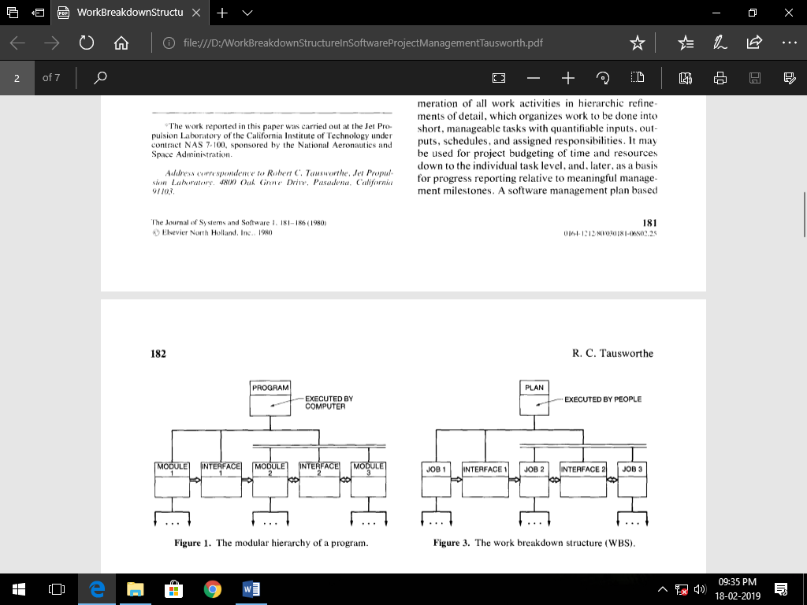



***Flowchart of Online Shopping:***

