|  |
| --- |
| University of Maryland University College |
| Web Page Foundations |
| Creating a Basic HTML eCommerce Website |
|  |
| **By Stephen Gubenia** |
| **1/24/2016** |

|  |
| --- |
| This lab the summary of building a simple HTML ecommerce website as well as the access.log analysis of the web build. It also contains screenshots of the working website. |

Contents

Introduction 1

Overview 1

Lab 3 Submission Requirements 1

Access.log Analysis 3

Sustains and Improvements 4

Conclusion 4

# Introduction

The purpose of this lab was to familiarize students HTML components and the concept of building simple applications in stages. Also to begin to understand the information contained in the Apache2 access.log file and how to interpret and analyze this information during a web application build.

# Overview

# 

Students were to create a simple themed ecommerce website of a fictitious company that provided a brief of the company and displayed twelve products with their images, descriptions and prices. A hyperlink for each product was to be provided that would provide more details when clicked. In addition an order form would be included that provided a user friendly interface allowing customers to select the quantity of each product and fill in first name, last name, street address, city, state, zip code, credit card type (Mastercard Visa, American Express), credit card number, and expiration date. The form also would provide a comment area allowing up to 300 words of comments. The form would take advantage of basic HTML components such as drop down lists, radio buttons, and check boxes as appropriate, but did not need to be functional as of yet.

# Lab 3 Submission Requirements

Figure 1 below shows the home page of my fictitious ZenWireless upon loading in the Firefox web browser. There is a brief description of the company provided at the top and a table of links is provided to the carrier websites that they support. The main content area below contains the twelve products with their descriptions.

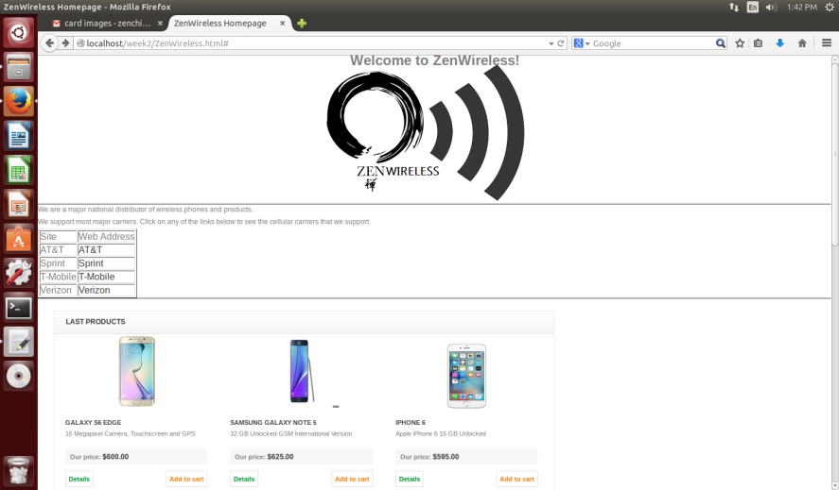

Figure 1 Screenshot of the homepage ZenWireless

Figure 2 below is the screen shot of the homepage scrolled down to show the main content area containing the twelve products. Each product has a picture, price, short description, and a button to link it to a details page as well as a “add to cart” button linking it to the order form. The product name and picture is also hyperlinked to the details page.

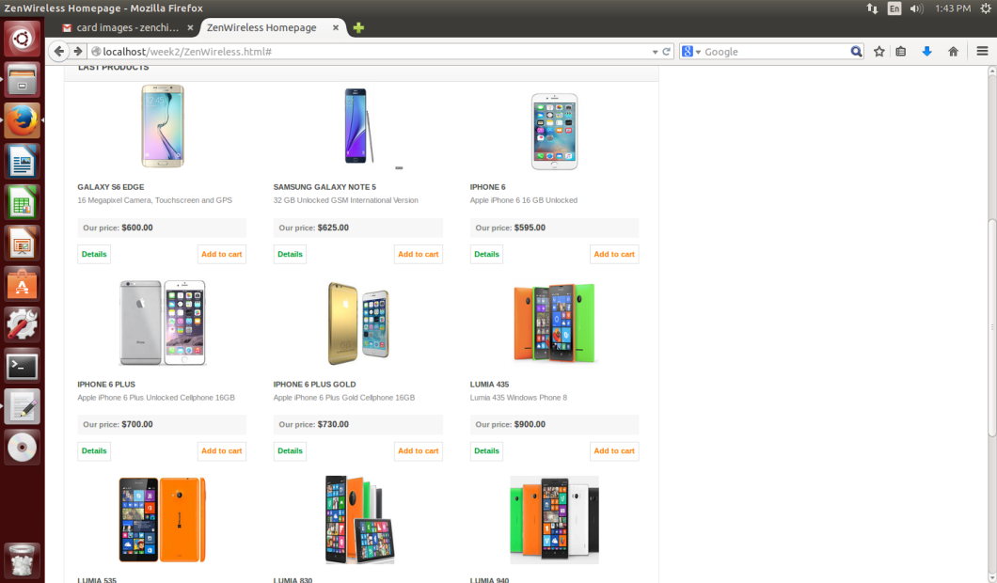

Figure 2 Screehot of the main content area of the ZenWireless homepage

Figure 3 below is what one of the detail pages looks like. All twelve products have a similar details page that contains a picture of the product, a table of carrier compatibility, and a linked list of product details.

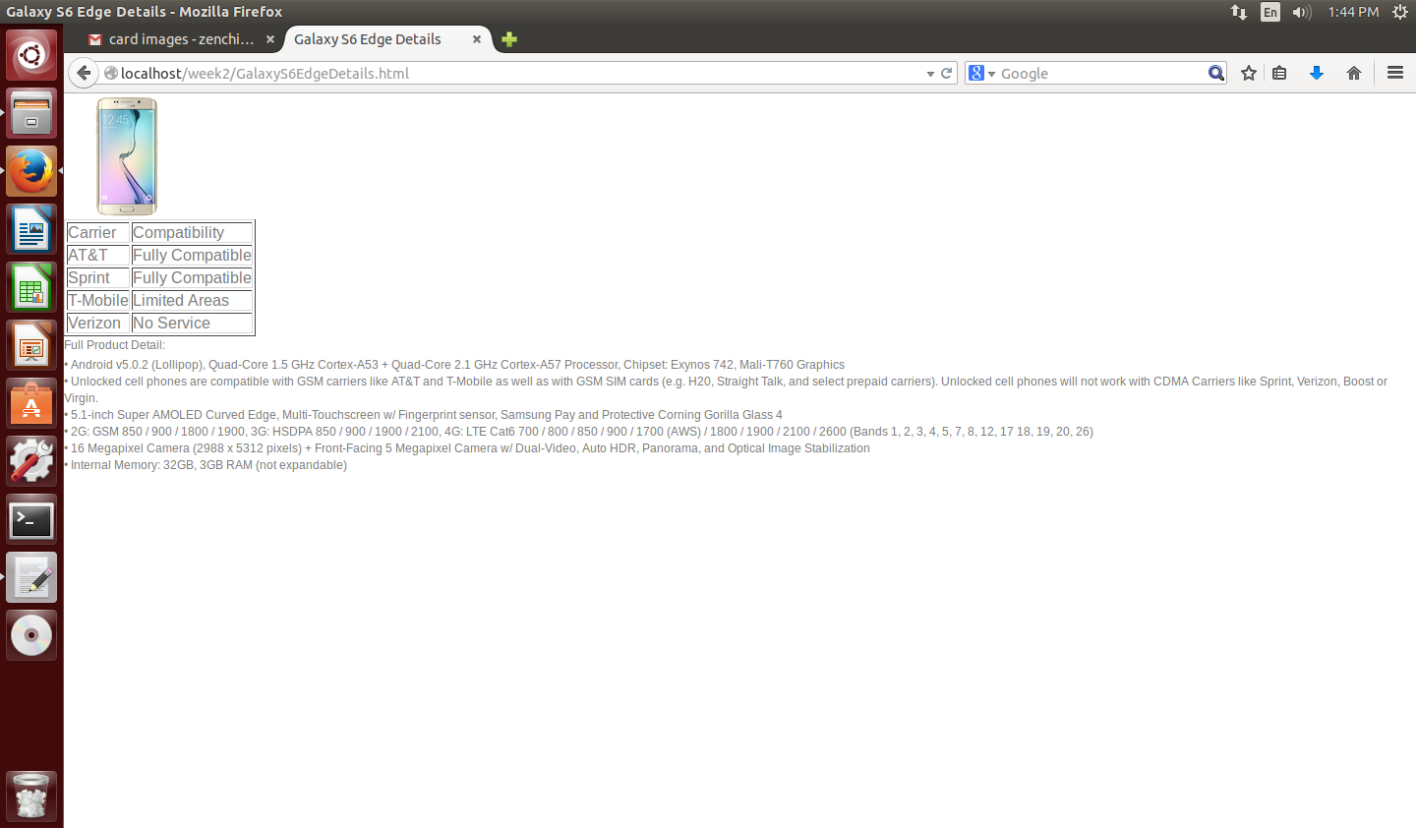

Figure 3 Screenshot of a product details page

Figure 4 below is a screen shot of the order form page which is linked to by the “add to cart” button. For now products are ordered by selecting the item from a drop down list and then entering the quantity into a text box. Ideally I would have used a script (PHP or JAVA) to retrieve the form attribute and the item selected would be retrieved and already entered into the form so the customer would only have to enter a quantity.

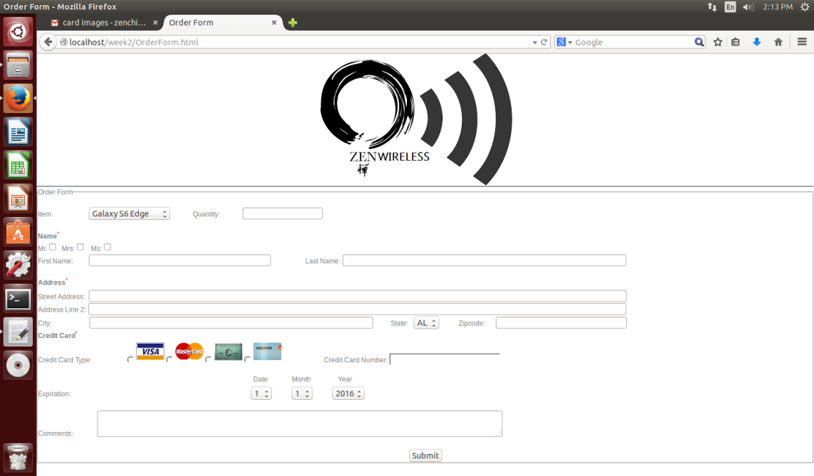

Figure 4 Screenshot of the order form page

# Access.log Analysis

I built the website in small increments over the course of two days so the access.log is in two pieces access.log and access.log.1. There are several web files, thirteen to be exact, the main homepage, twelve details pages, and the order form. I built each in stages so there is a lot of access information contained within the log file. I can clearly see how the size of my main home page grew with the bytes information provided after the 200 code. On several occasions I had input incorrect urls for image files and I can see the 404 codes generated for those. In fact I did that quite often so I have many 404 codes generated for image files. I have a few 304 codes which is most likely when I hit refresh on the homepage. I usually did this after modifying a details page or the order form page I would refresh the homepage before I would hit the button to link me to the other page. Some of the 304 codes came however when I was having some formatting problems on the homepage and I couldn’t figure out why an element wasn’t moving to where it was supposed to be. There is a long string of 304 codes in a row. It just ended up being that one of my items short descriptions was too long and the text was pushing everything over and screwing up my tile format for my products so I had to shorten the description. Other than that the log contains mostly the 200 codes of successful connections of either my homepage, the details pages, or the order form and shows clearly how the pages grew in size by my incremental build.

# Sustains and Improvements

The instructions for the lab were very detailed and easy to follow. The screenshots made it very easy to follow along. I would keep those the same. I liked the pre-lab elements as an HTML refresher before diving into building the ecommerce site. The CNShome.html document had very useful examples for this lab, but of course the W3schools website is also a very useful resource when building web applications. The information contained on the access.log analysis was very clear and concise and helped me to be able to easily interpret the information contained in the log.

Procuring twelve product images and descriptions to design a well-organized ecommerce web site from scratch is very time consuming, especially during a week when two labs are due. Perhaps either reducing the number of products or providing an image bank for students to use to simplify the lab would be helpful to future classes.

# Conclusion

This lab on web page foundations was lengthy, but fairly simple. It was a great HTML, and CSS refresher for me. I feel ready to move on to the next steps of writing functional web applications including scripts to retrieve the form data using the HTTP GET and POST methods as well as update databases using the PUT and DELETE methods. I also have gained an understanding of log analysis which is broadening by knowledge of web application security.