CEBU INSTITUTE OF TECHNOLOGY – UNIVERSITY
College of Computer Studies
Bachelor of Science in Information Technology
Software Design Description (SDD v2.0)
PlayIT
An Offline-First Gamified Early Literacy Mobile Application

Course | IT411 (Section G7) — Capstone & Research 2 | Semester 1, AY 2026–2027
Document Version | 2.0 (Post-MVP Architectural Baseline), revision 2.7
Publication Date | September 26, 2026 (Revised October 14, 2026)
Document Status | Submitted for Adviser Review and Evaluation
Prepared by | Group 56 — PlayIT Capstone Team: Riva, Zendrix (Team Lead); Palis, John James; Miel, Kaysean; Durano, Ashlee Skye; Bien, Erik Samuel
Adviser | Mr. Joemarie C. Amparo

Table of Contents
Document Revision History 4
1. Introduction 5
1.1 Purpose 5
1.2 System Scope 5
1.3 Definitions and Acronyms 6
1.4 References 6
2. Architectural Design 6
2.0 Implementation Status (checked against the code on 2026-10-13, branch refactor/hear-say-it at 89604d7) 6
2.1 System Architecture Paradigm 9
2.2 Decomposition & Architectural Layers 9
3. Detailed Component Design 10
3.1 Audio Subsystem Refactoring (FR-02, NFR-AUD-01) 10
3.1.1 AudioPlaybackManager (planned) 10
3.1.2 AudioComposer Component (planned) 11
3.2 Speech Recognition Subsystem & Visualizer (FR-03, NFR-ASR-01, NFR-PERF-01) 11
3.2.1 AudioRecord Loop & RMS Amplitude Pipeline 11
3.2.2 MicStateVisualizer Composable (planned) 12
3.3 Tutoring Layer & State Machine (FR-03, NFR-ASR-01, FR-NEW-REC) 12
3.3.1 SayItJudge with Dynamic Letter Grammars 12
3.3.2 TutorPolicy Finite State Machine (FSM) 13
3.4 Decodable Blend It Word Bank Refactoring (FR-13) 14
3.5 Database Architecture (Room Schema v4, planned) & Telemetry Logger (FR-14, FR-NEW-TEL) 14
3.5.1 Room Database Entities 14
3.5.2 Local CSV Export Manager 15
3.5.3 System Entity-Relationship Diagram 16
3.6 Pediatric Design System Tokens & Accessibility (NFR-ACC-01, NFR-ACC-02) 17
3.6.1 Touch Targets and Adaptive Dimensions (implemented) 17
3.6.2 Articulation Cue and Sound Captions (implemented) 17
3.6.3 Mascot and Companion Art (card 29b) 17
3.7 Module Class Diagrams 18
3.7.1 Module 1: Letter-Sound Acquisition (Hear It) 19
3.7.2 Module 2: Speech Production and Formative Tutoring (Say It) 20
3.7.3 Module 3: Phoneme Discrimination (Find It) 21
3.7.4 Module 4: Word Construction Checkpoint (Blend It) 22
3.7.5 Module 5: Mastery Progression, Gamification and Multi-Profile 23
3.7.6 Module 6: Telemetry, Parent Dashboard and Diagnostics 24
4. Detailed Interface & Interaction Workflows 25
4.1 Hear It Modeling Sequence Workflow 25
4.2 Say It Interaction & Correction Workflow 26
4.3 Find It Tap, Hearts and Restart Workflow 28
4.4 Blend It Word and Group Completion Workflow 29
4.5 Profile, Stars, Streak and Unlock Workflow 30
4.6 Parent Zone, Dashboard and Report Workflow 31
5. Technology Stack & External Dependencies 32
6. Verification & Architectural Testing Plan 32

Document Revision History
Version | Date | Primary Author(s) | Architectural Refactoring & Traceability Description
0.1 | May 11, 2026 | System Architect | Initial SDD draft based on SRS v2.0 (MVVM, Clean Architecture, Room SQLite, Vosk ASR).
0.2 | May 15, 2026 | System Architect | Added Word Challenge (Blend It) CVC synthesis checkpoint per adviser directive.
1.0 | May 20, 2026 | System Architect & Dev Team | Final Capstone 1 SDD: decoupled game modules, established baseline Room DB schema v1.
2.0 | September 26, 2026 | Lead Architect & Capstone Team | Comprehensive Renewal & Architectural Refactoring Based on MVP Validation (design; see §2.0 for what is implemented):  • Tutoring & Pedagogy Layer (§2.2): Designs LessonEngine, TutorPolicy finite state machine (FSM), and SayItJudge with per-letter dynamic grammars and error tagging; eliminated heart deductions in Say It.  • Audio Subsystem Architecture (§3.1): Refactored AudioPlaybackManager with AudioComposer and pre-cached SoundPool for instant phoneme playback; isolated pure phoneme (ph_​m.​wav) and key-word (kw_​m_​mouse.​wav) assets (FR-02, NFR-AUD-01).  • Speech Recognition Subsystem (§3.2): Plans to replace SpeechService (still used today) with an asynchronous AudioRecord 16kHz mono loop streaming raw PCM buffers to calculate normalized RMS amplitude for MicStateVisualizer while feeding Vosk Recognizer.​acceptWaveForm(); guaranteed tap-to-listening transition in ≤100ms (FR-03, NFR-PERF-01).  • Decodable Word Bank Refactoring (§3.4): Purged 5 invalid CVC words (AIM, BEE, TOY, BOY, ZOO) containing untaught vowel teams/diphthongs; replaced with AM, SUM, TUB, YAM, ZIP; flagged QUIZ exception (FR-13).  • Persistence & Telemetry (Room Schema v4, planned, §3.5): Extends the existing ProfileEntity (multi-profile up to 6) and plans LetterProgressEntity (spaced retrieval mastery), and TelemetryEventEntity (microsecond-accurate monotonic timestamps); added local PIN-gated CSV/PDF exporters (FR-14, FR-NEW-TEL).  • Pediatric Tokens & Accessibility (§3.6): Plans Modifier.​pediatricTouchTarget(64.​dp) and an ArticulationCue composable (NFR-ACC-01, NFR-ACC-02).
2.1 | October 5, 2026 | Capstone Team (Claude review) | Corrections for adviser review: new §2.0 implementation-status table (implemented vs planned); §3.3.1 judge uses word mode as in the code, with no fixed confidence threshold; Room schema v4 (v3 is current) with explicit migrations; revision 2.0 entries reworded as design, not completed work.
2.2 | October 9, 2026 | Capstone Team (Claude, sprint synchronization) | §2.0 re-checked against branch refactor/​hear-say-it after the Oct 9–10 sprint (cards 18–24, 03b, 15). Newly Implemented: adaptive dimensions and LessonScaffold; 4-state Say It mic (MicStatus, MicButton, time-based ripple); spoken Say It corrections; decodable Blend It word list; purposeful effects and screen transitions; responsive map (MapLayout); sound captions and ArticulationCue. §3.4 chapter letters corrected to the seeded groups; §3.6 replaced the design sketches with the implemented components. LessonEngine, AudioComposer, Room schema v4, telemetry and CSV export remain Planned.
2.3 | October 10, 2026 | Capstone Team (Claude, submission review) | Review for the IT411 submission, no design change: §3.1.1 and §3.1.2 use the shipped assets/​audio/ layout and the dated release manifests; §2.2 notes that the planned tutoring/ classes live in domain/​manager/ today; §3.1, §3.2 and §3.2.2 label the planned components; §4.2 uses the shipped Heard mic state (team decision 2026-10-06); §5 lists the short-vowel source; diagram alignment and §3.5.1 comment wrapping fixed.
2.4 | October 10, 2026 | Capstone Team (Claude, card 28) | Phone-test refinements (team decisions 2026-10-10): §2.0 adds the card 28 row (Hear It ends on the sound, Say It mic DONE after the third miss, Blend It sound-out that waits for each clip, live star totals from one SQL aggregate, one-tap map start) and marks captions as kept in code but not shown; §3.6.2 and §4.1 step 7 follow.
2.5 | October 11, 2026 | Capstone Team (Claude, diagrams) | Design diagrams added, traced from the code: §3.5.3 system ERD (Figure 1); §3.7 one class diagram per module (Figures 2–7); §4.1–§4.6 one sequence diagram per module (Figures 8–13); planned components are grey and marked «planned». §4.2 now marks NEEDS_​PRACTICE as planned (Room v4). No design change.
2.6 | October 11, 2026 | Capstone Team | Issued for adviser review and evaluation: the front matter states the submission status and the members' full names. §2.0 records the 9 mouth-shape pictures now in the app (image release 2026-10-10-mouth, card 24b) and the Hear It mouth cue beside the play button. No design change.
2.7 | October 14, 2026 | Capstone Team (Claude, card 30) | Synchronized with debug APK G (89604d7, 409 unit tests passing) for the October 14 submission. §2.0: the mouth cue is shown in Say It only (card 28c, team decision 2026-10-11); new rows for the phone-test fixes (cards 28b, 28d), the ElevenLabs clips for AM, TUB, YAM and the short /i/ with the Parent Zone credit (cards 15b, 09c), and the redrawn mascot and avatars (card 29b); the map labels below the 16 sp floor are listed. §3.1.1, §3.4, §3.6.2, the new §3.6.3, §3.7.1, §3.7.2, §4.1, §4.2 and §5 follow; Figures 2, 3 and 8 are redrawn for card 28c.

1. Introduction

1.1 Purpose
This Software Design Description (SDD v2.0) provides the definitive technical architecture, component breakdown, data schemas, and interface workflows for PlayIT. It translates the refactored functional and non-functional requirements defined in SRS v3.0 into a concrete, testable, and robust implementation blueprint. This renewed version directly resolves the technical and pedagogical bottlenecks identified during the Weeks 1–2 MVP Field Validation (schwa audio intrusion, microphone button hesitation, missing multi-profile telemetry, non-decodable words, and accessibility targets).

1.2 System Scope
This design document governs the entire PlayIT Android mobile application:
• Three-layer Clean Architecture with Model-View-ViewModel (MVVM) in Jetpack Compose.
• Autonomous, teacher-independent Tutoring & Pedagogy Engine (LessonEngine, TutorPolicy FSM, SayItJudge).
• Low-latency Audio Subsystem utilizing pre-cached SoundPool and runtime AudioComposer.
• Privacy-preserving, completely offline speech recognition via Vosk 0.3.47.
• Room SQLite Database (Schema v4, planned; the app is at v3 today) supporting multi-profile isolation and structured interaction telemetry.
• Pediatric-first design system strictly enforcing a zero-emoji policy and ≥ 64 dp touch targets.
• Local, unauthenticated Parent/Facilitator Dashboard with arithmetic safety gates and PDF/CSV report generation.

1.3 Definitions and Acronyms
• ASR: Automatic Speech Recognition.
• CVC: Consonant-Vowel-Consonant syllable/word structure.
• DAO: Data Access Object (Room persistence layer).
• FSM: Finite State Machine.
• MVVM: Model-View-ViewModel architectural pattern.
• PCM: Pulse-Code Modulation (uncompressed raw audio format).
• RMS: Root Mean Square (audio signal power measurement).
• Vosk: Lightweight offline speech recognition toolkit.

1.4 References
1. Gamma, E., Helm, R., Johnson, R., & Vlissides, J. (1994). Design Patterns: Elements of Reusable Object-Oriented Software. Addison-Wesley.
2. Martin, R. C. (2017). Clean Architecture: A Craftsman's Guide to Software Structure and Design. Prentice Hall.
3. IEEE Std 1016-2009: IEEE Standard for Information Technology—Systems Design—Software Design Descriptions.
4. PlayIT Software Requirements Specification (SRS v3.0), September 2026.

2. Architectural Design

2.0 Implementation Status (checked against the code on 2026-10-13, branch refactor/hear-say-it at 89604d7)
This document describes the target design for Weeks 4–9. The table separates what the app does today from what is planned, so the design is not read as a description of the current build.
Component | Status | Where / note
TutorPolicy (prompt ladder, no hearts in Say It) | Implemented, as a stateless policy | domain/​manager/​TutorPolicy.​kt; the FSM in §3.3.2 is the planned form
SpeechValidator (word-mode judge, per-letter foil grammars, error types) | Implemented | domain/​manager/​SpeechValidator.​kt; plays the role of the planned SayItJudge
VoskRecognizer with Vosk SpeechService | Implemented | data/​speech/​VoskRecognizer.​kt; the AudioRecord loop of §3.2 is planned (AudioCapture.​kt exists but is not wired in)
HearItSequenceBuilder (modeling sequence) | Implemented | domain/​manager/​HearItSequenceBuilder.​kt; a general AudioComposer is planned
Idle re-prompt (10 s) and next-step cues | Implemented | presentation/​components/​IdleRePrompt.​kt
HeartManager, StarCalculator, GridGenerator, ArithmeticGateManager | Implemented | domain/​manager/
ProfileEntity, SessionManager (up to 6 profiles) | Implemented | Room schema version 3 (PlayItDatabase.​kt)
Parent PDF report | Implemented | data/​pdf/​PdfExporter.​kt
Adaptive dimensions and lesson layout (WindowProfile, PlayItDimens, LessonScaffold) | Implemented | presentation/​theme/​Dimens.​kt, presentation/​components/​LessonScaffold.​kt; 64 dp touch and 16 sp text floors; tested in DimensTest, GummyContainerLayoutTest, LayoutMatrixTest (4 device sizes, font scale 1.3). Known gap: some map labels are smaller than 16 sp (the unit banner's section line 11 sp, the Blend It node badge 9.5 sp, the letter and star counters 12 to 13 sp); they are listed for the post-midterm polish card 31
Say It mic states (Idle, Listening, Heard, Result, and Done after the third miss) | Implemented | presentation/​sayit/​MicStatus.​kt, presentation/​sayit/​components/​MicButton.​kt; time-based ripple, no red; returns to Idle when the app is backgrounded; Done takes no taps (card 28); tested in MicStatusTest, SayItViewModelTest
Spoken Say It corrections (letter name, added vowel, remodel) | Implemented | presentation/​sayit/​SayItViewModel.​kt; tutor fragments fb_​letter_​name, fb_​its_​sound_​is, fb_​almost_​just, fb_​no_​ah, fb_​listen (Kokoro, audio release 2026-10-01; teacher audit pending); tested in SayItViewModelTest, AudioResolverTest
Decodable Blend It word list (§3.4) | Implemented | di/​DatabaseModule.​kt BLEND_​IT_​WORD_​SEEDS, written on every open; tested in BlendItWordSeedsTest. The AM, TUB and YAM word clips ship from audio release 2026-10-11-words (card 15b; row below). Teacher confirmation and the pictures for AM, TUB, YAM and ZIP are pending
Purposeful effects and screen transitions | Implemented | presentation/​components/​FeedbackEffects.​kt, navigation/​NavGraph.​kt, CelebrationOverlay.​kt; reduced motion gives fades only; no haptics; tested in FeedbackEffectsTest, PlayItMotionTest
Responsive map trail, compact header, unlock moment | Implemented | presentation/​map/​MapLayout.​kt, MapScreen.​kt, MapViewModel.​newlyUnlockedNodeId; tested in MapLayoutTest, TopStatsBarLayoutTest, MapViewModelTest
Mouth-shape cue ArticulationCue (§3.6.2), shown in Say It from the second miss; sound captions kept in code, not shown in the child view since card 28 (team decision 2026-10-10, confirmed 2026-10-11) | Implemented | domain/​model/​ArticulationGroup.​kt, domain/​manager/​CaptionText.​kt, presentation/​components/​CaptionBubble.​kt, ArticulationCue.​kt; the 9 mouth-shape pictures ship from image release 2026-10-10-mouth (card 24b). Since card 28c (team decision 2026-10-11) Hear It shows no mouth cue: the child watches the letter card while the sound plays. Say It shows a 96 dp cue beside the mic from the second miss ("Watch my lips"); tested in ArticulationGroupTest, CaptionTextTest, ArticulationCueTest, SayItViewModelTest, PictureAssetsTest, LayoutMatrixTest
Phone-test refinements (card 28): Hear It ends on the key word and the sound; the third Say It miss rests the mic and unlocks Next; Blend It sounds out each letter to the end (at least 750 ms) before the whole word; one-tap start of the active map node | Implemented | domain/​manager/​HearItSequenceBuilder.​kt, presentation/​sayit/​MicStatus.​kt, presentation/​blendit/​BlendItViewModel.​kt, presentation/​map/​MapTapRules.​kt; tested in HearItSequenceBuilderTest, SayItViewModelTest, BlendItViewModelTest, MapTapRulesTest
Live star totals on the map, the profile cards and the parent report | Implemented | data/​local/​dao/​ProfileDao.​kt sums lesson_​progress and blend_​it_​progress in SQL, the same sum as ReportGenerator; no schema change (card 28); tested in ProfileDaoStarsTest on an in-memory Room database
Phone-test fixes (cards 28b, 28d): truer letter-to-mouth pairs; after 10 s without a tap the main button wiggles; the unit banner title and the Say It attempt dots fit on compact screens; a lesson screen that moves to the next letter shows that letter's picture | Implemented | domain/​model/​ArticulationGroup.​kt, presentation/​components/​PulseModifier.​kt, presentation/​map/​components/​MarungkoGroupBanner.​kt, presentation/​components/​AssetImage.​kt (the picture state is keyed on the picture, card 28d); tested in ArticulationGroupTest, IdleWiggleTest, SayItViewModelTest, LayoutMatrixTest, AssetImageLoadTest
ElevenLabs clips (cards 15b, 09c): the Blend It words AM, TUB and YAM, and the short /i/ (team decisions 2026-10-11 and 2026-10-12; adviser confirmation pending) | Implemented | assets/​audio/​words/​word_​am.​wav, word_​tub.​wav, word_​yam.​wav and assets/​audio/​phonemes/​ph_​i.​wav from audio releases 2026-10-11-words and 2026-10-12-i; data/​audio/​AudioResolver.​kt resolves them. Free-plan clips, so the Parent Zone shows the credit "Some word voices made with ElevenLabs (elevenlabs.io)" (presentation/​dashboard/​components/​VoiceCredit.​kt); tested in AudioResolverTest, BlendItWordSeedsTest, VoiceCreditTest. Teacher audit pending
Redrawn mascot and companion avatars (card 29b, §3.6.3) | Implemented | 7 Lily poses in assets/​images/​mascot/ and 6 animal avatars in assets/​images/​characters/ from image release 2026-10-12-mascot; AvatarCircle and the map companions read CompanionAnimal.​assetPath; tested in PictureAssetsTest (releasedPicturesMatchManifest)
LessonEngine, LearnerModel (review scheduler) | Planned | —
AudioComposer, AudioPlaybackManager | Planned | Playback today goes through data/​audio/​AudioPlayer.​kt, which already uses a SoundPool for short clips
RMS-driven mic ripple (MicStateVisualizer with the AudioRecord loop of §3.2) | Planned | The 4 mic states are implemented (row above); the voice-driven ripple follows the planned AudioRecord loop (post-Round-2, team decision 2026-10-06)
LetterProgressEntity, TelemetryEventEntity, TelemetryLogger, CsvExportManager | Planned | Needs Room schema v4 and a migration
Modifier.​pediatricTouchTarget() as a single global modifier | Planned | The 64 dp floor is enforced today through PlayItDimens tokens and heightIn(min = 64.​dp) on every child-facing control

2.1 System Architecture Paradigm
PlayIT is structured around Clean Architecture principles combined with MVVM and unidirectional data flow (UDF) using Kotlin Coroutines and Jetpack Compose StateFlow. To guarantee autonomous child operation without requiring adult supervision, this refactored design situates a specialized Tutoring Layer between the Domain and Presentation layers.
+-----------------------------------------------------------------------------------+
| PRESENTATION LAYER (Jetpack Compose) |
| [HomeScreen] [MapScreen] [HearItScreen] [SayItScreen] [FindItScreen] |
| [BlendItScreen] [ProfileSwitcher] [ParentDashboard] [MicStateVisualizer] |
+-----------------------------------------+-----------------------------------------+
| StateFlow / UI Events
+-----------------------------------------v-----------------------------------------+
| TUTORING & PEDAGOGY LAYER |
| +--------------------+ +----------------------+ +---------------------------+ |
| | LessonEngine | | TutorPolicy (FSM) | | SayItJudge | |
| | - Sequence Runner | | - Error Dispatcher | | - Vosk Grammar Matcher | |
| | - Step Emitter | | - Prompt Ladder | | - Error Categorizer | |
| +--------------------+ +----------------------+ +---------------------------+ |
| +--------------------+ +----------------------+ +---------------------------+ |
| | AudioComposer | | LearnerModel | | TelemetryLogger | |
| | - Runtime Assembly | | - Spaced Review Queue| | - Monotonic Latency Clock | |
| +--------------------+ +----------------------+ +---------------------------+ |
+-----------------------------------------+-----------------------------------------+
| Pure Domain Interfaces
+-----------------------------------------v-----------------------------------------+
| DOMAIN LAYER |
| Repositories (Pure Kotlin - Zero Android Imports): |
| - SpeechRepository - AudioRepository - LessonRepository - ProfileRepository |
| - TelemetryRepository - GameProgressRepository - WordBankRepository |
+-----------------------------------------+-----------------------------------------+
| Repository Implementations
+-----------------------------------------v-----------------------------------------+
| DATA & INFRASTRUCTURE LAYER |
| +--------------------+ +----------------------+ +---------------------------+ |
| | Vosk Engine | | Audio Subsystem | | Room Database (Schema v4) | |
| | - AudioRecord Loop | | - SoundPool Cache | | - ProfileEntity | |
| | - 16kHz PCM Buffer | | - MediaPlayer backup | | - LetterProgressEntity | |
| | - RMS Calculator | | - Asset Manifest | | - TelemetryEventEntity | |
| +--------------------+ +----------------------+ +---------------------------+ |
+-----------------------------------------------------------------------------------+

2.2 Decomposition & Architectural Layers
1. Presentation Layer (presentation/): Contains UI composables and ViewModels. ViewModels observe domain StateFlows and emit immutable UI state objects. Composables remain purely declarative and react to state mutations without containing gameplay logic.
2. Tutoring & Pedagogy Layer (tutoring/, planned package): Governs learner pacing, scaffolding, and formative remediation. Decouples educational decision-making from UI view code. Today TutorPolicy and SpeechValidator (in the role of SayItJudge) live in domain/manager/ (§2.0):
◦ LessonEngine: Executes letter lesson scripts in sequential steps.
◦ TutorPolicy: Implements a finite state machine managing We Do, You Do, error corrections, and lead steps.
◦ SayItJudge: Evaluates captured speech buffers against constrained per-letter grammars, returning decisions and diagnostic error codes.
◦ LearnerModel: Tracks memory retention across sessions to power spaced retrieval warm-ups.
3. Domain Layer (domain/): Houses pure Kotlin enterprise business rules, data models, and repository interfaces. Contains zero android.* imports.
4. Data Layer (data/): Implements domain interfaces using hardware drivers (Vosk ASR, Android AudioRecord, SoundPool) and SQLite persistence (Room 2.6+).

3. Detailed Component Design

3.1 Audio Subsystem Refactoring (FR-02, NFR-AUD-01)
To ensure pure phoneme delivery with zero trailing vowel intrusion and instantaneous acoustic response, the audio subsystem decouples short acoustic phoneme bursts from long musical playback.

3.1.1 AudioPlaybackManager (planned)
• Underlying Driver: Android native SoundPool API with AudioAttributes.USAGE_GAME.
• Preloading Lifecycle: When the learner navigates to a chapter node on the Map Screen, all phoneme bursts for that letter (ph_<letter>.wav) are loaded into uncompressed memory.
• Physical Asset Segregation:
◦ assets/audio/phonemes/ph_<letter>.wav: Pure phoneme burst (800 ms continuous; ≤ 250 ms stops). Zero schwa trailing. Released so far: the held ph_m.wav and ph_s.wav, and the short ph_i.wav (0.28 s; the teacher audit judges its length). The other letters still play the MVP's phoneme_<letter>.mp3 until their clips are released.
◦ assets/audio/keywords/kw_<word>.wav: Key word pronunciation (e.g., kw_mouse.wav).
◦ assets/audio/words/word_<word>.wav: released Blend It word clips (AM, TUB, YAM); the other words still play the MVP's word_<word>.mp3.
◦ assets/audio/vo/tutor/car_<phrase>.wav: Spoken carrier phrases (e.g., car_listen.wav, car_this_letter_says.wav, car_say_it_with_me.wav, car_your_turn.wav).
• Provenance and license: each released clip is listed with its source, license and SHA-256 in its release manifest (docs/audio-release/<date>/manifest.json). The ElevenLabs clips (AM, TUB, YAM and the short /i/) are Free-plan audio: non-commercial use only, credited as "elevenlabs.io" at the bottom of the Parent Zone (VoiceCreditLine).

3.1.2 AudioComposer Component (planned)
AudioComposer will manage runtime assembly of the modeling sequence using duration metadata from the audio release manifests (docs/audio-release/<date>/manifest.json); today HearItSequenceBuilder builds the sequence (§2.0):
class AudioComposer @Inject constructor(
private val playbackManager: AudioPlaybackManager,
private val assetManifest: AssetManifestRepository
) {
suspend fun executeHearItSequence(letter: String, onStepUpdate: (SequenceStep) -> Unit) {
val script = assetManifest.getScript(letter)
for (step in script.steps) {
when (step) {
is Step.PlayCarrier -> {
onStepUpdate(SequenceStep.Carrier(step.id))
playbackManager.play(step.id)
delay(step.durationMs)
}
is Step.RevealMnemonic -> {
onStepUpdate(SequenceStep.Mnemonic(letter))
delay(step.durationMs)
}
is Step.PlayPhoneme -> {
onStepUpdate(SequenceStep.Phoneme(letter, isArticulationActive = true))
playbackManager.play("ph_$letter")
delay(step.durationMs + 500L) // 500ms pause between models
}
is Step.PlayKeyword -> {
onStepUpdate(SequenceStep.Keyword(step.word))
playbackManager.play("kw_${letter}_${step.word}")
delay(step.durationMs)
}
}
}
}
}

3.2 Speech Recognition Subsystem & Visualizer (FR-03, NFR-ASR-01, NFR-PERF-01)
To eliminate child hesitation at the mic and enable real-time visualization, the standard Vosk SpeechService wrapper is to be replaced with a low-level, non-blocking AudioRecord pipeline (planned for after Round 2; the shipped mic shows its four states with a time-based ripple, §2.0).

3.2.1 AudioRecord Loop & RMS Amplitude Pipeline
[Device Microphone (16 kHz Mono PCM)]
|
v
[AudioRecord Buffer] (1024 samples / 64 ms chunk)
|
+--------+--------+
| |
v v
[Compute RMS Amplitude] [Vosk Recognizer.acceptWaveForm()]
| |
v (0.0 to 1.0) v (Partial/Final Result)
[MicStateVisualizer] [SayItJudge Decision Logic]

• Audio Settings: Sample Rate: 16,000 Hz, Channel: CHANNEL_IN_MONO, Encoding: ENCODING_PCM_16BIT.
• RMS Calculation: For each 1024-sample buffer, root-mean-square amplitude is calculated:
RMS = √(1/N Σᵢ₌₁ᴺ xᵢ²), Normalized Level = coerceIn((20 log₁₀(RMS + 10⁻⁵) − Floor) / Range, 0.0, 1.0)
• Tap-to-Listening Transition: When the user taps the mic button (or carrier finishes), the ViewModel immediately mutates UI state to MicState.LISTENING in ≤ 20 ms, while the background recording coroutine initializes.

3.2.2 MicStateVisualizer Composable (planned)
@Composable
fun MicStateVisualizer(
state: MicState,
audioLevel: Float, // 0.0 to 1.0
onClick: () -> Unit,
modifier: Modifier = Modifier
) {
val animatedScale by animateFloatAsState(
targetValue = if (state == MicState.LISTENING) 1.0f + (audioLevel * 0.45f) else 1.0f,
animationSpec = spring(stiffness = Spring.StiffnessLow)
)
val rippleAlpha by animateFloatAsState(
targetValue = if (state == MicState.LISTENING) 0.35f + (audioLevel * 0.5f) else 0.0f
)
Box(contentAlignment = Alignment.Center, modifier = modifier.size(100.dp)) {
if (state == MicState.LISTENING) {
Box(
Modifier
.size(96.dp)
.scale(animatedScale)
.background(Color(0xFFFBBF24).copy(alpha = rippleAlpha), CircleShape)
)
}
IconButton(
onClick = onClick,
modifier = Modifier.size(72.dp).background(state.backgroundColor, CircleShape)
) {
Icon(state.icon, contentDescription = state.description, tint = Color.White)
}
}
}

3.3 Tutoring Layer & State Machine (FR-03, NFR-ASR-01, FR-NEW-REC)

3.3.1 SayItJudge with Dynamic Letter Grammars
Vosk is instantiated with a constrained per-letter runtime grammar rather than open vocabulary:
{
"letter": "m",
"mode": "WORD",
"grammar": ["mouse", "m", "em", "ma", "muh", "[unk]"],
"targetToken": "mouse",
"foils": {
"m": "LETTER_NAME",
"em": "LETTER_NAME",
"ma": "ADDED_VOWEL",
"muh": "ADDED_VOWEL"
}
}

• Error Classification:
◦ Scoring mode (hybrid): the scored check is word mode (the key word, e.g. "mouse"), as in SpeechValidator.grammarFor() today. Pure-sound grammars (<target_m>) are used for the recall check only if the on-device Vosk test with children passes; the Week 4 spike found that Vosk cannot confirm a held /m/, so SpeechValidator.SOUND_MODE_ENABLED = false (docs/spikes/vosk-foil-spike.md).
◦ Confidence: no fixed threshold is set in this design. If a confidence threshold is introduced, it is tuned on Round 2 data, validated on a held-out set, and kept in configuration (refactor spec §6.2, §6.4).
◦ Utterance matches targetToken → JudgeResult.CORRECT.
◦ Utterance matches "em" → JudgeResult.ERROR(ErrorType.LETTER_NAME).
◦ Utterance matches "ma" → JudgeResult.ERROR(ErrorType.ADDED_VOWEL).
◦ Utterance matches "[unk]" or nothing → JudgeResult.ERROR(ErrorType.UNKNOWN).

3.3.2 TutorPolicy Finite State Machine (FSM)
+------------+
| IDLE |
+-----+------+
| Carrier "Say it with me!" (We Do x2)
v
+------------+
| WE_DO |
+-----+------+
| Mascot Choral Practice Complete -> Carrier "Your Turn!"
v
+------------+ Mic Tap or Auto-Listen
+---> | LISTENING | <---------------------------------+
| +-----+------+ |
| | User speaks / AudioRecord captures |
| v |
| +------------+ |
| | EVALUATING | (Vosk ASR Grammar Match) |
| +-----+------+ |
| | |
| +---> Match == Target -------------------> | PRAISE -> Advance Node
| | |
| +---> Foil / Silence (Attempt < 3) |
| | | |
| | v |
| | [ERROR_CORRECTION] (Formative prompt) --+
| |
| +---> Foil / Silence (Attempt == 3)
| |
| v
| [LEAD] ("Let's say it together" -> Mark NEEDS_PRACTICE -> Advance)

3.4 Decodable Blend It Word Bank Refactoring (FR-13)
The seeded BlendItWord list (BLEND_IT_WORD_SEEDS in di/DatabaseModule.kt) carries the replacements below and is written on every app start, so existing installs receive them; each replacement keeps the word id it replaces, so learner progress is unaffected (card 15, implemented 2026-10-09; teacher confirmation of the list pending). The AM, TUB and YAM word clips were made with ElevenLabs Text to Speech after the Kokoro TUB takes added a vowel ("tahbi") (card 15b). The pictures for AM, TUB, YAM and ZIP are still pending, so these four words show no picture yet. The 5 invalid words identified during MVP validation are replaced:
Chapter | Unlocked Letters | Purged Word | Violation Reason | Replacement Word | Valid Letters Used
Ch 1 | m, s, a, i | AIM | Contains vowel team ai | AM | a, m
Ch 2 | + o, b, e, u | BEE | Contains vowel team ee | SUM | s, u, m
Ch 3 | + t, k, l, y | TOY | Contains diphthong oy | TUB | t, u, b
Ch 3 | + t, k, l, y | BOY | Contains diphthong oy | YAM | y, a, m
Ch 7 | + q, v, x, z | ZOO | Contains vowel team oo | ZIP | z, i, p
Ch 7 | + q, v, x, z | QUIZ | qu = /kw/ digraph | QUIZ | Kept as the documented exception (named in the seed comment and excluded by BlendItWordSeedsTest)

3.5 Database Architecture (Room Schema v4, planned) & Telemetry Logger (FR-14, FR-NEW-TEL)

3.5.1 Room Database Entities
// Profile Entity: Multi-Profile Management (FR-14).
// EXISTS in schema v3 (data/local/entity/ProfileEntity.kt); unchanged in v4.
// The name is optional for the child: onboarding is avatar-only and the default
// name is the avatar's name; a parent can rename the profile in the Parent Zone.
@Entity(tableName = "profiles")
data class ProfileEntity(
@PrimaryKey(autoGenerate = true) val profileId: Long = 0,
val name: String,
val avatarResId: Int,
val totalStars: Int = 0,
val currentStreak: Int = 0,
val lastPlayedAt: Long = System.currentTimeMillis(),
val createdAt: Long = System.currentTimeMillis()
)
// PLANNED for schema v4: LetterProgressEntity and TelemetryEventEntity below.
// Letter Progress Entity: Spaced Retrieval Mastery (FR-NEW-REC)
@Entity(
tableName = "letter_progress",
foreignKeys = [
ForeignKey(
entity = ProfileEntity::class,
parentColumns = ["profileId"],
childColumns = ["profileId"],
onDelete = ForeignKey.CASCADE
)
],
indices = [Index(value = ["profileId", "letter"], unique = true)]
)
data class LetterProgressEntity(
@PrimaryKey(autoGenerate = true) val id: Long = 0,
val profileId: Long,
val letter: String,
val masteryState: String, // "NEW", "INTRODUCED", "NEEDS_PRACTICE", "SECURE"
val echoPassCount: Int = 0,
val recallPassCount: Int = 0,
val lastSeenEpoch: Long = 0,
val nextReviewEpoch: Long = 0
)
// Telemetry Event Entity: Diagnostic Interaction Logging (FR-NEW-TEL)
@Entity(
tableName = "telemetry_events",
foreignKeys = [
ForeignKey(
entity = ProfileEntity::class,
parentColumns = ["profileId"],
childColumns = ["profileId"],
onDelete = ForeignKey.CASCADE
)
],
indices = [Index("profileId"), Index("eventType")]
)
data class TelemetryEventEntity(
@PrimaryKey(autoGenerate = true) val id: Long = 0,
val profileId: Long,
val sessionId: String,
val chapter: Int,
val letter: String,
val module: String, // "HEAR", "SAY", "FIND", "BLEND"
val eventType: String, // "mic_tap", "speech_end", "asr_result", "feedback_shown", etc.
val elapsedRealtimeMs: Long, // Monotonic SystemClock.elapsedRealtime() for latency
val wallClockEpoch: Long, // Epoch timestamp for audit correlation
val resultValue: String?, // Recognized text or correct/incorrect
val asrConfidence: Float?,
val errorType: String? // "LETTER_NAME", "ADDED_VOWEL", "SUBSTITUTION", "UNKNOWN"
)

3.5.2 Local CSV Export Manager
A local exporter reads telemetry_events for the active profile, formats records into RFC 4180 CSV, writes the file to context.filesDir/exports/, and launches the native Android Intent.ACTION_SEND share sheet behind the arithmetic gate.

3.5.3 System Entity-Relationship Diagram
Figure 1 shows the Room database playit_db as built (schema version 3, PlayItDatabase.kt).
• Tables: 11 tables in three groups:
◦ Curriculum, seeded on every open: phonemes, letter_groups, letter_group_members, blend_it_words.
◦ Learners: profiles, achievements.
◦ Progress and attempts: lesson_progress, blend_it_progress, say_it_attempts, find_it_attempts, blend_it_attempts.
• Foreign keys: every one is ON DELETE CASCADE, so deleting a profile removes all of that child's rows (FR-14).
• Star totals: the stored profiles.totalStars column is not what the app shows. The map and profile cards show SUM(lesson_progress.starsEarned) + SUM(blend_it_progress.starsEarned), computed in ProfileDao (card 28).
• Planned tables: the two schema v4 tables of §3.5.1 (letter_progress, telemetry_events) are grey and dashed.
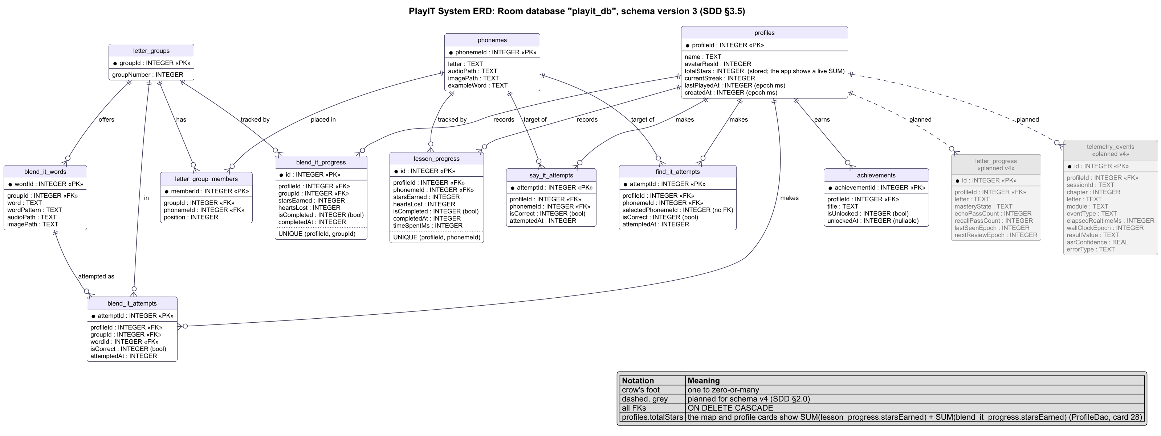
Figure 1. System ERD: Room database playit_db, schema version 3, with the planned v4 tables in grey

3.6 Pediatric Design System Tokens & Accessibility (NFR-ACC-01, NFR-ACC-02)

3.6.1 Touch Targets and Adaptive Dimensions (implemented)
The 64 dp touch floor and the 16 sp text floor are carried by design tokens rather than one global modifier. windowProfileFor(widthDp, heightDp) picks COMPACT (under 700 dp tall), REGULAR or WIDE (600 dp and wider), and LocalPlayItDimens provides the matching PlayItDimens (letter card height, primary button, mic size, Find It card size, tile size, map node size). Every child-facing control uses heightIn(min = 64.dp) or a token at least that large. LessonScaffold pins the top bar, header and bottom bar, and lets the body fit or scroll, capped at 560 dp wide on tablets:
@Composable
fun LessonScaffold(
topBar: @Composable () -> Unit,
header: @Composable () -> Unit,
bottomBar: @Composable () -> Unit,
modifier: Modifier = Modifier,
content: @Composable ColumnScope.() -> Unit,
)

LayoutMatrixTest renders Hear It, Say It, Find It, Blend It, the map, the complete screens, splash and the name prompt at 360x640, 360x740, 411x891 and 800x1280 dp (and at font scale 1.3), and fails if the main action is below the window.

3.6.2 Articulation Cue and Sound Captions (implemented)
Each letter maps to one of 9 mouth-shape groups (ArticulationGroup, pure Kotlin), an approximation for a child that a teacher checks during Gate 3. Captions come from CaptionText.forClip(path, letter, word): a phoneme clip shows /m/, a key word shows the word, a carrier shows its line, and a pause shows nothing. AudioPlayer.playSequence(paths, onItemStart, onComplete) reports each clip as it starts, so the Hear It view model computes the caption live; the screen does not show it (card 28).
@Composable
fun ArticulationCue(group: ArticulationGroup, size: Dp, modifier: Modifier = Modifier)
@Composable
fun CaptionBubble(caption: String?, modifier: Modifier = Modifier)

The 9 pictures ship in assets/images/mouth/ (image release 2026-10-10-mouth, card 24b); ArticulationCue draws nothing if a picture is missing.
• Say It: a 96 dp cue beside the mic from the second miss ("Watch my lips", spec Table 7).
• Hear It: no cue since card 28c (team decision 2026-10-11, adviser confirmation pending). During the modeling sequence the child looks at one thing, the letter card, and listens; a second picture would split a pre-reader's attention.
• Captions: kept in the code but not shown in the child view (card 28).

3.6.3 Mascot and Companion Art (card 29b)
• Lily: the orange tarsier has 7 poses in assets/images/mascot/ (idle, listening, pointing, thinking, encouraging, celebrating, waving). They were redrawn for one consistent style, not redesigned. MascotState picks the pose for each screen state; for example the profile screen waves when profiles exist.
• Companions: 6 animal avatars (cat, monkey, bunny, bear, frog, owl) are in assets/images/characters/. The profile AvatarCircle and the map companions both read CompanionAnimal.assetPath, so one picture serves both places.
• Release: all 13 pictures ship from image release 2026-10-12-mascot with their SHA-256 (§2.0).
• Not yet: the splash screen still draws an older vector tarsier in SplashScreen.kt. Replacing it with the waving pose is listed for card 31.

3.7 Module Class Diagrams
Figures 2 to 7 give one class diagram for each functional module of SRS §3.2.
• Source: traced from the code on refactor/hear-say-it (checked 2026-10-11; Figures 2, 3 and 8 rechecked on 2026-10-13 for card 28c).
• Layout: each diagram is grouped by the layers of §2.2 (presentation, domain, data).
• Planned classes: classes the earlier sections describe as planned are grey and marked «planned», with a dashed line to the class they would extend or replace (for example AudioComposer, LearnerModel, TelemetryLogger). Everything else exists in the app today.
• Sources: the diagram sources are in docs/diagrams/src/.

3.7.1 Module 1: Letter-Sound Acquisition (Hear It)
HearItViewModel builds the modeling sequence with HearItSequenceBuilder and plays it through AudioPlayer. Since card 28c the screen shows only the letter card, the play button and the step dots. The view model still computes the caption and the letter's ArticulationGroup, but the screen does not show them.
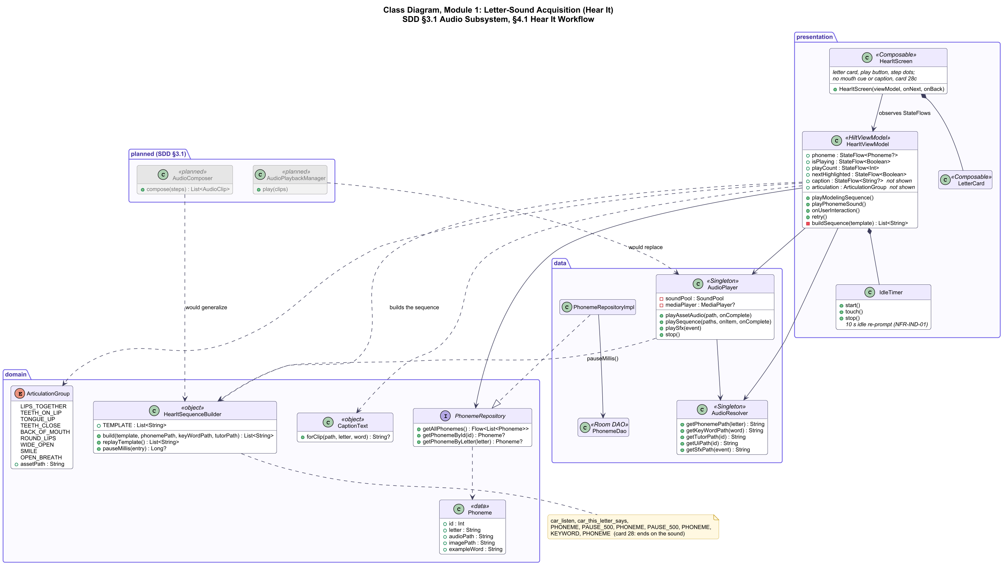
Figure 2. Class diagram, Module 1: Hear It

3.7.2 Module 2: Speech Production and Formative Tutoring (Say It)
• Judging and the prompt ladder: SpeechValidator (in the role of SayItJudge) judges the transcript. The stateless TutorPolicy maps the attempt number and the judgement to Praise, Correct or LeadAndMoveOn.
• Mic state: MicStatus drives the mic button.
• Mouth cue: from the second miss, showMouthCue puts ArticulationCue beside the mic, with the picture of the letter's ArticulationGroup.
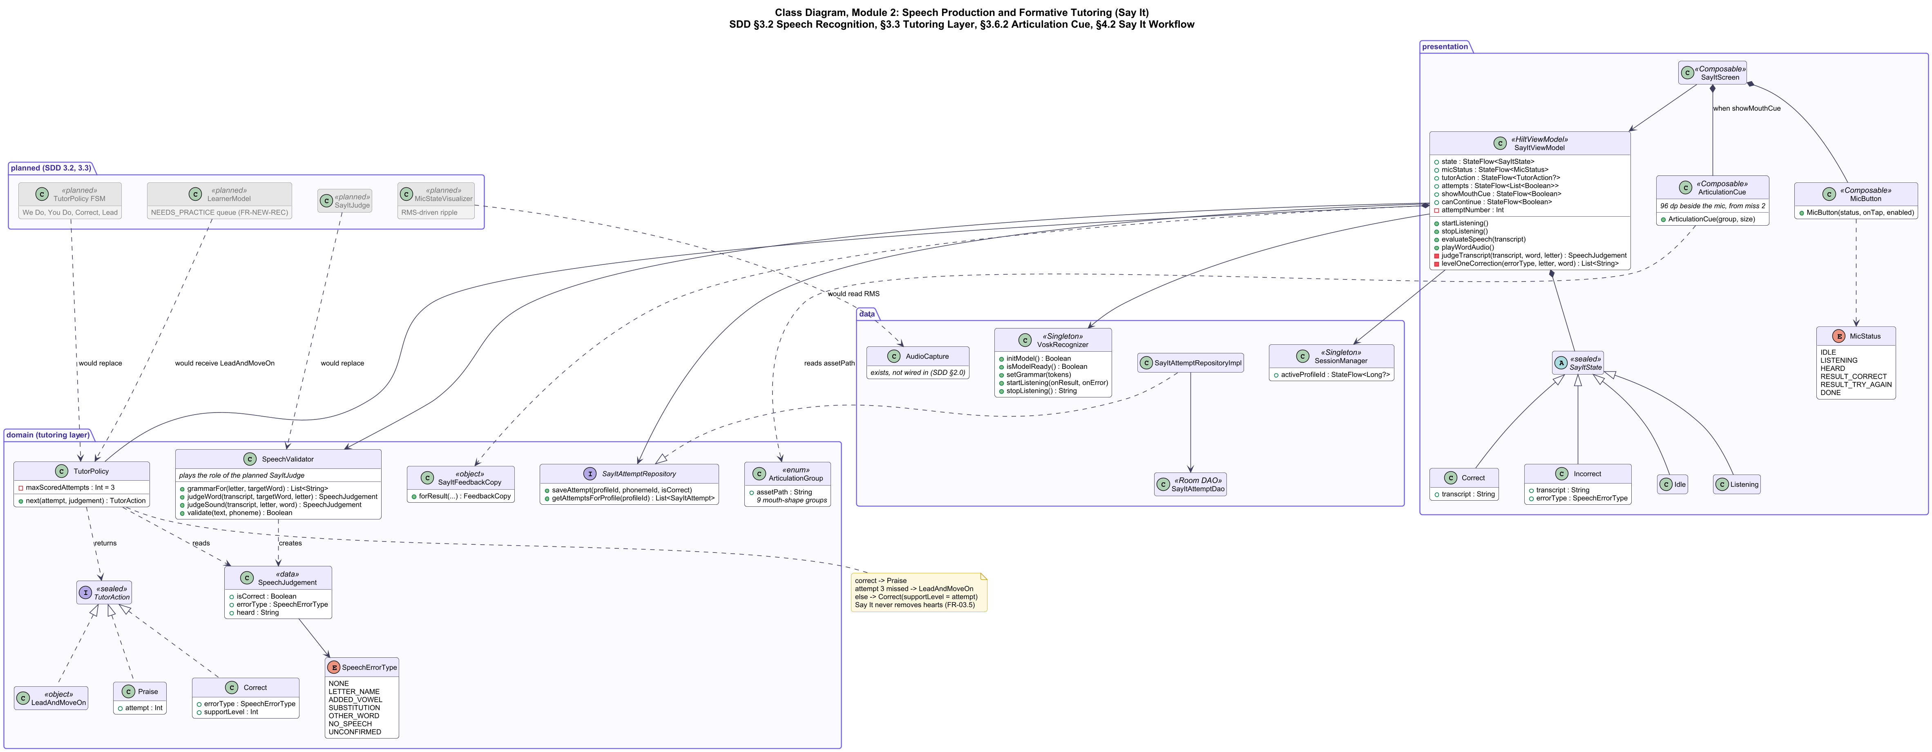
Figure 3. Class diagram, Module 2: Say It

3.7.3 Module 3: Phoneme Discrimination (Find It)
GridGenerator builds 5 pictures (3 targets, 2 distractors). HeartManager deducts hearts, recovers them and restarts with 3.
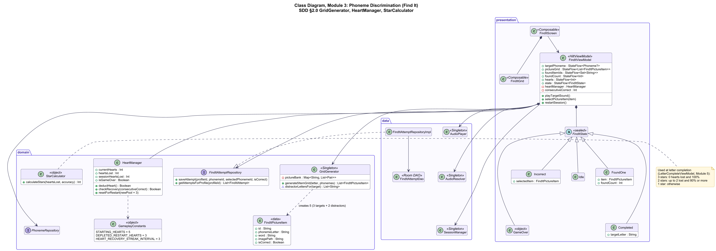
Figure 4. Class diagram, Module 3: Find It

3.7.4 Module 4: Word Construction Checkpoint (Blend It)
BlendItViewModel checks the tiles and runs the sound-out. BlendItCompleteViewModel scores the group with BlendItStarThresholds and saves BlendItProgress.
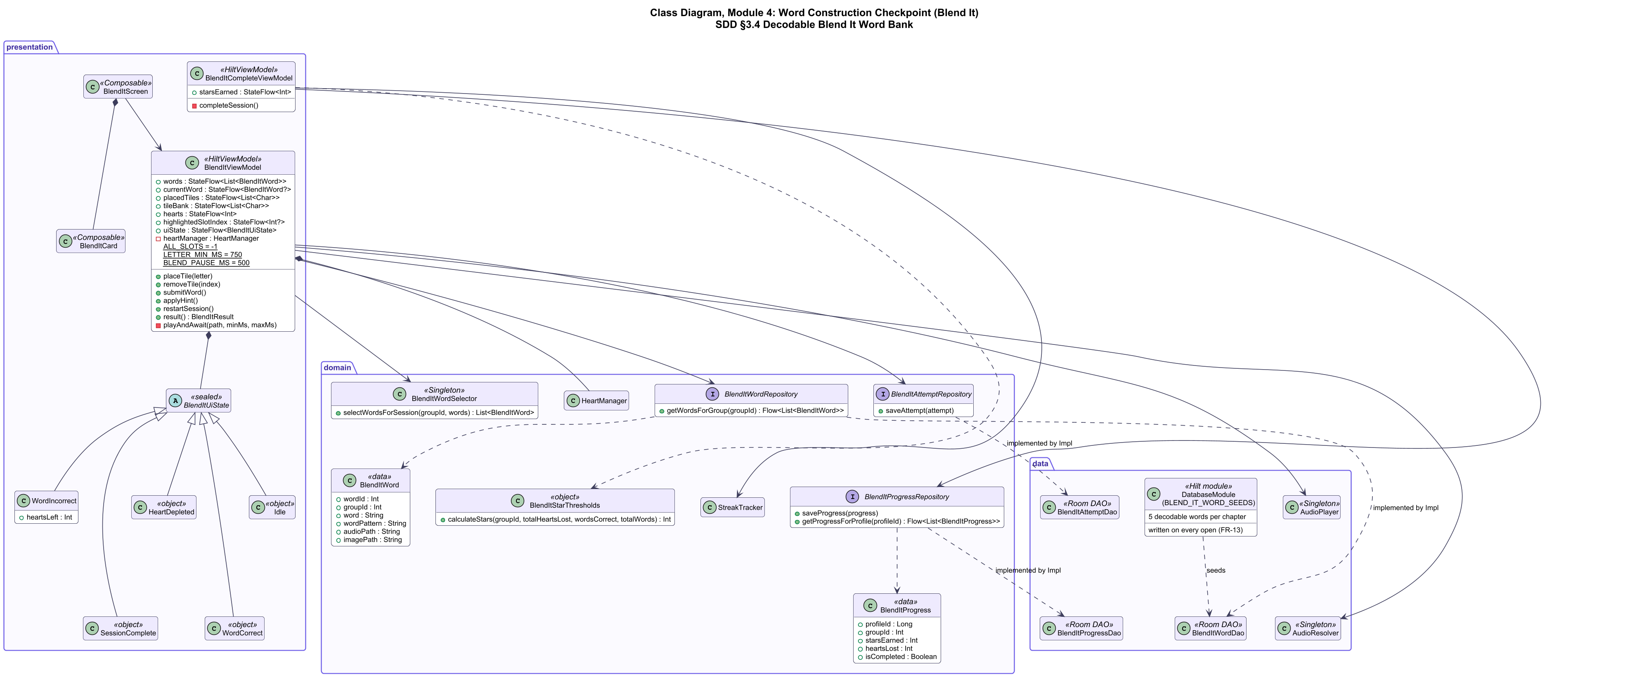
Figure 5. Class diagram, Module 4: Blend It

3.7.5 Module 5: Mastery Progression, Gamification and Multi-Profile
SessionManager holds the active profile. LetterCompleteViewModel saves stars and the streak. MapViewModel derives the nodes with UnlockManager and the live star total from ProfileDao.
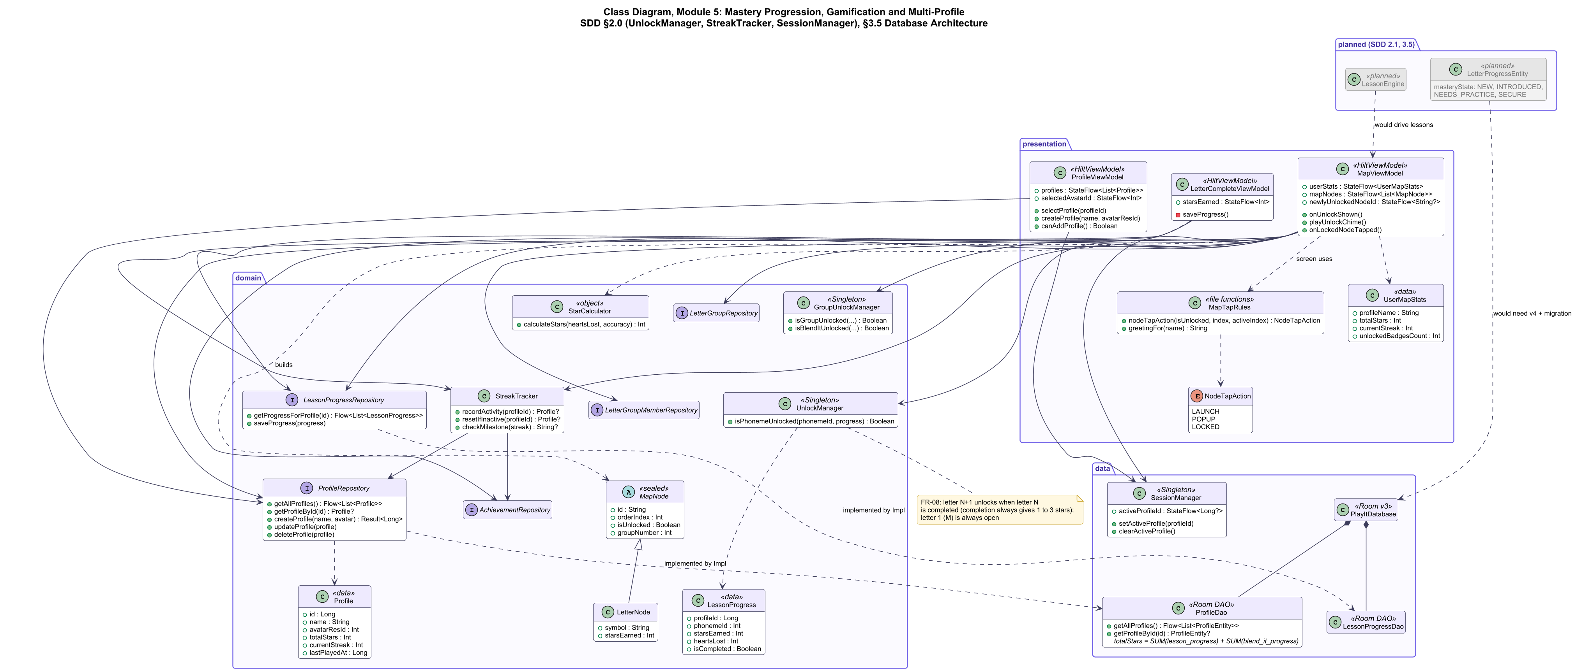
Figure 6. Class diagram, Module 5: Progression, gamification and profiles

3.7.6 Module 6: Telemetry, Parent Dashboard and Diagnostics
ReportGenerator aggregates the repositories into ProfileDashboardData and ReportData. PdfExporter writes the report. The arithmetic gate guards entry. The telemetry classes are planned.
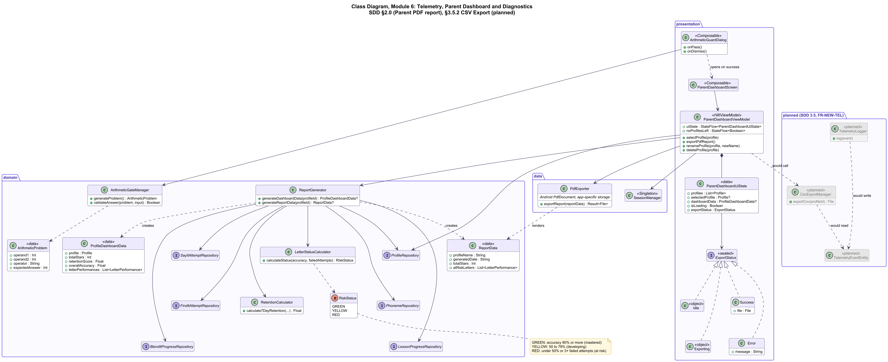
Figure 7. Class diagram, Module 6: Parent dashboard and diagnostics

4. Detailed Interface & Interaction Workflows

4.1 Hear It Modeling Sequence Workflow
User selects Letter -> Screen Loads -> SoundPool Preloads Letter Clips
-> Step 1: Mascot plays "Listen!" carrier (Audio + Animation)
-> Step 2: Letter card flips, displaying embedded Picture Mnemonic
-> Step 3: Mascot plays "This letter says..." carrier
-> Step 4: Pure phoneme plays 3 times (800ms hold or <=250ms stop)
(card 28c: no mouth cue or caption; the child watches the letter card)
-> Step 5: Mascot plays Keyword audio ("mouse") + Keyword image
-> Step 6: Pure phoneme plays 1 time
-> Step 7: "Great listening! Tap the big button." -> Next pulses -> Say It
(card 28: Hear It no longer ends with "Say it with me!")

Figure 8 shows the same workflow as the code runs it. Figures 8 to 13 give one sequence diagram for each module.
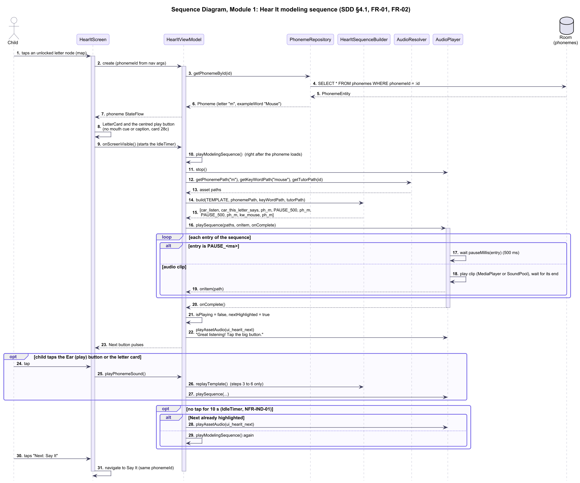
Figure 8. Sequence diagram, Module 1: Hear It modeling sequence

4.2 Say It Interaction & Correction Workflow
Screen Enters -> Mascot leads 2 Choral Turns ("Say it with me!")
-> Mascot plays "Your turn!"
-> MicState changes to LISTENING (<= 100ms); the ripple animates
(time-based today; RMS-driven once the AudioRecord loop lands)
-> Child vocalizes -> Vosk reports speech -> MicState changes to HEARD
-> Vosk signals End-of-Speech
-> SayItJudge (SpeechValidator today) checks the result against the per-letter grammar:
[Branch A: Target Match]
-> MicState changes to RESULT (Green)
-> Success chime plays + specific praise ("Yes! /m/, lips together!")
-> Award Star -> Advance to Find It
[Branch B: Foil Match or Silence (Attempt < 3)]
-> MicState changes to RESULT (Amber)
-> Formative prompt plays (e.g. "Almost! Just /m/, no 'ah'")
-> From the second miss the mouth cue shows beside the mic
-> Mic reactivates for retry
[Branch C: Foil Match or Silence (Attempt == 3)]
-> Mascot leads together-practice ("Let's say it together: /m/")
-> LetterProgressEntity marked NEEDS_PRACTICE (planned: Room v4)
-> Advance to Find It (Zero hearts deducted)

In the code today, the third miss saves the attempt rows and moves on; the NEEDS_PRACTICE mark waits for Room schema v4 (§2.0).
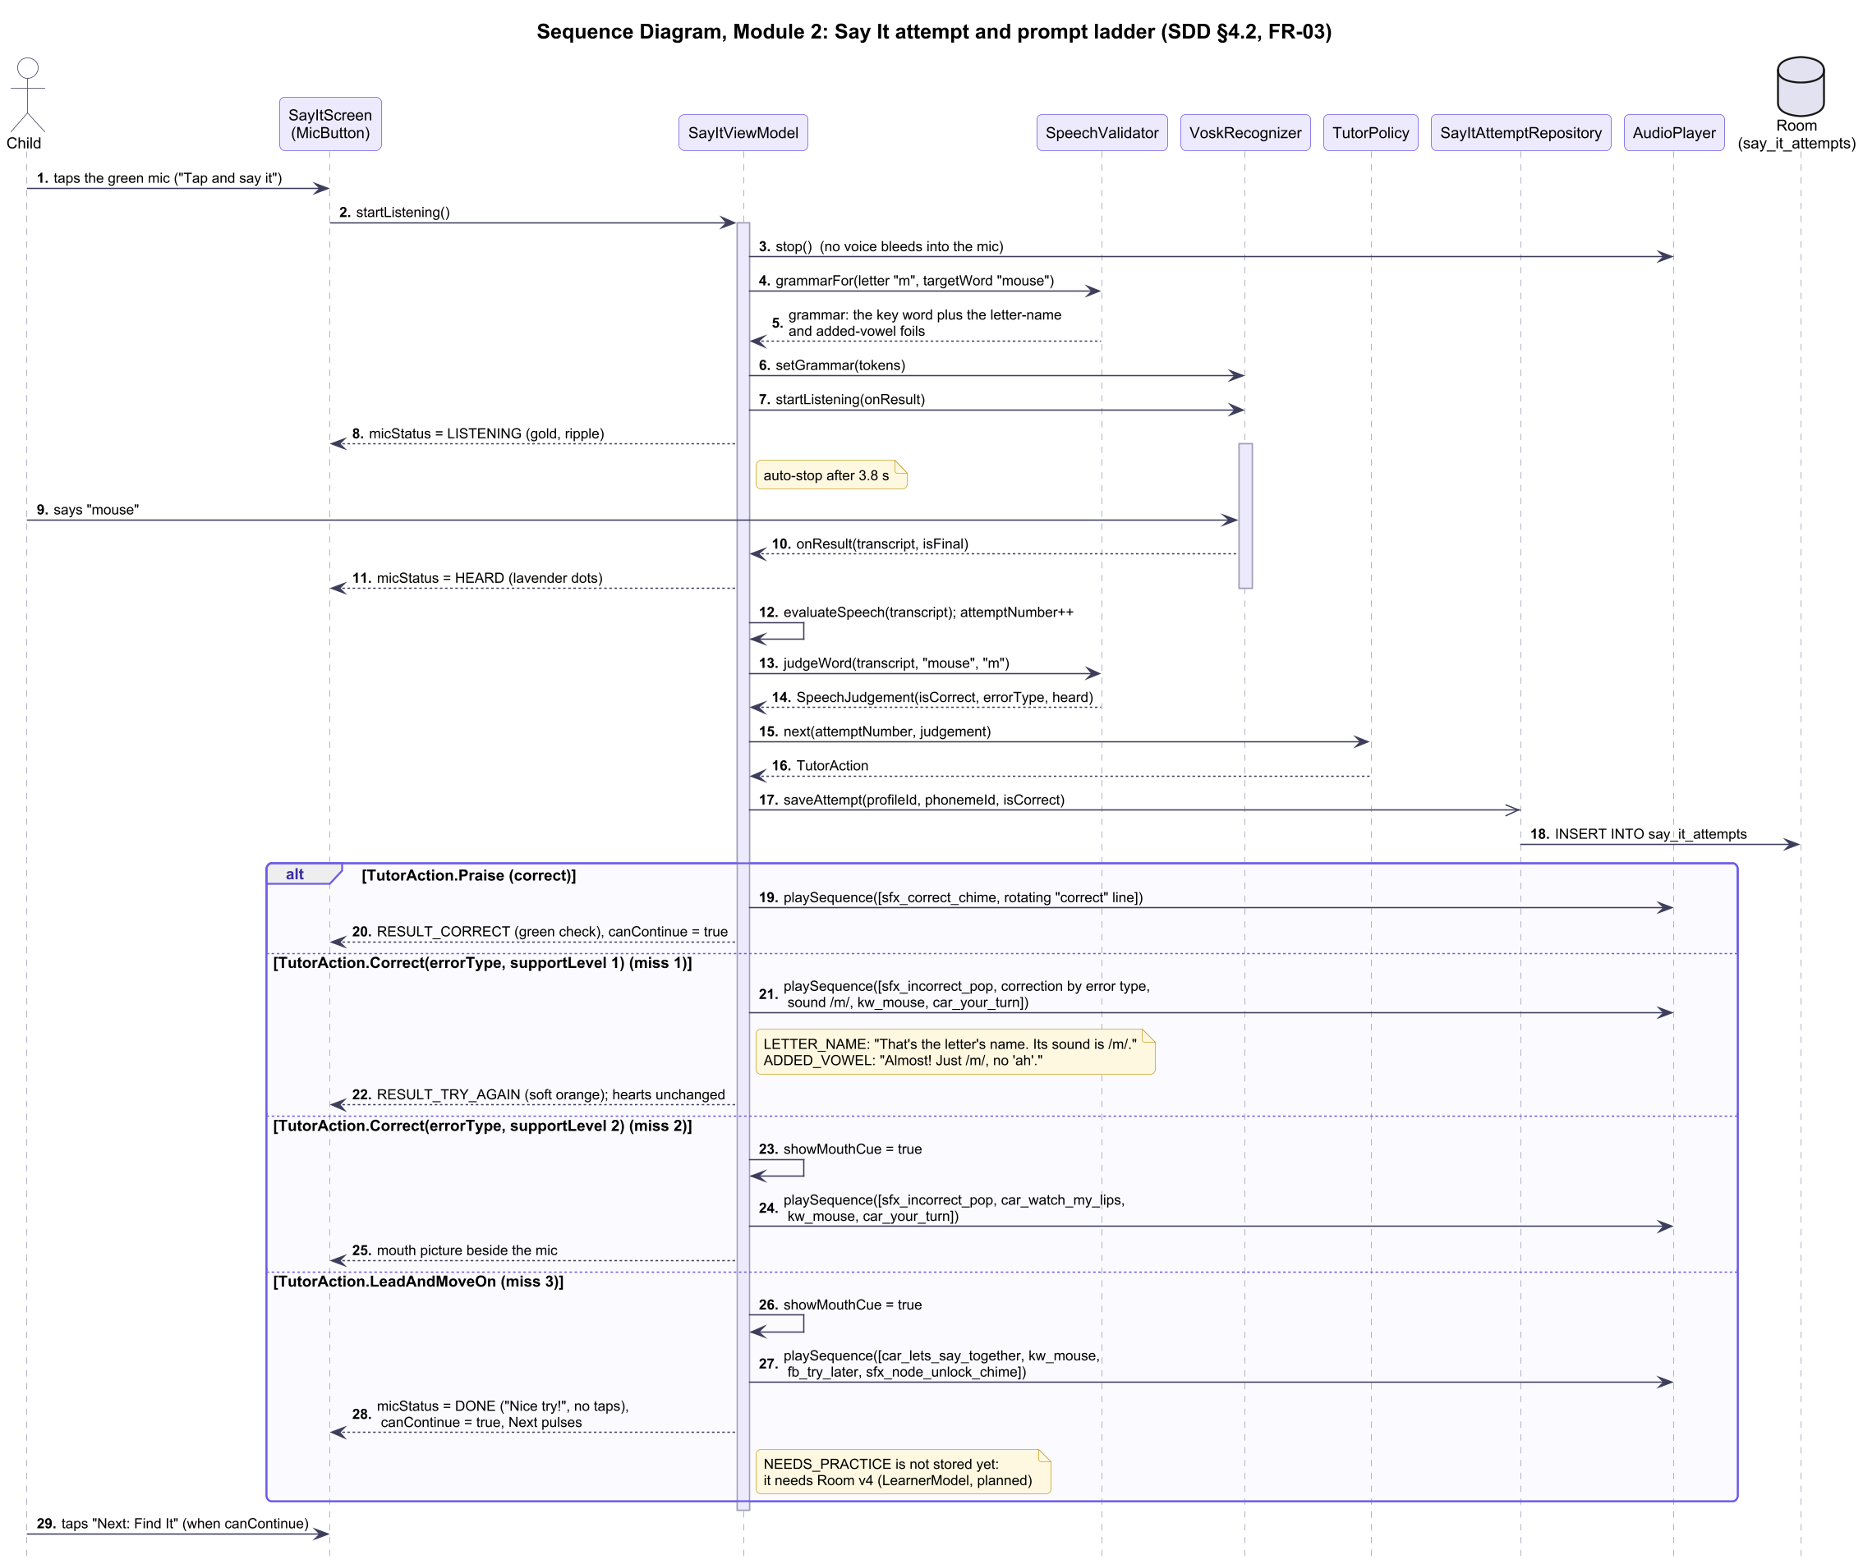
Figure 9. Sequence diagram, Module 2: Say It attempt and prompt ladder

4.3 Find It Tap, Hearts and Restart Workflow
• A correct tap: it counts towards the 3 targets. Every 3 correct taps in a row recover a heart, up to the starting pool.
• A wrong tap: it removes one heart. At 0 hearts the activity restarts with a 3-heart buffer (FR-05).
• Letter completion: the hearts lost in the session go to letter completion (§4.5).
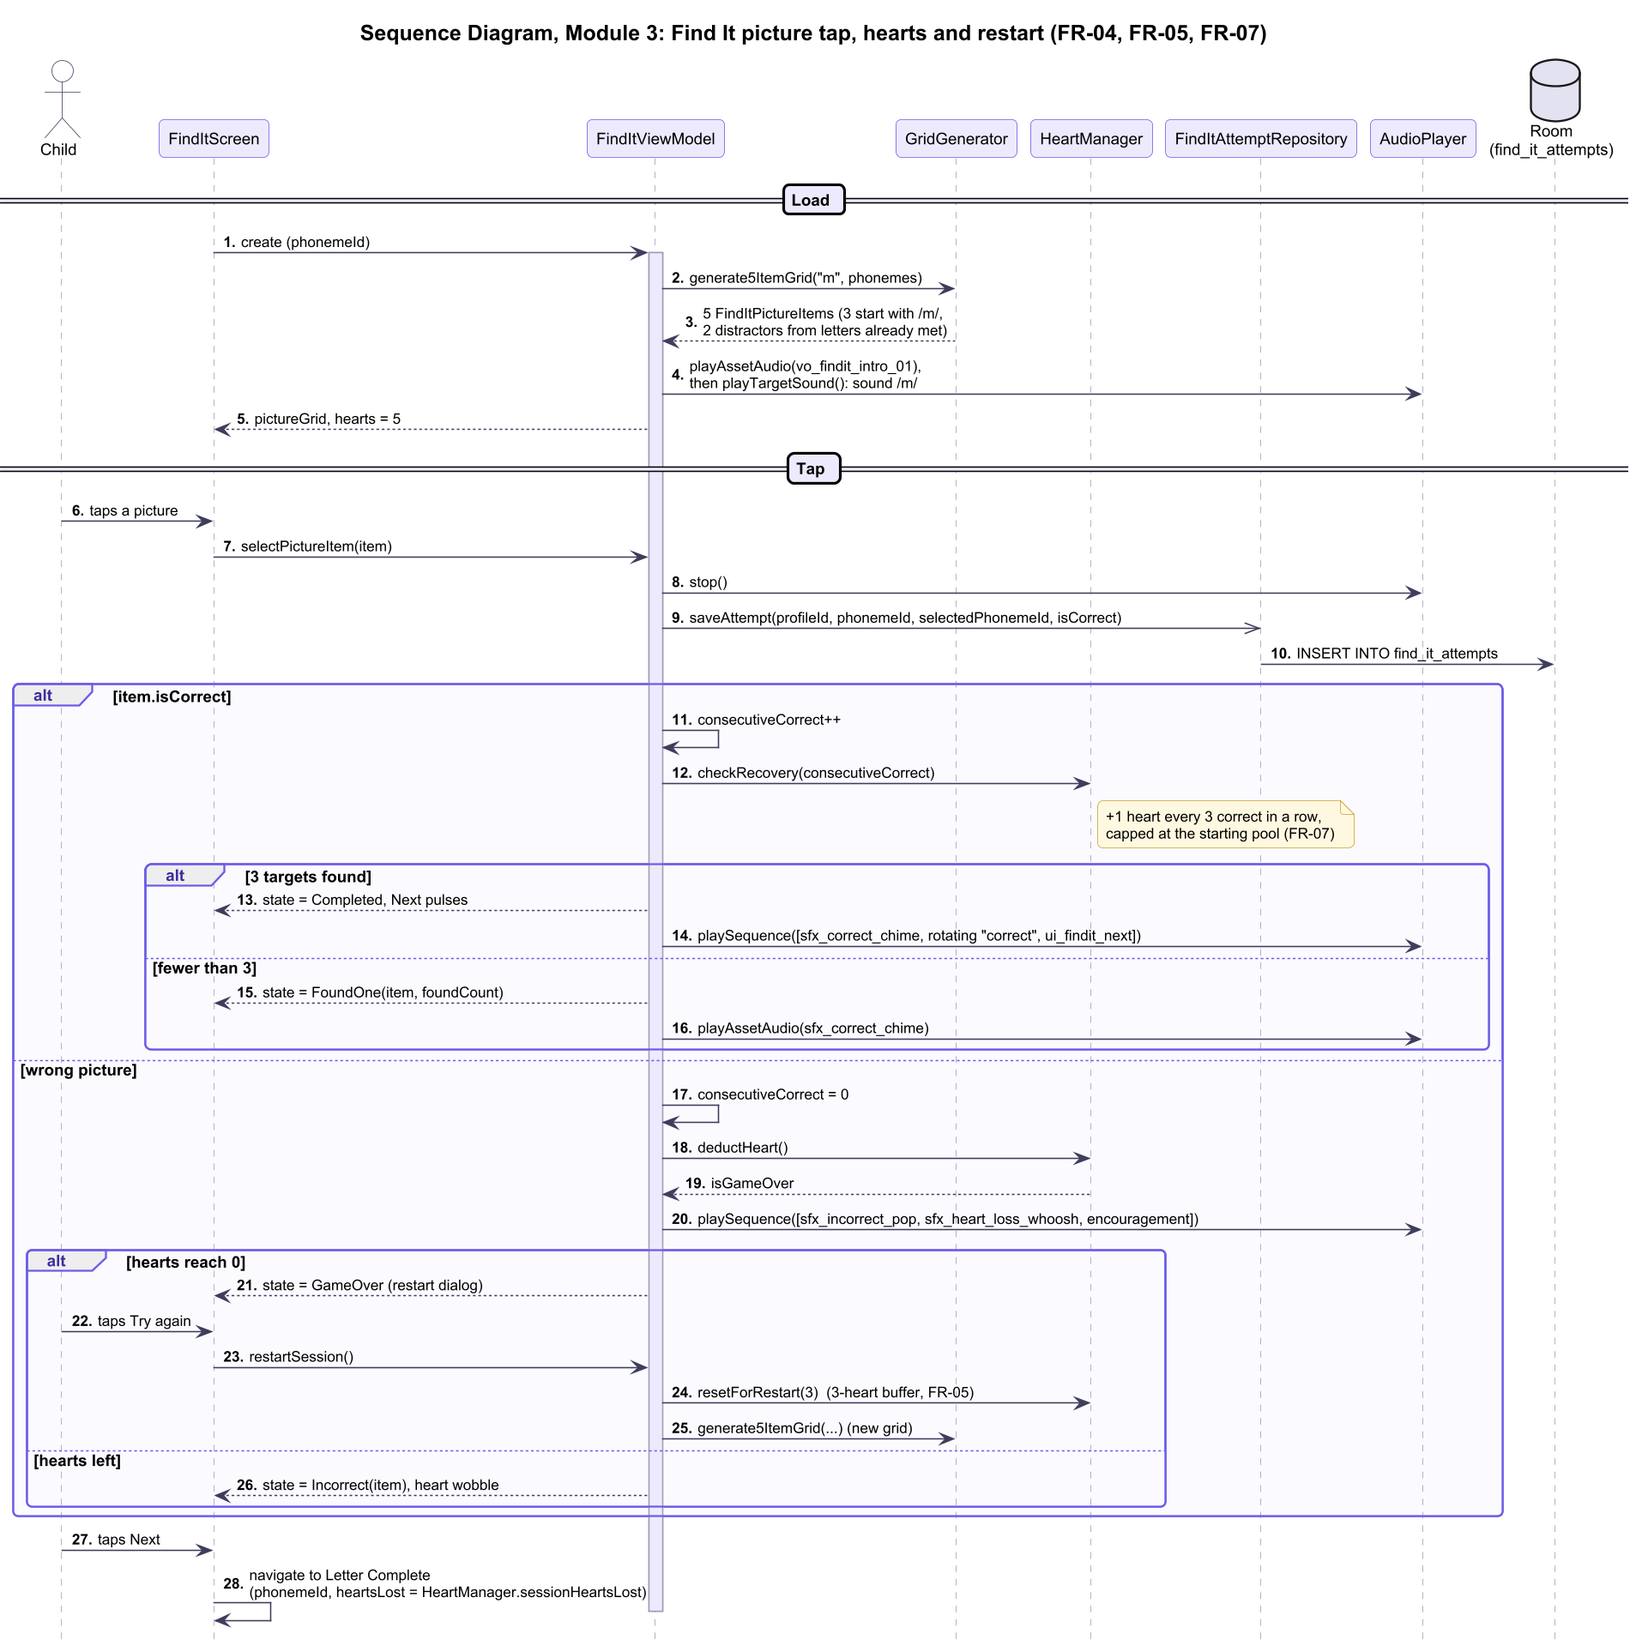
Figure 10. Sequence diagram, Module 3: Find It

4.4 Blend It Word and Group Completion Workflow
• Checking a word: each answer is saved.
• A correct word: the tiles light one by one while each letter sound plays to its end (at least 750 ms each). Then every tile lights together, and the whole word plays.
• Group completion: a finished group is scored and saved to blend_it_progress.
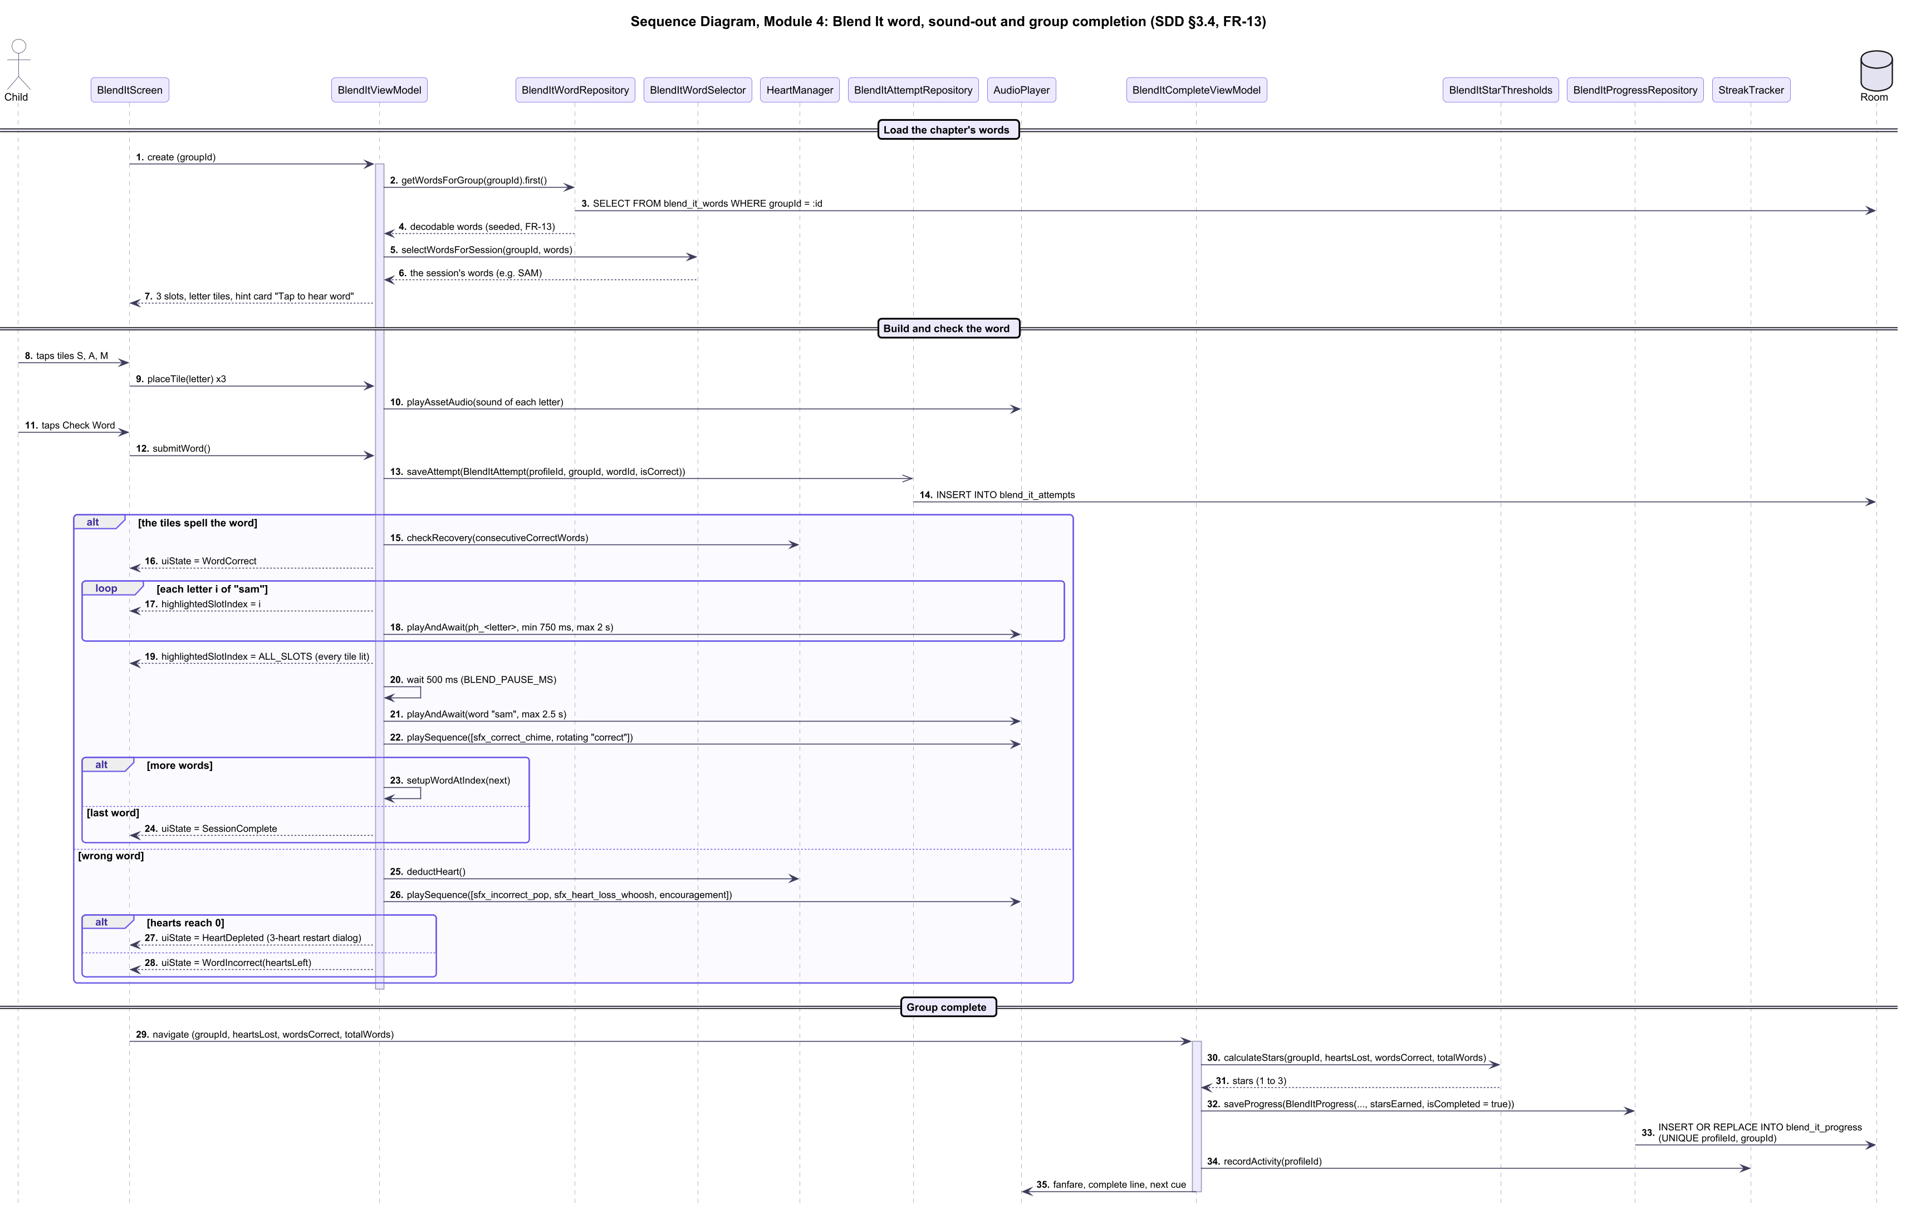
Figure 11. Sequence diagram, Module 4: Blend It

4.5 Profile, Stars, Streak and Unlock Workflow
• Profiles: the active profile scopes every read and write (FR-14).
• Letter completion: completing a letter saves its stars (FR-06) and updates the daily streak (FR-09).
• Map update: the map's Room flows re-emit, UnlockManager opens the next letter (FR-08), and the star total is recomputed in SQL.
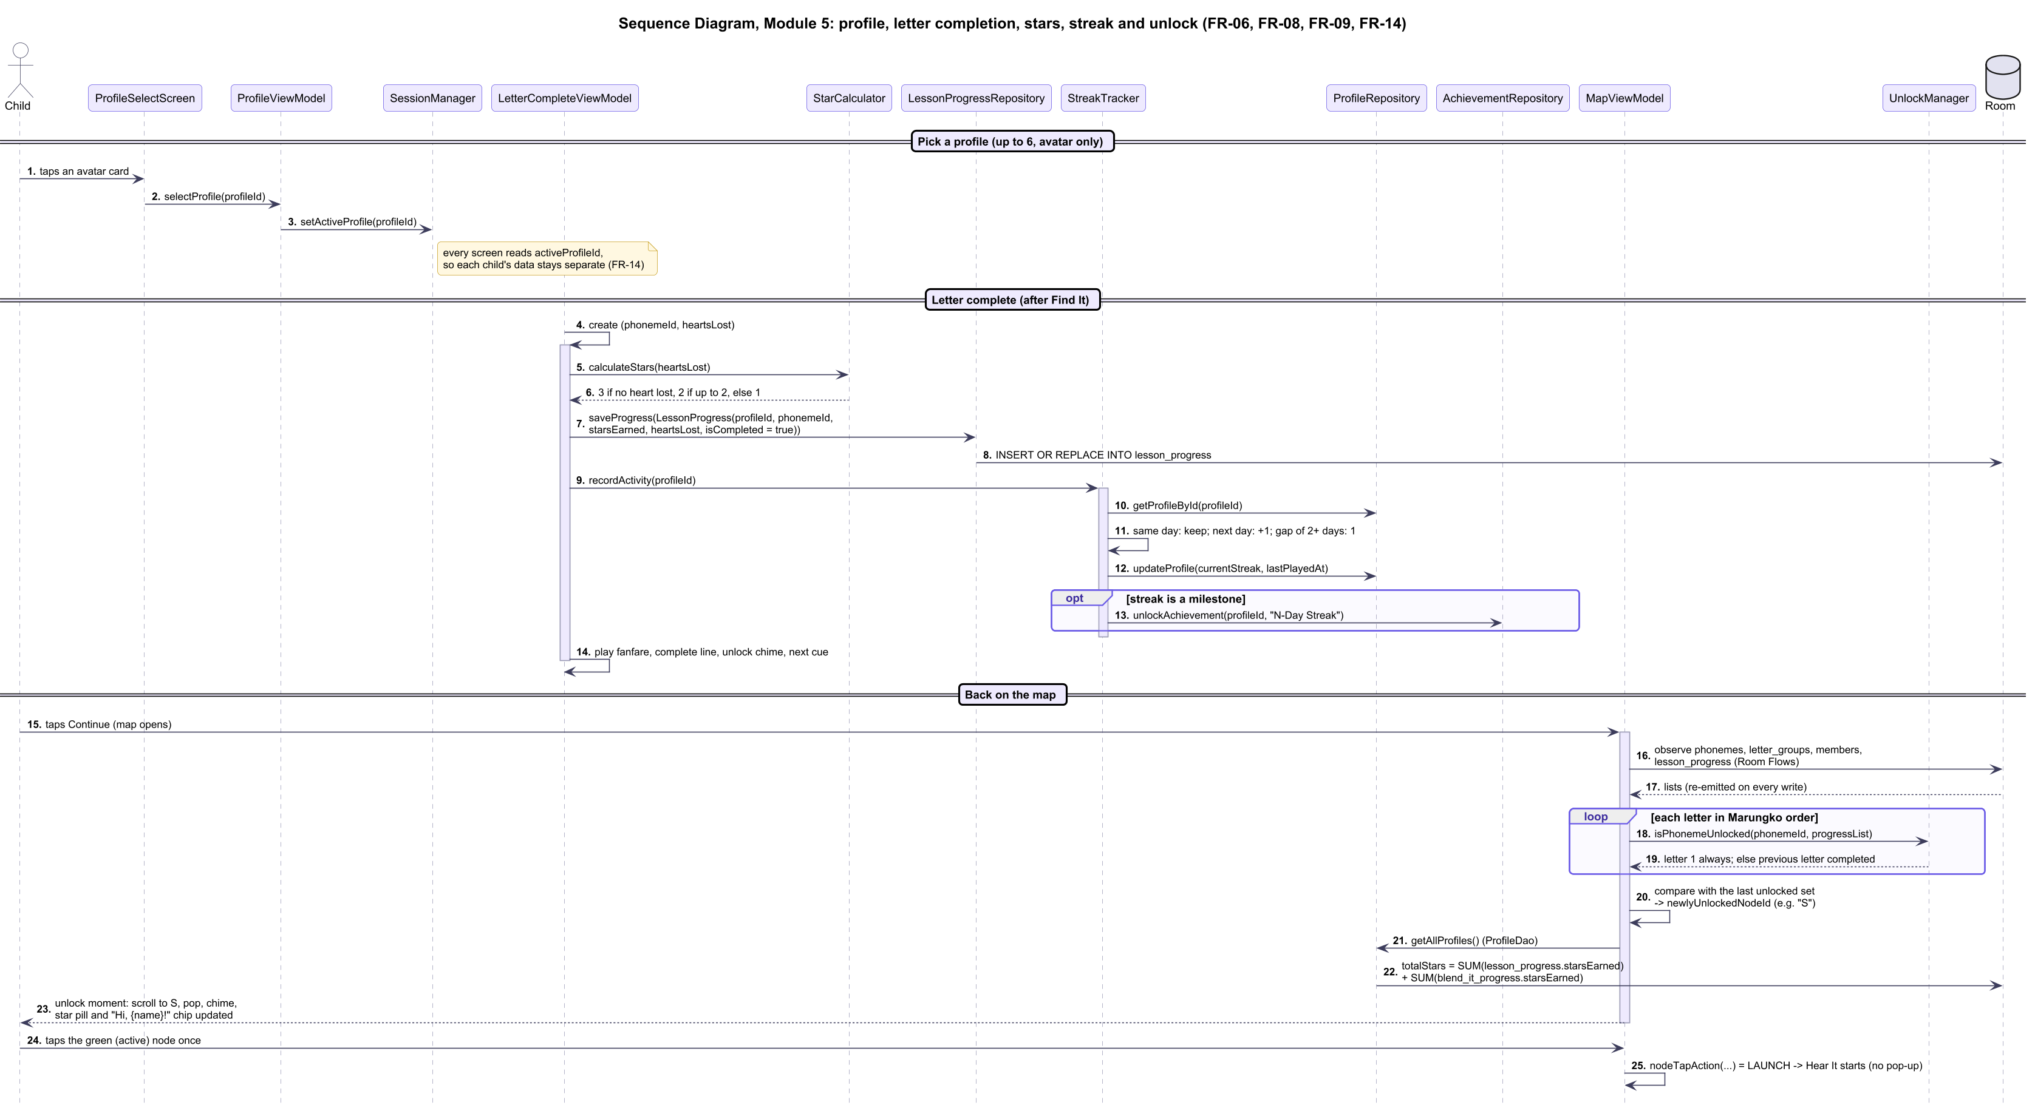
Figure 12. Sequence diagram, Module 5: progression and profiles

4.6 Parent Zone, Dashboard and Report Workflow
• Entry: an arithmetic problem guards the Parent Zone.
• Dashboard and report: the dashboard and the PDF report come from ReportGenerator.
• CSV export: the telemetry CSV export of §3.5.2 is shown in grey because it is planned.
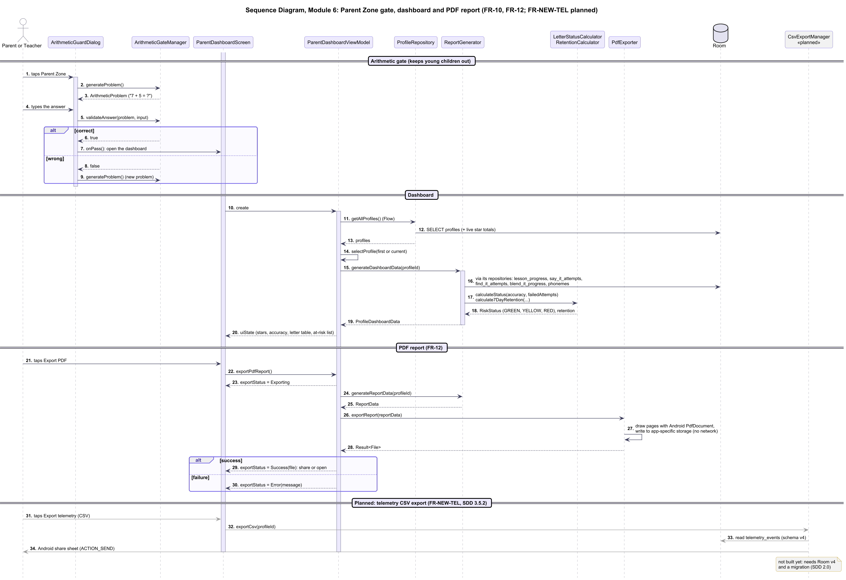
Figure 13. Sequence diagram, Module 6: Parent dashboard and report

5. Technology Stack & External Dependencies
Layer / Subsystem | Technology / Library | Version | Technical Justification & Usage Scope
Language | Kotlin | 1.9.22 | 100% pure Kotlin domain layer with coroutines and Flow.
UI Framework | Jetpack Compose | 1.5.4 | Declarative reactive UI toolkit utilizing Material Design 3 tokens.
Speech Engine | Vosk Android SDK | 0.3.47 | Lightweight offline speech recognition (vosk-model-small-en-us-0.​15).
Audio I/O | Android AudioRecord / SoundPool | Native | Non-blocking 16kHz PCM recording and zero-latency SoundPool playback.
Local Database | Android Jetpack Room | 2.6.1 | SQLite ORM managing profiles, spaced retrieval states, and telemetry.
Document Export | Android PdfDocument | Native | Zero-dependency local PDF progress report generation.
Audio Synthesis | Kokoro-82M / Chatterbox-Turbo / ElevenLabs Text to Speech | Apache-2.0 / MIT / ElevenLabs Free plan | Build-time tools, not shipped in the app. Kokoro voices the carrier phrases and key words; Chatterbox clones the Kokoro voice for held phonemes. ElevenLabs (model eleven_​v4, library voice "Lily Wolff") made the Blend It words AM, TUB, YAM and the short /i/, where the local tools' takes failed review ([proposed], adviser confirmation pending); Free-plan audio is non-commercial and is credited in the Parent Zone.

6. Verification & Architectural Testing Plan
1. Audio Latency & Purity Test Suite (TC-AUD-01, TC-AUD-02): Automated instrumentation tests verifying SoundPool stream start latency ≤ 50 ms and gate verification integrity.
2. Microphone Reactive Visualizer Suite (TC-MIC-01, TC-MIC-02): Robolectric/Espresso tests measuring state transition timestamp deltas (≤ 100 ms) and ripple scaling proportional to mock PCM input.
3. ASR Discrimination Suite (TC-ASR-01 to 06): Audio replay harness feeding benchmark child recordings (normal, foil, noise) into Vosk to verify ≥ 80% agreement and ≤ 15% false reject limits.
4. Room Schema Migration Suite (TC-DB-01, TC-DB-02): MigrationTestHelper verifying upgrade from Schema v3 (current) to Schema v4 without data loss. Prerequisites: set exportSchema = true and replace fallbackToDestructiveMigration() with explicit migrations (both planned).

