FARMER INTELLIGENCE PLATFORM · PROJECT DOSSIER · AUGUST 2026

AgroSaarthi
An offline-aware, multilingual farmer workspace for crop observation, market context, and farm-to-market readiness
AgroSaarthi is a farmer-facing product designed around a practical principle: a farmer should be able to keep farm records, field observations, crop photos, market context, and the next accountable action in one private workspace. The experience is intentionally calm, mobile-first, and local-language ready so that useful agricultural context remains accessible without turning the farmer into a data-entry operator.
Live project The deployed application is available at https://agrosaarthi-ckcm6acz.manus.space. The product retains secure sign-in, farmer-owned data, source-labelled market signals, and explicit uncertainty language throughout the decision flows.

1. Executive summary
Dimension | AgroSaarthi approach
Primary user | A local farmer managing one or more plots, crop observations, mapped locations, and harvest decisions.
Core value | Turn a farm detail—photo, crop, location, price, harvest window, or question—into a clear next step without hiding uncertainty.
Product experience | A premium Field Notes Atelier interface: warm paper surfaces, Khet Green hierarchy, season markers, contour textures, and responsive farmer-first workflows.
Delivery model | React 19 client, Express/tRPC server, Manus OAuth, MySQL/TiDB-compatible persistence, secure object storage, Google Maps proxy services, and server-side AI/data adapters.
Decision principle | Observation first; sources and freshness visible; advice framed cautiously; exact farm location private by default.

2. Problem and product response
Smallholder decision-making is often fragmented across memory, chat messages, weather guesses, local mandi conversations, paper notes, and photographs on a phone. The result is not simply a lack of information. It is a lack of connected, farmer-owned context. AgroSaarthi joins those fragments while preserving source labels and avoiding false certainty.
Field challenge | Product response
Separate plots get mixed together | Editable multi-farm records preserve crop, area, irrigation method, and an exact private map pin per plot.
Leaf photos are hard to interpret | Camera and saved-photo flows provide visible-sign triage, possible disease-signal wording, practical organic/IPM, treatment-safety, irrigation, and soil-health next checks, plus expert-review caveats.
Mandi data lacks context | CEDA records are labelled as latest available upstream values with their source date, and short-horizon trends are framed as a non-guaranteed source-data baseline.
Connectivity is uneven | The voice/advisory surface retains the last saved guidance on-device and clearly distinguishes live, offline, and unavailable states.
Post-harvest links are opaque | Harvest briefs combine crop, expected date, quantity, and notes, then discover nearby map-listed mandi, buyer/wholesale, storage, and transport places without fabricating availability.

3. Farmer experience and primary workflows
The application uses an authenticated farmer workspace rather than a generic dashboard. A persistent farm selector is the anchor. The home view surfaces the next practical action, while mobile navigation keeps Today, Diagnose, Market, Field Intelligence, Farms, and Settings within reach.
Workspace | Farmer workflow
Today | Review the currently selected farm and enter the crop-photo, market, or farm-record flow.
Diagnose | Capture a photo in the field or select a saved JPEG/PNG/WEBP image. Perform a direct review before a farm exists or save the photo to the selected farm for a permanent diagnosis record.
Market | Read the latest available CEDA modal/minimum/maximum context and refresh it on demand. Upstream date, source, and unavailable-data state are visible.
Field Intelligence | Review a transparent seven-day trend baseline, a crop-and-area harvest-window scenario, voice advisory, offline guidance, and a harvest-to-market brief.
My farms | Create, choose, or edit multiple farm records with crop, area, irrigation, map location, and privacy-aware persistence.
Settings | Change English, Hindi, or Marathi workspace language; change Field Paper/Night Field theme; review account context; sign out securely.
Saarthi | Open the roaming crop companion from every protected screen. Saarthi receives only the selected farm and minimal active-screen context required to answer the current question.

4. Technical architecture
The supplied system architecture is realised as an offline-aware client, a secure gateway-style application server, independently replaceable intelligence services, and a persistent data layer. The production implementation keeps sensitive credentials and AI/data-provider calls server-side.
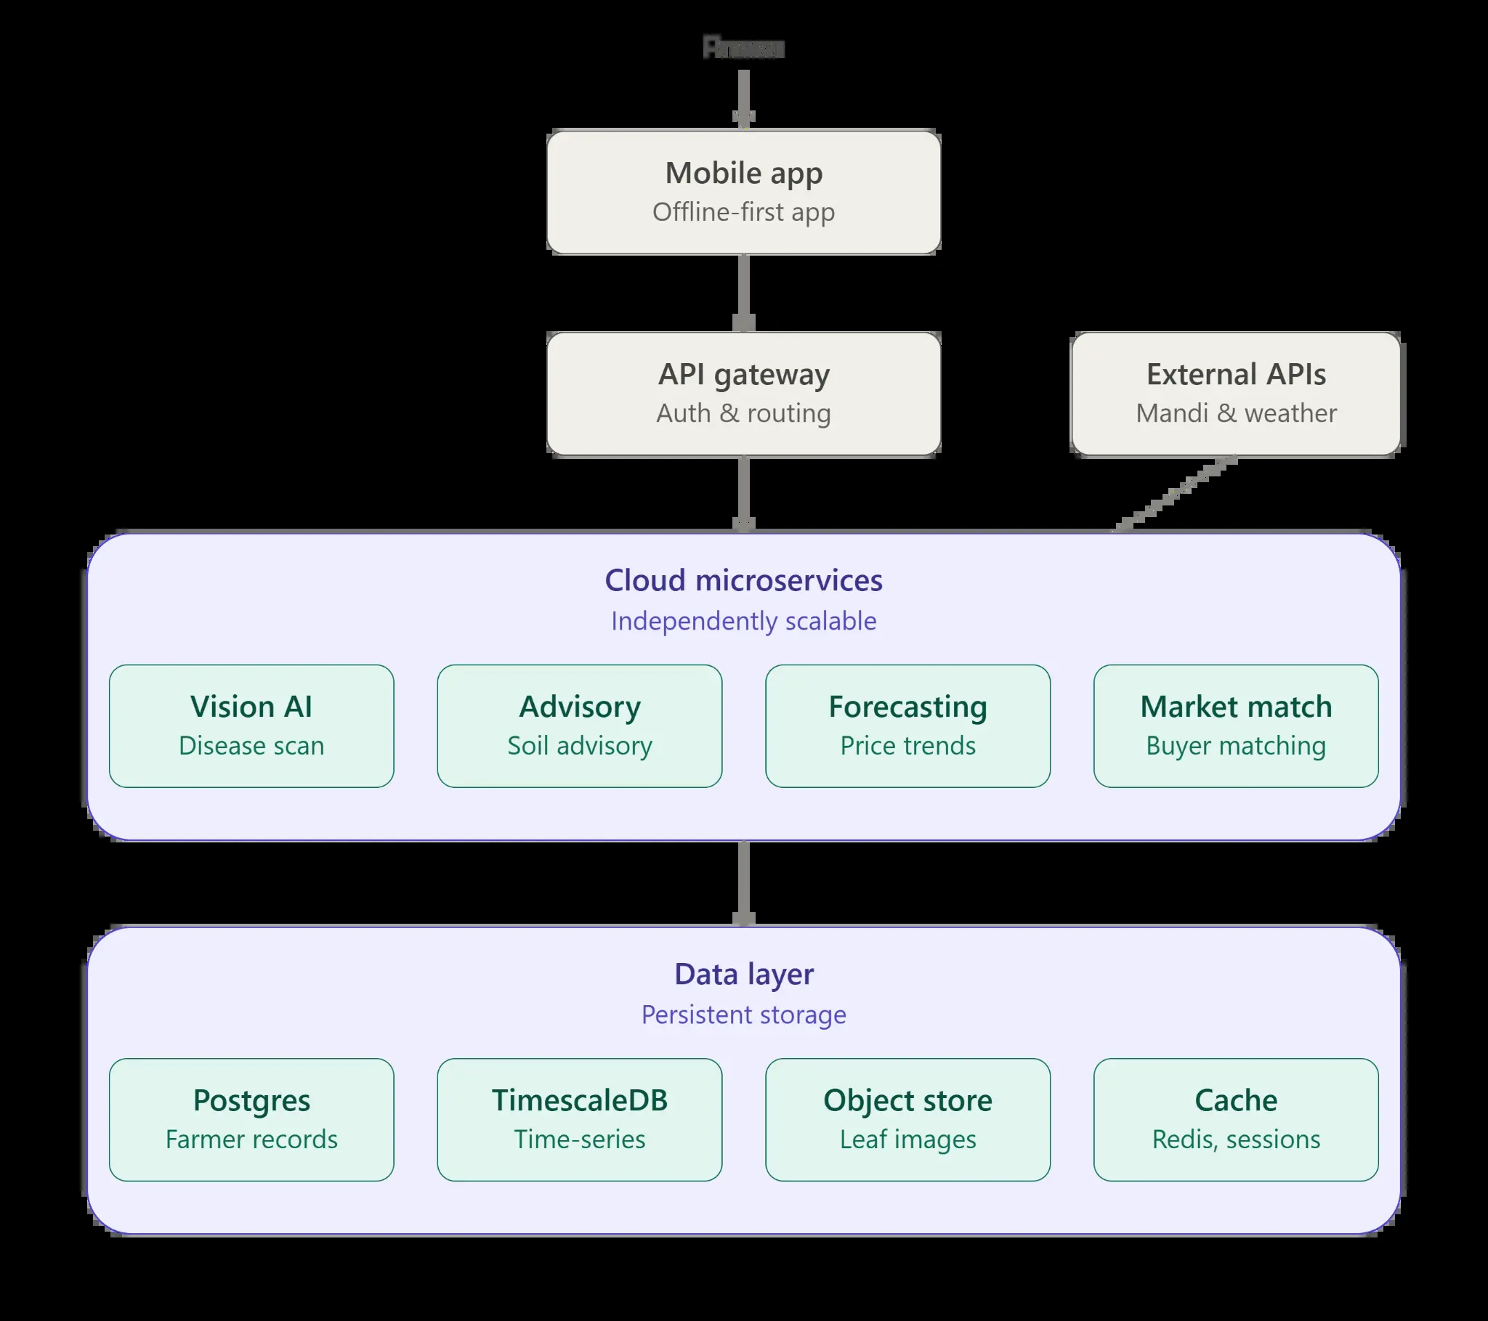
Figure 1. Shared AgroSaarthi reference architecture.
Layer | Implemented responsibilities
Client application | Responsive React workspace, localisation/theme persistence, camera/file input, MediaRecorder voice capture, cached advice, and Maps/Places presentation.
Secure application API | tRPC procedures protected by OAuth session context, input validation with Zod, owner-scoped farm/diagnosis/harvest-intent operations, and server-side provider access.
Intelligence services | Gemini-powered Saarthi contextual companion; image visible-sign/disease-signal triage; CEDA trend baseline; speech-to-text; and transparency/fallback policies.
Persistent data | User, farm, diagnosis, and harvest-intent tables; secure object-storage references for photos and voice files; browser-local language/theme/advisory cache.
External services | CEDA Agri Market Data, Google Maps/Places proxy, server-side Gemini, built-in storage, and transcription service.

5. Data model and privacy boundary
Entity | Purpose | Privacy boundary
User | OAuth-backed identity and role context. | Session cookies and identity are handled by the application server; no password form is stored in product code.
Farm | Name, crop, CEDA commodity mapping, area, irrigation, latitude/longitude, location label. | Owner-scoped. Exact coordinates are treated as private and are not shared by default.
Diagnosis | Photo-storage reference, crop, visible-sign review status, confidence, evidence, actions. | Owner-scoped. Image bytes live in secure storage; database records hold references and metadata.
Harvest intent | Expected harvest date, quantity, notes, and readiness status. | Owner-scoped. It does not disclose availability or commercial terms to third parties.
Browser preferences | Language, theme, and latest cached advisory. | Stored locally in the browser to preserve continuity during low-connectivity use.

Privacy rule Saarthi receives a minimal context snapshot: active screen, selected farm/crop, and current workflow state such as market source/date, saved diagnosis result, forecast range, harvest-brief count, or visual settings. It does not receive a full-screen capture, hidden account state, or unnecessary exact coordinates.

6. AI disease-signal triage and advisory
AgroSaarthi does not present image output as a confirmed plant pathology diagnosis. The crop-review flow asks the vision service to describe only what the image visibly supports, to use possible-signal language for potential disease indicators, and to return a clearer-photo or expert-review outcome when the evidence is weak. The advisory structure intentionally separates visible evidence from next checks.
Advisory field | Farmer-facing treatment
Possible disease signal | Shown only as a possible signal to confirm locally, never as certainty.
Organic/IPM | Discuss low-risk field-observation and integrated-pest-management options with a qualified local expert.
Treatment safety | No pesticide brand, active ingredient, dose, or mixture is prescribed by the application.
Irrigation | The app asks the farmer to observe water, drainage, rainfall, and crop condition before changing irrigation.
Soil health | The app asks the farmer to note recent fertiliser, rain, drainage, and visible field conditions.
Escalation | Spreading, severe, or unclear symptoms lead to a qualified local agronomist recommendation.

7. Market intelligence and yield-window planning
The market module fetches latest-available CEDA records server-side. The Field Intelligence page derives a seven-day direction baseline from up to 28 recent modal-price observations using a capped linear trend. The app exposes the observation count, direction, range, and confidence descriptor. It does not call this a guaranteed forecast or a sell recommendation.
Capability | Method | Guardrail
Latest mandi signal | Latest available modal/minimum/maximum CEDA source record for the selected commodity. | Upstream date and source are visible; unavailable data remains unavailable rather than replaced with a guessed value.
Seven-day price direction | Capped linear trend baseline over recent available source observations. | Presented as a source-data planning indicator, not a sale recommendation or price guarantee.
Yield window | Crop-and-area scenario using transparent generic ranges for planning. | Explicitly not a scientific yield prediction without on-field crop stage, weather, soil, and input data.
Harvest brief | Expected harvest date and quantity linked to a private farm record. | The farmer validates any buyer, transport, storage, capacity, demand, or commercial term directly.

8. Voice, multilingual, and offline-aware interaction
Voice advisory uses the browser MediaRecorder to capture a short recording. Audio is placed in secure storage, transcribed server-side, and sent to the companion with the same active-screen context as text chat. The farmer can select English, Hindi, Marathi, or an explicit Hinglish mode that guides transcription toward code-mixed Hindi and English. The last saved advisory is retained on-device and shown clearly when the browser reports that it is offline.
State | Visible behaviour
Live | Voice question is recorded, transcribed, and answered by Saarthi. The UI identifies a live response.
Offline | The control does not pretend to transcribe. It surfaces the most recent saved guidance for the selected farm or general workspace.
Service unavailable | The UI reports the fallback condition and asks the farmer to retry with a stable connection rather than making up a response.
Language continuity | App language is persisted in browser storage; the voice-language choice is visible at the moment of capture.

9. Live Saarthi companion
The roaming Saarthi companion is powered by a server-side Gemini integration. The supplied API key is stored as a secret and is not exposed to the browser. Saarthi reads structured screen context rather than indiscriminate screen contents. The context includes the active workspace and relevant, minimal state: selected farm/crop, market source/date/status, latest saved diagnosis result, trend/harvest-brief state, or selected language/theme. Its header distinguishes live Gemini output from a connection-aware fallback.
Screen | Context Saarthi may receive
Home | Selected farm name, crop, area, irrigation, and the fact that crop photo/market/farm actions are available.
Diagnose | Selected crop plus the latest saved diagnosis title/status/confidence, or direct-photo availability when no farm is selected.
Market | Latest CEDA value, unit, upstream date, source, and availability status for the selected crop.
Field Intelligence | Trend midpoint/direction/confidence, harvest-brief count, and selected farm context.
Farms | The fact that private farm records can be created or edited; no full map or unneeded location exposure.
Settings | Selected display language and visual theme.

10. Farm-to-market linkage
Farm-to-market support starts with a private harvest intent. The farmer captures an expected date, quantity, and handling/buyer note. The app then uses the selected private farm pin to discover nearby map-listed agricultural mandi, buyer/wholesale, storage, and transport places. This is a useful operational bridge, but the product deliberately does not claim that a listed organisation has buyer demand, available capacity, transport availability, or agreed terms.
Commercial integrity Map-listed infrastructure is a discovery lead, not a confirmed match. A production partnership layer can add verified directories, availability feeds, requests for quotation, consent-driven buyer contact, and transport/storage capacity after suitable providers are connected.

11. Security, reliability, and safety
- All farm, diagnosis, and harvest-intent procedures are owner-scoped behind secure OAuth session context.
- Gemini, storage, transcription, and external market calls run server-side. Credentials stay in environment management and are never sent to the frontend.
- Crop image review is visible-sign triage, not a pathology diagnosis or pesticide prescription. The product asks for expert review where evidence is limited or risks may be serious.
- Price and forecast surfaces show their source, data date, uncertainty, and non-guarantee language.
- Offline and provider-failure states are explicit. The product prefers a transparent unavailable or fallback response to fabricated data.
- Object storage holds photo and voice bytes; persistent tables hold references and necessary metadata rather than file blobs.

12. Local development and deployment
The project runs as a full-stack React/tRPC/Express application. Keep authentication enabled in local development; it protects farm records, exact map pins, and crop observations. The repository contains LOCAL_DEVELOPMENT.md and .env.example for setup guidance.
pnpm install
pnpm dev
# After schema changes
pnpm drizzle-kit generate
# Review generated SQL, then apply it using the project database workflow.
pnpm db:push
# Quality gates
pnpm check
pnpm test
pnpm build
Configuration group | Purpose
DATABASE_URL | MySQL/TiDB-compatible persistence for accounts, farms, diagnoses, and harvest intents.
OAuth variables | Secure sign-in and protected session flow.
BUILT_IN_FORGE_API_URL / BUILT_IN_FORGE_API_KEY | Server-side storage, transcription, and built-in service infrastructure.
GEMINI_API_KEY | Server-side live Saarthi contextual companion. Never expose this in browser code or source control.
Frontend Forge/Maps variables | Google Maps/Places proxy service for private farm pins and nearby infrastructure discovery.

13. Quality assurance status
Quality gate | Current evidence
Type safety | TypeScript validation passes for client and server contracts.
Unit tests | Coverage includes OAuth logout, crop-companion fallback, CEDA normalisation/trend projection, browser audio-data parsing, Gemini credential validation, and a live contextual Gemini response.
Production build | The Vite/esbuild production bundle has been built successfully after the advanced feature additions.
Responsive review | The farmer entry/home experience and the corrected mobile heading treatment have been reviewed at narrow mobile dimensions. Protected workflows should also be checked with a signed-in farmer account before a field trial.

14. Delivery roadmap
Horizon | Recommended next step
Field pilot | Conduct signed-in farmer tests for camera/photo review, voice transcription, language switching, trend interpretation, and harvest brief creation on low-bandwidth devices.
Agronomy hardening | Validate visible-sign prompts and escalation criteria with regional agricultural experts; add crop-specific datasets only after accuracy and governance evaluation.
Market expansion | Connect official state/mandi sources where available and make commodity/region coverage explicit.
Verified commerce | Add consent-based buyer, transporter, and storage partner directories, capacity updates, quote requests, and audit trails.
Offline resilience | Progress from last-advisory cache to a service-worker-backed offline pack for recent farms, crop guidance, and selected market context.

References
[1] CEDA Agri Market Data: https://agmarknet.ceda.ashoka.edu.in/
[2] data.gov.in, Current daily mandi commodity price catalogue: https://www.data.gov.in/catalog/current-daily-price-various-commodities-various-markets-mandi
[3] Google Maps Platform documentation: https://developers.google.com/maps/documentation
[4] Gemini API documentation: https://ai.google.dev/gemini-api/docs
Project note This dossier describes the application implementation and its intentional limitations. It should be read alongside the local development handover for environment-specific configuration and deployment controls.

