课后作业：案例——找爷孙关系
2018年8月1日
12:59

案例文件：
﻿褚英 努尔哈赤
皇太极 努尔哈赤
多尔衮 努尔哈赤
多铎 努尔哈赤
豪格 皇太极
福临(顺治) 皇太极
福全 福临(顺治)
玄烨(康熙) 福临(顺治)

第一列是孩子辈，第二列是父母辈。现在要得到爷孙辈的关系

比如最后的输出结果：
爷爷辈:[努尔哈赤]-->孙子辈:[福临(顺治), 豪格]
爷爷辈:[皇太极]-->孙子辈:[玄烨(康熙), 福全]

YesunMapper代码：
public class YesunMapper extends Mapper<LongWritable,Text,Text,Text>{

@Override
protected void map(LongWritable key, Text value, Mapper<LongWritable, Text, Text, Text>.Context context)
throws IOException, InterruptedException {

String line=value.toString();
String s1=line.split(" ")[0];
String s2=line.split(" ")[1];
context.write(new Text(s1), new Text("+" + s2));
context.write(new Text(s2), new Text("-" + s1));

}
}

YesunReducer代码：
public class YesunReducer extends Reducer<Text,Text,Text,NullWritable>{

@Override
protected void reduce(Text key, Iterable<Text> values, Reducer<Text, Text, Text, NullWritable>.Context context)
throws IOException, InterruptedException {
ArrayList<String> grandpaList=new ArrayList<>();
ArrayList<String> grandsonList=new ArrayList<>();

for(Text value:values){
if(value.toString().startsWith("+")){
grandpaList.add(value.toString().substring(1));
}else{
grandsonList.add(value.toString().substring(1));
}
}
if(grandpaList.size()>0&&grandsonList.size()>0){
String grandpa=grandpaList.toString();
String grandson=grandsonList.toString();

String relation="爷爷辈:"+grandpa+"-->孙子辈:"+grandson;

context.write(new Text(relation),NullWritable.get());
}

}
}

Driver代码：
public class Driver {

public static void main(String[] args) throws Exception {
Configuration conf=new Configuration();
Job job=Job.getInstance(conf);

job.setJarByClass(Driver.class);
job.setMapperClass(YesunMapper.class);

job.setMapOutputKeyClass(Text.class);
job.setMapOutputValueClass(Text.class);

job.setReducerClass(YesunReducer.class);
job.setOutputKeyClass(Text.class);
job.setOutputValueClass(NullWritable.class);

FileInputFormat.addInputPath(job, new Path("hdfs://192.168.150.137:9000/yesun"));

FileOutputFormat.setOutputPath(job,new Path("hdfs://192.168.150.137:9000/yesun/result"));

job.waitForCompletion(true);

}

}

job任务执行流程

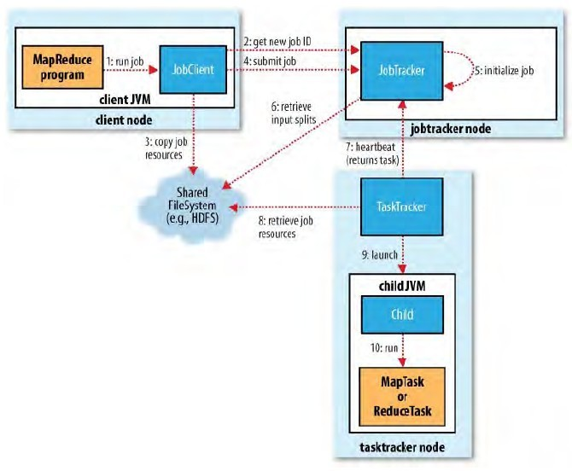
1.run job阶段。此阶段有客户端来完成，底层有一个JobClient类来做具体实现。run job阶段：①做job环境信息的收集，比如各个组件类，以及输出kv类型，然后检测是否合法 ②检测输入路径的合法性，以及输出结果路径的合法性
如果检测未通过，则直接报错返回，不会做后续的job提交动作。

2.如果run job的检测通过，JobClient会向JobTracker为当前job申请jobId，jobId是全局唯一的，用于标识一个Job。

3.copy job resources阶段。此阶段 ，JobClient把job的运算资源上传到HDFS。路径为：/tmp/hadoop-yarn/staging/用户/
运算资源包括：①jar包 ②文件的切片信息 ③job.xml 整个job的环境参数

4.当JobClient将运算资源上传到HDFS之后，提交job （sumbit job）

5.6 初始化job环境信息以及获取job的切片数量，目的是获取整个Job的MapTask任务数量和ReduceTask的任务数量。MapTask任务数=切片（Split)数量。 ReduceTask的任务数量=代码设置。

7.TaskTracker向JobTracker领取任务，要满足数据本地化策略。
此外要明确切片和切块的概念。
切片是一个对象，（FileSplit），分装的是一个切块的描述信息
切块是文件块，里面存储的是真正的文件数据
补充：MR框架为了确保行读取的完整性，会做行的追溯。这个过程肯定会发生网络数据传输。

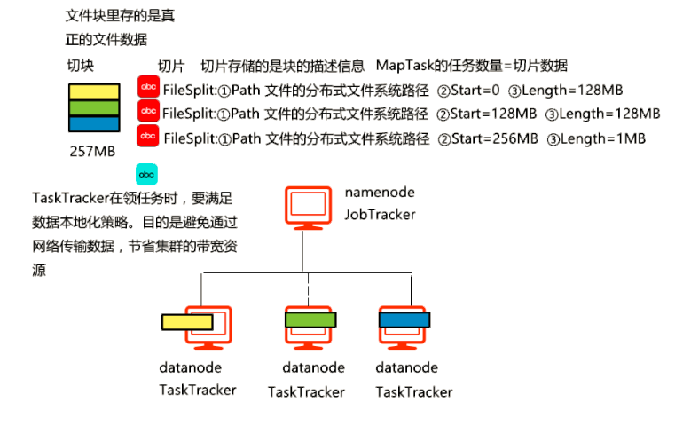
8.TaskTracker去HDFS下载job的运算资源。体现的思想：移动的是运算（运算资料），而不是数据。
9.10 启动JVM进程，运行MapTask或ReduceTask

案例——计算成绩
2016年9月8日
13:23

案列说明：
有三个成绩文件，chinese.txt,english.txt,math.txt

文件数据内容：
chinese.txt：  1 zhang 89  2 zhang 73  3 zhang 67  1 wang 49  2 wang 83  3 wang 27  1 li 77  2 li 66  3 li 89 | english.txt：  1 zhang 55  2 zhang 69  3 zhang 75  1 wang 44  2 wang 64  3 wang 86  1 li 76  2 li 84  3 li 93 | math.txt：  1 zhang 85  2 zhang 59  3 zhang 95  1 wang 74  2 wang 67  3 wang 96  1 li 45  2 li 76  3 li 67

作业要求：
计算每个人 三个月，每科的总成绩
结果格式：
li Student [ name=li, chinese=232, english=253, math=188]
wang Student [ name=wang, chinese=159, english=194, math=237]
zhang Student [ name=zhang, chinese=229, english=199, math=239]

技术点
FileSpilt 对象获取文件名

Student代码：
public class Student implements Writable{

private int month;
private String name;
private int chinese;
private int english;
private int math;

@Override
public void write(DataOutput out) throws IOException {
out.writeInt(month);
out.writeUTF(name);
out.writeInt(chinese);
out.writeInt(english);
out.writeInt(math);

}

@Override
public void readFields(DataInput in) throws IOException {
this.month=in.readInt();
this.name=in.readUTF();
this.chinese=in.readInt();
this.english=in.readInt();
this.math=in.readInt();

}

…………
@Override
public String toString() {
return "Student [ name=" + name + ", chinese=" + chinese + ", english=" + english
+ ", math=" + math + "]";
}

}
ScoreCountMapper代码：
public class ScoreCountMapper extends Mapper<LongWritable, Text, Text, Student> {

@Override
protected void map(LongWritable key, Text value,
Mapper<LongWritable, Text, Text, Student>.Context context)
throws IOException, InterruptedException {
String line=value.toString();
String[] data=line.split(" ");

Student student=new Student();
student.setName(data[1]);

//注意：包别导错了，用这个包：org.apache.hadoop.mapreduce.lib.input.FileSplit
FileSplit split= (FileSplit) context.getInputSplit();
if(split.getPath().getName().equals("chinese.txt")){
student.setChinese(Integer.parseInt(data[2]));

}
if(split.getPath().getName().equals("english.txt")){
student.setEnglish(Integer.parseInt(data[2]));

}
if(split.getPath().getName().equals("math.txt")){
student.setMath(Integer.parseInt(data[2]));

}

context.write(new Text(student.getName()), student);
}

}
ScoreCountReducer代码：
public class ScoreCountReducer extends Reducer<Text, Student,Text,Student>{

@Override
protected void reduce(Text key, Iterable<Student> values, Reducer<Text, Student, Text, Student>.Context context)
throws IOException, InterruptedException {
Student reduceStudent=new Student();
reduceStudent.setName(key.toString());
for(Student student:values){
reduceStudent.setChinese(reduceStudent.getChinese()+student.getChinese());
reduceStudent.setEnglish(reduceStudent.getEnglish()+student.getEnglish());
reduceStudent.setMath(reduceStudent.getMath()+student.getMath());
}
context.write(key, reduceStudent);
}
}
ScoreDriver代码：
public class ScoreCountDriver {

public static void main(String[] args) throws Exception {
Configuration conf=new Configuration();
Job job=Job.getInstance(conf);

job.setJarByClass(ScoreCountDriver.class);
job.setMapperClass(ScoreCountMapper.class);
job.setReducerClass(ScoreCountReducer.class);

job.setMapOutputKeyClass(Text.class);
job.setMapOutputValueClass(Student.class);

job.setOutputKeyClass(Text.class);
job.setOutputValueClass(Student.class);

FileInputFormat.setInputPaths(job,new Path("hdfs://192.168.234.22:9000/score"));
FileOutputFormat.setOutputPath(job, new Path("hdfs://192.168.234.22:9000/score/result"));

job.waitForCompletion(true);

}
}

案例——排序
2015年12月7日
19:50
源文件：
惊天破 72
机械师2 83
奇异博士 67
但丁密码 79
比利林恩的中场战事 84
侠探杰克:永不回头 68
龙珠Z:复活的弗利萨 79
长城 56
夺路而逃 69
神奇动物在哪里 57
驴得水 68
我不是潘金莲 75
你的名字 77
大闹天竺 42
捉迷藏 78
凶手还未睡 23
魔发精灵 68
勇士之门 35
罗曼蒂克消亡史 67
小明和他的小伙伴们 36

Hadoop插件中文乱码解决办法：
Eclipse=>Preferences=》workspace

MR会对Mapper输出key做排序。

结果文件：
电影名 热度值

Movie代码：
public class Movie implements WritableComparable<Movie>{
private String name;
private int hot;

@Override
public void write(DataOutput out) throws IOException {
out.writeUTF(name);
out.writeInt(hot);

}

@Override
public void readFields(DataInput in) throws IOException {
this.name=in.readUTF();
this.hot=in.readInt();

}

@Override
public int compareTo(Movie o) {

return this.hot-o.hot;
}

public String getName() {
return name;
}

public void setName(String name) {
this.name = name;
}

public int getHot() {
return hot;
}

public void setHot(int hot) {
this.hot = hot;
}

@Override
public String toString() {
return "Movie [name=" + name + ", hot=" + hot + "]";
}

}
SortMapper代码：
public class SortMapper extends Mapper<LongWritable,Text,Movie,NullWritable>{
@Override
protected void map(LongWritable key, Text value, Mapper<LongWritable, Text, Movie,NullWritable>.Context context)
throws IOException, InterruptedException {

String line=value.toString();
String name=line.split(" ")[0];
int hot=Integer.parseInt(line.split(" ")[1]);
System.out.println(name+":"+hot);
Movie movie=new Movie();
movie.setName(name);
movie.setHot(hot);
context.write(movie,NullWritable.get());

}

}
SortDriver代码：
public static void main(String[] args) throws Exception {
Configuration conf=new Configuration();
Job job=Job.getInstance(conf);

job.setJarByClass(SortDriver.class);

job.setMapperClass(SortMapper.class);

job.setMapOutputKeyClass(Movie.class);

job.setMapOutputValueClass(NullWritable.class);

FileInputFormat.setInputPaths(job,new Path("hdfs://192.168.234.191:9000/sort"));

FileOutputFormat.setOutputPath(job,new Path("hdfs://192.168.234.191:9000/sort/result"));

job.waitForCompletion(true);
}

案例——全排序

需求说明
有这样一组数字，要求利用3个reduce来处理，并且生成的三个结果文件，是整体有序的。
源数据：
82 239 231
23 22 213
123 232 124
213 3434 232
4546 565 123
231 231
2334 231
1123 5656 657
12313 4324 213
123 2 232 32
343 123 4535
12321 3442 453
1233 342 453
1231 322 452
232 343 455
3123 3434 3242

生成的三个结果文件：
文件1 | 文件2 | 文件3
2 1  22 1  23 1  32 1  82 1 | 123 4  124 1  213 3  231 4  232 4  239 1  322 1  342 1  343 2  452 1  453 2  455 1  565 1  657 1 | 1123 1  1231 1  1233 1  2334 1  3123 1  3242 1  3434 2  3442 1  4324 1  4535 1  4546 1  5656 1  12313 1  12321 1

实现思路
如果是一个reduce，那肯定就是全排序。但如果只单纯指定3个reduce数量，Hadoop会默认根据Key的hash进行分区，这样不会出现三个结果文件是全排序的情况。所以，需要自定义分区，在自定义分区里，根据数据采样边界来对数据进行分区。

自定义分区代码：
public class AuthPartitioner extends Partitioner<IntWritable, IntWritable>{

@Override
public int getPartition(IntWritable key, IntWritable value, int numPartitions) {
String num=String.valueOf(key.get());
if(num.matches("[0-9][0-9]")||num.matches("[0-9]")){
return 0;
}
if(num.matches("[0-9][0-9][0-9]")){
return 1;
}else{
return 2;
}

}

}
Mapper代码：
public class SimpleMapper extends Mapper<LongWritable,Text,IntWritable,IntWritable>{
@Override
protected void map(LongWritable key, Text value,
Mapper<LongWritable, Text, IntWritable, IntWritable>.Context context)
throws IOException, InterruptedException {
String line=value.toString();
String[] data=line.split(" ");
for(String num:data){
context.write(new IntWritable(Integer.parseInt(num)), new IntWritable(1));
}

}

}
Reducer代码：
public class SimpleReducer extends Reducer<IntWritable, IntWritable, IntWritable, IntWritable>{
@Override
protected void reduce(IntWritable num, Iterable<IntWritable> counts,
Reducer<IntWritable, IntWritable, IntWritable, IntWritable>.Context context)
throws IOException, InterruptedException {
int result=0;
for(IntWritable count:counts){
result=result+count.get();
}
context.write(num, new IntWritable(result));
}

}
Driver代码：
public class SimpleDriver {

public static void main(String[] args) throws Exception {
Configuration conf=new Configuration();
Job job=Job.getInstance(conf);

job.setJarByClass(SimpleDriver.class);
job.setMapperClass(SimpleMapper.class);
job.setReducerClass(SimpleReducer.class);

job.setMapOutputKeyClass(IntWritable.class);
job.setMapOutputValueClass(IntWritable.class);
job.setOutputKeyClass(IntWritable.class);
job.setOutputValueClass(IntWritable.class);
job.setPartitionerClass(AuthPartitioner.class);

job.setNumReduceTasks(3);

FileInputFormat.setInputPaths(job, new Path("hdfs://192.168.234.21:9000/totalsort"));
FileOutputFormat.setOutputPath(job, new Path("hdfs://192.168.234.21:9000/totalsort/result"));

job.waitForCompletion(true);

}
}

案例——Job嵌套（链）
2018年8月1日
11:17

文件：
1|zhang 100
2|wang 200
3|zhang 150
4|lisi 190
5|wang 50
6|zhang 80
7|lisi 50

要求：统计每个人的总利润，并按利润做降序排序

最后的结果如下：
Profit [name=zhang, profit=330]
Profit [name=wang, profit=250]
Profit [name=lisi, profit=240]

完成这个要求需要两个MR job，第一个Job用于利润的统计，第二个Job用于排序

ProfitMapper代码：
public class ProfitMapper extends Mapper<LongWritable,Text,Text,IntWritable>{
@Override
protected void map(LongWritable key, Text value, Mapper<LongWritable, Text, Text, IntWritable>.Context context)
throws IOException, InterruptedException {

String line=value.toString();
String name=line.split("\\|")[1].split(" ")[0];
int profit=Integer.parseInt(line.split("\\|")[1].split(" ")[1]);

context.write(new Text(name), new IntWritable(profit));
}

}

ProfitReducer代码：
public class ProfitReducer extends Reducer<Text, IntWritable,Text,IntWritable>{

@Override
protected void reduce(Text key, Iterable<IntWritable> values,
Reducer<Text, IntWritable, Text, IntWritable>.Context context) throws IOException, InterruptedException {

int sum=0;
for(IntWritable value:values){
sum=sum+value.get();
}
context.write(key, new IntWritable(sum));
}
}

Profit代码：
public class Profit implements WritableComparable<Profit>{

private String name;
private int profit;
@Override
public void write(DataOutput out) throws IOException {
out.writeUTF(name);
out.writeInt(profit);

}
@Override
public void readFields(DataInput in) throws IOException {
this.name=in.readUTF();
this.profit=in.readInt();

}
@Override
public int compareTo(Profit o) {

return o.profit-this.profit;
}
public String getName() {
return name;
}
public void setName(String name) {
this.name = name;
}
public int getProfit() {
return profit;
}
public void setProfit(int profit) {
this.profit = profit;
}
@Override
public String toString() {
return "Profit [name=" + name + ", profit=" + profit + "]";
}

}

SortMapper代码：
public class SortMapper extends Mapper<LongWritable, Text,Profit,NullWritable>{

@Override
protected void map(LongWritable key, Text value, Mapper<LongWritable, Text, Profit, NullWritable>.Context context)
throws IOException, InterruptedException {

String line=value.toString();
String name=line.split("\t")[0];
int profit=Integer.parseInt(line.split("\t")[1]);

Profit p=new Profit();
p.setName(name);
p.setProfit(profit);

context.write(p, NullWritable.get());
}
}

Driver代码：
public class Driver {

public static void main(String[] args) throws Exception {
Configuration conf=new Configuration();
Job job=Job.getInstance(conf);

job.setJarByClass(Driver.class);
job.setMapperClass(ProfitMapper.class);
job.setReducerClass(ProfitReducer.class);

job.setMapOutputKeyClass(Text.class);
job.setMapOutputValueClass(IntWritable.class);

job.setOutputKeyClass(Text.class);
job.setOutputValueClass(IntWritable.class);

FileInputFormat.addInputPath(job, new Path("hdfs://192.168.150.137:9000/profit"));
FileOutputFormat.setOutputPath(job,new Path("hdfs://192.168.150.137:9000/profit/result"));

if(job.waitForCompletion(true)){
Job job2=Job.getInstance(conf);
job2.setMapperClass(SortMapper.class);
job2.setMapOutputKeyClass(Profit.class);
job2.setOutputValueClass(NullWritable.class);

FileInputFormat.addInputPath(job2, new Path("hdfs://192.168.150.137:9000/profit/result"));
FileOutputFormat.setOutputPath(job2,new Path("hdfs://192.168.150.137:9000/profit/sortresult"));

job2.waitForCompletion(true);
}
}
}

课后作业—倒排索引
2018年8月2日
10:00
a.txt
hello hadoop
hello world
hello hadoop

b.txt
hello spark
hello hive
hello hadoop

c.txt
hello hadoop
1803 hadoop
hadoop hive

最后形成的倒排索引表：
1803 c.txt 1
hadoop c.txt 2 b.txt 1 a.txt 2
hello c.txt 1 b.txt 3 a.txt 3
hive c.txt 1 b.txt 1
spark b.txt 1
world a.txt 1

课后作业：案例——找出潜在好友
2018年8月1日
14:37

案例文件：
tom rose
tom jim
tom smith
tom lucy
rose tom
rose lucy
rose smith
jim tom
jim lucy
smith jim
smith tom
smith rose

比如tom认识rose，但是rose不认识jim，则那么rose-jim就是一对潜在好友，但tom-rose早就认识了，因此不算为潜在好友。

最后的结果为：
jim-rose
lucy-smith

