000dd05eh: 银角
02 01
40 20 00 00
14 00 EA B4
14 00 EC B4
14 00 EE B4
14 00 F0 B4
1D 00 2E D0 //动作
1D 00 4C CF //被魔法挨打的效果
14 00 F2 B4
1D 00 1A D0
00 00 00 00
1D 00 1A D0
00 00 00 00
1D 00 48 CF
00 00 00 00
28 00 FA A6
1D 00 DE B7
1D 00 56 B9 //图片判定索引
1D 00 12 BA //判定
25 00 7F 13 //图片基址
A0 00 ; 血管
00 00 00 08 AI指针
1D 00 70 CF ;dcf70---------------->
00 00 00 00
00 00 00 00 ;

*****************************************************************

银角王

招式 x坐标 y坐标 z坐标
000dcf70h: 00 03 00 00 2C 01 00 00 18 00 00 00 00 00 00 00 00 00 00 00
000dcf84h: 01 03 00 00 2C 01 00 00 18 00 00 00 00 00 00 00 00 00 00 00
000dcf98h: 02 03 00 00 5E 01 00 00 20 00 00 00 00 00 00 00 00 00 00 00
000dcfach: 03 03 00 00 2C 01 00 00 18 00 00 00 00 00 00 00 1D 00 70 CF *****返回
00 03 00 00 C8 00 00 00 08 00 00 00 00 00 00 00 1D 00 98 CF
01 03 00 00 2C 01 00 00 08 00 00 00 00 00 00 00 1D 00 AC CF
02 03 00 00 5E 01 00 00 08 00 00 00 00 00 00 00 00 00 00 00
03 03 00 00 C8 00 00 00 08 00 00 00 00 00 00 00 1D 00 84 CF

现在我们分析下招式,先看下调试模式
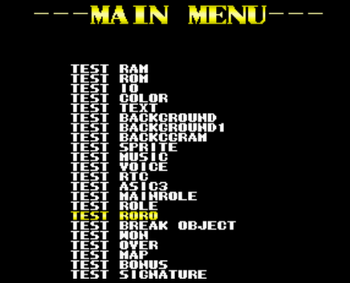
之后按START键进入
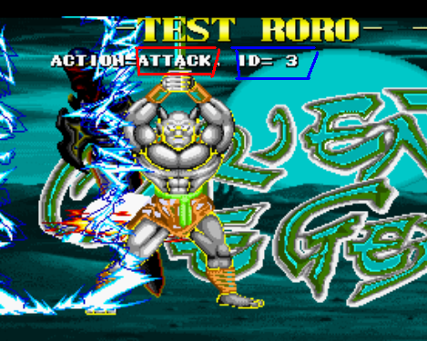
你会见到上面的图片,现在我拿
000dcfach: 03 03 00 00 2C 01 00 00 18 00 00 00 00 00 00 00 1D 00 70 CF
这个来分析下
蓝色的03表示什么意思呢?其实表示上图蓝色框ID = 3
红色03表示上图红色框的ATTACK
(注意: WAIT = 0 , START = 1, MOTION = 2, ATTACK = 3, KILL = 6, CANING = 8, VICTOR = 9 )

绿色00 00 可能是X坐标,黄色2C 01可能是Y坐标,紫色00 00可能是Z坐标,
我是这样分析的,如果BOSS距离主角如上的坐标系时,那么BOSS就会使用招式03 03

至于18 00 是什么,我现在还未知道是什么?

指针1D 00 70 CF是个返回指针,它的作用:

当使用招式03 03后,接着继续使用指针1D 00 70 CF即dcf70

当然dcf70h是
000dcf70h: 00 03 00 00 2C 01 00 00 18 00 00 00 00 00 00 00 00 00 00 00

作者:心林
2007-10-5

