User Guide for Web Testing Demo

# Introduction

This Demo is for vCD login testing, it contain 2 test case and support 3 browsers on 8 locales. The tester can create own test case depend this Demo.

# Environment

JDK: jdk1.8.0_20

Selenium: selenium-server-standalone-2.44.0.jar

testng: testng-6.8.21.jar

log4j: log4j-core-2.2.jar and log4j-api-2.2.jar

# Start to Use

This demo can run on local or remote client, before run this demo, you must do some settings on your environment.

## Configure on your local

This demo can run on 3 browsers on 8 locales, but when you run it on IE/Chrome, you must **change the locale manual**

## Configure on your remote client

Prepare a negative client and install java

Run the command as below:

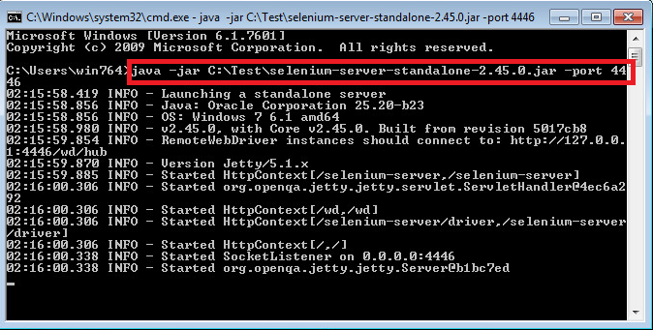

Notes: The default port is 4444, you can change it to any port which is not be used.

After run the command successfully as above, you can use https://<your client IP>:4446/ to access it

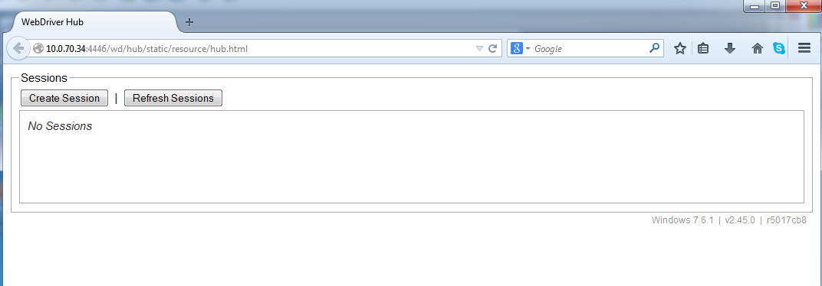

## Start to run

1. Configure the Test Data

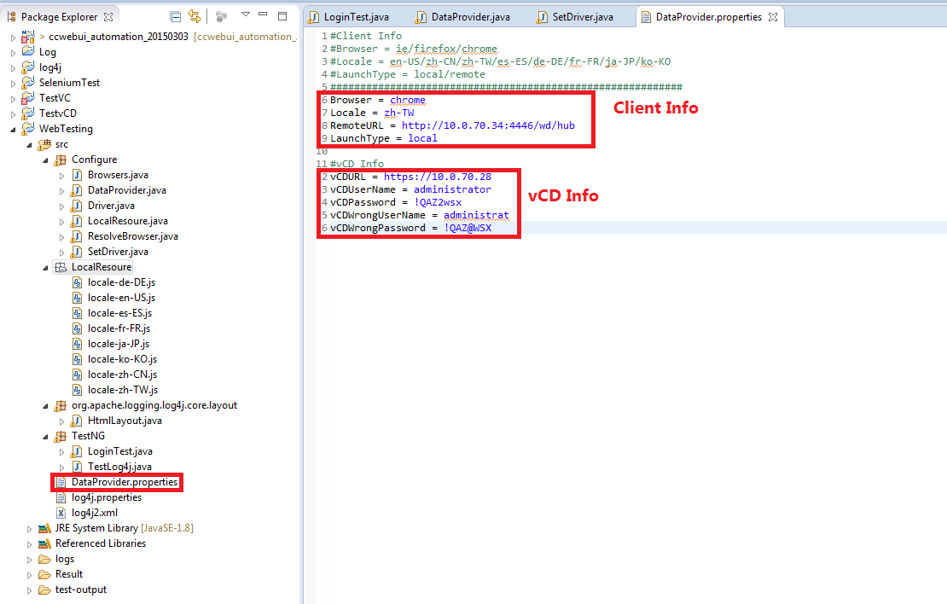

1. Run the “LoginTest.java” as testing

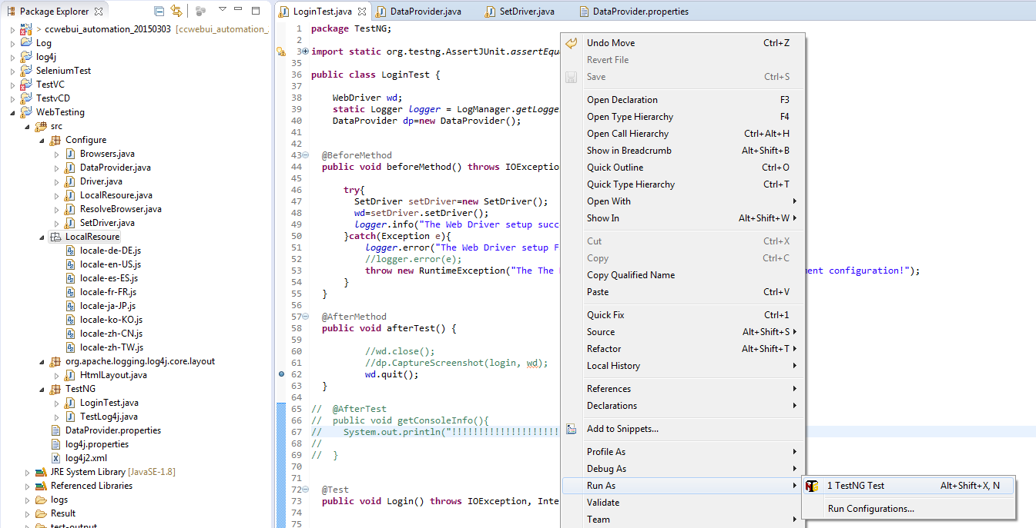

Notes: When you use the IE/Chrome, you must down the IE/Chrome Driver and set the path for the drivers.

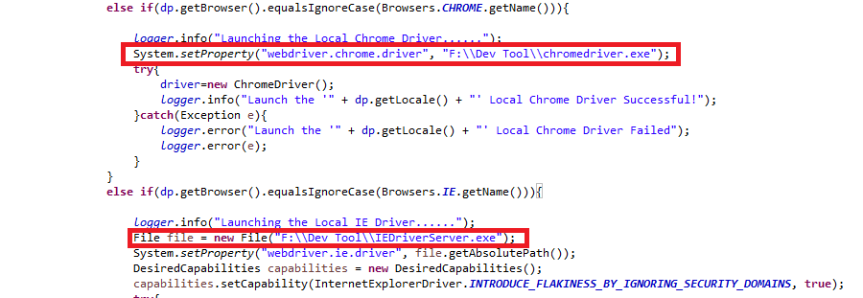

# Result analyze

After the Domo run complete, the log result will store in <project path>/Result folder and testng logs is in <project path>/test-output.

