**Appendix**

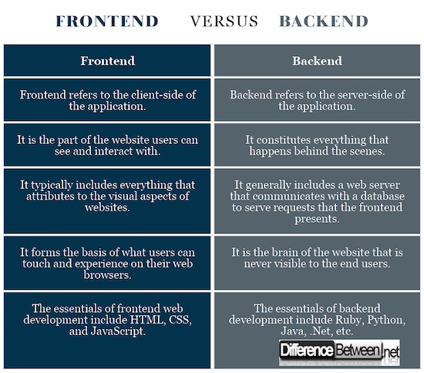

***Table 1.0*** *Frontend vs Backend*

Frontend: a part of the website that interacts with users directly, which is also referred as client-side. The languages used in fronted are HTML, CSS, JavaScript, and the frameworks and libraries are AngularJS, React.js, jQuery, and SASS.

Backend: the other part of the website that stores and arranges data and connects to the frontend to ensure everything on the client-side is working properly, it is also referred as server-side. Some of backend languages are PHP, C++, Java, Python, JavaScript, Node.js, and the list of frameworks are Express, Django, Rails, Laravel, Spring. etc.