**Supporting Information for**

**Peatland degradation increased biodiversity and polyphenols accumulation**

Zeng Jia1, Chen Huai2,3, Bai Yinping1, Dong Faqin4, Yang Zhenan5, Yang Suizhuang1, Yang Gang1*

1 School of Life Science and Engineering, Southwest University of Science and Technology, Mianyang 621010, China, 2 Key Laboratory of Mountain Ecological Restoration and Bioresource Utilization ＆Ecological Restoration Biodiversity Conservation, Key Laboratory of Sichuan Province, Chengdu Institute of Biology, Chinese Academy of Sciences, Chengdu, 610041, China, 3 Zoige Peatland and Global Change Research Station, Chengdu Institute of Biology, Chinese Academy of Sciences, Hongyuan 624400, China, 4 Key Laboratory of Solid Waste Treatment and Resource Recycle, Ministry of Education, Southwest University of Science and Technology, Mianyang 621010, China, 5 Key Laboratory of Southwest China Wildlife Resources Conservation (China West Normal University), Ministry of Education；No.1 Shi Da Road, Nanchong, Sichuan, China, 637000

**\* Corresponding authors**: Associate Prof. Gang Yang, PhD

1. mail: [yanggang903@swust.edu.cn](mailto:yanggang903@swust.edu.cn) or [yanggang903@163.com](mailto:yanggang903@163.com)

**Contents of this file**

Figures S1 to S5

**Introduction**

**The support information provides the same charts and tables as in this article, as well as the data to generate the charts.**

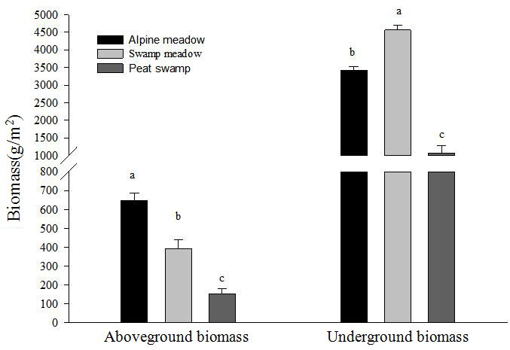

**Fig 1** **Changes in aboveground and belowground biomass in different stages of peatland degradation (Different letters indicate significant differences, P<0.05)**

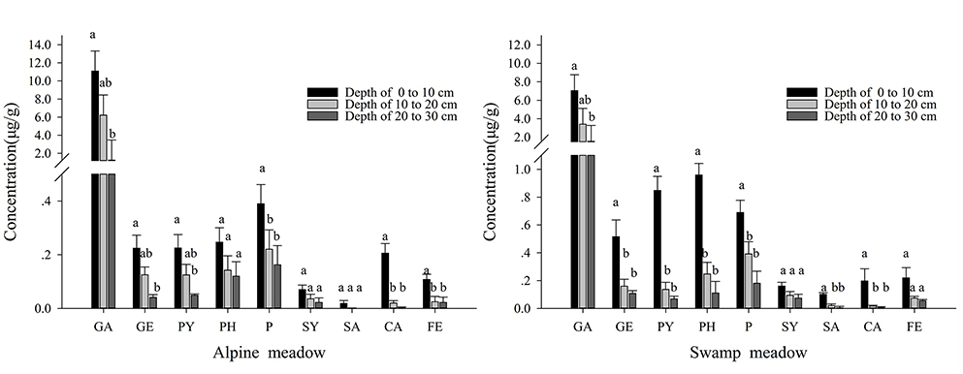

**Fig 2 Nine main phenolic compounds in peatland varied with soil depth (different letters indicatesignificant difference between different soil depth, P < 0.05)** Note: gallic acid (**GA**), gentisic acid (**GE**), catechin (**PY**), p-hydroxybenzoic acid (**PH**), 4-coumaric acid (**P**), syringic acid (**SY**), salicylic acid (**SA**), caffeic acid (**CA**), ferulic acid (**FE**).

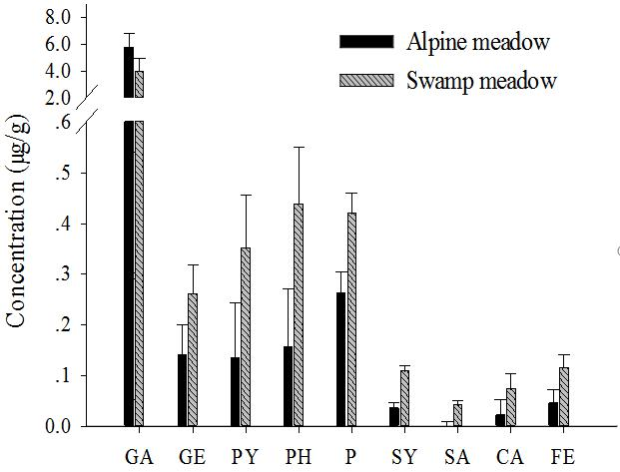

**Fig 3 The concentration of nine phenolic compounds in alpine meadow and swamp meadow.** Note:gallic acid (**GA**), gentisic acid (**GE**), catechin (**PY**), p-hydroxybenzoic acid (**PH**), 4-coumaric acid (**P**), syringic acid (**SY**), salicylic acid (**SA**), caffeic acid (**CA**), ferulic acid (**FE**).

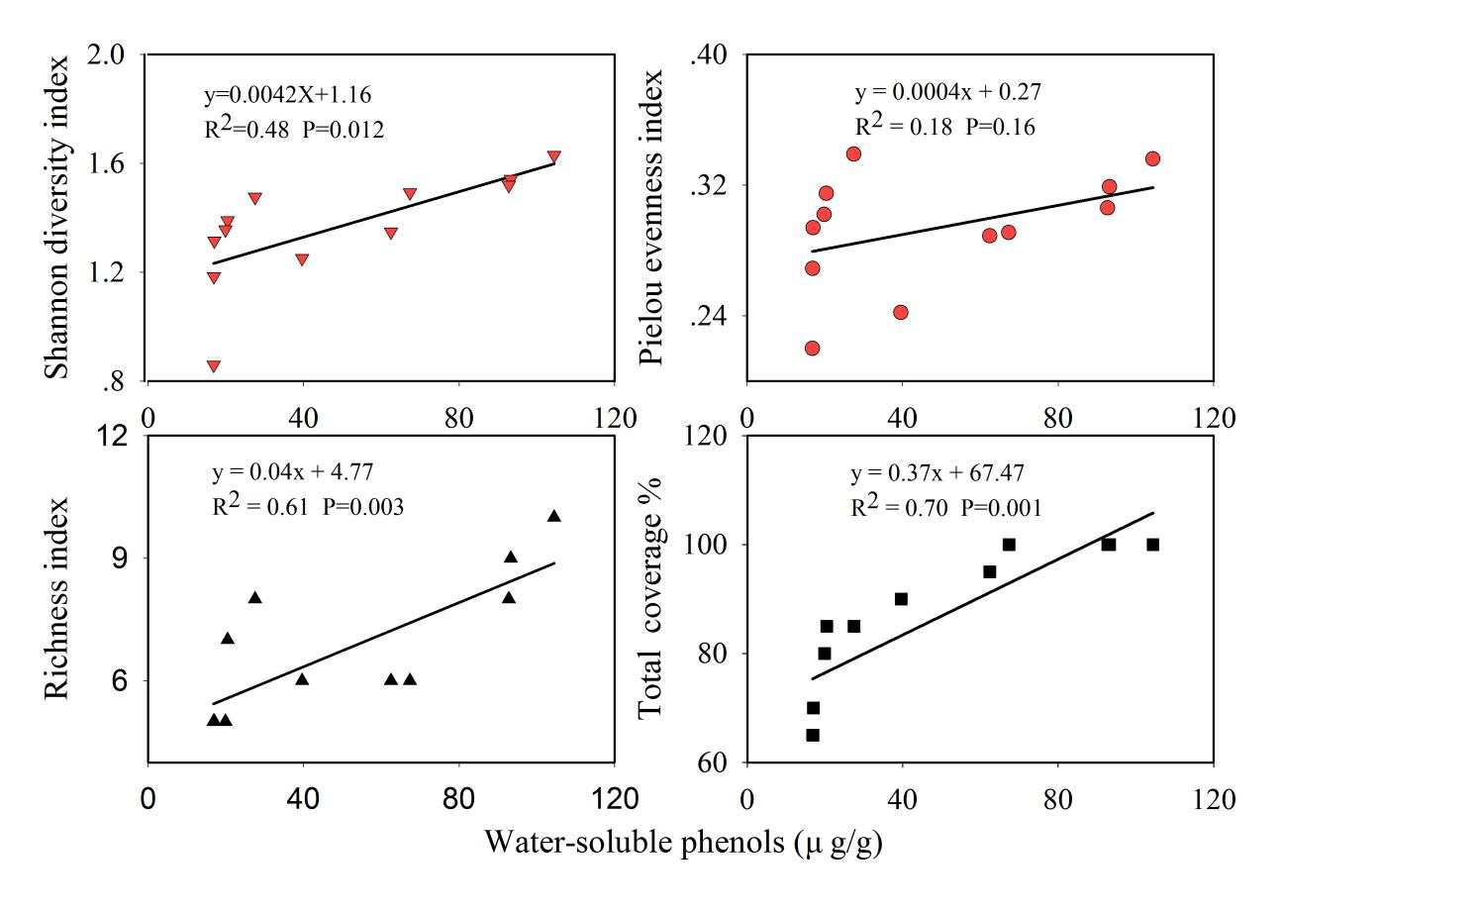

**Fig 4 Regression analysis of the concentration of water-soluble phenols and vegetation coverage, diversity, richness and evenness index**

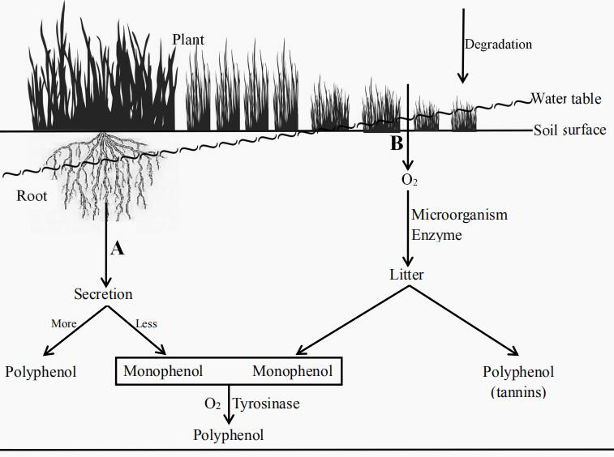

**Fig 5 Water level, oxygen and vegetation affect the accumulation of phenols in peatland** Note: In the process of peatland degradation, A: Decreasing water level promoting vascular plant growth and plant diversity. Root secretion increased, producing a large number of water-soluble phenols (mainly polyphenols). B: The oxygen-enriched environment increases the activity of microorganisms and enzymes that decompose plant litter into polyphenol (tannins) and Monophenols. Eventually, monophenols are converted by tyrosinase into polyphenols.