Zengjie XIA

Zx252@cam.ac.uk

Version 2.0

Aggregate Charaterization   
Toolkit

User Manual

Contents

Installation Guide 2

Run Program 2

Diffraction-limited Image Analysis 3

Data preparation 3

Analysis 3

Tag and Orthogonal Analysis 4

Super-resolution Image Analysis 7

Program Workflow 7

Data preparation 7

Analysis 7

Parameter Explained 8

Liposome Assay Analysis 9

Data preparation 9

Analysis 9

# Installation Guide

1. Install Anaconda3 (if applicable)
2. Double click the ‘setup_conda_env.bat’ to install the environment and required packages.

# Run Program

1. Run ‘Anaconda Prompt’ from Start Menu.
2. Change conda environment by:

conda activate ACT_python3

1. Run program:

python ‘/path-to-folder/main.py’

*Or you can drag the main.py file into the prompt window.

# Diffraction-limited Image Analysis

## Data preparation

The images should have file name with coordinates: **XnYnRnWnCn**, **XnYnRnWn** or **Posn**. They can be either **.tiff** images or stacks.

## Analysis

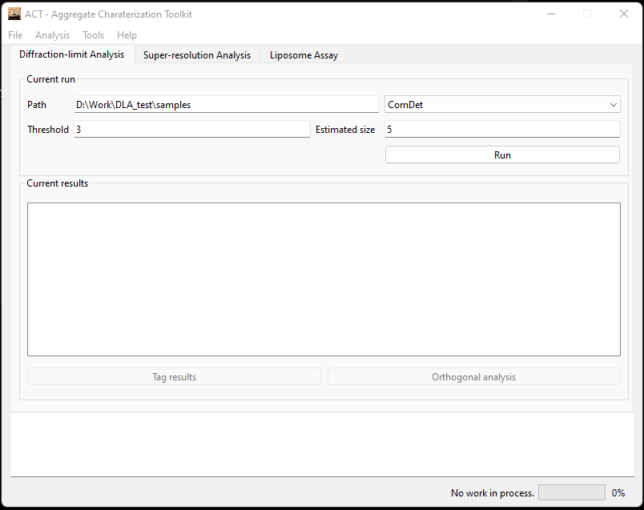

1. Copy& paste the path for the data to be analysed in the box. (Or click ‘Load…’ option in ‘File’ to browse folder.
2. Input the parameters accordingly.
3. Select calculation method. (You can read instructions on parameter selection by choose the method you are using in ‘Help’ menu.)
4. Click ‘Run’.

## Tag and Orthogonal Analysis

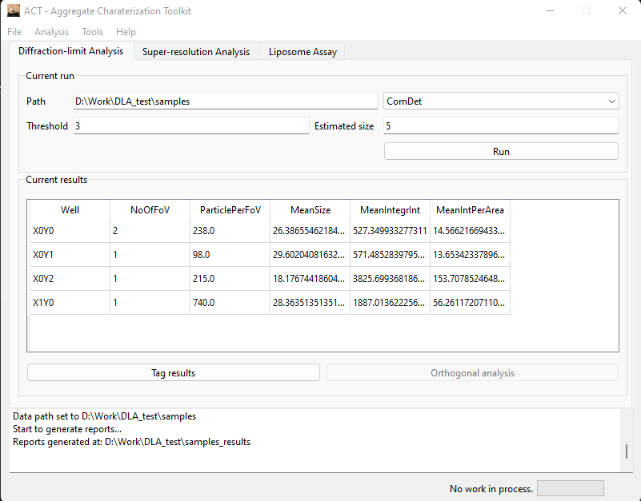

1. After running the analysis, ‘Tag results’ button would be enabled.

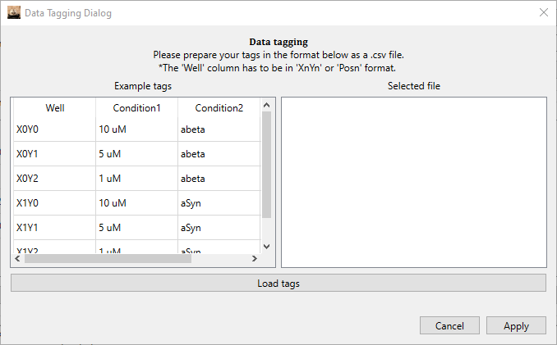

1. Prepare a tagging reference as request and ‘Load tags’ (Hint: Use extra condition ‘Experiment’ to handle experiments with multiple variables.)
2. The tagged results would show up in the ‘Current results’ window after ‘Apply’

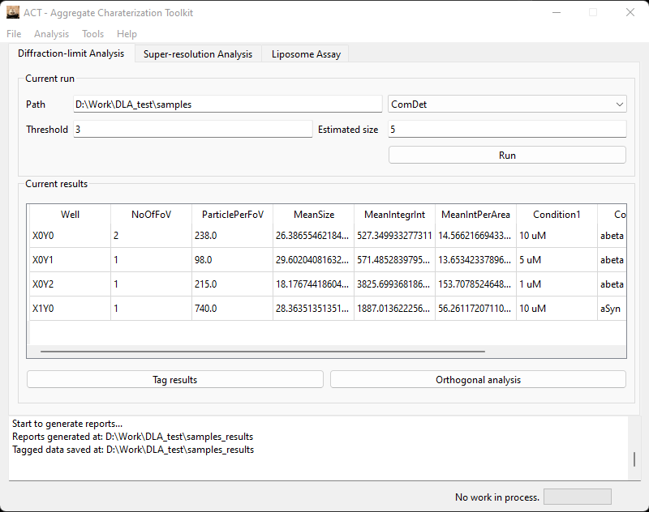

1. Then ‘Orthogonal analysis’ button would be enabled.

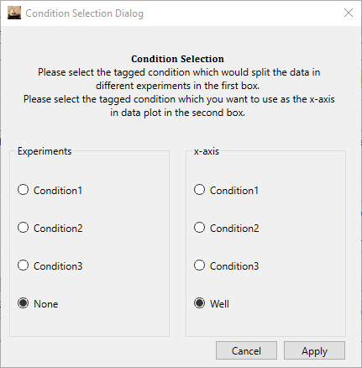

1. In the condition selection window, choose the condition which would split your dataset into different experiments and the condition which you would choose as the x-axis for data plotting.

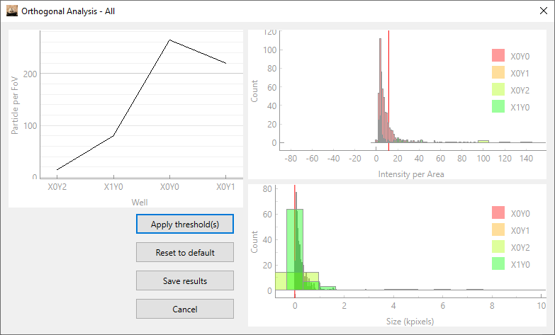

1. This window would be generated for each of your experiments.
   1. The legend of plots can be moved freely.
   2. Scroll the plot can zoom in/out.
   3. Right click and ‘Export…’ allows you save the plot.
2. Drag the RED line on the plots allows you to set threshold on intensity per area/size of particle. (Place the red line where your sample result is well distinguished from your blank.)
3. Click ‘Apply threshold(s)’, and you can see how the thresholds work for your data.
4. ‘Reset to default’ does what it says.
5. ‘Save results’ would save the data with applied threshold separately.

# Super-resolution Image Analysis

## Program Workflow

## Data preparation

The images should have file name with coordinates: **XnYnRnWnCn** or **XnYnRnWn**. They should be **.tiff** image stacks.

## Analysis

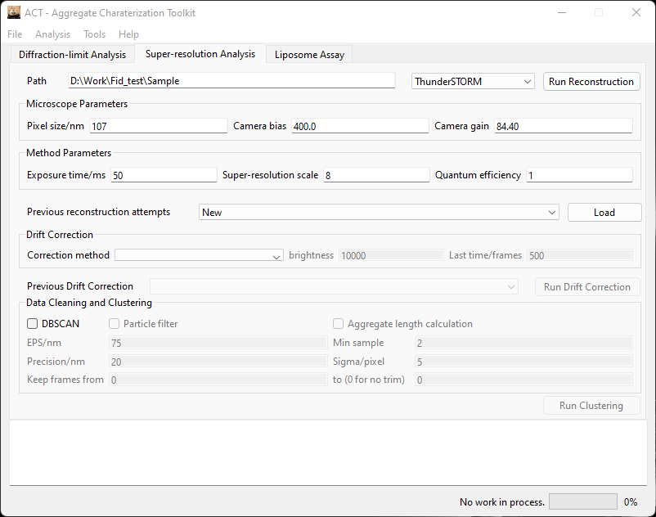

1. Copy& paste the path for the data to be analysed in the box. (Or click ‘Load…’ option in ‘File’ to browse folder.
2. Two reconstruction methods are available: ThunderSTORM and GDSC SMLM 1. Information on the methods can be found at <https://zitmen.github.io/thunderstorm/> and <https://github.com/aherbert/gdsc-smlm/> respectively.
3. Input the parameters accordingly.
4. See Program Workflow for what calculations will be run when a button is clicked.
5. Click ‘Load’ when a previous attempt needs to be used. (Or refresh the attempt selections manually.)

## Parameter Explained

* Microscope Parameters
  + Pixel size: The size of each pixel in nanometres.
  + Camera bias: The electronic offset added to the output signal from the camera sensor to ensure that the displayed signal level is always a positive number of counts.
  + Camera gain: The EM gain of the EMCCD. Set to 0 for non-EM CCD
* Method Parameters
  + Exposure time: The exposure time for each frame.
  + Super-resolution scale: The number of pixels to be split into during reconstruction.
  + Quantum efficiency (ThunderSTORM only): Quantum efficiency of the camera used.
* Drift Correction
  + Fiducial Maker – ThunderSTORM
    - Max distance: The maximum merging distance in which a molecule must appear to be considered as a fiducial marker.
    - Min visibility ratio: and the minimum number of frames in which a molecule must appear to be considered as a fiducial marker.
  + Cross-correlation – ThunderSTORM
    - Bin size: The list of localized molecules is split into **bin size + 1 batches** based on the frame in which they appeared.
    - Magnification: Super-resolution scale used for the reconstruction.
* Data Cleaning and Clustering
  + EPS: The maximum distance between two particles to be considered as neighbour.
  + Min sample: The minimum number of particles to be considered as a cluster.
  + Precision: Filter for reconstruction precision.
  + Sigma: Filter for reconstruction sigma.
  + Keep frames from: The number of frames to be removed from the start.
  + To (0 for no trim): The index of the last frame to be kept.

# Liposome Assay Analysis

## Data preparation

The data needs to be organized in the following manner:

* Data_to_be_analysed
  + Sample_1
    - Blank
      * XnYnRnWnCn
    - Sample
      * XnYnRnWnCn
    - Ionomycin
      * XnYnRnWnCn
  + Sample_2
    - Blank
    - Sample
    - Ionomycin
  + Sample_3
  + …

**\*The ‘Blank’, ‘Sample’ and ‘Ionomycin’ images must be put into the folders with the exact name for the program to identify them.**

## Analysis

1. Copy& paste the path for the data to be analysed in the box. (Or click ‘Load…’ option in ‘File’ to browse folder.
2. Input threshold. The threshold represents the difference between the intensity of the peak and the local background.
3. Click ‘Run’
4. *Liposome assay analysis may take quite a long time for the image alignment and particle localisation processes.
5. Please check out our paper: [Ultrasensitive Measurement of Ca2+ Influx into Lipid Vesicles Induced by Protein Aggregates](https://onlinelibrary.wiley.com/doi/full/10.1002/anie.201700966) for details on this experiment.