**Installation Guide**

Open ‘Anaconda Prompt’ from Start Menu.

Change directory to the folder containing the program by:

cd /path-to-folder/

Run setup program:

setup_conda_env.bat

**Run Program**

Open ‘Anaconda Prompt’ from Start Menu.

Change conda environment:

conda activate DLA_python3

Run program:

python /path-to-folder/main.py

*You can drag the main.py file into the prompt window.

**Data preparation**

The images should have file name with coordinates: **XnYnRnWnCn**, **XnYnRnWn** or **Posn**. They can be either .tiff images or stacks.

**Analysis**

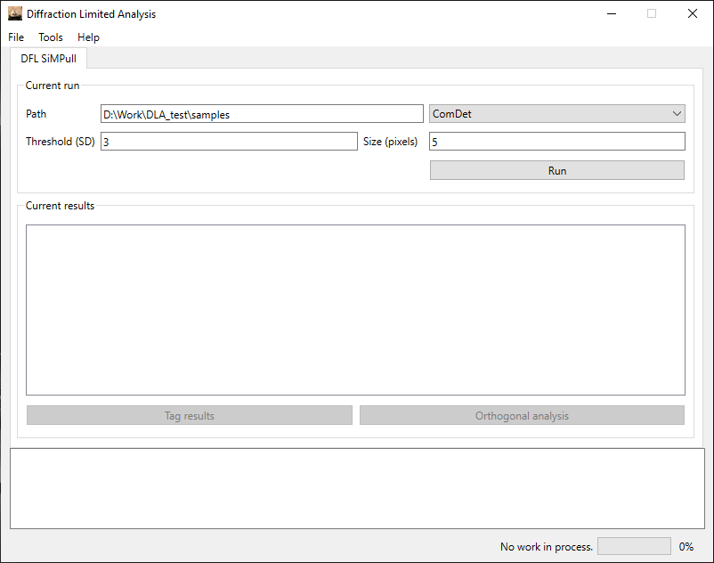

1. Copy& paste the path for the data to be analysed in the box. (Or click ‘Load…’ option in ‘File’ to browse folder.
2. Change the parameters accordingly.
3. Select calculation method. (You can read instructions on parameter selection by choose the method you are using in ‘Help’ menu.)
4. Click ‘Run’.

**Tag and Orthogonal Analysis**

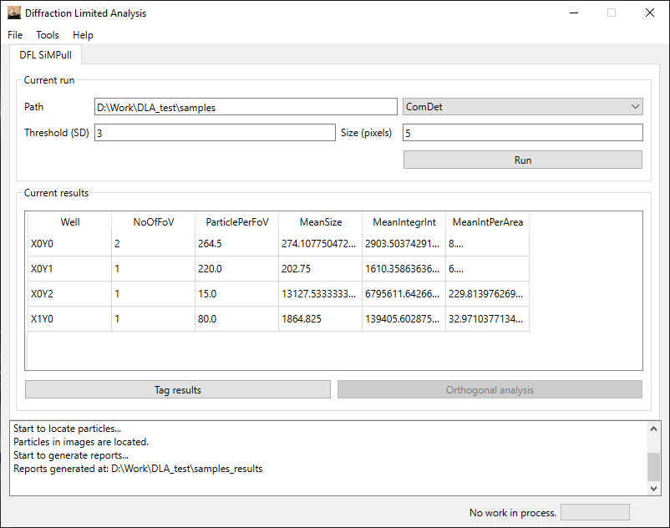

1. After running the analysis, ‘Tag results’ button would be enabled.

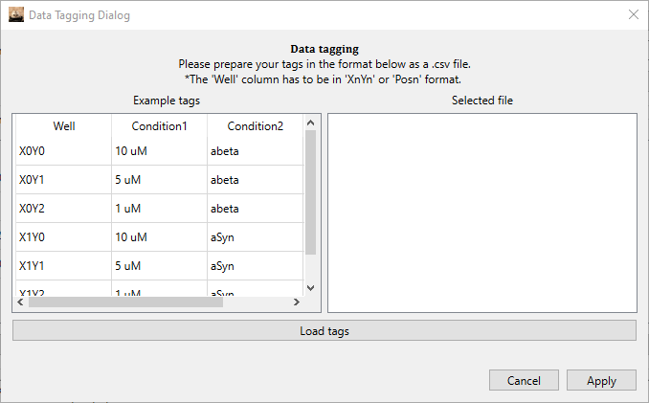

1. Prepare a tagging reference as request and ‘Load tags’ (Hint: Use extra condition ‘Experiment’ to handle experiments with multiple variables.)
2. The tagged results would show up in the ‘Current results’ window after ‘Apply’

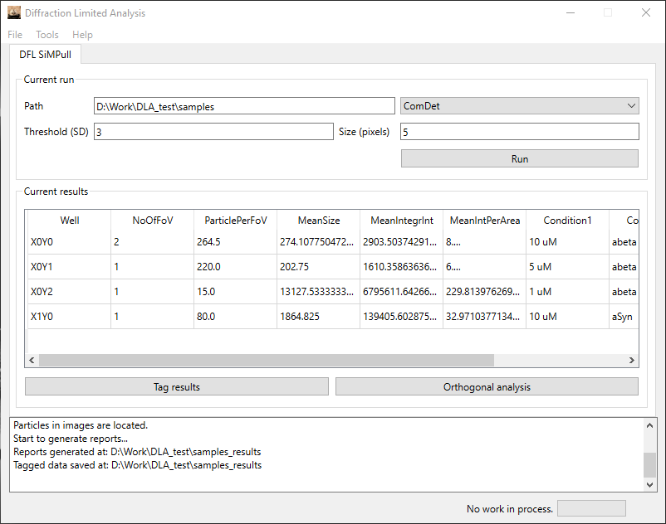

1. Then ‘Orthogonal analysis’ button would be enabled.

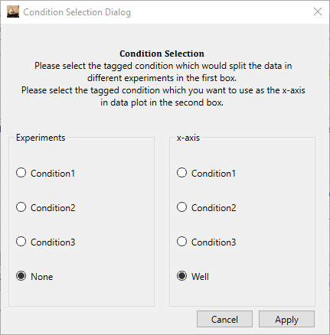

1. In the condition selection window, choose the condition which would split your dataset into different experiments and the condition which you would choose as the x-axis for data plotting.

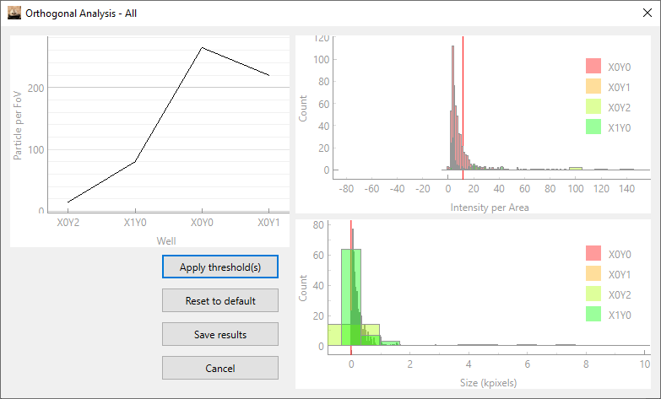

1. This window would be generated for each of your experiments.
   1. The legend of plots can be moved freely.
   2. Scroll the plot can zoom in/out.
   3. Right click and ‘Export…’ allows you save the plot.
2. Drag the RED line on the plots allows you to set threshold on intensity per area/size of particle. (Place the red line where your sample result is well distinguished from your blank.)
3. Click ‘Apply threshold(s)’, and you can see how the thresholds work for your data.
4. ‘Reset to default’ does what it says.
5. ‘Save results’ would save the data with applied threshold separately.